17. Assessment of the Atka mackerel stock in the   
Bering Sea and Aleutian Islands

Sandra Lowe, James Ianelli, Wayne Palsson, and Ben Fissel

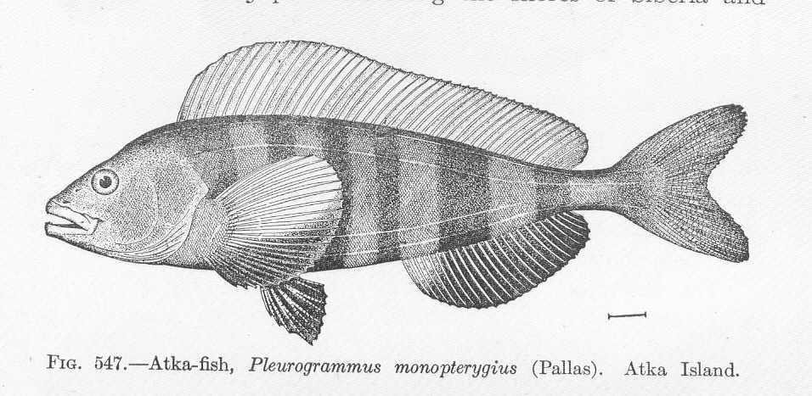

# Executive Summary

Relative to the November 2019 SAFE report, the following substantive changes have been made in the assessment of Atka mackerel.

### Summary of Changes in Assessment Input

1. The 2019 catch estimate was updated and estimated total catch for 2020 was set equal to the TAC (59,305 t).
2. Estimated 2021 and 2022 catches are 60,400 t and 56,925 t, respectively.
3. The 2019 fishery age composition data were added.
4. The estimated average selectivity for 2015-2019 was used for projections.
5. We assume that approximately 85% of the BSAI-wide ABC is likely to be taken under the revised Steller Sea Lion Reasonable and Prudent Alternatives (SSL RPAs) implemented in 2015. This percentage was applied to the 2021 and 2022 maximum permissible ABCs, and those reduced amounts were assumed to be caught in order to estimate the 2021 and 2022 ABCs and OFL values.
6. As in 2019, the sample sizes specified for fishery age composition data were rescaled to have the same means as in the original baseline model (100) but varied relative to the number of hauls for the fishery. The 2019 data were added.

## Summary of Changes in the Assessment Methodology

There were no changes in the model configuration.

## Summary of Results

1. The addition of the 2019 fishery age composition information impacted the estimated magnitude of the 2012- and 2013-year classes which increased 5 and 7% respectively, relative to last year’s assessment. The 2012-year class is estimated to be 50% above average. The 2015-year class increased 10% relative to last year’s estimate, but remains just below (15%) the long term average recruitment.
2. Estimated values of *B100%*, *B40%* , *B35%* are essentially unchanged (-0.2%) relative to last year’s assessment.
3. Projected 2021 female spawning biomass (107,830 t) is 2% lower relative to last year’s estimate of 2020 female spawning biomass, and 3% higher relative to last year’s projection for 2021.
4. Projected 2021 female spawning biomass is below *B40%* (116,330 t) at *B37%*, thereby placing BSAIAtka mackerel in Tier 3b.
5. The current estimate of *F40% adj*= 0.43 is 5% higher relative to last year’s estimate of *F40% adj* due to changes in the fishery selectivity used for projections.
6. The projected 2021 yield at *maxFABC* = *F40% adj =* 0.43 is 73,590 t, which is 5% higher relative to last year’s estimate for 2020.
7. The projected 2021 overfishing level at *F35%* *adj* = 0.51 is 85,580 t, which is 5% higher than last year’s estimate for 2020.

|  |  |  |  |  |
| --- | --- | --- | --- | --- |
| **Quantity** | As estimated or  *specified last* year for: | | As estimated or  *recommended this* year for: | |
| 2020 | 2021 | 2021* | 2022* |
| *M* (natural mortality rate) | 0.30 | 0.30 | 0.30 | 0.30 |
| Tier | 3b | 3b | 3b | 3b |
| Projected total (age 1+) biomass (t) | 515,890 | 534,220 | 560,360 | 599,690 |
| Projected Female spawning biomass | 109,900 | 104,700 | 107,830 | 102,950 |
| *B100%* | 291,780 | 291,780 | 290,820 | 290,820 |
| *B40%* | 116,600 | 116,600 | 116,330 | 116,330 |
| *B35%* | 102,020 | 99,320 | 101,790 | 101,790 |
| *FOFL* | 0.48 | 0.46 | 0.51 | 0.49 |
| *maxFABC* | 0.41 | 0.39 | 0.43 | 0.41 |
| *FABC* | 0.41 | 0.39 | 0.43 | 0.41 |
| OFL (t) | 81,200 | 74,800 | 85,580 | 79,660 |
| maxABC (t) | 70,100 | 64,400 | 73,590 | 68,220 |
| ABC (t) | 70,100 | 64,400 | 73,590 | 68,220 |
| **Status** | As determined *this* year for: | | As determined *this* year for: | |
| 2018 | 2019 | 2019 | 2020 |
| Overfishing | No | n/a | No | n/a |
| Overfished | n/a | No | n/a | No |
| Approaching overfished | n/a | No | n/a | No |

*Projections are based on estimated total catch of 60,400 t and 56,925 t in place of maximum permissible ABC for 2021 and 2022, respectively.

### Area apportionment of ABC

The apportionments of the 2021 and 2022 recommended ABCs based on the most recent 4-survey weighted average:

|  |  |  |  |  |  |  |  |
| --- | --- | --- | --- | --- | --- | --- | --- |
|  | Survey Year | | | | 2021 & 2022 Apportionment | 2021 | 2022 |
| 2012 | 2014 | 2016 | 2018 | ABC | ABC |
| 541+SBS | 12% | 42% | 35% | 38% | 0.35 | 25,760 | 23,880 |
| 542 | 39% | 28% | 30% | 7% | 0.21 | 15,450 | 14,330 |
| 543 | 48% | 30% | 35% | 55% | 0.44 | 32,380 | 30,010 |
| Weights | 8 | 12 | 18 | 27 | 1.00 |  |  |
| Total ABC | |  |  |  |  | 73,590 | 68,220 |

## Responses to SSC and Plan Team Comments on Assessments in General

***From the December 2019 SSC minutes:***

* “*The SSC requests that the GPTs, as time allows, update the risk tables for the 2020 full assessments, as the SSC found this exercise to be very helpful.*”

The BSAI Atka mackerel assessment includes an updated risk table.

* *“The SSC also requests authors to note changes in risk scoring from one assessment to the next, along with the rationale. The SSC reminds the authors that the tables are intended to capture risks and uncertainties that are NOT addressed in assessment and/or the application of the Tier system. In cases where these concerns are partially addressed, the SSC requests that the authors clearly articulate the extent to which the listed items are not already addressed by the assessment and/or the Tier system.”*

There were no changes in the risk scoring from last year’s assessment. The extent to which issues are partially addressed in the assessment are articulated in the risk table discussion.

* *“The SSC recommends dropping the overall risk scores in the tables as these provided no additional information relative to ABC-setting and seemed to cause confusion”.*

The current assessment has dropped the overall risk score from the table.

* “*The SSC requests that the table explanations be included in all the assessments which include a risk table for completeness.*”

The risk table explanations are included.

***From the October SSC 2020 minutes: “****The SSC supports the JPT’s recommendation for authors to explicitly consider the survey loss analyses (or analyses like them) in developing their risk tables for this year, but does not suggest a standardized approach for all species, noting important differences in the behavior of individual assessments.*”

We discuss and consider the survey loss analyses in the risk table discussion

***From the November 2019 Joint and BSAI Plan Team minutes***: “*The Teams recommended that authors continue to fill out the risk tables for full assessments. The Teams recommended that adjustment of ABC in response to levels of concern should be left to the discretion of the author, the Team(s), and/or the SSC, but should not be mandated by the inclusion of a >1 level in any particular category*.”

A risk table is provided for the BSAI Atka mackerel assessment.

***From the September 2020 Joint and BSAI Plan Team minutes***:

There were no comments on assessments in general from the September 2020 Joint and BSAI Plan Team minutes.

## Responses to SSC and Plan Team Comments Specific to the Atka Mackerel Assessment

***From the December SSC 2019 minutes*:**

* *Continuing to develop appropriate apportionment methods for this stock in the future, with an emphasis on investigating the application and validation of the autoregressive spatio-temporal modeling approach developed in the VAST modeling framework for such purposes. As appropriate, this apportionment should consider use of both survey data and fishery CPUE.*

Work on apportionment methods for Atka mackerel will be resumed in 2021. Jim Ianelli and I are collaborators on a funded project: A simulation and case-study comparison of existing and spatio-temporal methods to apportion coastwide catch limits for subregional management. The project objective is to compare the performance of conventional and alternative approaches to inform fisheries management councils regarding spatial distribution for subregional harvest regulations. The results of this project will be directly applicable to BSAI Atka mackerel. In addition, a working group was formed this year to coordinate and promote research using fishery CPUE to develop abundance indices, composition data, and measure fishery performance for use in the risk tables. We hope to apply this research to develop an alternative apportionment method using both survey data and fishery CPUE.

* *Reporting fish condition in the assessment over time at smaller spatial scales than in the ESR. The assessment noted that trends in condition differ across the AI but did not elaborate.*

We will include a discussion and plots of length-weight residuals (as a proxy for fish condition) for the Aleutian Islands by subareas for 1990-2018, in the planned 2021 ESP.

* *Taking into consideration that historical fishery evidence of linkages between the AI and GOA populations of Atka mackerel suggest source-sink population dynamics that may account for unexplained fluctuations in the AI population when modeled as a single unit, especially in the eastern region, and exploring the strength of these connections to evaluate changes in the assessment approach (e.g., modeling as two separate stocks versus one metapopulation).*

Gulf of Alaska (GOA) Atka mackerel are a Tier 6 stock (no reliable estimates of biomass), and a directed fishery is prohibited in the GOA due to Steller sea lion regulations. There are significant differences in population size, distribution, recruitment patterns, and resilience to fishing, suggesting that management as separate stocks is appropriate. Bottom trawl surveys and fishery data suggest that the Atka mackerel population in the GOA is smaller and much more patchily distributed than that in the AI, and composed almost entirely of fish >30 cm in length. However, there is clearly some level of connection between the Aleutian Islands and the GOA, particularly in the western GOA (WGOA). We will conduct an updated meta-analysis, and investigate using the VAST modeling framework to estimate an Aleutian Islands population that includes the WGOA.

***From the November 2019 BSAI Plan Team minutes:*** *“The Team recommended that an Ecosystem and Socioeconomic Profile (ESP) be developed for this stock in 2020*.”

Due to Covid-19, plans for an ESP have been delayed to 2021.

***From the September 2020 BSAI Team minutes****:*

An Atka mackerel document was not presented in September 2020.

# Introduction

*Native Names:* In the Aleut languages, Atka mackerel are known as *tmadgi-{* among the Eastern and Atkan Aleuts and Atkan of Bering Island. They are also known as *tavyi-{* among the Attuan Aleuts (Sepez *et al.* 2003).

## Distribution

Atka mackerel (*Pleurogrammus monopterygius*) are widely distributed along the continental shelf across the North Pacific Ocean and Bering Sea from Asia to North America. On the Asian side they extend from the Kuril Islands to Provideniya Bay (Rutenburg 1962); moving eastward, they are distributed throughout the Komandorskiye and Aleutian Islands (AI), north along the eastern Bering Sea (EBS) shelf, and through the Gulf of Alaska (GOA) to southeast Alaska.

## Early life history

Atka mackerel are a substrate-spawning fish with male parental care. Single or multiple clumps of adhesive eggs are laid on rocky substrates in individual male territories within nesting colonies where males brood eggs for a protracted period. Nesting colonies are widespread across the continental shelf of the Aleutian Islands and western GOA down to bottom depths of 144 m (Lauth *et al*. 2007b). Historical data from ichthyoplankton tows done on the outer shelf and slope off Kodiak Island in the 1970’s and 1980’s (Kendall and Dunn 1985) suggest that nesting colonies may have existed at one time in the central GOA. Possible factors limiting the upper and lower depth limit of Atka mackerel nesting habitat include insufficient light penetration and the deleterious effects of unsuitable water temperatures, wave surge, or high densities of kelp and green sea urchins (Gorbunova 1962, Lauth *et al.* 2007b, Zolotov 1993).

In the eastern and central AI, larvae hatch from October to January with maximum hatching in late November (Lauth *et al.* 2007a). After hatching, larvae are neustonic and about 10 mm in length (Kendall and Dunn 1985). Along the outer shelf and slope of Kodiak Island, larvae caught in the fall were about 10.3 mm compared to larvae caught the following spring which were about 17.6 mm (Kendall and Dunn 1985). Larvae and fry have been observed in coastal areas and at great distances offshore (>500 km) in the Bering Sea and North Pacific Ocean (Gorbunova 1962, Materese *et al*. 2003, Mel’nikow and Efimkin 2003).

The Bering-Aleutian Salmon International Survey (BASIS) project studies the distribution and abundance of salmon during the ocean ppahse of their life cycle. BASIS conducted standardized surveys of the upper pelagic layer in the EBS shelf using a surface trawl in 2004-2006. In addition to collecting data pertaining to salmon species, BASIS also collected and recorded information for many other Alaskan fish species, including juvenile Atka mackerel. The EBS shelf was sampled during the mid-August through September from 2004 to 2006 and juvenile Atka mackerel with lengths ranging from 150-200 mm were distributed along the outer shelf in the southern EBS shelf and along the outer middle shelf between St. George and St. Matthew Islands (Appendix B in Lowe *et al*. 2007). The fate or ecological role of these juveniles is unknown since adult Atka mackerel are much less common or absent in annual standardized bottom trawl surveys in the EBS shelf (Lauth and Acuna 2009).

## Reproductive ecology

The reproductive cycle consists of three phases: 1) establishing territories, 2) spawning, and 3) brooding (Lauth *et al*. 2007a). In early June, a fraction of the adult males end schooling and diurnal behavior and begin aggregating and establishing territories on rocky substrate in nesting colonies (Lauth *et al*. 2007a). The widespread distribution and broad depth range of nesting colonies suggests that previous conjecture of a concerted nearshore spawning migration by males in the AI is not accurate (Lauth *et al.* 2007b). Geologic, oceanographic, and biotic features vary considerably among nesting colonies, however, nesting habitat is invariably rocky and perfused with moderate or strong currents (Lauth *et al.* 2007b). Many nesting sites in the AI are inside fishery trawl exclusion zones which may serve as *de facto* marine reserves for protecting Atka mackerel (Cooper *et al*. 2010).

The spawning phase begins in late July, peaks in early September, and ends in mid-October (Lauth *et al*. 2007a). Mature females spawn an average of 4.6 separate batches of eggs during the 12-week spawning period or about one egg batch every 2.5 weeks (McDermott *et al*.2007). After spawning ends, territorial males with nests continue to brood egg masses until hatching. Incubation times for developing eggs decrease logarithmically with an increase in water temperature and range from 39 days at a water temperature of 12.2° C to 169 days at 1.6 °C, however, an incubation water temperature of 15 °C was lethal to developing embryos *in situ* (Guthridge and Hillgruber 2008). Higher water temperatures in the range of water temperatures observed in nesting colonies, 3.9 °C to 10.5 °C (Gorbunova 1962, Lauth *et al*. 2007b), can result in long incubation times extending the male brooding phase into January or February (Lauth *et al*. 2007a).

## Prey and predators

Adult Atka mackerel in the Aleutians consume a variety of prey, but principally calanoid copepods and euphausiids (Yang 1999), and are consumed by a variety of piscivores, including groundfish (e.g., Pacific cod and arrowtooth flounder, Livingston *et al.* unpubl. manuscr.), marine mammals (e.g., northern fur seals and Steller sea lions, Kajimura 1984, NMFS 1995, Sinclair and Zeppelin 2002, Sinclair *et al*. 2013), and seabirds (e.g., thick-billed murres, tufted puffins, and short-tailed shearwaters, Springer *et al.* 1999).

Predation on Atka mackerel eggs by cottids and other hexagrammids is prevalent during the spawning season as is cannibalism by other Atka mackerel of both sexes (heterocannibalism) and by males from their own nest (filial cannibalism; Canino *et al*. 2008, Yang 1999, Zolotov 1993). Filial egg cannibalism is a common phenomenon in species with extended paternal care.

Rand *et al*. (2010) analyzed Atka mackerel stomach data and determined that the east to west size cline in Atka mackerel sizes across the Aleutian Islands, was the result of food quality rather than food quantity or temperature, and may reflect local productivity. Atka mackerel near Amchitka Island (area 542) were eating more copepods and less euphausiids, whereas fish at Seguam pass (area 541) were eating more energy rich euphausiids and forage fish (Rand *et al*. 2010).

Nichol and Somerton (2002) examined the diurnal vertical migrations of Atka mackerel using archival tags and related these movements to light intensity and current velocity. Atka mackerel displayed strong diel behavior, with vertical movements away from the bottom occurring almost exclusively during daylight hours, presumably for feeding, and little to no movement at night (where they were closely associated with the bottom).

## Stock structure

A morphological and meristic study suggests there may be separate populations in the GOA and the AI (Levada 1979). This study was based on comparisons of samples collected off Kodiak Island in the central Gulf, and the Rat Islands in the Aleutians. Lee (1985) also conducted a morphological study of Atka mackerel from the Bering Sea, AI, and GOA. The data showed some differences (although not consistent by area for each characteristic analyzed), suggesting a certain degree of reproductive isolation. Results from an allozyme genetics study comparing Atka mackerel samples from the western GOA with samples from the eastern, central, and western AI showed no evidence of discrete stocks (Lowe *et al.* 1998). A survey of genetic variation in Atka mackerel using microsatellite DNA markers provided little evidence of genetic structuring over the species range, although slight regional heterogeneity was evident in comparisons between some areas (Canino *et al*. 2010). Samples collected from the AI, Japan, and the GOA did not exhibit genetic isolation by distance or a consistent pattern of differentiation. Examination of these results over time (2004, 2006) showed temporal stability in Stalemate Bank, but not at Seguam Pass. These results indicate a lack of structuring in Atka mackerel over a large portion of the species range, perhaps reflecting high dispersal, a recent population expansion and large effective population size, or some combination of all these factors (Canino *et al*. 2010).

The question remains as to whether the Aleutian Island and Gulf of Alaska populations of Atka mackerel should be managed as a unit stock or separate populations given that there is a lack of consistent genetic stock structure over the species range. There are significant differences in population size, distribution, recruitment patterns, and resilience to fishing, suggesting that management as separate stocks is appropriate. Bottom trawl surveys and fishery data suggest that the Atka mackerel population in the GOA is smaller and much more patchily distributed than that in the AI, and composed almost entirely of fish >30 cm in length. There are also more areas of moderate Atka mackerel density in the AI than in the GOA. The lack of small fish in the GOA suggests that Atka mackerel recruit to that region differently than in the AI. Nesting sites have been located in the GOA in the Shumagin Islands (Lauth *et al.* 2007a), and historical ichthyoplankton data from the 1970’s around Kodiak Island indicate there was a spawning and nesting population even further to the east (Kendall and Dunn 1985), but the source of these spawning populations is unknown. They may be migrant fish from strong year classes in the AI or a self-perpetuating population in the GOA, or some combination of the two. The idea that the western GOA is the eastern extent of their geographic range might also explain the greater sensitivity to fishing depletion in the GOA as reflected by the history of the GOA fishery since the early 1970s. Catches of Atka mackerel from the GOA peaked in 1975 at about 27,000 t. Recruitment to the AI population was low from 1980-1985, and catches in the GOA declined to 0 in 1986. Only after a series of large year classes recruited to the AI region in the late 1980s, did the population and fishery reestablish in the GOA beginning in the early 1990s. After passage of these year classes through the population, the GOA population, as sampled in the 1996 and 1999 GOA bottom trawl surveys, has declined and is very patchy in its distribution. More recently, the strong 1999, 2006, and 2007 year classes documented in the AI showed up in the GOA. Leslie depletion analyses using historical AI and GOA fishery data suggest that catchability increased from one year to the next in the GOA fished areas, but remained the same in the AI areas (Lowe and Fritz 1996; 1997). These differences in population resilience, size, distribution, and recruitment support separate assessments and management of the GOA and AI stocks and a conservative approach to the management of the GOA portion of the population.

## Management units

Amendment 28 to the Bering Sea/Aleutian Islands (BSAI) Fishery Management Plan became effective in mid-1993, and divided the Aleutian subarea into three districts at 177°W and 177°E for the purposes of spatially apportioning Total Allowable Catches (TAC). Since 1994, the BSAI Atka mackerel TAC has been allocated to the three regions (541 Eastern Aleutians, 542 Central Aleutians, and 543 Western Aleutians).

# Fishery

## Catch history

Atka mackerel became a reported species group in the BSAI Fishery Management Plan in 1978. Catches (including discards and community development quota [CDQ] catches), corresponding Acceptable Biological Catches (ABC), TAC, and Overfishing Levels (OFL) set by the North Pacific Fishery Management Council (NPFMC or Council) from 1978 to the present are given in Table 17.1. Non-commercial removals are presented in Appendix 17A. These supplemental catch data are estimates of total available removals that do not occur during directed groundfish fishing activities. These include removals incurred during research, subsistence, personal use, recreational, and exempted fishing permit activities.

From 1970-1979, Atka mackerel were landed off Alaska exclusively by the distant water fleets of the U.S.S.R., Japan and the Republic of Korea. U.S. joint venture fisheries began in 1980 and dominated the landings of Atka mackerel from 1982 through 1988. Total landings declined from 1980-1983 primarily due to changes in target species and allocations to various nations rather than changes in stock abundance. Catches increased quickly thereafter, and from 1985-1987 Atka mackerel catches averaged 34,000 t annually, dropping to a low of 18,000 t in 1989. The last joint venture allocation of Atka mackerel off Alaska was in 1989, and since 1990, all Atka mackerel landings have been made by U.S. fishermen. Beginning in 1992, TACs increased steadily in response to evidence of a large exploitable biomass, particularly in the central and western AI.

## Description of the directed fishery

### Fishery

The patterns of the Atka mackerel fishery generally reflect the behavior of the species: (1) the fishery is highly localized and usually occurs in the same few locations each year; (2) the schooling semi-pelagic nature of the species makes it particularly susceptible to trawl gear fished on the bottom; and (3) trawling occurs almost exclusively at depths less than 200 m. In the early 1970s, most Atka mackerel catches were in the western AI (west of 180°W longitude). In the late 1970s and through the 1980s, fishing effort moved eastward, with the majority of landings occurring near Seguam and Amlia Islands. In 1984 and 1985 the majority of landings came from a single 0.5° latitude by 1° longitude block bounded by 52° 30' N, 53° N, 172° W, and 173° W in Seguam Pass (73% in 1984, 52% in 1985). Areas fished by the Atka mackerel fishery from 1977 to 1992 are displayed in Fritz (1993). Areas of 2019 and 2020 fishery operations are shown in Figure 17.1.

Fishing locations and CPUE since 2015 have been very similar (Figure 17.1, Figure 17. 1 in Lowe *et al*. 2016, 2017, 2018, 2019). Of note are the fishery operations in the Central (542) area, particularly just preceding and during the AFSC bottom trawl surveys of the Central area during July 1-19, 2018. A total of 153 and 156 fishery hauls were observed July 1-19 in the Central area during the 2017 and 2018 fisheries, respectively. Fishery catch per unit effort (CPUE, extrapolated kg/haul) was also similar in 2017 and 2018, with fishery CPUE rates slightly higher in the 2018 Central area fishery during July 1-19, 2018. Also, fishing was more concentrated in 2018 relative to 2017 in the Central area during July 1-19 (unpublished data, S. Lowe, AFSC). It is unknown if the 2018 fishery had any impacts on the survey catch rates of Atka mackerel in the Central area during July 1-19, 2018. The 2018 survey catches of Atka mackerel in the Central area were significantly down, and the survey did not encounter any moderate to large catches of Atka mackerel as in previous years (See Survey data section below).

Atka mackerel are caught almost exclusively by the Amendment 80 Fleet. The fishery for Atka mackerel has been a catch share fishery since 2008 when Amendment 80 to the BSAI Groundfish FMP was implemented, rationalizing the fleet of catcher/processor vessels in the Bering Sea and Aleutian Islands region targeting flatfish, Atka mackerel and Pacific ocean perch.

### Market

An economic performance report for 2019 for BSAI Atka mackerel is included in Appendix 17B (Fissel 2020). The U.S. (Alaska), Japan and Russian are the major producers of Atka mackerel.[1] Approximately 90% of the Alaska caught Atka mackerel is processed as head-and-gut (H&G) products, while the remainder is mostly sold as whole fish (Table 17B-1 in Appendix 17B). However, in 2019 99% of the catch was processed as H&G as whole fish production dropped off. The domestic market for Atka mackerel is minimal, and data indicate U.S. imports are approximately 0.1% of global production. Virtually all of Alaska’s Atka mackerel production is exported, mostly to Asian markets in Japan, South Korea, and northern China. In Asia it undergoes secondary processing into products like surimi, salted-and-split and other consumable product forms (Table 17B-2 in Appendix 17B). Based on U.S. export statistics, approximately 60% of Alaska’s Atka mackerel is exported to Japanese markets where it is particularly popular in the northern Hokkaido region. Atka mackerel has a unique cultural significance and is a symbolic fish in the Hokkaido region (AFSC 2016).

International production of Atka mackerel has been on the decline because of reductions in Japanese and Russian catch and production, which were particularly severe in 2015 and have continued. As a result, the U.S. has captured a larger share of global production and supplied 55% of the global market of Atka mackerel in 2018 (Table 17B-2 in Appendix 17B). The 2015 opening of previously restricted areas off the Aleutians in Area 541 has given industry more access to larger fish which yield a higher price per pound in the market. The increased price of Atka mackerel in recent years has helped to maintain first-wholesale value despite reduced production volume (Table 17B-2 in Appendix 17B).

## Management history

Prior to 1992, ABCs were allocated to the entire Aleutian management district with no additional spatial management. However, because of increases in the ABC beginning in 1992, the Council recognized the need to disperse fishing effort throughout the range of the stock to minimize the likelihood of localized depletions. In 1993, Amendment 28 to the BSAI Fishery Management Plan became effective, dividing the Aleutian subarea into three districts at 177°W and 177°E for the purposes of spatially apportioning TACs (Figure 17.1). From 1994-2014, the BSAI Atka mackerel TAC was allocated to the three regions based on the average distribution of biomass estimated from the AI bottom trawl surveys. Beginning in 2015, The ABC was apportioned by applying the random effects model to AI survey biomass estimates. Table 17.2 gives the time series of BSAI Atka mackerel catches, corresponding ABC, OFL, and TAC by region.

In June 1998, the Council passed a fishery regulatory amendment that proposed a four-year timetable to temporally and spatially disperse and reduce the level of Atka mackerel fishing within Steller sea lion critical habitat (CH) in the BSAI Islands. Temporal dispersion was accomplished by dividing the BSAI Atka mackerel TAC into two equal seasonal allowances, an A-season beginning January 1 and ending April 15, and a B-season from September 1 to November 1. The goal of spatial dispersion was to reduce the proportion of each seasonal allowance caught within CH to no more than 40% by the year 2002. No CH allowance was established in the Eastern subarea because of the year-round 20 nm trawl exclusion zone around the sea lion rookeries on Seguam and Agligadak Islands that minimized effort within CH. The regulations implementing this four-year phased-in change to Atka mackerel fishery management became effective on January 22, 1999 and lasted only 3 years (through 2001). In 2002, new regulations affecting the management of the Atka mackerel, pollock, and Pacific cod fisheries went into effect. Furthermore, all trawling was prohibited in CH from August 8, 2000 through November 30, 2000 by the Western District of the Federal Court because of violations of the Endangered Species Act (ESA).

As part of the plan to respond to the Court and comply with the ESA, NMFS and the NPFMC formulated new regulations for the management of Steller sea lion and groundfish fishery interactions that went into effect in 2002. The objectives of temporal and spatial fishery dispersion, cornerstones of the 1999 regulations, were retained. Season dates and allocations remained the same (A season: 50% of annual TAC from 20 January to 15 April; B season: 50% from 1 September to 1 November). However, the maximum seasonal catch percentage from CH was raised from the goal of 40% in the 1999 regulations to 60%. To compensate, effort within CH in the Central (542) and Western (543) Aleutian fisheries was limited by allowing access to each subarea to half the fleet at a time. Vessels fishing for Atka mackerel were randomly assigned to one of two teams, which started fishing in either area 542 or 543. Vessels were not permitted to switch areas until the other team had caught the CH allocation assigned to that area. In the 2002 regulations, trawling for Atka mackerel was prohibited within 10 nm of all rookeries in areas 542 and 543; this was extended to 15 nm around Buldir Island and 3 nm around all major sea lion haulouts. Steller sea lion CH east of 178° W in the Aleutian district, including all CH in subarea 541 and a 1° longitude-wide portion of subarea 542, was closed to directed Atka mackerel fishing.

The 2010 NMFS Biological Opinion (BiOp) found that the fisheries for Alaska groundfish in the Bering Sea and AI and GOA, and the cumulative effects of these fisheries, are likely to jeopardize the continued existence of the western distinct population segment (DPS) of Steller sea lions, and alsolikely to adversely modify the designated critical habitat of the western DPS of Steller sea lions. Because this BiOp found jeopardy and adverse modification of critical habitat, the agency was required to implement reasonable and prudent alternatives (RPAs) to the proposed actions (the fisheries). The 2010 BiOp included RPAs which required changes in groundfish fishery management in Management Sub-areas 543, 542, and 541 in the AI Management Area. NOAA Fisheries implemented the RPAs via an interim final rule before the start of the 2011 fishery in January.

The RPAs from the 2010 BiOp and the 2014 Section 7 Consultation Biological Opinion specific to Atka mackerel are listed below.

### RPAs from the 2010 Biological Opinion

#### In Area 543:

* Prohibit retention by all federally permitted vessels of Atka mackerel and Pacific cod.
* Establish a TAC for Atka mackerel sufficient to support the incidental discarded catch that may occur in other targeted groundfish fisheries (e.g., Pacific ocean perch).
* Eliminate the Atka mackerel platoon management system in the HLA.

#### In Area 542:

* Close waters from 0–3 nm around Kanaga Island/Ship Rock to directed fishing for groundfish by federally permitted vessels.
* Set TAC for Area 542 to no more than 47 percent of the Area 543 ABC.
* Between 177° E to 179° W longitude and 178° W to 177° W longitude, close critical habitat from 0–20 nm to directed fishing for Atka mackerel by federally permitted vessels year round.
* Between 179° W to 178° W longitude, close critical habitat from 0-10 nm to directed fishing for Atka mackerel by federally permitted vessels year round. Between 179° W and 178° W longitude, close critical habitat from 10-20 nm to directed fishing for Atka mackerel by federally permitted vessels not participating in a harvest cooperative or fishing a CDQ allocation.
* Add a 50:50 seasonal apportionment to the CDQ allocation to mirror seasonal apportionments for Atka mackerel harvest cooperatives.
* Limit the amount of Atka mackerel harvest allowed inside critical habitat to no more than 10 percent of the annual allocation for each harvest cooperative or CDQ group. Evenly divide the annual critical habitat harvest limit between the A and B seasons.
* Change the Atka mackerel seasons to January 20, 12:00 noon to June 10, 12:00 noon for the A season and June 10, 12:00 noon to November 1, 12:00 noon for the B season.
* Eliminate the Atka mackerel platoon management system in the HLA.

#### In Area 541:

* Change the Bering Sea Area 541 Atka mackerel seasons to January 20, 12:00 noon to June 10, 12:00 noon for the A season and June 10,12:00 noon to November 1, 12:00 noon for the B season.

#### In Bering Sea subarea:

* Close the Bering Sea subarea year round to directed fishing for Atka mackerel.
* Prohibit trawling for Atka mackerel from 0 to 20 nm around all Steller sea lion rookeries and haulouts and in the Bogoslof Foraging Area.

### Revised RPAs from the 2014 Biological Opinion

The season dates for the AI Atka mackerel trawl fishery are modified relative to the action analyzed in the 2010 Biological Opinion. The season dates from the action in the 2010 BiOp, the interim final rule, and the 2014 BiOp are shown in the table below.

|  |  |  |  |  |
| --- | --- | --- | --- | --- |
|  | A Season | | B Season | |
| Start | End | Start | End |
| Action in 2010 BiOp | 20-Jan | 15-Apr | 1-Sep | 1-Nov |
| Interim Final Rule | 20-Jan | 10-Jun | 10-Jun | 1-Nov |
| Action in 2014 BiOp | 20-Jan | 10-Jun | 10-Jun | 31-Dec |

#### In Area 543:

* Modify the closure around Buldir Island from a 0 to 15 nm closure to trawl fishing for Atka mackerel to a 0 to 10 nm closure.
* Limit the Area 543 Atka mackerel TAC to less than or equal to 65 percent of the ABC.

The action analyzed in the 2010 BiOp did not include an Area 543-specific Atka mackerel harvest limit and prohibited directed fishing for Atka mackerel and Pacific cod.

#### In Area 542:

* Close Steller sea lion CH to Atka mackerel fishing between 178°E and 180° longitude.
* Increase 0 to 10 nm closures to 0 to 20 nm closures year-round at five rookeries (Ayugadak Point, Amchitka/Column Rocks, Amchitka Island/East Cape, Semisopochnoi/Petrel, and Semisopochnoi/Pochnoi)
* Increase 0 to 3 nm closures to 0 to 20 nm at six haulouts (Unalga and Dinkum Rocks, Amatignak Island/Nitrof Point, Amchitka Island/Cape Ivakin, Hawadax Island (formerly Rat Island), Little Sitkin Island, and Segula Island).

The action analyzed in the 2010 BiOp included an Area 542-specific Atka mackerel harvest limit which set TAC for Area 542 to no more than 47 percent of the Area 542 ABC. The revised action does not include an Area 542-specific Atka mackerel harvest limit.

#### In Area 541:

* Open a portion of CH in Area 541 from 12 to 20 nm southeast of Seguam Island.
* Beyond the 50 percent seasonal apportionments there is no limit on the amount of the Atka mackerel TAC that could be harvested inside this open area of CH.

All of CH in Area 541 was closed to Atka mackerel fishing under the action analyzed in the 2010 BiOp. Fishing for Atka mackerel has been prohibited in Steller sea lion CH in Area 541 since 2001.

#### In Bering Sea Subarea:

Management of the Atka mackerel TAC in the AI Area 541 is combined with the Bering Sea subarea. In general, the harvest of Atka mackerel in the Bering Sea is incidental to harvest of other groundfish target species, and occurs in relatively small quantities in critical habitat areas closed to directed fishing for Atka mackerel.

* Modify maximum retainable amount (MRA) regulations for Amendment 80 vessels and Western Alaska Community Development Quota (CDQ) entities operating in the Bering Sea subarea to revise the method for calculating the MRA.

The effect of the modifications in the Bering Sea subarea would provide for more of the combined Bering Sea/541 Atka mackerel TAC to be harvested in the Bering Sea subarea rather than the AI.

Amendment 78 to the BSAI Groundfish FMP closed a large portion of the AI subarea to

nonpelagic trawling. The Amendment 78 closures to nonpelagic trawling include the AI Habitat Conservation Area (AIHCA), the AI Coral Habitat Protection Areas, and the Bowers Ridge Habitat Conservation Zone, located in the northern portion of Area 542 and 543. These closures were implemented on July 28, 2006. These closures are in addition to the Steller sea lion protection measures and, in combination, substantially limit the locations available for nonpelagic trawling in the AI subarea

Amendment 80 to the BSAI Groundfish FMP was adopted by the Council in June 2006 and implemented for the 2008 fishing year. This action allocated several BSAI non-pollock trawl groundfish species (including Atka mackerel) among trawl fishery sectors, facilitated the formation of harvesting cooperatives in the non-American Fisheries Act (non-AFA) trawl catcher/processor sector, and established a limited access privilege program (also referred to as a catch share program). The Alaska Seafood Cooperative (AKSC) formerly the Best Use Cooperative was formed under Amendment 80 which includes most of the participants in the BSAI Atka mackerel fishery.

## Bycatch and discards

Atka mackerel are rarely caught as bycatch in other directed Aleutian Islands fisheries. The largest amounts of discards of Atka mackerel, which are likely under-size fish, occur in the directed Atka mackerel trawl fishery. Atka mackerel are also caught as bycatch in the trawl Pacific cod and rockfish fisheries. Discard data have been available for the groundfish fishery since 1990. Discards of Atka mackerel for 1990-1999 and 2000-2009 have been presented in previous assessments (Lowe *et al.* 2003 and Lowe *et al*. 2011, respectively). Bering Sea/Aleutian Islands fisheries Atka mackerel discard data from 2010 to the present in are given below:

|  |  |  |  |  |  |
| --- | --- | --- | --- | --- | --- |
|  |  | Atka mackerel retained and discarded catch in the directed Atka mackerel fisheries (Atka mackerel), and all other directed fisheries (All others) | | | |
| Year | Fishery | Discarded (t) | Retained (t) | Total (t) | Discard  Rate (%) |
| 2010 | Atka mackerel | 3,880 | 63,191 | 67,071 | 5.8 |
|  | All others | 101 | 1,475 | 1,576 |  |
|  | All | 3,975 | 64,671 | 68,646 |  |
| 2011 | Atka mackerel | 1,191 | 47,377 | 48,568 | 2.5 |
|  | All others | 582 | 2,521 | 3,102 |  |
|  | All | 1,766 | 50,044 | 51,810 |  |
| 2012 | Atka mackerel | 929 | 44,097 | 45,026 | 2.1 |
|  | All others | 410 | 2,389 | 2,799 |  |
|  | All | 1,344 | 46,481 | 47,825 |  |
| 2013 | Atka mackerel | 448 | 19,387 | 19,835 | 2.3 |
|  | All others | 245 | 3,101 | 3,346 |  |
|  | All | 702 | 22,479 | 23,181 |  |
| 2014 | Atka mackerel | 113 | 28,053 | 28,166 | 0.4 |
|  | All others | 274 | 2,511 | 2,785 |  |
|  | All | 387 | 30,564 | 30,951 |  |
| 2015 | Atka mackerel | 555 | 46,979 | 47,533 | 1.2 |
|  | All others | 245 | 5,499 | 5,734 |  |
|  | All | 789 | 52,478 | 53,267 |  |
| 2016 | Atka mackerel | 285 | 48,082 | 48,367 | 0.6 |
|  | All others | 142 | 5,976 | 6,118 |  |
|  | All | 427 | 54,058 | 54,485 |  |
| 2017 | Atka mackerel | 309 | 58,390 | 58,699 | 0.5 |
|  | All others | 82 | 5,665 | 5,747 |  |
|  | All | 394 | 64,055 | 64,449 |  |
| 2018 | Atka mackerel | 497 | 63,573 | 64,070 | 0.8 |
|  | All others | 188 | 6,129 | 6,317 |  |
|  | All | 692 | 69,702 | 70,394 |  |
| 2019 | Atka mackerel | 413 | 47,593 | 48,006 | 0.9 |
|  | All others | 190 | 9,012 | 9,202 |  |
|  | All | 603 | 56,605 | 57,208 |  |

Discard rates were 2-3% until 2009 when the discard rate increased to nearly 4% (Lowe *et al*. 2003, Lowe *et al*. 2011). The increases in 2009 and 2010 may have been due to large numbers of small fish from the 2006 and 2007 year classes (Lowe *et al*. 2011). The large decrease in the 2011 discard rate likely reflects regulatory changes to the operation of the Atka mackerel fishery. In 2014, the discard rate dropped to less than 1% in 2014. In 2015, the Western Aleutian sub-area (543) was re-opened to limited directed fishing for Atka mackerel, and the discard rate increased to slightly over 1%. Discard rates since 2015 have been under 1%.

Until 1998, discard rates of Atka mackerel by all fisheries had generally been greatest in the western AI (543) and lowest in the east (541, Lowe *et al.* 2003). In the 2004 fishery, the discard rates decreased in both the central and western Aleutians (542 & 543) while the eastern rate increased (Lowe *et al*. 2011). Subsequently, the 2005 discard rates dropped significantly in all three areas, contributing to the large overall drop in the 2005 discard rate (Lowe *et al*. 2011). Discard rates have continued to decrease in eastern AI (541) since 2005, and discard rates in the Central AI (542) have increased, reflecting a shift in effort of the Atka mackerel fishery. The 2011-2014 data from the Western AI (543) are minimal Atka mackerel catches from the rockfish fisheries; directed fishing for Atka mackerel in 543 was prohibited under Steller sea lion protection measures. The discard rates in the Eastern and Central AI dropped significantly in 2014 to less than 1%. In 2015 under the revised Steller sea lion RPAs, the TAC reduction in the Central AI was removed and the Western AI was re-opened to directed fishing for Atka mackerel. Since 2015, discard rates in all areas have been below 1.5%.

|  |  |  |  |  |
| --- | --- | --- | --- | --- |
|  |  | Atka mackerel catch and discard in all Aleutian Islands fisheries by subarea | | |
| Year |  | **541** | **542** | **543** |
| 2010 | Retained (t) | 23,073 | 24,035 | 17,460 |
|  | Discarded (t) | 384 | 2,354 | 1,190 |
|  | ***Rate*** | ***2%*** | ***9%*** | ***6%*** |
| 2011 | Retained (t) | 39,214 | 9,828 | 0.3 |
|  | Discarded (t) | 467 | 886 | 205 |
|  | ***Rate*** | ***2%*** | ***8%*** | ***100%*** |
| 2012 | Retained (t) | 36,034 | 9,599 | 0.2 |
|  | Discarded (t) | 308 | 723 | 195 |
|  | ***Rate*** | ***1%*** | ***7%*** | ***100%*** |
| 2013 | Retained (t) | 15,481 | 416 | 1.3 |
|  | Discarded (t) | 149 | 6,867 | 119 |
|  | ***Rate*** | ***1%*** | ***6%*** | ***99%*** |
| 2014 | Retained (t) | 21,011 | 9,434 | 2 |
|  | Discarded (t) | 42 | 86 | 240 |
|  | ***Rate*** | ***0.2%*** | ***0.9%*** | ***99%*** |
| 2015 | Retained (t) | 25,896 | 16,281 | 10,155 |
|  | Discarded (t) | 182 | 391 | 98 |
|  | ***Rate*** | ***0.7%*** | ***2.3%*** | ***1%*** |
| 2016 | Retained (t) | 27,885 | 15,652 | 10,265 |
|  | Discarded (t) | 115 | 143 | 65 |
|  | ***Rate*** | ***0.4%*** | ***0.9%*** | ***0.6%*** |
| 2017 | Retained (t) | 33,817 | 17,618 | 12,324 |
|  | Discarded (t) | 129 | 130 | 109 |
|  | ***Rate*** | ***0.4%*** | ***0.7%*** | ***0.9%*** |
| 2018 | Retained (t) | 34,646 | 20,744 | 13,287 |
|  | Discarded (t) | 294 | 146 | 132 |
|  | ***Rate*** | ***0.8%*** | ***0.7%*** | ***1.0%*** |
| 2019 | Retained (t) | 22,396 | 13,975 | 19,205 |
|  | Discarded (t) | 134 | 135 | 236 |
|  | ***Rate*** | ***0.6*** | ***1.0%*** | ***1.2%*** |

# Data

The BSAI Atka mackerel assessment uses the following data in the assessment model:

|  |  |  |
| --- | --- | --- |
| **Source** | **Data** | **Years** |
| NMFS Aleutian Islands groundfish bottom trawl surveys | Survey biomass | 1991, 1994, 1997, 2000, 2002 2004, 2006, 2010, 2012, 2014, 2016, 2018 |
| Age Composition | 1991, 1994, 1997, 2000 2002, 2004, 2006, 2010, 2012, 2014, 2016, 2018 |
| U.S. Atka mackerel trawl fisheries | Catch | 1977-2020 |
|  | Age Composition | 1977-2019 |

## Fishery data

Fishery data consist of total catch biomass from 1977 to 2019 and projected end of year 2020 catch data (Table 17.1). Based on Atka mackerel catch levels as of mid-October, we project the 2020 end of year catch to be equal to the TAC (59,305 t). Appendix 17A contains Atka mackerel catches from sources other than those that are included in the Alaska Region’s official estimate of catch listed in Table 17.1 (e.g., removals due to scientific surveys, subsistence fishing, recreational fishing, and fisheries managed under other FMPs). The only significant non-commercial catches of Atka mackerel are from the AFSC summer bottom trawl surveys in the Aleutian Islands Table 17A-1.

### Fishery Length Frequencies

From 1977 to 1988, commercial catches were sampled for length and age structures by the NMFS foreign fisheries observer program. There was no JV allocation of Atka mackerel in 1989, when the fishery became fully domestic. Since the domestic observer program was not in full operation until 1990, there was little opportunity to collect age and length data in 1989. Also, the 1980 and 1981 foreign observer samples were small, so these data were supplemented with length samples taken by R.O.K. fisheries personnel from their commercial landings. Data from the foreign fisheries are presented in Lowe and Fritz (1996).

Atka mackerel length distributions from the 2019 and preliminary 2020 fisheries by management area are shown in Figures 17.2 and 17.3, respectively. The modes at about 36-39 cm (areas 542, 543) and 41 cm (area 541) in the 2019 length distributions represent the 2012 and 2013 year classes. The available 2020 fishery data are presented and should be considered preliminary, but are similar to the 2019 distributions.

### Fishery Age Data

Length measurements collected by observers and otoliths read by the AFSC Age and Growth Lab (Table 17.3) were used to create age-length keys to determine the age composition of the catch from 1977-2017 (Table 17.4). In previous assessments (prior to 2008), the catch-at-age in numbers was compiled using total annual BSAI catches and global (Aleutian-wide) year-specific age-length keys. The formulas used are described by Kimura (1989). As with the length frequencies, the age data for 1980-1981 and 1989 presented problems. The commercial catches in 1980 and 1981 were not sampled for age structures, and there were too few age structures collected in 1989 to construct a reasonable age-length key. Kimura and Ronholt (1988) used the 1980 survey age-length key to estimate the 1980 commercial catch age distribution, and these data were further used to estimate the 1981 commercial catch age distribution with a mixture model (Kimura and Chikuni 1987). However, this method did not provide satisfactory results for the 1989 catch data and that year has been excluded from the analyses (Lowe *et al*. 2007).

An alternative approach to compiling the catch-at-age data was adopted in the 2008 assessment in response to issues raised during the 2008 Center for Independent Experts (CIE) review of the Aleutian Islands Atka mackerel and pollock assessments. This method uses stratified catch by region (Table 17.2) and compiles (to the extent possible) region-specific age-length keys stratified by sex. This method also accounts for the relative weights of the catch taken within strata in different years. This approach was applied to catch-at-age data after 1989 (the period when consistent observer data were available) and follows the methods described by Kimura (1989) and modified by Dorn (1992; Table 17.4). Briefly, length-stratified age data are used to construct age-length keys for each stratum and sex. These keys are then applied to randomly sampled catch length frequency data. The stratum-specific age composition estimates are then weighted by the catch within each stratum to arrive at an overall age composition for each year. In summary, estimates of the proportion of catch-at-age are derived from the mean of the bootstrap sampling of the revised catch-at-age estimates. The bootstrap method also allows evaluation of sample-size scaling that better reflect inter-annual differences in sampling and observer coverage. Since body mass is applied in this estimation, stratum-weighted mean weights-at-age are available with the estimates of catch-at-age. The three strata for the Atka mackerel coincide with the three management areas (eastern, central, and western regions of the Aleutian Islands). This method was used to derive the age compositions for 1990-2019 (the period for which all the necessary information is readily available). Prior to 1990, the catch-age composition estimates remain the same as in previous assessments.

The most notable features of the estimated catch-at-age data (Table 17.4) are the strong 1975, 1977, 1999, 2000, and 2001 year classes, and large numbers of the 2006 and 2012 year classes which showed up in the 2009-2012 and 2015-2019 fisheries, respectively. The 1975 year class appeared strong as 3 and 4-year-olds in 1978 and 1979. It is unclear why this year class did not continue to show up strongly after age 4. The 1977 year class appeared strong through 1987, after entering the fishery as 3-year-olds in 1980. The 2002 fishery age data showed the first appearance in the fishery of the exceptionally strong 1999 year class, and the 2003 and 2004 fishery data showed the first appearance of large numbers from the 2000 and 2001 year classes, respectively. The 2012 fishery data are dominated by 5 and 6-year-olds of the 2007 and 2006 year classes, respectively, and continue to show the presence of the 2001 year class. Significant numbers of 4 year olds of the 2009 year class were observed in 2013, and the 2011 year class dominated the 2014 fishery catch-at-age data, which also showed the continued presence of large numbers of the 2009 year class. Most recently, the 2016-2019 catch data are mainly comprised of the 2012 year class, and no longer show a strong presence of the 2009 and 2011 year classes (Table 17.4).

Atka mackerel are a summer-fall spawning fish that do not appear to lay down an otolith annulus in the first year (Anderl *et al.*, 1996). The Alaska Fisheries Science Center Age and Growth Unit adds one year to the number of otolith hyaline zones determined for Atka mackerel otoliths. All age data presented in this report have been corrected in this way.

## Survey data

Atka mackerel are a difficult species to survey because: (1) they do not have a swim bladder, making them poor targets for hydroacoustic surveys; (2) they prefer hard, rough and rocky bottom which makes sampling with survey bottom trawl gear difficult; (3) their diel schooling behavior and patchy distribution result in survey estimates associated with large variances; and 4) Atka mackerel are thought to be very responsive to tide cycles. During extremes in the tidal cycle, Atka mackerel may not be accessible which could affect their availability to the survey. Despite these shortcomings, the U.S.-Japan cooperative bottom trawl surveys conducted in 1980, 1983, 1986, and the 1991- 2018 domestic trawl surveys, provide the only direct estimates of population biomass from throughout the Aleutian Islands region. It is important to note that the biomass estimates from the early U.S-Japan cooperative surveys are not directly comparable with the biomass estimates obtained from the U.S. trawl surveys because of differences in the net, fishing power of the vessels and sampling design (Barbeaux *et al.* 2004). Due to differences in area and depth coverage of the U.S-Japan cooperative surveys, we present this historical data (Table 17.5), but these data are not used in the assessment model.

The 2020 Aleutian Islands survey was cancelled due Covid-19; the potential impacts due to increased uncertainty are discussed below for the risk table. The most recent Aleutian Islands biomass estimate from the 2018 Aleutian Islands bottom trawl survey is 355,213 t, down 21% relative to the 2016 survey estimate (Table 17.6b). The breakdown of the Aleutian biomass estimates by area corresponds to the management sub-districts (541-Eastern, 542-Central, and 543-Western). The decrease in biomass in the 2018 survey is essentially a result of the largest decrease in biomass observed in the Central Aleutian area (Table 17.6b). Relative to the 2016 survey, the 2018 biomass estimates are down 14% in the Western area, down 80% in the Central area, and up 6% in the Eastern area (Figure 17.4). The 95% confidence interval about the mean total 2018 Bering Sea/Aleutian Islands biomass estimate is 138,870-571,555 t. The coefficient of variation (*CV*) of the 2018 mean BSAI biomass is 30% (Table 17.6b).

The distribution of biomass in the Western, Central, and Eastern Aleutians and the southern Bering Sea has shifted between each of the surveys, most dramatically in area 541 in the 2000 and 2012 surveys, and recently in the Central area (542) in the 2018 survey (Figure 17.4). The 2018 Central Aleutian area biomass estimate of 26,615 t was the lowest in the survey time series, contributing only 7% of the total 2018 Aleutian biomass, and representing an 80% decline relative to the 2016 survey (Table 17.6b). The 2018 Central area survey biomass estimate represents an extreme unexplained decrease. Atka mackerel are thought to be very responsive to tide cycles and current patterns, and the catchability of Atka mackerel may be influenced by currents. However, there were no changes in survey protocols during 2018 that affected trawling operations with respect to tidal cycles. Gear temperatures in the 100 to 200 m depth stratum where 99% of Atka mackerel are caught in the surveys, were similar during the 2014, 2016, and 2018 surveys in area 542, and all three surveys were conducted in years with significantly warmer than average temperatures, especially in 2016 (Figure 17.5). The 2018 survey start date in the Central Aleutians was July 1, 2018 which is within a day or two of the start dates of the 2014 and 2016 surveys.

The 2000 Eastern Aleutian area biomass estimate (900 t) was the lowest of all surveys. There are several factors that may have had a significant impact on the distribution of Atka mackerel that were discussed in Lowe *et al.* (2001). The 2012 survey also did not observe large catches of Atka mackerel in the Eastern Aleutian area, resulting in the second lowest biomass estimate of the time series. The area specific variances for area 541 have always been high relative to 542 and 543; the distribution of Atka mackerel in 541 is patchier with episodic large catches often resulting from trawl samples in the major passes (Table 17.6b).

Variation in survey biomass and low estimates for 2000 and 2012 may have been affected by colder than average temperatures in the region and their effects on fish behavior. Gear temperature near the bottom during the 2000 and 2012 surveys in area 541 were colder than average for the 100 to 200 m depth stratum where 99% of the Atka mackerel are caught in the surveys (Figure 17.5). This is in contrast to the 2018 which was a significantly warm year (Figure 17.5).

Other factors could also affect survey catches. Sampling in area 541 includes passes with high currents that may affect towing success and catchability during daily tidal cycles and bi-weekly spring and neap tides. Atka mackerel are thought to be very responsive to tide cycles and current patterns, and catchability of Atka mackerel may be influenced by currents. However, there were no changes in survey protocols during 2012 that affected trawling operations with respect to tidal cycles and tows at stations were attempted with some failures through different current strengths. Three stations were resampled at the end of the cruise in area 541 in 2012 without any effect on the catch per unit effort of Atka mackerel. There is no evidence to suggest that the survey vessels were not sampling properly in 2012 and 2018. Appendix 1 in Lowe *et al*. (2001) examined the distribution of historical Atka mackerel survey data. Simulation results showed that it is very possible to underestimate the true biomass when the target organism has a very patchy distribution (E. Conners, Appendix 1 in Lowe *et al*. 2001).

Atka mackerel exhibit a very patchy distribution and biomass estimates are influenced by large isolated catches. In 2018, the survey estimated 25,654 t of biomass in the southern Bering Sea (*CV*=70%). Very little biomass has been observed in the southern Bering Sea since the 2010 survey, although the 2018 biomass estimate represented a large but highly uncertain increase in biomass relative to the previous three surveys (Table 17.6b).

In the 2018 survey, the largest haul occurred in the Eastern Aleutians off the Islands of Four Mountains (Figure 17.6). Moderately large hauls also occurred in Seguam Pass in the Eastern Aleutians. Moderate to large catches of Atka mackerel were completely absent in the Central Aleutian area (including Petral Bank) in significant contrast to previous surveys (Figure 17.6). Moderately large catches in the Western Aleutians were observed at Buldir Island, and no large catches were observed at Stalemate Bank as in previous surveys (Figure 17.6).

The percent occurrence of Atka mackerel in the Aleutian Islands surveys prior to 2016 ranged from 50-60%. The percent of occurrence of Atka mackerel in the 2016 survey dropped to 38%, and increased to 48% in the most recent 2018 survey. By area, the rates of encounter in the 2018 survey were 52% in the Western AI, 58% in the Central AI, and 39% in the Eastern AI area. Although biomass was the lowest in the Central area in the 2018 survey, the Central area had the highest rate of encounter of Atka mackerel. Very small catches of Atka mackerel were consistently found through much of the Central area.

Temperatures profiles from the 2014, 2016, and 2018 surveys were some of the warmest on record in the time series over all depth strata (Figure 17.5). Studies suggest that temperature affects the incubation period and potentially the occupation of nesting habitats by males (Lauth *et al*. 2007a). Recent studies of habitat-based definitions of essential fish habitat (EFH) in the Aleutian Islands demonstrate that water temperature can be an important determinant of EFH for many groundfish species (Laman *et al*. 2017). The effect of temperature on survey catchability and fish behavior is unknown, but could affect the vertical or broad scale distribution of Atka mackerel to make them less available to the trawl during cold years.

### Survey length frequencies

The bottom trawl surveys have consistently revealed a strong east-west gradient in Atka mackerel size similar to fishery data, with the smallest fish in the west and progressively larger fish to the east along the Aleutian Islands chain. The 2018 survey length frequency distributions also show a strong east-west gradient in Atka mackerel size, although the pattern is somewhat obscured in the Central Aleutians which showed a bimodal distribution with modes at 32-33 and 39-41 cm (Figure 17.7). A bimodal distribution in the Central area was also observed in the 2016 survey (Figure 17.7 in Lowe *et al*. 2017).

### Survey age data

The 2018 survey age composition are mainly comprised of 5 and 6-year olds of the 2012 and 2013 year classes (40%), and 3-year olds of the 2015 year class (Figure 17.8). The 2009 year class is still prevalent. The mean age in the 2018 survey is 6 years. For comparison, the 2018 Aleutian Islands fishery age composition is shown and similar to the 2018 survey age data are comprised of 3, 5 and 6-year olds (Figure 17.8). Unlike the survey data, the 2009 year class are not prevalent in the fishery data. Table 17.7 gives estimated survey numbers at age of Atka mackerel from the Bering Sea/Aleutian Islands trawl surveys and numbers of Atka mackerel otoliths aged.

The 2018 Aleutian Islands survey adopted a random sampling scheme (previous surveys used a length-stratified scheme). The request was made to sample approximately 300 Atka mackerel otoliths per area, with an overall target of otoliths from 1,000 Atka mackerel. The 2018 Aleutian Islands survey was able to randomly sample and age 1,052 Atka mackerel otoliths, a significantly higher number than has ever been collected in the Aleutian surveys. A random sampling scheme will continue to be used for Aleutian Islands Atka mackerel.

An analysis conducted previous to this assessment in response to Plan Team and SSC comments (Appendix 17C, Lowe *et al*. 2018), concluded that there was no real benefit to including the 1986 survey age composition, and that including these data was inconsistent given that the model does not include the 1986 survey index. We proposed to exclude the 1986 survey age composition in the 2018 and future assessments which was accepted by the BSAI Plan Team and SSC.

### Survey abundance indices

Previous assessments revealed that the partial time series of relative indices from the 1980, 1983, 1986 Aleutian Islands surveys did not provide useful additional information to the model and have been omitted from the assessment since 2001. In the 2018 assessment, we conducted a sensitivity analysis of time-varying selectivity for the survey as suggested by the BSAI Plan Team. Initial explorations allowed for a separate selectivity pattern for 1986 and included the 1986 survey biomass estimate (The 1986 survey was the most comprehensive of the 1980s surveys). The assumption was that different survey protocols during the 1980s may warrant allowing a selectivity change for that year. This was tested but failed to improve the model fit to the survey biomass and also had minimal impact on results (Appendix 17C, Lowe *et al*. 2018).

# Analytic Approach

Since 2002 BSAI Atka mackerel stock assessment has been implemented using the Assessment Model for Alaska (AMAK)[2] from the Toolbox, which is similar to the stock synthesis application (Methot 1989, 1990; Fournier and Archibald 1982, Fournier 1998). The AMAK model allows increased flexibility in specifying models with uncertainty in changes in fishery selectivity and other parameters such as natural mortality and survey catchability (Lowe *et al.* 2002). This approach (AMAK) has also been adopted for the Aleutian Islands pollock stock assessment (Barbeaux *et al.* 2004).

## Model structure

The AMAK models catch-at-age with the standard Baranov catch equation. The population dynamics follows numbers-at-age over the period of catch history (here 1977-2020) with natural and age-specific fishing mortality occurring throughout the 11-age-groups that are modeled (1-11+). Age 1 recruitment in each year is estimated as deviations from a mean value expected from an underlying stock-recruitment curve. Deviations between the observations and the expected values are quantified with a specified error model and cast in terms of a penalized log-likelihood. The overall log-likelihood (*L*) is the sum of the log-likelihoods for each data component and prior specification (e.g., for affecting the extent selectivity is allowed to vary). Appendix 17D Tables 17D-1 – 17D-3 provide a description of the variables used, and the basic equations describing the population dynamics of Atka mackerel as they relate to the available data. The quasi[3] likelihood components and the distribution assumption of the error structure are given below:

|  |  |  |  |
| --- | --- | --- | --- |
| **Data component** | **Years of data** | **Likelihood form** | ***CV* or sample size (*N*)** |
| Catch biomass | 1977-2020 | Lognormal | *CV*=5% |
| Fishery catch age composition | 1977-2019 | **Multinomial** | **Year specific *N*=2-236, Ave.=100** |
| Survey biomass | 1991, 1994, 1997, 2000, 2002 2004, 2006, 2010, 2012, 2014, 2016, 2018 | Lognormal | Average *CV*=26% |
| Survey age composition | 1991, 1994, 1997, 2000 2002, 2004, 2006, 2010, 2012, 2014, 2016, 2018 | Multinomial | *N*=13-37, Ave.=26 |
| Recruitment deviations |  | Lognormal |  |
| Stock recruitment curve |  | Lognormal |  |
| Selectivity smoothness (in age-coefficients, survey and fishery) |  | Lognormal |  |
| Selectivity change over time (fishery and survey) |  | Lognormal |  |
| Priors (where applicable) |  | Lognormal |  |

### Input sample size

Model fitting and parameter estimation is affected by assumptions on effective sample size as inputs to reflect age-composition data (via the multinomial likelihood). In previous assessments, “effective sample sizes” (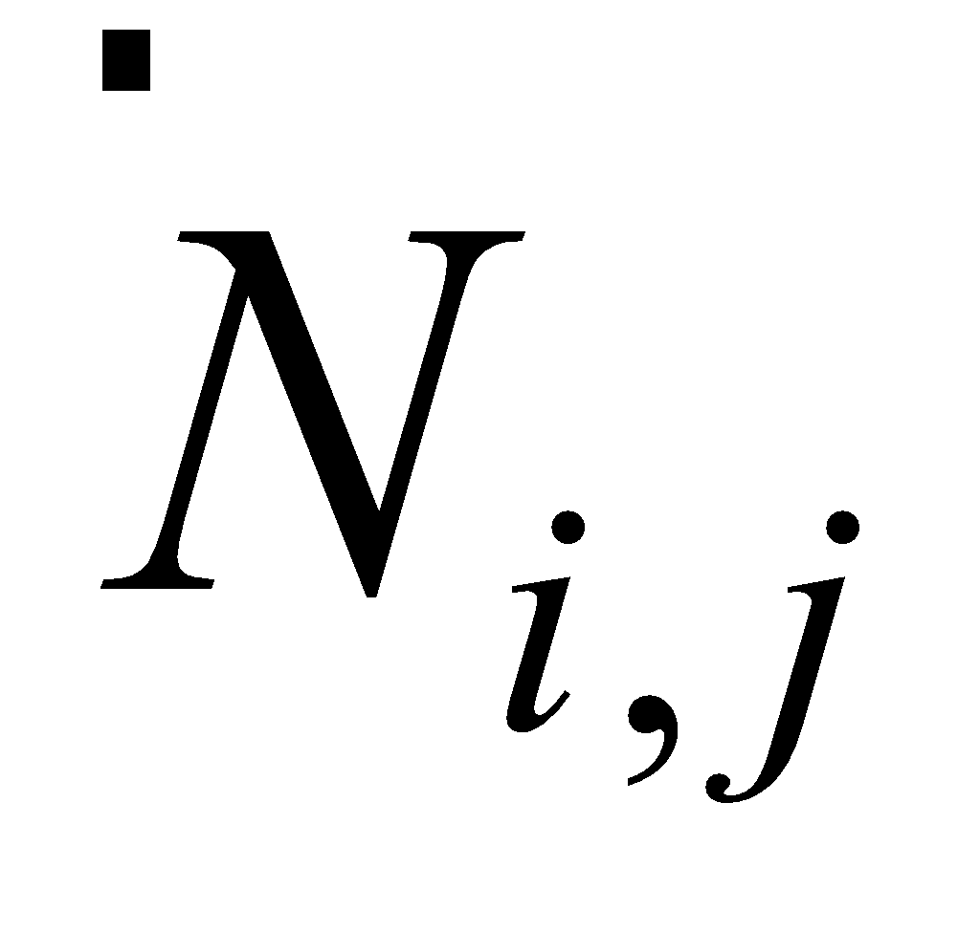) were estimated (where *i* indexes year, and *j* indexes age) as:

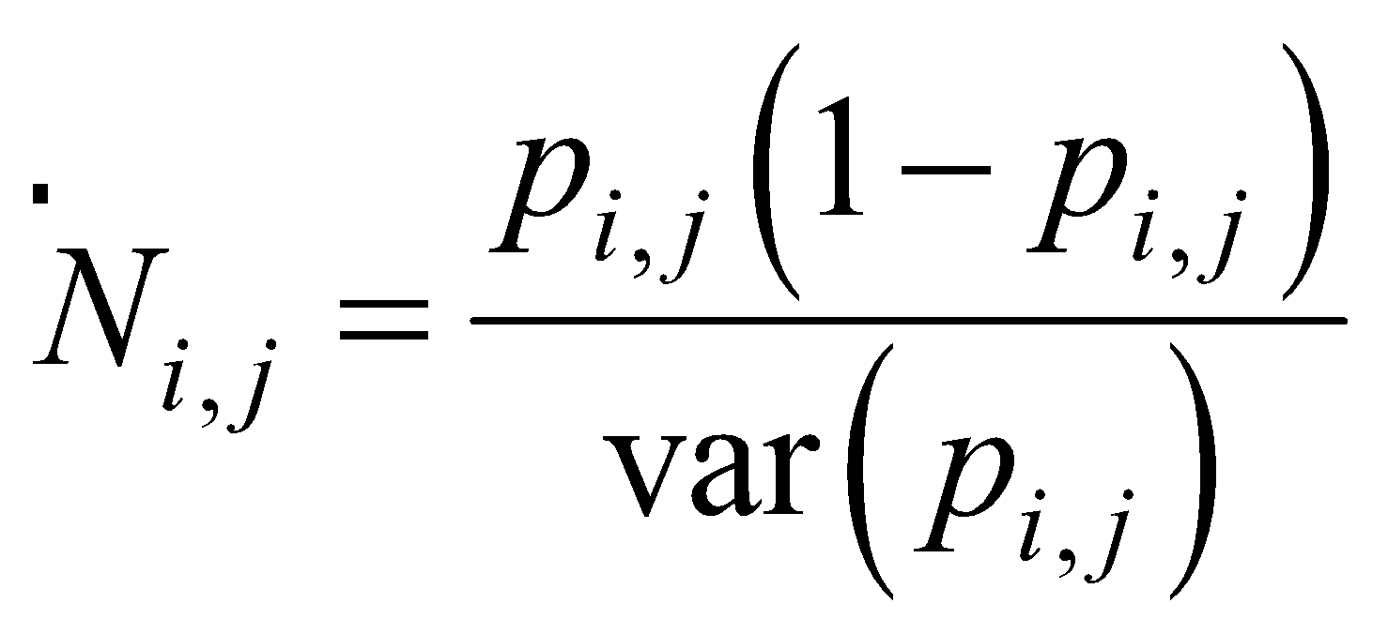

where 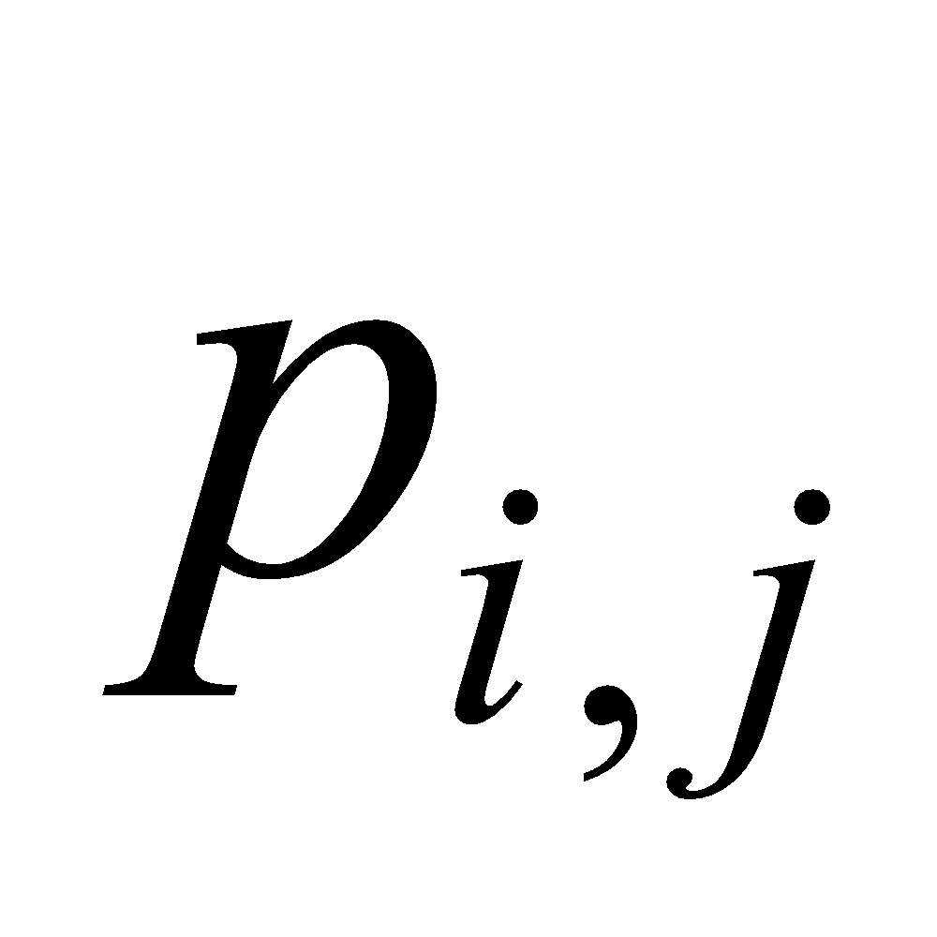 is the proportion of Atka mackerel in age group *j* in year *i* plus an added constant of 0.01 to provide some robustness*.* The variance of was obtained from the estimates of variance in catch-at-age (Dorn 1992). Thompson and Dorn (2003, p. 137) and Thompson (AFSC pers. comm.) noted that the above is a random variable that has its own distribution. Thompson and Dorn (2003) show that the harmonic mean of this distribution is equal to the true sample size in the multinomial distribution. This property was used in the previous assessments to obtain sample size estimates for the (post 1989) fishery numbers-at-age estimates (scaled to have a mean of 100; earlier years were set to constant values).

In the 2016 assessment (Lowe *et al*. 2016), assumptions on sample sizes for age composition data were re-evaluated. For the fishery, the number of Atka mackerel lengths measured varied substantially as did the number of hauls from which hard-parts were sampled from fish for age-determinations. A comparison of values used in the 2015 assessment, and the scaled number of hauls shows differing patterns over time (Figure 17.10 in Lowe *et al*. 2016). Stewart and Hamel (2014) found the maximum realized sample sizes for fishery biological data to be related both to the number of hauls and individual fish sampled from those hauls, and that a relative measure proportional to the number of hauls sampled might be a better indicator of sampling intensity. Therefore, for Model 16.0 (introduced in the 2016 assessment) and Model 16.0b (introduced in the 2017 assessment, see *Model Evaluation* in Lowe *et al*. 2017), the post-1989 fishery sample sizes were scaled to have the same mean as the 2015 assessment model (*N*=100) but varied relative to the number of hauls sampled; earlier years were set to constant values.

The table below gives the fishery sample sizes for Model 16.0b.

|  |  |  |  |  |  |  |  |  |  |  |  |
| --- | --- | --- | --- | --- | --- | --- | --- | --- | --- | --- | --- |
| 1977 | 1978 | 1979 | 1980 | 1981 | 1982 | 1983 | 1984 | 1985 | 1986 | 1987 | 1988 |
| 25 | 25 | 25 | 25 | 50 | 50 | 50 | 50 | 50 | 50 | 50 | 50 |
| 1990 | 1991 | 1992 | 1993 | 1994 | 1995 | 1996 | 1997 | 1998 | 1999 | 2000 | 2001 |
| 47 | 6 | 3 | 2 | 28 | 23 | 22 | 5 | 27 | 74 | 94 | 66 |
| 2002 | 2003 | 2004 | 2005 | 2006 | 2007 | 2008 | 2009 | 2010 | 2011 | 2012 | 2013 |
| 68 | 146 | 131 | 147 | 139 | 143 | 163 | 168 | 156 | 115 | 154 | 112 |
| 2014 | 2015 | 2016 | 2017 | 2018 | 2019 |  |  |  |  |  |  |
| 153 | 219 | 236 | 200 | 200 | 200 |  |  |  |  |  |  |

Following Lowe *et al*. (2017) time-varying sample sizes for survey age compositions were scaled to have a mean of approximately 50 and varied with the number of Atka mackerel hauls, but effective sample sizes for the survey age compositions were estimated following Francis (2011, equation TA1.8, Francis weights). The table below gives the survey sample sizes for Model 16.0b tuned using Francis weights.

|  |  |
| --- | --- |
| **Survey** | |
| Year | Sample Size |
| 1986 | 16 |
| 1991 | 19 |
| 1994 | 19 |
| 1997 | 13 |
| 2000 | 20 |
| 2002 | 35 |
| 2004 | 37 |
| 2006 | 28 |
| 2010 | 36 |
| 2012 | 31 |
| 2014 | 34 |
| 2016 | 24 |
| 2018 | 25 |
| Avg. | 26 |

An ageing error conversion matrix is used in the assessment model to translate model population numbers at age to expected fishery catch at age. We estimated this matrix using an ageing error model fit to the observed percent agreement at ages 2 through 10. Mean percent agreement is close to 100% at age 2 and declines to 54% at age 10. Annual estimates of percent agreement are variable, but show no obvious trend, hence a single conversion matrix for all years in the assessment model was adopted. The model is based on a linear increase in the standard deviation of ageing error and the assumption that ageing error is normally distributed. The model predicts percent agreement by taking into account the probability that both readers are correct, both readers are off by one year in the same direction, and both readers are off by two years in the same direction. The probability that both readers agree and were off by more than two years was considered negligible.

## Parameters estimated outside the assessment model

The following parameters were estimated independently of other parameters outside of the assessment model: natural mortality (*M*), length and weight at age parameters, and maturity at age and length parameters. A description of these parameters and how they were estimated follows.

### Natural mortality

Natural mortality (*M*) is a difficult parameter to estimate reliably. Previously, we conducted preliminary explorations of alternative formulations of age-specific natural mortality (*M*) specified outside the assessment model (Lowe and Ianelli 2016; unpublished data). Alternatives included the Lorenzen model (Lorenzen, 1996), and the *M*-at-age formulation suggested in the report of the Natural Mortality Workshop held in 2009 (the “best ad-hoc mortality model” in that report [see Brodziak *et al.* 2011]). In response to Plan Team and SSC requests to continue investigation of age-specific natural mortality, we included a third method (Gislason, 2010) in a further investigation of age-specific *M*, and use a rescaled average vector of *M* for model evaluation (Appendix 17C, Lowe *et al*. 2018). These three methods are initially based on theoretical life history and or ecological relationships that are then evaluated using meta-analysis, resulting in an empirical equation relating *M* to more easily measured quantities of length and weight.

Results of age-specific natural mortality estimates from the three methods described above were relatively consistent and suggested higher mortality rates for age classes younger than the age at maturity, particularly for ages 1-2 (Appendix 17C, Lowe *et al*. 2018). We used an ensemble approach and averaged the results for all three methods. We then used the method recommended by Clay Porch in Brodziak *et al*. (2011) to rescale the average age-specific values, and this rescaled average schedule was used to explore the impact of higher age-specific mortality for the younger ages.

In summary, the implementation of age-specific natural mortality improved model fits for some components, particularly the fishery age composition and stock recruitment components. The largest impacts of age-specific *M* is on the younger ages, particularly for ages 1 and 2 with estimated values of *M* of 1.04 and 0.56, respectively (Appendix 17C, Lowe *et al*. 2018). The assessment model has a lot of flexibility for age 1 recruitment, and the high estimated *M* for age 1 is accommodated by greatly inflated estimates of age 1 recruitment. Spawning biomass estimates were also scaled higher relative to the constant *M* assessment model. However, biological reference rates and ABC and OFL reflected only minor increases. Although estimates of age 1 recruitment differ greatly between the 2models (constant *M* and age-specific *M*), age 1 recruits have low impact to stock dynamics given selectivity and maturity schedules for Atka mackerel. We concluded that the natural mortality estimate of 0.3 is a conservative assumption based on a previous meta-analysis (Lowe and Fritz, 1997). This value seems to fit reasonably well with other key estimated parameters (e.g. survey catchability and selectivity), and we recommended continuing with the assumption of fixed constant *M*=0.3. This recommendation was accepted by the Plan Team and SSC. This year’s assessment assumes a fixed natural mortality rate of 0.3

### Length and weight at age

Atka mackerel exhibit large annual and geographic variability in length at age. Because survey data provide the most uniform sampling of the Aleutian Islands region, data from these surveys were used to evaluate variability in growth (Kimura and Ronholt 1988, Lowe *et al.* 1998). Kimura and Ronholt (1988) conducted an analysis of variance on length-at-age data from the 1980, 1983, and 1986 U.S.-Japan surveys, and the U.S.-U.S.S.R. surveys in 1982 and 1985, stratified by six areas. Results showed that length at age did not differ significantly by sex, and was smallest in the west and largest in the east. Studies by Lowe *et al.* (1998), Rand *et al*. (2010), and McDermott *et al*. (2014) corroborated differential growth in three sub-areas of the Aleutian Islands and the Western GOA, and the east to west differential size cline. Based on the work of Kimura and Ronholt (1988), and annual examination of length and age data by sex which has found no differences, growth parameters are presented for combined sexes.

Parameters of the von Bertalanffy length-age equation and a weight-length equation have been calculated for (1) the combined 2010, 2012, 2014, and 2016 survey data for the entire Aleutians region, and for the Eastern (541), Central (542), and Western (543) subareas, and (2) the combined 2014-2016 fishery data for the same areas:

|  |  |  |  |
| --- | --- | --- | --- |
| Data source | *L∞*(cm) | *K* | *t0* |
| **2010, 2012, 2014, 2016 surveys** |  |  |  |
| Areas combined | 43.23 | 0.384 | -0.027 |
| 541 | 46.35 | 0.371 | -0.374 |
| 542 | 42.76 | 0.377 | -0.037 |
| 543 | 40.41 | 0.442 | 0.060 |
| **2014-2016 fishery** |  |  |  |
| Areas combined | 41.52 | 0.318 | -2.082 |
| 541 | 45.06 | 0.295 | -2.188 |
| 542 | 39.52 | 0.466 | -0.164 |
| 543 | 39.88 | 0.516 | 0.515 |

Length-age equation: Length (cm) = *L∞*{1-exp[-*K*(age-*t0*)]}

Both the survey and fishery data show a clear east to west size cline in length at age with the largest fish found in the eastern Aleutians.

The weight-length relationship determined from the same data sets are as follows:

weight (kg) = 5.70E-06 × length (cm) 3.217 (2010, 2012, 2014, 2016 surveys; N = 1,784) weight (kg) = 3.84E-05 × length (cm) 2.679 (2014-2016 fisheries; N = 6,610).

The observed differences in the weight-length relationships from the survey and fishery data, particularly in the exponent of length, probably reflect the differences in the timing of sample collection. The survey data were all collected in summer, the spawning period of Atka mackerel when gonad weight would contribute the most to total weight. The fishery data were collected primarily in winter, when gonad weight would be a smaller percentage of total weight than in summer.

Year-specific weight-at-age estimates are used in the model to scale fishery and survey catch-at-age (and the modeled numbers-at-age) to total catch biomass and are intended to represent the average weight-at-age of the catch. Separate annual survey weights-at-age are compiled by expanding modeled numbers into age-selected survey biomass levels (Table 17.8a). Specifically, survey estimates of length-at-age were obtained using year-specific age-length keys. Weights-at-age were estimated by multiplying the length distribution at age from the age-length key, by the mean weight-at-length from each year-specific data set (De Robertis and Williams 2008). In addition, a single vector of weight-at-age values based on the 2014, 2016, and 2018 surveys is used to derive population biomass from the modeled numbers-at-age in order to allow for better estimation of current biomass (Table 17.8a).

The fishery weight-at-age data presented in previous assessments (prior to 2008) were compiled based on unweighted, unstratified (Aleutian-wide) fishery catch-age samples to construct the year-specific age-length keys (see Table 17.8 in Lowe *et al*. 2007). Beginning with the 2008 assessment, the weights-at-age for the post 1989 fishery reflect stratum-weighted values based on the relative catches. The fishery weight-at-age data presented in Table 17.8b for 1990 to 2019, were compiled using the region-specific age-length key estimation scheme described above in the Fishery Data section. Prior to 1990, the fishery weight-at-age estimates are as in previous assessments and given in Table 17.8b.

### Maturity at age and length

Female maturity at length and age were determined for Aleutian Islands Atka mackerel (McDermott and Lowe, 1997). The estimated female maturity at age is used in the assessment models. The age at 50% maturity is 3.6 years. Length at 50% maturity differs by area as the length at age differs by Aleutian Islands sub-areas:

Length at 50% maturity (cm)

Eastern Aleutians (541) 35.91

Central Aleutians (542) 33.55

Western Aleutians (543) 33.64

The maturity schedules are given in Table 17.9. Cooper *et al*. (2010) examined spatial and temporal variation in Atka mackerel female maturity at length and age. Maturity at length data varied significantly between different geographic areas and years, while maturity at age data failed to indicate differences and corroborated the age at 50% maturity determined by McDermott and Lowe (1997).

## Parameters estimated inside the assessment model

Deviations between the observations and the expected values are quantified with a specified error structure. Lognormal error is assumed for survey biomass estimates and fishery catch, and a multinomial error structure is assumed for survey and fishery age compositions. These error structures are used to estimate the following parameters conditionally within the model (fishing mortality, survey selectivity, survey catchability, age 1 recruitment). A description of these parameters and how they were estimated follows.

### Fishing mortality

Fishing mortality is parameterized to be separable with a year component and an age (selectivity) component. The selectivity relationship is modeled with a smoothed non-parametric relationship that can take on any shape (with penalties controlling the degree of change over time, degree of declining selectivity at age (dome-shape,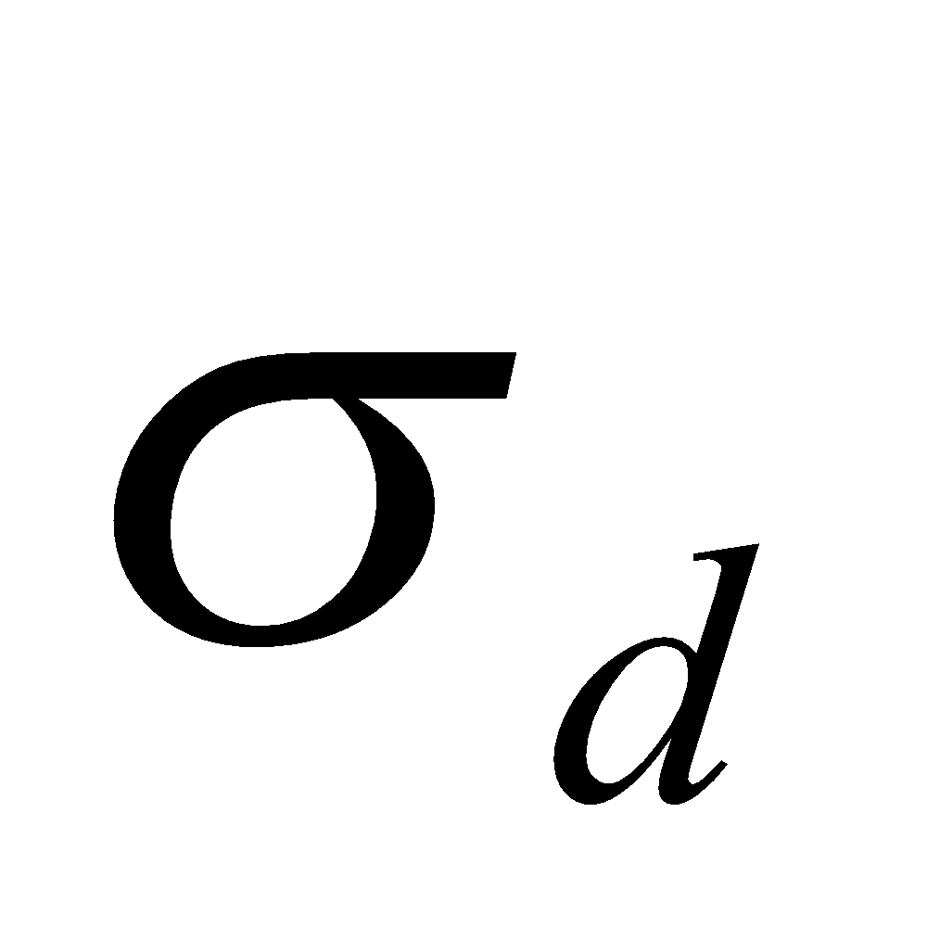), and curvature as specified by the user; Table A-2). Selectivity is conditioned so that the mean value over all ages will be equal to one. To provide regularity in the age component, a moderate penalty was imposed on sharp shifts in selectivity between ages (curvature) using the sum of squared second differences (log-scale). In addition, the age component parameters are assumed constant for ages 10 and older. Asymptotic growth is reached at about age 9 to 10 years. Thus, it seemed reasonable to assume that selectivity of fish older than age 10 would be the same. A moderate penalty was imposed to allow the model limited flexibility on degree of declining selectivity at age. In the 2012 assessment we evaluated a range of alternative values for the prior penalty of the parameter determining the degree of dome-shape () for fishery selectivity. Based on these results, a value of 0.3 for  was chosen for the selected model (Lowe *et al*. 2012) and is carried forward unchanged in this assessment.

Since the 2016 assessment, we tuned the time-varying fishery selectivity variance (*σ*f_sel) using the Francis weighting method (Francis 2011, equation TA1.8) on the fishery age composition data for Model 16.0b as described below. We consider that the mean input sample size for the fishery age composition is reasonable (mean=100) and that the lack of fit (or potential overfitting) could be adjusted by finding the appropriate level of inter-annual variability in selectivity. The procedure for tuning the degree of time-varying selectivity variability given input samples sizes was done iteratively by simply adjusting the variance term for selectivity variability (*σf_sel*) to achieve a “Francis weight” of 1.0 (or nearly). Typically, this was achieved in 3-4 iterations, and was done by manually editing the variance terms (which could differ by year, but for this case, were set to be the same for each year within a trial run). The original documentation for the smoothness (second differencing) penalty (*L2*) was provided in Appendix Table 17D-3 of the 2017 (and previous) assessments as:

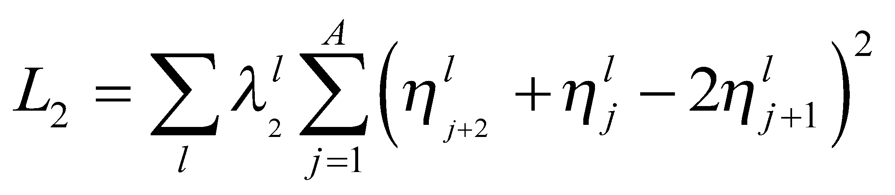,

where *λ* is the weight for the prior on smoothness for selectivity. The index *l* is equal to *s* or *f* for survey or fishery selectivity respectively (in this case it is *f* ). The index *j* denotes age with *A* being the maximum age modeled. The parameter *ƞ* is the age effect for fishery selectivity.

However, in previous assessments we omitted discussion of how the *σf_sel* parameter relates to this equation. The relationship between *σf_sel*  and $λ_{2}^{l}$ is:

$λ_{2}^{l}=\frac{1}{2σ_{f_sel}^{2}}$.

Regarding selectivity variability adjustments relative to results, we suggest that tuning by adjusting the *σf_sel* term provides a defensible statistical approach to setting the degree of selectivity variability (and thereby perhaps better track age-specific fishing mortality), assuming the effective sample size (to include overdispersion) is approximately correct. In contrast, other approaches, e.g., constant or blocked selectivity specifications, require downweighting the fishery age composition data, thereby implicitly accepting that the “model is correct” and the data are problematic. We consider the fishery age data to be the most robust of the data inputs. Model 16.0b, the current assessment model, uses Francis (2011) weights to tune the constraint governing the amount of time variability in fishery selectivity.

The current assessment model (Model 16.0b), incorporates time-varying fishery selectivity with constraints and penalties as described above.

### Survey selectivity and catchability

In response to Plan Team and SSC requests, a sensitivity analysis of time-varying selectivity was conducted in 2017 (Lowe *et al*. 2017) Based on the results of this analysis, the bottom trawl survey, selectivity-at-age follows a parameterization similar to the fishery selectivity-at-age (except with no allowance for time-varying selectivity).

As in the past, we also restricted survey catchability and selectivity-at-age to average 1.0 over ages 4-10 (i.e., as a combination of non-parametric selectivity-at-age and the scalar (*q*). This was done to avoid situations where the product of selectivity-at-age and *q* results in unreasonable values, and to standardize the ages over which selectivity most reasonably applies. Since the 2004 assessment (Lowe *et al*. 2004), we have used a moderate prior on *q* (mean = 1.0, *σ*² = 0.2²).

### Recruitment

The Beverton-Holt form of stock recruitment relationship based on Francis (1992) was used (Table A-2). Values for the stock recruitment function parameters *α* and *β* are calculated from the values of *R0* (the number of 0-year-olds in the absence of exploitation and recruitment variability) and the “steepness” of the stock-recruit relationship (*h*, Table A-2). The “steepness” parameter is the fraction of *R0* to be expected (in the absence of recruitment variability) when the mature biomass is reduced to 20% of its pristine level (Francis 1992). Past assessments have assumed a value of 0.8. A value of *h* = 0.8 implies that at 20% of the unfished spawning stock size, an expected value of 80% of the unfished recruitment level will result. Model runs exploring other values of *h* and the use of a prior on *h* were explored in previous assessments (Lowe *et al.* 2002), but were found to have little or no bearing on the stock assessment results and were not carried forward for further evaluation at the time. As in past years, we assumed *h* = 0.8 for all model runs since previous work showed that assessment results were insensitive to this assumption (and given the Tier 3 status does not affect future projections). Prior to the 2012 assessment, the recruitment variance was fixed at a value 0.6. Since 2012, we estimate this value.

# Results

## Model evaluation

The 2016 assessment introduced Model 16.0 with sample sizes varied relative to the number of hauls sampled. The 2017 assessment introduced Model 16.0b which provided for statistical estimation of the amount of time variability in fishery selectivity through tuning of the time-varying selectivity term (*σ*f_sel) with the Francis method (2011), and the survey age composition sample sizes were also tuned using the Francis method.

The 2018 assessment responded to BSAI Plan Team and the SSC requests for further evaluations of the Francis (2011) weights and selectivity changes implemented in Model 16.0b. These requests included:

1. Continue to investigate fishery selectivity time blocks, with blocks linked to identifiable changes in the fishery,
2. Evaluate the sensitivity of model results to an assumed average sample size of 100 for the fishery age composition data, or better yet (if possible), find a way to tune the sample size and the constraint governing the amount of time variability in fishery selectivity simultaneously and,
3. Investigate which parameters (including derived quantities) are changing in the retrospective peels that might contribute to the relationship between historical scale and number of peels.

The full evaluations of Model 16.0b are contained in Appendix 17C in Lowe *et al*. (2018).

### New data introduced in 2020

Model 16.0b (the accepted model configuration used for the 2018 and 2019 assessments) was updated with new data. The 2019 catch was updated, and the 2020 total year catch was assumed to equal the 2020 TAC of 59,305 t. The 2019 fishery age compositions were added.

### Retrospective analysis

Atka mackerel have a reasonable retrospective pattern for the last 6-7 years of predicting spawning biomass, with periods that are lower and higher (Figure 17.9). However, after data from 2012-2014 are dropped from the model, most subsequent retrospective runs resulted in biomass that was historically considerably higher. We concluded that the reason for the odd pattern can be attributed to the survey age compositions (Lowe *et al*. 2017). Given the assumed natural mortality as fixed (and constant over time), and the recent period of data with relatively large numbers of Atka mackerel in the survey “plus age group”, the survey selectivity was fairly asymptotically shaped (see *Selectivity* section below). However, for the retrospectives which ignore those recent years of data, the survey selectivity becomes much more dome-shaped, hence the early period biomass estimates were estimated to be considerably higher.

The 2018 assessment investigated which parameters (including derived quantities) were changing in the retrospective peels that might contribute to the relationship between historical scale and number of peels. We concluded that the observed pattern is attributed to the addition of recent survey estimates, and suggested that the retrospective bias is a reflection of the data rather than issues with the model configuration (Lowe *et al*. 2018). In general, this type of retrospective pattern seems to be consistent with the uncertainty estimates of biomass for a species that is relatively patchily distributed, and trawl survey estimates that have a high level of variability. This interpretation still holds in the current assessment. The revised Mohn’s rho statistic was calculated to be 0.047.

### Choice of final model

This year is a straight forward update of Model 16.0b detailed in Lowe *et al*. (2019).

A summary of key results from the selected Model 16.0b is presented in Table 17.10. Results from the 2019 assessment model (16.0b) with updated data are presented for comparison.

## Model fit

Key results from Model 16.0b are presented in Table 17.10. The coefficient of variation or *CV* (reflecting uncertainty) about the 2019 biomass estimate is 25% and the *CV*s on the strength of the 2006 and 2012 year classes at age 1 are 14 and 16%, respectively (Table 17.10). Recruitment variability (SigmaR) was moderate and estimated to be 0.48. Sample size values (using McAllister and Ianelli 1997 method) were calculated for the fishery data and the bottom trawl survey data as a diagnostic. This gave effective sample size estimates (relative to model fit) for the fishery of 194 and survey data was 103. The overall residual root-mean square error (RMSE) for the survey biomass data was estimated at 0.276, which is in line with estimates of sampling-error *CV*s for the survey which range from 14-35% and average 26% over the time series (Table 17.6).

Figure 17.10 compares the observed and estimated survey biomass abundance values for the BSAI for Model 16.0b. The decreases in biomass indicated by the 1994 and 1997 surveys followed by the large increases in biomass from the 2002 and 2004 surveys appear to be consistent with recruitment patterns. However, the large increase observed in the 2004 survey was not fit as well by the model compared to the 2000, 2002, and 2006 surveys. In the 2004 survey, an unusually high biomass (268,000 t) was estimated for the southern Bering Sea area. This value represented 23% of the entire 2004 BSAI survey biomass estimate. The 2006 survey indicates a downward trend which is consistent with the population age composition at the time. The 2010 survey biomass estimate indicated a large increase that was not predicted by the assessment model. The 2010 survey biomass estimate for the southern Bering Sea was also unusually high (103,500 t) and represented a 741% increase over the 2006 southern Bering Sea estimate. The 2012 survey biomass estimate is the lowest value and associated with the lowest variance in the time series, but is not fit by the model (Figure 17.10). However, the declining trend in biomass indicated by the three most recent surveys is consistent with the population age composition. Population biomass would be expected to decline as the most recent strong year class (2006 year class) is aging and past peak cohort biomass. We note that the model’s predicted survey biomass trend is very conservative relative to the 2004, 2010, and 2014 observed bottom trawl survey biomass values, but fits the other survey years quite well (survey catchability is approximately equal to 1).

The fits to the survey and fishery age compositions for Model 16.0b are depicted in Figures 17.11 and 17.12, respectively. The model fits the fishery age composition data well particularly after 1997, and the survey age composition data less so. This reflects the fact that the sample sizes for age and length composition data are higher for the fishery in most years than the survey. It is interesting to note that the 2014 survey observed significantly fewer 3-year olds (2011 year class) than predicted, whereas the 2014 fishery catch was comprised of a larger proportion of 3-year olds than predicted. The 2015 fishery age composition did not show large numbers of 4-year olds of the 2011 year class (Figure 17.12). The 2016 fishery data showed slightly lower proportions of 5-year olds of the 2011 year class than predicted, in contrast to the 2016 survey which showed much lower than expected numbers of the 2011 year class (Figure 17.11). The 2016 fishery and survey data showed large numbers of 4-year olds of the 2012 year class. The 2012 year class comprised 35, 30, 29, and 24% of the 2016, 2017, 2018, and 2019 fishery age compositions, respectively. The 2016 survey also showed a large number of 3-year olds from the 2013 year class which showed up in the 2017-2019 fishery data. Both the 2018 survey and fishery age data show a lack of 4-year olds from the 2014 year class. The 2018 fishery and survey age data show some similarities, but for the most part the 2018 survey age data are very poorly fit in contrast to the 2018 fishery age data. The 2016-2019 fishery age data show the progression of the 2012 and 2013 year classes. We also note an unusual pattern in recent survey data (2010, 2012, 2014, and 2018) of relatively large numbers of Atka mackerel in the “plus group” (Figure 17.11).

These figures highlight the patterns in changing age compositions over time. Note that the older age groups in the fishery age data are largely absent until around 1985 when the 1977 year class appears. Fits to recent fishery age composition data in Lowe *et al*. (2012) and Lowe *et al*. (2016) indicated a need for greater flexibility in selectivity. The assessments allowed for more flexibility to estimate time-varying fishery selectivity, which improved fits to the fishery age compositions.

The results discussed below are based on the recommended Model 16.0b with updated 2018 fishery and survey catch- and weight-at-age values.

## Time series results

### Selectivity

For Atka mackerel, the estimated selectivity patterns are particularly important in describing their dynamics. Previous assessments focused on the transitions between ages and time-varying selectivity (Lowe *et al.* 2002, 2008, 2013). The current assessment allows for flexibility over time (fishery only) and age (Figures 17.13, 17.14, and 17.15; also Table 17.11). The current assessment’s terminal year fishery selectivity estimate (2019) and the average selectivity used for projections (2015-2019) are fairly similar to, but differ slightly over some age ranges from the terminal year and average selectivity for projections used in the 2019 assessment, showing lower selectivity except for the peak years (Figure 17.14). The current assessment’s terminal year (2019) selectivity pattern shows a peak for 7-year olds (2012 year class) and a more defined drop in the selectivity for 8-10 year olds (Figures 17.13 and 17.14). The 2014 selectivity pattern initially showed an unusual large numbers of 3-year olds of the 2011 year class which have not persisted in the fishery data (Figure 17.13).

The fishery catches generally consist of fish 3-11 years old. The fishery exhibits a dome-shaped selectivity pattern which is more pronounced prior to 1992 during the foreign and joint venture fisheries conducted during 1977-1983 and 1984-1991, respectively (Figure 17.13). After 1991, fishery selectivity patterns are relatively consistent but do show differences at ages 3-7 and more notable differences at age 8 and older. Fish older than age 9 make up a very small percentage of the population each year, and the differences in the selectivity assumptions for the older ages are not likely to have a large impact. However, differences in selectivity for ages 3-8 can have a significant impact. The recent patterns since 2000 reflect the large numbers of fish from the 1999, 2000, 2001, 2006, 2007, and 2012 year classes (Table 17.4). The age at 50% selectivity is estimated at about ages 3-4 in 2006-2013 as the large year classes moved through the population. A shift occurred recently with a large number of 3-year olds dominating the 2014 fishery age composition, and the age at 50% selectivity decreased to about 2.5 years. However, this year class did not continue to show up after 2014. The age at 50% selectivity of the current assessment’s terminal year (2019) is about 5 years (Figure 17.14). It is important to note the maturity-at-age vector relative to the current selectivity patterns (age at 50% maturity is 3.6 years). The age at 50% maturity is lower relative to the age at 50% selectivity for the average selectivity used for projections (2015-2019). Maturity-at-age is much lower relative to recent average selectivity over ages 3-6 (Figure 17.14).

Survey catches are mostly comprised of fish 3-9 years old. The 2018 survey is dominated by 5- and 6- year olds of the 2012 and 2013 year classes which is similar to the 2018 fishery data (Figure 17.8). A 17-year old fish was found in the 2012 survey and 3, 16-year old fish were caught in the 2014 survey. The current model configuration estimates a moderately dome-shape selectivity pattern (Figure 17.15), similar to the terminal year selectivity pattern for the fishery (Figure 17.14). It is interesting to note that the survey tends to catch higher numbers of young fish (<3 years) and older fish (>10 years) relative to the fishery.

Both the fishery and survey show dome-shaped selectivity. The dome-shaped patterns reflect the age compositions fairly well, but the mechanisms responsible for dome-shaped selectivity are uncertain and several factors likely contribute. As discussed above, the foreign and joint venture fisheries catches show a distinct lack of older fish in fishery catches. The decline in older age selectivity occurs after about 8 years old, which also corresponds with asymptotic growth and full maturity. Large, older fish may be less available to the fishery and survey. Mature fish may be aggregated and unavailable to the summer surveys which can occur during the spawning season. Temperature may also affect recruitment of Atka mackerel and availability to the bottom trawl survey.

### Abundance trend

The estimated time series of total numbers at age are given in Table 17.12. The estimated time series of total biomass (ages 1+) and female spawning biomass with approximate upper and lower 95% confidence limits are given in Table 17.13a. A comparison of the age 3+ biomass and spawning biomass trends from the current and previous assessments (Table 17.13b and Figure 17.16 top panel) indicates consistent trends throughout the time series, i.e., biomass increased during the early 80s and again in the late 80s to early 90s. After the estimated peak spawning biomass in 1992, spawning biomass declined for nearly 10 years until 2001 (Figure 17.16 top panel). Thereafter, spawning biomass began a steep increase which continued to 2005. The abundance trend has been declining since the most recent peak in 2005 which represented a build-up of biomass from the exceptionally strong 1999-2001 year classes. Estimates from the current assessment (Model 16.0b) are very similar to last year’s assessment (Model 16.0b) results (Figure 17.16). However, the current assessment spawning biomass is slightly lower over the time series until 2016, after which the current assessment spawning biomass levels are just above the estimates from the last year’s assessment. Differences in spawning biomass levels are attributed to revised estimates of recent recruitment levels of the 2012 and 2013 year classes (Figure 17.16).

### Recruitment trend

The estimated time series of age 1 recruits indicates the strong 1977 year class as the most notable in the current assessment, followed by the 1999, 2001, 1988 and 2000 year classes (Table 17.14, Figure 17.16). The 1999, 2000, and 2001 year classes are estimated to be three of the five largest recent year classes in the time series (approximately 1.7, 1.1, and 1.2 billion recruits, respectively) due to the persistent observations of these year classes in the fishery and survey catches. The current assessment estimates above average (greater than 20% of the mean) recruitment from the 1977, 1988, 1992, 1995, 1998, 1999, 2000, 2001, 2006, 2007, and 2012 year classes (Figure 17.16, Table 17.14). The 2014, 1996, and 2008 year classes are the lowest in the time series, estimated at 171, 204 and 235 million recruits, respectively.

The average estimated recruitment from the time series 1978-2019 is 584 million fish and the median is 480 million fish (Table 17.14). The entire time series of recruitments (years 1977-2019) includes the 1976-2019 year classes. The Alaska Fisheries Science Center has recognized that an environmental “regime shift” affecting the long-term productive capacity of the groundfish stocks in the BSAI occurred during the period 1976-1977, and the 2019 estimate is only based on one year of data. Thus, the average recruitment value presented in the assessment is based on year classes spawned after 1976 through 2019 (1977-2018) year classes). Projections of biomass are based on estimated recruitments from the years 1978-2019 using a stochastic projection model described below.

Estimated age 1 recruits versus female spawning biomass with the Beverton-Holt stock recruitment curve plotted is shown in Figure 17.17. There are no estimates of female spawning biomass less than 108,000 t. The five largest year classes in the time series were all spawned from biomass levels ranging from 150,000-180,000 t. However, this range of female spawning biomass also spawned several years of low recruitment (Figure 17.17).

### Trend in exploitation

The estimated time series of fishing mortalities on fully selected age groups and the catch-to-biomass (age 3+) ratios are given in Table 17.15 and shown in Figure 17.18.

## Projections and harvest recommendations

Results and recommendations in this section pertain to the authors’ recommended Model 16.0b.

*Amendment 56 Reference Points*

Amendment 56 to the BSAI Groundfish Fishery Management Plan (FMP) defines “overfishing level” (OFL), the fishing mortality rate used to set OFL (*FOFL*), the maximum permissible ABC, and the fishing mortality rate used to set the maximum permissible ABC (*max FABC*). The fishing mortality rate used to set ABC (*FABC*) may be less than this maximum permissible level, but not greater. The overfishing and maximum allowable ABC fishing mortality rates are given in terms of percentages of unfished female spawning biomass (*FSPR%*), on fully selected age groups. The associated long-term average female spawning biomass that would be expected under average estimated recruitment from 1978-2019 (584 million age-1 recruits) and *F* equal to *F40%* and *F35%* are denoted *B40%* and *B35%* , respectively. The Tiers require reference point estimates for biomass level determinations. We present the following reference points for BSAI Atka mackerel for Tier 3 of Amendment 56. For our analyses, we computed the following values from Model 16.0b results based on recruitment from post-1976 spawning events:

*B100%* = 290,820 t female spawning biomass

*B40%* = 116,330 t female spawning biomass

*B35%* = 101,790 tfemale spawning biomass

### Specification of OFL and Maximum Permissible ABC

In the current assessment, Model 16.0b is configured with time-varying selectivity. We use a 5-year average (2015-2019) to reflect recent conditions for projections and computing ABC which gives:

|  |  |
| --- | --- |
| Full selection *F*s | 2020 |
| *F*2020 | 0.31 |
| *F*40% adj | 0.43 |
| *F*35% adj | 0.51 |
| *F*2020/*F*40%adj | 0.72 |

For specification purposes to project the 2021 ABC, we assumed a total 2020 year end catch of 59,305 t equal to the 2020 TAC. For projecting to 2022, an expected catch in 2021 is also required. Recognizing that the modified Steller sea lion RPAs implemented in 2015 require a TAC reduction in Area 543, we assume a stock-wide catch based on a reduced overall BSAI-wide Atka mackerel catch for 2021. Under the modified Steller sea lion RPAs, the Area 543 Atka mackerel TAC is set less than or equal to 65 percent of the Area 543 ABC. This percentage (65%) was applied to the Western Aleutian Islands maximum permissible 2021 ABC estimate, and that amount was summed with the maximum permissible ABC estimates for the Eastern and Central Aleutian areas for a total estimated 2021 catch. The total estimated 2021 catch was assumed to be caught in order to estimate the 2022 ABC and OFL values. We estimated that about 85% of the BSAI-wide 2021 ABC is likely to be taken.

It is important to note that for BSAI Atka mackerel, projected female spawning biomass calculations depend on the harvest strategy because spawning biomass is estimated at peak spawning (August). Thus, projections incorporate 7 months of the specified fishing mortality rate. The projected 2021 female spawning biomass (*SSB2021*) is estimated to be 107,820 t given assumed 2020 catch and 7 months of the estimated 2021 catch reflecting the Steller sea lion RPA adjustment to the 2021 ABC.

The projected 2021 female spawning biomass estimate is below the *B40%* value of 116,330 t, placing BSAI Atka mackerel in **Tier 3b**. The 2022 female spawning biomass estimate is also below *B40%*. The maximum permissible ABC and OFL values under **Tier 3b** are:

|  |  |  |  |  |  |  |  |
| --- | --- | --- | --- | --- | --- | --- | --- |
| Year | Catch* | ABC | *F*ABC | OFL | *FOFL* | SSB | Tier |
| 2021 | 60,400 | 73,590 | 0.43 | 85,580 | 0.51 | 107,820 | 3b |
| 2022 | 56,925 | 68,220 | 0.41 | 79,660 | 0.49 | 102,810 | 3b |

* Catches in 2021 and 2021 are less than the recommended maximum permissible ABCs to reflect expected catch reductions under Steller sea lion RPAs.

### Standard Harvest Scenarios and Projection Methodology

A standard set of projections is required for each stock managed under Tiers 1, 2, or 3, of Amendment 56. This set of projections encompasses seven harvest scenarios designed to satisfy the requirements of Amendment 56, the National Environmental Policy Act, and the Magnuson-Stevens Fishery Conservation and Management Act (MSFCMA).

For each scenario, the projections begin with the vector of 2020 numbers at age estimated in the assessment. This vector is then projected forward to the beginning of 2033 using a fixed value of natural mortality of 0.3, the recent schedule of selectivity estimated in the assessment (in this case the average 2015-2019 selectivity), and the best available estimate of total (year-end) catch for 2020 (in this case assumed to be 59,305 equal to TAC). In addition, the 2021 and 2022 catches are reduced to accommodate Steller sea lion RPA TAC reductions for Scenarios 1 and 2. In each subsequent year, the fishing mortality rate is prescribed on the basis of the spawning biomass in that year and the respective harvest scenario. In each year, recruitment is drawn from an inverse Gaussian distribution whose parameters consist of maximum likelihood estimates determined from recruitments estimated in the assessment. Spawning biomass is computed in each year based on the time of peak spawning (August) and the maturity and population weight schedules described in the assessment. Total catch is assumed to equal the catch associated with the respective harvest scenario in all years, except that in the first two years of the projection, a lower catch may be specified for stocks where catch is typically below ABC (as is the case for Atka mackerel). This projection scheme is run 500 times to obtain distributions of possible future stock sizes, fishing mortality rates, and catches.

Five of the seven standard scenarios are designed to provide a range of harvest alternatives that are likely to bracket the final TACs for 2021 and 2022, are as follows (“*max* *FABC*” refers to the maximum permissible value of *FABC* under Amendment 56):

*Scenario 1*: In all future years, *F* is set equal to *max* *FABC*. (Rationale: Historically, TAC has been constrained by ABC, so this scenario provides a likely upper limit on future TACs.).

*Scenario 2*: In all future years, *F* is set equal to a constant fraction of *max* *FABC*, where this fraction is equal to the ratio of the *FABC* value for 2021 recommended in the assessment to the *max* *FABC* for 2021, and where catches for 2021 and 2022 are estimated at their most likely values given the 2021 and 2022 maximum permissible ABSs under this scenario. (Rationale: When *FABC* is set at a value below *max* *FABC*, it is often set at the value recommended in the stock assessment).

*Scenario 3*: In all future years, *F* is set equal to the average of the five most recent years. (Rationale: For some stocks, TAC can be well below ABC, and recent average *F* may provide a better indicator of *FTAC* than *FABC*.)

*Scenario 4*: In all future years, the upper bound on *FABC* is set equal to *F60%*. (Rationale: This scenario provides a likely lower bound on *FABC* that still allows future harvest rates to be adjusted downward when stocks fall below reference levels).

*Scenario 5*: In all future years, *F* is set equal to zero. (Rationale: In extreme cases, TAC may be set at a level close to zero.)

Two other scenarios are needed to satisfy the MSFCMA’s requirement to determine whether a stock is currently in an overfished condition or is approaching an overfished condition. These two scenarios are as follows (for Tier 3 stocks, the MSY level is defined as *B35%*):

*Scenario 6*: In all future years, *F* is set equal to *FOFL*. (Rationale: This scenario determines whether a stock is overfished. If the stock is expected to be 1) above its MSY level in 2020 or 2) above ½ of its MSY level in 2020 and above its MSY level in 2030 under this scenario, then the stock is not overfished.)

*Scenario 7*: In 2021 and 2022, *F* is set equal to *max* *FABC*, and in all subsequent years, *F* is set equal to *FOFL*. (Rationale: This scenario determines whether a stock is approaching an overfished condition. If the stock is 1) above its MSY level in 2022 or 2) above 1/2 of its MSY level in 2022 and expected to be above its MSY level in 2032 under this scenario, then the stock is not approaching an overfished condition.).

The projections of female spawning biomass, fishing mortality rate, and catch corresponding to the seven standard harvest scenarios are shown in Table 17.16

### Status Determination

Under the MSFCMA, the Secretary of Commerce is required to report on the status of each U.S. fishery with respect to overfishing. This assessment reports the answer to three questions: 1) Is the stock being subjected to overfishing? 2) Is the stock currently overfished? 3) Is the stock approaching an overfished condition?

*Is the stock approaching an overfished condition?* The official catch estimate for the most recent complete year (2019) is 57,206 t. This is less than the 2019 OFL of 79,200 t. Therefore, the BSAI Atka mackerel stock is not being subject to overfishing.

Harvest scenarios #6 and #7 are intended to permit determination of the status of a stock with respect to its minimum stock size threshold (MSST). Any stock that is below its MSST is defined to be *overfished*. Any stock that is expected to fall below its MSST in the next two years is defined to be *approaching* an overfished condition. Harvest scenarios #6 and #7 are used in these determinations as follows:

*Is the stock overfished?* This depends on the stock’s estimated spawning biomass in 2020:

a) If spawning biomass for 2020 is estimated to be below ½ *B35%*, the stock is below its MSST.

b) If spawning biomass for 2020 is estimated to be above *B35%*, the stock is above its MSST.

c) If spawning biomass for 2020 is estimated to be above ½ *B35%* but below *B35%*, the stock’s status relative to MSST is determined by referring to harvest scenario #6 (Table 17.16). If the mean spawning biomass for 2030 is below *B35%*, the stock is below its MSST. Otherwise, the stock is above its MSST.

*Is the stock approaching an overfished condition?* This is determined by referring to harvest scenario #7 (Table 17.16):

a) If the mean spawning biomass for 2022 is below ½ *B35%*, the stock is approaching an overfished condition.

b) If the mean spawning biomass for 2022 is above *B35%*, the stock is not approaching an overfished condition.

c) If the mean spawning biomass for 2022 is above ½ *B35%* but below *B35%*, the determination depends on the mean spawning biomass for 2032. If the mean spawning biomass for 2032 is below *B35%*, the stock is approaching an overfished condition. Otherwise, the stock is not approaching an overfished condition.

Based on the above criteria and Table 17.16, the BSAI Atka mackerel stock is not overfished and is not approaching an overfished condition.

### Should the ABC be reduced below the maximum permissible ABC?

The SSC in its December 2019 minutes recommended that all assessment authors use the risk table when determining whether to recommend an ABC lower than the maximum permissible. The SSC also requested the addition of a fourth column on fishery performance, which has been included in the table below.

|  |  |  |  |  |
| --- | --- | --- | --- | --- |
|  | *Assessment-related considerations* | *Population dynamics considerations* | *Environmental/ecosystem considerations* | *Fishery Performance* |
| Level 1: Normal | Typical to moderately increased uncertainty/minor unresolved issues in assessment. | Stock trends are typical for the stock; recent recruitment is within normal range. | No apparent environmental/ecosystem concerns | No apparent fishery/resource-use performance and/or behavior concerns |
| Level 2: Substantially increased concerns | Substantially increased assessment uncertainty/ unresolved issues. | Stock trends are unusual; abundance increasing or decreasing faster than has been seen recently, or recruitment pattern is atypical. | Some indicators showing an adverse signals relevant to the stock but the pattern is not consistent across all indicators. | Some indicators showing adverse signals but the pattern is not consistent across all indicators |
| Level 3: Major Concern | Major problems with the stock assessment; very poor fits to data; high level of uncertainty; strong retrospective bias. | Stock trends are highly unusual; very rapid changes in stock abundance, or highly atypical recruitment patterns. | Multiple indicators showing consistent adverse signals a) across the same trophic level as the stock, and/or b) up or down trophic levels (i.e., predators and prey of the stock) | Multiple indicators showing consistent adverse signals a) across different sectors, and/or b) different gear types |
| Level 4: Extreme concern | Severe problems with the stock assessment; severe retrospective bias. Assessment considered unreliable. | Stock trends are unprecedented; More rapid changes in stock abundance than have ever been seen previously, or a very long stretch of poor recruitment compared to previous patterns. | Extreme anomalies in multiple ecosystem indicators that are highly likely to impact the stock; Potential for cascading effects on other ecosystem components | Extreme anomalies in multiple performance indicators that are highly likely to impact the stock |

The table is applied by evaluating the severity of four types of considerations that could be used to support a scientific recommendation to reduce the ABC from the maximum permissible. These considerations are stock assessment considerations, population dynamics considerations, environmental/ecosystem considerations, and fishery performance. Examples of the types of concerns that might be relevant include the following:

1. Assessment considerations—data-inputs: biased ages, skipped surveys, lack of fishery-independent trend data; model fits: poor fits to fits to fishery or survey data, inability to simultaneously fit multiple data inputs; model performance: poor model convergence, multiple minima in the likelihood surface, parameters hitting bounds; estimation uncertainty: poorly-estimated but influential year classes; retrospective bias in biomass estimates.
2. Population dynamics considerations—decreasing biomass trend, poor recent recruitment, inability of the stock to rebuild, abrupt increase or decrease in stock abundance.
3. Environmental/ecosystem considerations—adverse trends in environmental/ecosystem indicators, ecosystem model results, decreases in ecosystem productivity, decreases in prey abundance or availability, increases or increases in predator abundance or productivity.
4. Fishery performance—fishery CPUE is showing a contrasting pattern from the stock biomass trend, unusual spatial pattern of fishing, changes in the percent of TAC taken, changes in the duration of fishery openings.

Assessment considerations: The BSAI Atka mackerel assessment has a reasonable retrospective pattern for the last 5 years of predicting spawning biomass, with periods that are lower and higher. However, after data from 2012-2014 are dropped from the model, most subsequent retrospective runs resulted in biomass that was historically considerably higher (Figure 17.9). The 2018 assessment investigated which parameters (including derived quantities) were changing in the retrospective peels that might contribute to the relationship between historical scale and number of peels (Appendix 17C, Lowe *et al*. 2018). The robust fishery age data which is generally well fit, prevents the model from fitting the 2012 and 2016 extremely large drops in Atka mackerel survey biomass. In conclusion, the observed retrospective pattern is attributed to the addition of recent survey estimates, and we suggest that the retrospective bias is a reflection of the data rather than issues with the model configuration. In general, this type of retrospective pattern seems to be consistent with the uncertainty estimates of biomass for a species that is relatively patchily distributed, and trawl survey estimates that have a high level of variability. As noted, the fishery age data is generally well fit, and the survey age data is fit less so. Trawl survey estimates of Aleutian Islands biomass are highly variable. The 2012 survey decreased 70% relative to the 2010 survey, the 2014 survey increased 161% relative to the 2012 survey, and the 2016 survey decreased 38% relative to the 2014 survey. The most recent survey showed a 21% decrease in Atka mackerel biomass relative to the 2016 estimate (Figure 17.10). Most of this decrease is attributed to the Central Aleutians area where biomass declined 80% relative to the 2016 Central area Atka mackerel biomass (Figure 17.4).

The cancellation of the 2020 Aleutian Islands survey was problematic in that there was no new data to inform the 2018 survey biomass estimate for the assessment, as well as no new survey composition data. Bryan *et al*. 2020 conducted a retrospective analysis looking at the loss of survey data (index and composition data) for several groundfish and crab species to quantify uncertainty in assessment model quantities and management advice. The Atka mackerel stock assessment relies on the biennial Aleutian Islands bottom trawl survey as a primary source of fisheries-independent information. The distributions of the spawning stock biomass CV in the terminal year for Atka mackerel indicated that the uncertainty is greater (CV is larger) when the model does not have the most recent survey information. The assessment models become more positively biased (i.e., overestimates biomass) and uncertainty in terminal year estimates of biomass is greater, when the most recent survey data are removed from the assessment as compared to the standard retrospective. The potential added uncertainty due to the lack of the 2020 survey was not captured by the assessment model. However, the overall 2018 BSAI survey data point was fit fairly well by the assessment model (Figure 17.10), and supported by recent estimates of below average recruitment and only one slightly above average recruitment (2012 year class, Figure 17.16). We rated the assessment-related concern as Level 1. We have typical to moderately increased concerns about assessment-related uncertainty, particularly in regard to the survey data.

Population dynamics considerations: The BSAI Atka mackerel assessment shows a decline in female spawning biomass since peak biomass in 2005. The peak biomass in 2005 is the result of 3 back-to-back very strong year classes (1999, 2000, 2001 year classes; Figure 17.16). Since these year classes entered the population, there have only been two moderately strong year classes (2006 and 2007 year classes), and the most recent slightly above average 2012 year class. Gaps of about 4-6 years between strong year classes seems to be typical for Atka mackerel throughout the time series of estimated recruitments (Figure 17.16). However, the appearance of only a slightly above average year class (2012 year class) following the 2006 and 2007 strong year classes which were 54% above average is unusual. As the 2006 and 2007 year classes have aged and moved through the population, there has been no strong recruitment to slow down or stop the declining trend in spawning biomass. However, we note that the 2016-2019 fisheries were dominated by the 2012 year class. The 2018 survey and fishery age data are dominated by the 2012, and 2013 year classes (Figure 17.8). These year classes comprised nearly 40% of 2018 survey age composition, and 60% of the 2018 fishery age composition. Atka mackerel have been 3b since the 2019 assessment. Under the Tier 3b *F40%*adj harvest strategy and assuming SSL RPA catch reductions in 2021 and 2022, female spawning biomass is projected to be below *B40%* in 2021 but increase and remain above *B40%* from 2026 through 2033 (Figure 17.19 and Table 17.16 Scenarios 1 and 2). If SSL RPA catch reductions are in place beyond 2022, expected female spawning biomass levels would be higher than projected after 2022. We rated the population dynamics-related concern as Level 1. Stock trends are typical for the stock and expected given the stock dynamics; recent recruitment is within the lower end of the normal range and the magnitude of the 2012 and 2013 year classes has increased in recent assessments.

Environmental/Ecosystem considerations: Due to lack of 2020 surveys and fieldwork, many ecosystem indicators were not measured this year. Thus, much of the ecosystem information available for this year is derived from remote sensing. Atka mackerel are typically found between 3.5 - 5.5°C in the AI survey. The National Centers for Environmental Prediction Global Ocean Data Assimilation System (GODAS) temperature anomalies for the 100-250 m depth range show that significantly warmer temperatures have remained since 2016 (when they were found at up to 7°C temperatures); the GODAS estimates are supported by the water column temperatures indicator for the AI (AI ESR Physical factors 2020). In general, higher ambient temperatures incur bioenergetic costs for ectothermic fish such that, all else being equal, consumption must increase to maintain fish condition. Thus, the persistent higher temperatures may be considered a negative indicator for Atka mackerel. Higher temperatures that increase consumption demands beyond what is available may impact body conditions.The observed body condition of Atka mackerel in the survey has been lower than the survey mean from 2012 - 2018 in the eastern half of the AI LME (ie, the survey areas named “southern Bering Sea” and “eastern Aleutians”). However fish condition has been above or at the survey mean in the western half of the AI LME, suggesting that ecosystem conditions there have been more supportive of Atka mackerel somatic growth.

Although we don’t have direct abundance estimates of copepods, which comprise 76% of small (<20 cm) and 54% of large Atka mackerel diet, we can infer that copepods experienced lower predation pressure this year based on the biannual cycle and record abundance of Kamchatka pink salmon during 2019. The biannual cycle and cascading effects of pink salmon predation on copepods has been documented before by Springer 2014, Batten *et al*. 2018. Time-series of either young ages or total Atka mackerel population by region do not show alternate years of high number of fish, as they do for Pacfic ocean perch. However, the increased consumption of copepods in the high abundance years of Kamchatka pink salmon might be limiting the availability of prey for Atka mackerel through competitive pressure. Based on the Kamchatka pink-salmon – copepods relationship, it is reasonable to assume that copepod prey availability to Atka mackerel in 2020 would be higher than in odd years when pink salmon abundance is high. Other inferences we can make about zooplankton prey availability are from the seabird reproductive success and the Continuous Plankton Recorder sampling, for which the most recent data are from 2019. Planktivorous auklets that nest in the western Aleutians at Buldir Island had good reproductive success 2016-2019, suggesting that zooplankton were sufficiently abundant during these years to support successful production of chicks and possibly indicative of abundant zooplankton prey in that area. Data from the Continuous Plankton Recorders that sample near the Aleutian chain show anomalously small copepod taxa from 2016-2018, but larger in 2019, which may indicate a recent increase in the quality of zooplankton prey available to Atka mackerel. However, fishermen reported encountering “anorexic” and soft fish this year, which may be reflective of prey limitations and/or changes in spawn timing (pers.comm., Ocean Peace LLC). A study by Matta *et al*. 2020 failed to detect any significant relationships between Atka mackerel body conditions and prey abundance, suggesting that other measures of fish health and fitness should be explored. This may explain why there are mixed recent signals for availability of Atka mackerel prey.

Atka mackerel are a key prey for Steller sea lions, Pacific cod, arrowtooth flounder, and Pacific halibut (AFSC Groundfish Food Habits database). Recent data suggest that Steller sea lion populations have continued to decline in the western Aleutians (AI ESR), suggesting that their predatory impact on Atka has not increased. However, Pacific cod has been consistently increasing after a steady decline from 2000 to 2012. Arrowtooth flounder biomass peaked in 2006 and has been decreasing since, as has Pacific halibut since 1997 based on AI survey biomass estimates. Together there are no clear signs of changes in predation pressure that would be influencing Atka mackerel.

The recent higher temperatures and reports of skinny/soft fish indicate the potential for some negative impacts on Atka mackerel. In contrast, higher presumed abundances of copepods due to decreased pink salmon abundance and forecasts of near normal sea surface temperatures in the AI this coming winter may be considered positive indicators for Atka mackerel. Taken together, the limited ecosystem information suggest no immediate concerns and warrant a risk score of 1 at present.

Fishery performance considerations: Appendix 17C examined available NMFS observer data from the fishery. We analyzed data from eight vessels that consistently operated from 2008-2019 (through Aug 15, 2019) and summarized their tow duration, observed catch, and mean nominal CPUE (computed as the sum of observed catch divided by hours fished. The nominal CPUE by region showed a decline in rates since 2015 in areas 541 and 542, but has been stable but variable in area 543. Catches since 2015 have been relatively consistent and ranged from 53,000-70,000 t. Fishery catches of BSAI Atka mackerel have not shown any unusual trends in location, timing and catch levels. There are no apparent fishery/resource-use performance and/or behavior concerns therefore, we rated the fishery performance-related concern as Level 1.

These results are summarized in the table below:

|  |  |  |  |
| --- | --- | --- | --- |
| *Assessment-related considerations* | *Population dynamics considerations* | *Environmental/ ecosystem considerations* | *Fishery Performance considerations* |
| Level 1: Typical to moderately increased concerns | Level 1: Stock trends are typical for the stock; recent recruitment is within normal range. | Level 1: No apparent environmental/  ecosystem concerns | Level 1: No apparent fishery/resource-use performance and/or behavior concerns |

There are no changes to the risk table scores relative to last year, and the scores suggests that setting the ABC below the maximum permissible is not warranted.

### ABC Recommendation

The recommended model (Model 16.0b) provides reasonable fits to the available data and previously has been selected as appropriate for providing advice on BSAI Atka mackerel catch levels. We note that the survey data remain highly uncertain and the 2018 survey biomass estimate decrease was mainly due to poor catch rates in the Central area. The 2018 survey biomass trends were inconsistent throughout the Aleutians: the EAI increased 6% and the WAI decreased 14% in contrast to an 80% drop in the CAI relative to the 2016 survey estimates. This pattern conflicts with fishery observations and observed catch fishery catch rates. The 2012 year class estimate was above average and has increased in recent assessments. The assessment model estimates indicate a declining trend in spawning biomass below *B40%* from 2020 through 2025. However, since the maximum permissible *FABC* will be adjusted downwards (since in Tier 3b, below *B40%*), the maximum permissible Tier 3b *FABC* is appropriately precautionary (for Atka mackerel). Recent fishing mortality rates have been below *FABC*. For perspective, a plot of relative harvest rate (*Ft* /*F35%*) versus relative female spawning biomass (*Bt*/*B35%*) is shown in Figure 17.20. For all of the time series the current assessment estimates that relative harvest rates have been below 1, and the relative spawning biomass rates have been greater than 1.0.

**The 2021 recommended ABC based on the Tier 3b *FABC* rate (0.43) is 73,590 t. The 2021 OFL is 85,580 t.**

**The 2022 recommended ABC associated with the Tier 3b *FABC* is 68,220 t and the 2022 OFL is 79,660 t. Note that these calculations assume 2021 catches were equal to 85% of the 2020 ABC.**

The recommended 2021 ABC is 5% higher than 2020 ABC specified last year.

*Area Allocation of Harvests*

Amendment 28 of the BSAI Fishery Management Plan divided the Aleutian subarea into 3 districts at 177° E and 177° W longitude, providing the mechanism to apportion the Aleutian Atka mackerel ABCs and TACs. Previous to 2016, the Council used a 4-survey weighted average to apportion the BSAI Atka mackerel ABC. The rationale for the weighting scheme was described in Lowe *et al.* (2001). The SSC requested that the Atka mackerel assessment use the random effects (RE) model for setting subarea ABC allocations (Dec. 2015 SSC minutes). This method has been applied since the 2015 assessment. Based on applying this method to each area separately (Figure 17.21), and then summing to get the overall BSAI biomass, the percentage apportionments for the Aleutian Islands subareas based on the 2018 RE model are shown below:

|  |  |
| --- | --- |
|  | 2018 Random Effects Model |
|
| 5411 | **50%** |
| 542 | **10%** |
| 543 | **40%** |

1Includes eastern Aleutian Islands and southern Bering Sea areas.

The apportionments from the 2018 RE model reflected the large drop in the 2018 Central area survey biomass estimate relative to the 2016 estimate. The 2018 RE Central area apportionment represents a 71% decrease relative to the 2017 RE Central area apportionment.

The 2018 bottom trawl survey tows conducted July 1-19, 2018 in the Central Aleutian area did not encounter any moderate to large catches of Atka mackerel and were inconsistent with reported fishing conditions in the region. Therefore, last year we recommended applying the 4-survey weighted average for ABC apportionments for 2019 and 2020 as an interim allocation scheme until further research and evaluations could be conducted (Lowe *et al*. 2018). A next step would be to apply the vector-autoregressive spatio-temporal (VAST) modeling framework. To date, challenges using VAST for the Aleutian Islands (for Atka mackerel at least), remain.

Appendix 17C (presented last year), is an investigation of an alternative area apportionment method incorporating available NMFS observer data from the fishery. We incorporated auxiliary population information in the random effects model (in this case nominal fishery CPUE) as presented in Hulson *et al. In prep* (draft available [here](https://meetings.npfmc.org/CommentReview/DownloadFile?p=e1be2507-06d9-41e9-9b4d-0f45e7d9408e.pdf&fileName=Random%20effect%20model%20for%20two%20indices.pdf)) which combined available survey data and a secondary index (in that case, region-specific estimates from the longline survey). We applied the same survey data as for the random effects model in Lowe *et al*. (2018), but added the information on nominal CPUE from the fishery. The model was applied with varying relative weights according to the indices. Appendix 17C examined five models that spanned the range from 1) zero weight, 2) half the weight of the survey index, 3) equal weight as the survey index, 4) double the weight of the survey index, and 5) all the weight to the fishery CPUE data.

Although the application of nominal fishery CPUE data for abundance trends is problematic—for example data are unavailable for search time, and selectivity and catchability can differ—the relative patterns between regions may be a reasonable proxy for relative abundances. The BSAI Plan Team noted the potential disadvantages of needing to specify the between-index weights, and diluting the impact of the survey index with an alternative index that may not be a good measure of relative biomass (Sept. 2019 BSAI Plan Team minutes). The BSAI Plan Team recommended that the authors investigate the application of median smoothers, the potential for hyperstability within the Atka mackerel fishery to impact this method, the available trip length data, and the potential to develop an objective weighting for the new approach. The SSC generally supported these recommendations and highlighted that VAST should be a priority for future development as well.The SSC noted hyperstability of the fishery CPUE might be considered a feature, rather than a drawback of the fishery CPUE index as the hyperstability is likely similar across areas and will help achieve the objective of stabilizing the apportionment.

The SSC noted that combining the fishery CPUE and trawl survey indices using random effects is a new method that may also offer stability in apportionment until the VAST indices can be evaluated. The SSC recommended that the combined indices be brought forward for consideration in December, and noted that “The choice of weightings between the indices is likely to be a subjective decision, but perhaps a method similar to that used for the thornyhead assessment would be useful in the selection of weighting”. The apportionment percentages by Aleutian Islands management area with different weightings of fishery CPUE data as presented in Table 1 of Appendix 17C, are given below for consideration. We have not developed an objective weighting approach for this preliminary method.

Apportionment percentages by Aleutian Islands management areas with different weightings of fishery CPUE data:

|  |  |  |  |
| --- | --- | --- | --- |
| CPUE weight | Eastern | Central | Western |
| 0.0 | 49.6% | 9.3% | 41.1% |
| 0.5 | 43.8% | 17.0% | 39.2% |
| 1.0 | 40.8% | 20.4% | 38.7% |
| 2.0 | 38.0% | 22.8% | 39.2% |
| 100 | 32.7% | 26.2% | 41.1% |

Due to the cancelled 2020 Aleutian survey and no new data in which to inform apportionment methodology, we again present apportionments by Aleutian Islands management areas for the 4-survey weighted average (recommended last year and again this year):

|  |  |  |  |  |  |  |  |
| --- | --- | --- | --- | --- | --- | --- | --- |
|  |  | Weighted Average (Recommended) | |  |  |  |  |
|  | Survey Year | | | | 2021 & 2022 Apportionment | **2021** | **2022** |
| 2012 | 2014 | 2016 | 2018 | **ABC** | **ABC** |
| 541+SBS | 12% | 42% | 35% | 38% | 0.35 | **25,760** | **23,880** |
| 542 | 39% | 28% | 30% | 7% | 0.21 | **15,450** | **14,330** |
| 543 | 48% | 30% | 35% | 55% | 0.44 | **32,380** | **30,010** |
| Weights | 8 | 12 | 18 | 27 | 1.00 |  |  |
| Total ABC |  |  |  |  |  | **73,590** | **68,220** |

Because we have not fully investigated the combined indices RE model approach, or the VAST modeling framework, we continue to recommend the 4-survey weighted average for the interim until further research and evaluations can be done. The 4-survey weighted average for ABC apportionments for 2021 and 2022 are given above in bold text.

To fulfill reporting requirements for the Species Information System, each model was used to reverse-engineer the fishing mortality rate corresponding to the specified OFL for the last complete year (2019). The reverse-engineered *FOFL* values (*RE FOFL*) for this year’s model is 0.216 for BSAI Atka mackerel.

# Ecosystem Considerations

Overall, the Aleutian ecosystem has shown a response to the recent warm years that has similar characteristics to those in the Gulf of Alaska. As the water column and surface temperatures shifted to anomalously warm in 2013/2014, the mean size of the copepod community became smaller than the long term mean, indicating that smaller-bodied copepod species became relatively abundant as is expected (Zador and Ortiz 2018). In general, planktivorous seabirds have had fewer reproductive failures during these warm years relative to piscivorous seabirds, indicating that zooplankton resources were largely sufficient while forage fish were periodically lacking. The zooplankton community in the Aleutians is largely dominated by copepods, and the ecosystem itself is oceanic in nature. There is a consistent long term trend whereby the proportion of rockfish biomass (Pacific ocean perch and northern rockfish) has been consistently increasing compared to that of Atka mackerel and pollock combined (Zador and Ortiz 2018). Since the early 1990s the Aleutian Islands ecosystem has changed from a system where two thirds of the pelagic foragers biomass was made up of Atka mackerel and pollock, to a system composed of half or even two thirds composed by rockfish (Zador and Ortiz 2018).

**Ecosystem effects on BSAI Atka mackerel** *Note:* *This section was not updated and will be removed in next year’s assessment and included in the 2021 planned ESP.*

### Prey availability/abundance trends

Adult Atka mackerel in the Aleutians consume a variety of prey, but are primarily zooplanktivors, consuming mainly euphausiids and calanoid copepods (Yang 1996, Yang 2003). Other zooplankton prey include larvaceans, gastropods, jellyfish, pteropods, amphipods, isopods, and shrimp (Yang and Nelson 2000, Yang 2003, Yang *et al.* 2006). Atka mackerel also consume fish, such as sculpins, juvenile Pacific halibut, eulachon, Pacific sand lance, juvenile Kamchatka flounder, juvenile pollock, and eelpouts, in small proportions relative to zooplankton (Yang and Nelson 2000, Yang *et al.* 2006, Aydin *et al.* 2007). The proportions of these various prey groups consumed by Atka mackerel vary with year and location (Yang and Nelson 2000). Atka mackerel diet data also shows a longitudinal gradient, with euphausiids dominating diets in the east and copepods and other zooplankton dominating in the west. Greater piscivory, especially on myctophids, occurs in the island passes (Ortiz, 2007). Rand *et al*. (2010) found that Atka mackerel near Amchitka Island (area 542) were eating more copepods and less euphausiids, whereas fish at Seguam pass (area 541) were eating more energy rich euphausiids and forage fish.

Figure 17.22 shows the food web of the Aleutian Islands summer survey region, based on trawl survey and food habits data, with an emphasis on the predators and prey of Atka mackerel (see the current Ecosystem Assessment’s ecosystem modeling results section for a description of the methodology for constructing the food web). Food habits data from 1990-1994 indicate that Atka mackerel feed on calanoid copepods (40%) and euphausiids (25%) followed by squids (10%), juvenile pollock (6%), and finally a range of zooplankton including fish larvae, benthic amphipods, and gelatinous filter feeders (Figure 17.23a). It is noted that Figure 17.23a shows an aggregate diet for the Aleutian Islands based on data collected from 1990-1994; the diet of Atka mackerel varies temporally and spatially (Yang and Nelson 2000, Ortiz 2007, Rand *et al*. 2010).

Monitoring trends in Atka mackerel prey populations may, in the future, help elucidate Atka mackerel population trends. There are no long-term continuous time series of zooplankton biomass information available for the AI. However, Continuous Plankton Recorders (CPRs) have been deployed in the North Pacific routinely since 2000. An index of Copepod Community Size is derived from the CPR data and calculated for three regions: the oceanic North-East Pacific, the Alaskan shelf SE of Cook Inlet, and the deep waters of the southern Bering Sea (Batten 2016). Ocean conditions in 2014-2016 were warm across much of the North Pacific. The Copepod Community Size index saw strong negative anomalies for all three regions indicating a community biased toward smaller species than typical for May (Batten 2018). The Bering Sea data are only represented by the fall sampling, but 2015 values were the smallest since 2009 at this time of year (Batten 2016). In the Bering Sea region north of the Western and Central Aleutian Islands that is sampled by the continuous plankton recorder, spring diatom abundances and mesozooplankton biomass anomalies were near neutral in 2015. Changes in abundance or biomass, together with size, influence availability of prey to predators. Prey size as indexed by mean Copepod Community Size index may reflect changes in the nutritional quality of the organism to their predators. While mesozooplankton biomass anomalies remained positive during the last 3 years, the reduced average size of the copepod community suggests numerous, smaller prey items, which may require more work by predators to obtain their nutritional needs (Batten 2018).

Least auklets (*Aethia pusilla*) and crested auklets (*A. cristatella*) are small, abundant seabirds that nest in the Aleutian Islands. The USFWS stations field biologists to monitor auklet chick diets and reproductive success annually at Buldir Island and less frequently at other islands on which they occur. Crested auklet chick diets consist of mainly euphausiids and copepods. Due to the lack of time series of direct measurements of zooplankton in the Aleutian Islands, biologists monitor reproductive anomalies of least and crested auklets to serve as indicators of copepod and euphausiid abundance. Reproductive anomalies were selected as the metric of interest instead of chick diets because reproductive success is an integrative indictor of ecosystem productivity and forage for planktivorous commercially-fished species (Zador 2015).

Reproductive success is defined as the ratio of number of nest sites with a fledged chick to the number of nest sites with eggs. In the Western AI ecoregion, reproductive success of least and crested auklets were recorded annually at Buldir Island from 1988-2018 with the exception of 1989 and 1999. In the Central ecoregion, reproductive success was monitored annually at Kasatochi Island from 1996-2007. In 2008 a volcanic eruption covered the monitored colony in ash, disrupting breeding. It is unknown when auklets will nest there again and if so, whether observations will continue (Zador 2015).

In the Western ecoregion, the reproductive success of planktivorous auklets, serving as indicators of zooplankton production, increased from low values prior to 2015, to above average from 2015-2018 (Zador and Ortiz 2018). The increase was seen in both crested auklets, which feed their chicks mainly euphausiids and copepods, and least auklets, which focus on copepods. Thus, it is suggested that sufficient zooplankton were available to support reproductive success. Recent trends in auklet reproductive success in the Central ecoregion are unknown due to the disruption of the monitored colony in 2008, when the volcano on Kasatochi Island erupted. A suitable replacement indicator has not yet been identified. Planktivorous auklets are not as numerous in the Eastern ecoregion as in the Central and Western ecoregions and are not monitored in the Eastern ecoregion (Zador 2015).

### Predator population trends

Atka mackerel are consumed by a variety of piscivores, including groundfish (e.g., Pacific cod, Pacific halibut, and arrowtooth flounder, Livingston *et al.* unpubl. manuscr.), marine mammals (e.g., northern fur seals and Steller sea lions, Kajimura 1984, NMFS 1995, Sinclair and Zeppelin 2002, Sinclair *et al*. 2013), skates, and seabirds (e.g., thick-billed murres, tufted puffins, and short-tailed shearwaters, Springer *et al.* 1999).

Apportionment of Atka mackerel mortality between fishing, predation, and unexplained mortality, based on the consumption rates and food habits of predators averaged over 1990-1994 is shown in Figure 17.24. During these years, approximately 20% of the Atka mackerel exploitation rate (as calculated by stock assessment) was due to the fishery, 62% due to predation, and 18% “unexplained”, where “unexplained” is the difference between the stock assessment total mortality and the sum of fisheries exploitation and quantified predation. This unexplained mortality may be due to data uncertainty, or Atka mackerel mortality due to disease, migration, senescence, etc. Of the 62% of mortality due to predation, a little less than half (25% of total) is due to Pacific cod predation, and one quarter (15% of total) due to Steller sea lion predation, with the remainder spread across a range of predators (Figure 17.23b), based on Steller sea lion diets published by Merrick *et al.* (1997) and summer fish food habits data from the Resource Ecology and Ecosystem (REEM) food habits database.

If converted to tonnages, the food habits data translates to 100,000-120,000 t/year of Atka mackerel consumed by predatory fish (of which approximately 60,000 t is consumed by Pacific cod), and 40,000-80,000 t/year consumed by Steller sea lions during the early 1990s. Estimating the consumption of Atka mackerel by birds is more difficult to quantify due to data limitations: based on colony counts and residency times, predation by birds, primarily kittiwakes, fulmars, and puffins, on all forage and rockfish combined in the Aleutian Islands is at most 70,000 t/year (Hunt *et al.* 2000). However, colony specific diet studies, for example for Buldir Island, indicate that the vast majority of prey found in these birds is sandlance, myctophids, and other smaller forage fish, with Atka mackerel never specifically identified as prey items, and “unidentified greenlings” occurring infrequently (Dragoo *et al.* 2001). The food web model’s estimate, based on foraging overlap between species, estimates the total Atka mackerel consumption by birds to be less than 2,000 t/year. While this might be an underestimate, it should be noted that most predation would occur on juveniles (<1year old) which is not counted in the stock assessment’s total exploitation rates.

Analysis of reproductive effort data (mean hatch date and reproductive success) indicated that 2015 was a poor reproductive year for many seabirds. The North Pacific experienced the second warm year after several sequential cold years. These oceanographic changes have influenced biological components of the ecosystem, which appears to have negative influences on seabird reproductive activity (Zador 2015). Black-legged kittiwakes had moderate reproductive success in 2016 at the Semidi Islands, in contrast to the complete failure in 2015 for kittiwakes as well as other seabird species (Zador 2015). In general, seabirds in the Aleutians did not experience widespread failures like the Gulf of Alaska did during the marine heat wave of the past few years. However many seabirds did poorly in 2018 at Buldir and had mixed success at Aiktak (Renner and Rojek 2018). Tufted puffins completely failed at Buldir only one other time, in 2011. In general, tufted puffins can adapt their foraging to what is available, so their failure suggests a potentially broad lack of prey that includes forage fish and squid (Renner and Rojek 2018). Seabird population trends could potentially affect juvenile Atka mackerel mortality, but this has not been quantified in the AI.

Steller sea lion food habits data (from analysis of scats) from the Aleutian Islands indicate that Atka mackerel is the most common prey item throughout the year (NMFS 1995, Sinclair and Zeppelin 2002, Sinclair *et al*. 2013). The prevalence of Atka mackerel and walleye pollock in sea lion scats reflected the distributions of each fish species in the Aleutian Islands region. The percentage occurrence of Atka mackerel was progressively greater in samples taken in the central and western Aleutian Islands, where most of the Atka mackerel biomass in the Aleutian Islands is located. Conversely, the percentage occurrence of pollock was greatest in the eastern Aleutian Islands. Steller sea lions and Pacific cod are a significant source of mortality of Atka mackerel in the AI, and predation events by these predators, may increase or decrease the degree of predator control due to the changing size of their populations.

During the 2012 NMFS Atka mackerel tag recovery survey, there was an opportunity to study the prey distribution of a Steller sea lion adult female that was tagged with a satellite-tracking tag in November 2011 by the AFSC Marine Mammal Laboratory. A hydroacoustic transect was conducted, species composition data was collected from trawl hauls, and camera tows were conducted in the area where the sea lion was feeding (South Petrel Bank). This provided a unique opportunity to investigate possible prey species availability during the same time and in the same location where the tagged female sea lion was diving. The Steller sea lion appeared to be diving in an area with high prey diversity: 5 spatially close trawl hauls each a captured a different predominant prey species (including Pacific ocean perch, northern rockfish, walleye pollock, Pacific cod, and Atka mackerel (McDermott *et al*. 2014); <http://www.afsc.noaa.gov/REFM/Stocks/fit/FITcruiserpts.htm>).

The abundance trends of Aleutian Islands Pacific cod has been quite variable, alternating between increases and decreases in recent surveys, and Aleutian Islands arrowtooth flounder has been increasing. Northern fur seals are showing declines, and Steller sea lions have shown some slight increases except in the Western Aleutians where the adult population decreased rapidly at approximately -7% per year. Sub-area Steller sea lion adult population trends improved to the east through the western Gulf of Alaska, where the annual trend was approximately +4% per year. Regional trends in pup production are similar to trends in non-pup counts, with continued steep declines in the western Aleutians, a less steep decline in the central Aleutians, and improvement in the eastern Aleutians. The population trends of seabirds are mixed, some increases, some decreases, and others stable. However, many seabirds did poorly in 2018 at Buldir and tufted puffins completely failed at Buldir. Seabird population trends could potentially affect juvenile Atka mackerel mortality. Declining trends in predator abundance could lead to possible decreases in Atka mackerel mortality, while increases in predator biomass could potentially increase the mortality.

### Changes in habitat quality

#### Atka mackerel habitat associations

Another objective of the NMFS tagging studies (described in the *Fishery* section above), was to characterize Atka mackerel habitat by conducting underwater camera tows in each area where fish were recaptured. Underwater camera tows were used to explore habitat characteristics in areas of high Atka mackerel abundance. In camera tows from the Central and Eastern Aleutian Islands, Atka mackerel were associated almost exclusively with coarse-grained and rocky substrates. At Seguam and Petrel, greater than 60% of substrate identified during camera tows was rock (largely bedrock and boulders), while the remainder was largely gravel and cobble. At Tanaga, gravel and cobble composed 75% of all substrate. In all three study areas, fine-grained substrates (sand and mud) composed less than 1% of the substrate. At Seguam, nearly all substrate had between 26%-75% biocover (sponges and corals). Biocover at Tanaga and Petrel ranged from nearly bare to almost 100% (McDermott *et al*. 2014). Impacts to these habitats could potentially affect Atka mackerel, but at this time only associations to these habitat types have been established.

#### Climate

Interestingly, strong year classes of AI Atka mackerel have occurred in years of hypothesized climate regime shifts 1977, 1988, and 1999, as indicated by indices such as the Pacific Decadal Oscillation (Francis and Hare 1994, Hare and Mantua 2000, Boldt 2005). Bailey *et al.* (1995) noted that some fish species show strong recruitment at the beginning of climate regime shifts and suggested that it was due to a disruption of the community structure providing a temporary release from predation and competition. It is unclear if this is the mechanism that influences Atka mackerel year class strength in the Aleutian Islands. El Niño Southern Oscillation (ENSO) events are another source of climate forcing that influences the North Pacific. Hollowed *et al.* (2001) found that gadids in the GOA have a higher proportion of strong year classes in ENSO years. There was, however, no relationship between strong year classes of AI Atka mackerel and ENSO events (Hollowed *et al.* 2001). The state of the North Pacific atmosphere-ocean system during 2015-2016 featured the continuance of warm sea surface temperature anomalies that became prominent late in 2013. A strong El Niño developed during winter 2015-2016 (Zador and Yasumiishi 2016). The North Pacific atmospheric-ocean climate system during fall 2017 to summer 2018 was similar to that during 2016-2017. A weak La Nina developed during winter 2017-2018 along with a weaker than normal Aleutian Low, similar to the previous year (Bond 2018).

Eddies in the Alaskan Stream south of the Aleutian Islands have been shown to influence flow into the Bering Sea through the Aleutian Passes (Okkonen, 1996). By influencing flow through the passes, eddies could impact flow in the Aleutian North Slope Current and Bering Slope Current as well as inuencing the transports of heat, salt and nutrients (Mordy *et al*., 2005; Stabeno *et al*., 2005) into the Bering Sea.

Average eddy kinetic energy (EKE, cm2 s-2) from south of Amutka Pass in the Aleutian Islands was examined and found to be potentially informative (S. Lowe unpubl. Data). Particularly strong eddies were observed south of Amukta Pass in 1997, 1999, 2004, 2006/2007, 2009/2010, and summer 2012 (Ladd 2016). The 1999-2001 and the 2006 Atka mackerel year classes were strong, the 2012 year class is slightly above average. Eddy energy in the region has been low from the fall 2012 through 2018 (Ladd 2018). In early 2016, a small eddy was present in the region, resulting in slightly above average EKE (Ladd 2016). These trends indicate that higher than average volume, heat, salt, and nutrient fluxes to the Bering Sea through Amukta Pass may have occurred in 1997/1998, 1999, 2004, 2006/2007, 2009/2010, and summer 2012. These fluxes were likely smaller during the period from fall 2012 until early 2015 and may have been slightly enhanced in early 2016 (Ladd 2016). The role of eddies may be the transport of larva which hatch in the fall, and or the increase in nutrients and favorable environment conditions. Further research is needed to determine the effects of climate on growth and year class strength, and the temporal and spatial scales over which these effects occur.

#### Bottom temperature

The distribution of Atka mackerel spawning and nesting sites are thought to be limited by water temperature (Gorbunova 1962). Temperatures below 3 °C and above 15 °C are lethal to eggs or unfavorable for embryonic development depending on the exposure time (Gorbunova 1962). Temperatures recorded at Alaskan nesting sites, 3.9 – 10.7 ºC, do not appear to be limiting, as they were within this range (Lauth *et al.* 2007b). The 2000 and 2012 Aleutian Islands summer bottom temperatures indicated that these were the coldest years followed by summer bottom temperatures from the 2002 survey, which indicated the second coldest year (Figure 17.5). The 2004 AI summer bottom temperatures indicated that 2004 was an average year, while the 2006 and 2010 bottom temperatures were slightly below average. The average bottom temperatures measured in the 2014 survey were the third highest of the Aleutian surveys, significantly higher than the 2000 and 2012 surveys and very similar to the 1991 and 1997 surveys. The 2016 survey bottom temperatures were the highest in the Aleutian survey time series.

The temperature anomaly profiles from the 2016 AI survey data appear to be some of the warmest on record (Figure 17.5). These warm anomalies were also some of the most pervasive (vertically and longitudinally) recorded to date. The profiles from 2016 are similar to those of 2014 and share the characteristics of widely distributed warm surface waters along with greater thermal stratification although the 2016 anomalies are more broadly dispersed and penetrate deeper (Laman 2016). By contrast, the 2000 AI survey remains one of the coldest years in the record. The last three survey years in the AI have generally been warmer than previous years with the exception of 1997 which was comparable with the thermal anomalies observed in 2014 and 2016 (Laman 2018). The 2018 AI profile suggests a return to slightly cooler conditions relative to 2016, but is still amongst the warmer years from the records with warm anomalies penetrating deeper and distributed more extensively across the Aleutian archipelago than in 2014 (Laman 2018). These differences among survey years illustrate the highly variable and dynamic oceanographic environment found in the Aleutian archipelago. Recent phenomena of the resilient ridge of atmospheric high pressure that helped to establish the warm water “Blob” in the Northeast Pacific influenced water temperatures in the Aleutian Islands. The formation and intensification of the warm blob in 2014 and 2015 followed by the ENSO in 2015-16 almost certainly influenced the temperatures observed during the 2016 AI bottom trawl survey (Laman 2016). Phenomena like these influence both Aleutian Islands and Bering Sea ecosystems and fish populations.

Thermal regime and mixed-layer-depth differences are known to influence regional biological processes

and impact fish populations. In the AI, the magnitude of primary production depends on mixed-layer-depth (Mordy *et al*., 2005) while ontogenesis of Atka mackerel eggs and larvae is temperature dependent (Lauth *et al*., 2007a). Recent studies of habitat-based definitions of essential fish habitat (EFH) in the Aleutian Islands demonstrate that water temperature can be an important determinant of EFH for many groundfish species (Laman *et al*. 2017). The effect of temperature on survey catchability and fish behavior is unknown, but could affect the vertical or broad scale distribution of Atka mackerel to make them less available to the trawl during cold years. It is unclear what effect the recent warm temperatures may have on Atka mackerel nesting sites that are within this depth range, or on adult fish distributions in response to water temperatures.

## Atka mackerel fishery effects on the ecosystem

### Atka mackerel fishery contribution to bycatch

The levels of bycatch in the Atka mackerel fishery of prohibited species, forage fish, Habitat Areas of Particular Concern (HAPC) biota, marine mammals, birds, and other sensitive non-target species is relatively low except for the species which are noted in Table 17.17 and 17.18 and discussed below.

The Atka mackerel fishery has very low bycatch levels of some species of HAPC biota, e.g. seapens and whips. The bycatch of sponges and coral in the Atka mackerel fishery is highly variable. During 2017 to 2019, the directed Atka mackerel fishery took 150-170 t of sponges and about 13 t of corals. It is unknown if the absolute levels of sponge and coral bycatch in the Atka mackerel fishery are of concern.

### Fishing gear effects on spawning and nesting habitat

Bottom contact fisheries could have direct negative impacts on Atka mackerel by destroying egg nests and/or removing the males that are guarding nests (Lauth *et al.* 2007b); however, this has not been examined quantitatively. It was previously thought that all Atka mackerel migrated to shallow, nearshore areas for spawning and nesting sites. When nearshore bottom trawl exclusion zones near Steller sea lion rookeries were implemented this was hypothesized to eliminate much of the overlap between bottom trawl fisheries and Atka mackerel nesting areas (Fritz and Lowe 1998). Lauth *et al.* (2007b), however found that nesting sites in Alaska were “…widespread across the continental shelf and found over a much broader depth range…”. The use of bottom contact fishing gear, such as bottom trawls, pot gear, and longline gear, utilized in July to January could, therefore, still potentially affect Atka mackerel nesting areas, despite trawl closures in nearshore areas around Steller sea lion rookeries.

Management measures for the Atka mackerel fishery have an impact on the fishery interactions with Steller sea lions and on Atka mackerel habitat. Substantial parts of the Aleutian Islands were closed to trawling for Atka mackerel and Pacific cod (the predominant target species) as well as longlining for Pacific cod in early 2011 as part of mitigation measures for Steller sea lions. Management area 543 and large sections of 542 were included in this closure. The western and central Aleutian Islands were subsequently reopened to trawling in 2015.

Observed fishing effort is used as an indicator of total fishing effort (Olson 2015), and can be used as an indicator of potential habitat disturbance. For the period 2005-2014 there were 23,499 observed bottom trawl tows in the Aleutian Islands (Olson 2015). During 2014, the amount of observed bottom trawl effort was 1,789 tows, which is almost 24 percent below average for the 10-year period. It represents a decrease over 2013. Patterns of high and low fishing effort are dispersed throughout the Aleutian Islands. The primary catches in these areas are Pacific cod, Pacific ocean perch, and Atka mackerel. In 2014, areas of anomalous fishing effort were minimal but scattered throughout the region, with higher than average observed effort east of Agattu Island and on Petrel Bank. Some areas that were closed in 2011 due to Steller sea lion management measures were reopened to varying degrees in 2015. In 2006, the Aleutian Islands Habitat Conservation Area (AIHCA) closed approximately 279,114 nm2 to bottom trawl fishing in the three AI management areas (Olson 2015). Changes in management regulations and the amount of Atka mackerel fishing effort is likely to have ecosystem impacts.

NMFS has conducted ongoing tagging studies to determine the efficacy of trawl exclusion zones as a fishery-Steller sea lion management tool and to determine the local movement rates and abundance of Atka mackerel. A comprehensive report funded through the North Pacific Fishery Research Board (NPRB) that examined local scale fishery interactions of Atka mackerel and Steller sea lions in areas 541 and 543, will be forthcoming in 2018.

Indirect effects of bottom contact fishing gear, such as effects on fish habitat, may also have implications for Atka mackerel. Living substrate that is susceptible to fishing gear includes sponges, seapens, sea anemones, ascidians, and bryozoans (Malecha *et al.* 2005). Of these, Atka mackerel sampled in the NMFS bottom trawl survey are primarily associated with emergent epifauna such as sponges and corals (Malecha *et al.* 2005, Stone 2006). Effects of fishing gear on these living substrates could, in turn, affect fish species that are associated with them.

### Concentration of Atka mackerel catches in time and space

Analyses of historic fishery CPUE revealed that the fishery may create temporary localized depletions of Atka mackerel, and historic fishery harvest rates in localized areas may have been high enough to affect prey availability of Steller sea lions (Section 12.2.2 of Lowe and Fritz 1997). The localized pattern of fishing for Atka mackerel could have created temporary reductions in the size and density of localized Atka mackerel populations which may have affected Steller sea lion foraging success during the time the fishery was operating and for a period of unknown duration after the fishery closed. As a precautionary measure, the NPFMC passed regulations in 1998 and 2001 (described above) to disperse fishing effort temporally and spatially as well as reduce effort within Steller sea lion critical habitat.

Steller sea lion protection measures have spread out Atka mackerel harvests in time and space through the implementation of seasonal and area-specific TACs and harvest limits within sea lion critical habitat. Most recently, RPAs from the 2010 BiOp closed the entire Western Aleutians (Area 543) to directed fishing for Atka mackerel, and several closures were implemented in critical habitat in the Central Aleutians (Area 542) and the TAC for Area 542 was reduced to no more than 47 percent of the Area 543 ABC. These measures were in place from 2011 to 2014. Revised RPAs were implemented in 2015. For the 2015 fishery, the Area 543 Atka mackerel TAC was set to less than or equal to 65 percent of the Area 543 ABC. In Area 542, there are expanded area closures and no requirement for a TAC reduction. Concentration of catches in time and space is still an issue of possible concern and research efforts continue to monitor and assess the availability of Atka mackerel biomass in areas of concern. Also, in some cases the sea lion protection measures have forced the fishery to concentrate in areas outside of critical habitat that had previously experienced lower levels of exploitation. The impact of the fishery in these areas outside of critical habitat is unknown.

### Atka mackerel fishery effects on amount of large size Atka mackerel

The numbers of large size Atka mackerel are largely impacted by highly variable year class strength rather than by the directed fishery. Year to year differences are attributed to natural fluctuations.

### Atka mackerel fishery effects on Atka mackerel age-at-maturity and fecundity

The effects of the fishery on the age-at-maturity and fecundity of Atka mackerel are unknown. Studies were conducted to determine age-at-maturity (McDermott and Lowe 1997, Cooper *et al*. 2010) and fecundity (McDermott 2003, McDermott *et al*. 2007) of Atka mackerel. These are recent studies and there are no earlier studies for comparison on fish from an unexploited population. Further studies would be needed to determine if there have been changes over time and whether changes could be attributed to the fishery.

### Atka mackerel fishery contribution to discards and offal production

There is no time series of the offal production from the Atka mackerel fishery. The Atka mackerel fishery has taken on average, about 400 t of non-target discards in the Aleutian Islands from 2015 to 2019. Most of the Atka mackerel fishery discards of target species are comprised of small Atka mackerel. The average discards of Atka mackerel in the Atka mackerel fishery have been about 412 t over 2015-2019.

# Data Gaps and Research Priorities

More information on Atka mackerel habitat preferences would be useful to improve our understanding of Essential Fish Habitat (EFH), and improve our assessment of the impacts to habitat due to fishing. Better habitat mapping of the Aleutian Islands would provide information for survey stratification and the extent of trawlable and untrawlable habitat.

The high variability in survey abundance and trend estimates is a major source of uncertainty in the assessment. Other approaches for analyzing the survey data such as spatial models, incorporating spatial covariates, especially those that are habitat related, into predictive estimates are research priorities. Changes in survey tow duration starting in 2002 may have resulted in a higher encounter rate for this species and may have resulted in an inconsistency in estimating the biomass over the complete time series. An evaluation of the survey data in terms of tow duration changes, survey design and the development of alternate estimation approaches possibly incorporating habitat information are research priorities.

Studies to determine the impacts of environmental indicators such as temperature regime on Atka mackerel are needed. Further studies to determine whether there have been any changes in life history parameters over time (e.g. fecundity, and weight- and length-at-age) would be informative.

# Acknowledgements

We thank the AFSC survey personnel for the collection of data and providing the biomass estimates. We are especially grateful to all the fishery observers working with the Fishery Monitoring and Analysis (FMA) Division who collect vital data for the stock assessments. We also thank the staff of the AFSC Age and Growth Unit for the ageing of otoliths used to determine the age compositions in the assessment. Thank you to Ivonne Ortiz and Stephani Zador (AFSC) for her help in developing the risk table and providing environmental/ecosystem considerations for the assessment.

# Literature Cited

Alaska Fisheries Science Center. 2016. Wholesale market profiles for Alaska groundfish and crab fisheries. 134 p. Alaska Fish. Sci. Cent., NOAA, Natl. Mar. Fish. Serv., 7600 Sand Point Way NE, Seattle WA98115

Aydin, K., S. Gaichas, I. Ortiz, D. Kinzey, and N. Friday. 2007. A comparison of the Bering Sea, Gulf of Alaska, and Aleutian Islands large marine ecosystems through food web modeling. U.S. Dep.   
Commer., NOAA Tech. Memo. NMFS-AFSC-178, 298 p.

Alverson, D.L., and M.J. Carney. 1975. A graphic review of the growth and decay of population cohorts. J. Cons. Int. Explor. Mer 36:133-143.

Anderl, D.M., A. Nishimura, and S.A. Lowe. 1996. Is the first annulus on the otolith of the Atka mackerel, *Pleurogrammus monopterygius*, missing? Fish. Bull. 94:163-169.

Bailey, K.M., J.F. Piatt, T.C. Royer, S.A. Macklin, R.K. Reed, M. Shima, R.C. Francis, A.B. Hollowed, D.A. Somerton, R.D. Brodeur, W.J. Ingraham, P.J. Anderson, and W.S. Wooster. 1995. ENSO events in the northern Gulf of Alaska, and effects on selected marine fisheries. Calif. Coop. Oceanic Fish. Invest. Rep. 36:78-96.

Barbeaux, S., J. Ianelli, and E. Brown. 2004. Stock assessment of Aleutian Islands region pollock. *In* Stock Assessment and Fishery Evaluation Report for the Groundfish Resources of the Bering Sea/Aleutian Islands Regions. North Pacific Fisheries Management Council, P.O. Box 103136, Anchorage, AK.

Batten, S. 2016. Continuous plankton recorder data from the Northeast Pacific: lower trophic level in 2015. In S. Zador and E. Yasumiishi (Eds.) Ecosystem Considerations 2016, Status of the Aleutian Islands Marine Ecosystem. North Pacific Fishery Management Council, 605 W. 4th Ave., Suite 306, Anchorage, AK 99501.

Batten, S. 2018. Continuous plankton recorder data from the Aleutian Islands and southern Bering Sea through 2017. In S. Zador and I. Ortiz (Eds.) Ecosystem Status Report 2018 Aleutian Islands. North Pacific Fishery Management Council, 605 W. 4th Avenue, Suite 306, Anchorage, AK 99301.

Boldt, J.L. (Ed). 2005. Ecosystem indicators for the North Pacific and their implications for stock assessment: Proceedings of first annual meeting of NOAA’s Ecological Indicators research program. AFSC Processed Rep.2005-04, Alaska Fish. Sci. Cent., Natl. Mar. Fish. Serv., NOAA, 7600 Sand Point Way N.E., Seattle, WA 98115.

Bond, N. 2018. North Pacific climate overview. In S. Zador and I. Ortiz (Eds.) Ecosystem Status Report 2018 Aleutian Islands. North Pacific Fishery Management Council, 605 W. 4th Avenue, Suite 306, Anchorage, AK 99301.

Brodziak, J., Ianelli, J., Lorenzen, K., and Methot R.D. Jr. (eds) (2011) Estimating natural mortality in stock assessment applications. U.S. Dep. Commer., NOAA Tech. Memo. NMFS-F/SPO-119, 38 p.

Bryan, M.D., M. Dorn, W.J. Stockhausen, S.J, Barbeaux, J. Ianelli, S. Lowe, C. McGilliard, C. Monnahan, P. Spencer, I. Spies, and G. Thompson. 2020. Evaluating the impact of a lack of recent survey data in Alaska. Unpublished report. Alaska Fish. Sci. Cent., Natl. Mar. Fish. Serv., NOAA, 7600 Sand Point Way N.E., Seattle, WA 98115.

Canino, M.F, I.B. Spies, M.M. Hollowed, and J.L. Guthridge. 2008. Mating behavior of Atka mackerel inferred from genetic analysis of egg masses in the wild and in captivity. Marine and Coastal Fisheries.

Canino, M.F., I.B. Spies, S.A. Lowe, and W.S. Grant. 2010. Highly discordant nuclear and mitochondrial DNA diversities in Atka mackerel. Marine and Coastal Fisheries: Dynamics, Management, and Ecosystem Science. 2:388–398, 2010 DOI: 10.1577/C09-24.1

Center for the Advancement of Population Assessment Methodology (CAPAM), NOAA/NMFS. 2013. P. Crone, M. Maunder, J. Valero, J. McDaniel, and B. Semmens, *eds*. Selectivity: theory, estimation, and application in fishery stock assessment models. Workshop Series Report, June 2013.

Cooper, D. W., S. F. McDermott and J. N. Ianelli. 2010. Spatial and temporal variability in Atka mackerel female maturity at length and age. Marine and Coastal Fisheries, 2:329-338.

<http://www.tandfonline.com/doi/abs/10.1577/C09-45.1>

DeRobertis, A. and K. Williams. 2008. Length –weight relationships in fisheries studies: the standard allometric model should be applied with caution. Trans. Amer. Fish. Soc. 137:707-719, 2008.

Dorn, M.W. 1992. Detecting environmental covariates of Pacific whiting *Merluccius productus* growth using a growth-increment regression model. Fish. Bull. 90:260-275.

Dragoo, D.E., G.V. Byrd, and D.B. Irons. 2001. Breeding status, population trends, and diets of seabirds in Alaska, 2000. U.S. Fish and Wildl. Serv. Report AMNWR 01/07.

Fournier, D. 1998. An Introduction to AD model builder for use in nonlinear modeling and statistics. Otter Research Ltd. PO Box 2040, Sidney BC V8L3S3, Canada, 53p.

Fournier, D., and C. P. Archibald. 1982. A general theory for analyzing catch at age data. Can. J. Fish. Aquat. Sci. 39:1195-1207.

Francis, R.C., and S.R. Hare. 1994. Decadal scale regime shifts in the large marine ecosystems of the northeast Pacific: A case for historical science. Fish. Oceanogr. 3(1):279-291.

Francis, R.I.C.C. 1992. Use of risk analysis to assess fishery management strategies: a case study using orange roughy (*Hoplostethus atlanticus*) on the Chatham Rise, New Zealand. Can. J. Fish. Aquat. Sci. 49: 922-930.

Francis, R.I.C.C 2011. Data weighting in statistical fisheries stock assessment models. Can. Journ. Fish. Aquat. Sci. 1138: 1124-1138.

Fritz, L.W. 1993. Trawl locations of walleye pollock and Atka mackerel fisheries in the Bering Sea, Aleutian Islands, and Gulf of Alaska from 1977-1992. AFSC Processed Report 93-08, NMFS, 7600 Sand Point Way, NE, Seattle, WA 98115. 162 pp.

Fritz, L.W. and S.A. Lowe. 1998. Seasonal distributions of Atka mackerel (*Pleurogrammus monopterygius*) in commercially-fished areas of the Aleutian Islands and Gulf of Alaska. NOAA Tech. Memo. NMFS-AFSC-92. 29p.

Gislason, H., N. Daan, J. C. Rice and J. G. Pope. 2010. Size, growth, temperature and natural mortality of marine fish. Fish and Fisheries 11:149-158.

Gorbunova, N.N. 1962. Razmnozhenie I razvite ryb semeistva terpugovykh (Hexagrammidae) (Spawning and development of greenlings (family Hexagrammidae)). Tr. Inst. Okeanol., Akad. Nauk SSSR 59:118-182. In Russian. (Trans. By Isr. Program Sci. Trans., 1970, p. 121-185 in T.S. Rass (editor), Greenlings: taxonomy, biology, interoceanic transplantation; available from the U.S. Dep. Commer., Natl. Tech. Inf. Serv., Springfield, VA., as TT 69-55097).

Guthridge, J.L. and N. Hillgruber. 2008. Embryonic development of Atka mackerel (*Pleurogrammus monopterygius*) and the effect of temperature. Pages 43-65 *in* S. F. McDermott, M. Canino, N. Hillgruber, D. W. Cooper, I. Spies, J. Guthridge, J. N. Ianelli, P. Woods. 2008. Atka mackerel *Pleurogrammus monopterygius* reproductive ecology in Alaska. North Pacific Research Board Final report, 163p.

Hare, S.R., and N.J. Mantua. 2000. Empirical evidence for North Pacific regime shifts in 1977 and 1989. Prog. Oceanogr. 47:103-145.

Hollowed, A.B., S.R. Hare, and W.S. Wooster. 2001. Pacific Basin climate variability and patterns of Northeast Pacific marine fish production. Prog. Oceanogr. 49:257-282.

Hulson, P.-J. F. Ianelli, J. N., Spencer, P. D., and K. B. Echave. [*In prep*](https://meetings.npfmc.org/CommentReview/DownloadFile?p=e1be2507-06d9-41e9-9b4d-0f45e7d9408e.pdf&fileName=Random%20effect%20model%20for%20two%20indices.pdf)*.* Using multiple indices for biomass and apportionment estimation of Alaska groundfish stocks, Alaska Fisheries Science Center, National Marine Fisheries Service 17109 Point Lena Loop Rd. Juneau, AK 99801.

Hunt, G.L. Jr., H. Kato, and S.M. McKinnell [eds.] 2000. Predation by marine birds and mammals in the subarctic north Pacific Ocean. North Pacific Marine Science Organization (PICES) Scientific Report #25. 165 p.

Kajimura, H. 1984. Opportunistic feeding of the northern fur seal *Callorhinus ursinus*, in the eastern north Pacific Ocean and eastern Bering Sea. NOAA Tech. Rept. NMFS SSRF-779. USDOC, NOAA, NMFS, 49 pp.

Kendall, A.W., and J.R. Dunn. 1985. Ichthyoplankton of the continental shelf near Kodiak Island, Alaska. U.S. Department of Commerce, NOAA Technical Report NMFS 20, 89 p.

Kimura, D.K. 1989. Variability in estimating catch-in-numbers-at-age and its impact on cohort analysis. P.57-66, In Effects of ocean variability on recruitment and evaluation of parameters used in stock assessment models, R.J. Beamish and G.A. McFarlane (editors), Can. Spec. Pub. Fish. Aquat. 108.

Kimura D.K. and L.L. Ronholt. 1988. In R.G. Bakkala (editor), Condition of groundfish resources of the eastern Bering Sea and Aleutian Islands region in 1987, p. 143-171. U.S. Dep. Commer., NOAA Tech. Memo. NMFS F/NWC-139.

Kimura, D.K., and S. Chikuni. 1987. Mixtures of empirical distributions: an iterative application of the age-length key. Biometrics 43: 23-35.

Ladd, C. 2016. Eddies in the Aleutian Islands, In S. Zador and E. Yasumiishi (Eds.) Ecosystem Considerations 2016, Status of the Aleutian Islands Marine Ecosystem. North Pacific Fishery Management Council, 605 W. 4th Ave., Suite 306, Anchorage, AK 99501.

Laman, N. 2016. Water temperature data collections – Aleutian Islands trawl surveys. In S. Zador and E. Yasumiishi (Eds.) Ecosystem Considerations 2016, Status of the Aleutian Islands Marine Ecosystem. North Pacific Fishery Management Council, 605 W. 4th Ave., Suite 306, Anchorage, AK 99501.

Laman, N. 2018. Water temperature data collections – Aleutian Islands trawl surveys. In S. Zador and I. Ortiz, (Eds.) Ecosystem status report 2018 Aleutian Islands. North Pacific Fishery Management Council, 605 W. 4th Ave., Suite 306, Anchorage, AK 99501.

Laman, E.A., C.N. Rooper, K. Turner, S. Rooney, D.W. Cooper, and M. Zimmerman. 2017. Using species distribution models to describe essential fish habitat in Alaska. Can. J. Fish. Aquat. Sci. Published on the web 29 September 2017, <https://doi.org/10.1139/cjfas-2017-0181>

Lauth, R.R., and E. Acuna. 2009. Results of the 2008 eastern Bering Sea continental shelf bottom trawl survey of groundfish and invertebrate resources. U.S. Dep. Commer., NOAA Tech. Memo., NMFS-AFSC-195, 229 p.

Lauth, R.R., J. Guthridge, D. Nichol, S.W. Mcentire, and N. Hillgruber. 2007a. Timing and duration of mating and brooding periods of Atka mackerel (*Pleurogrammus monopterygius*) in the North Pacific Ocean. Fish. Bull., U.S. 105:560-570.  
<http://fishbull.noaa.gov/1054/lauth.pdf>

Lauth, R.R., S.W. Mcentire, and H.H. Zenger, Jr. 2007b. Geographic distribution, depth range, and description of Atka mackerel *Pleurogrammus monopterygius* nesting habitat in Alaska. Alaska Fish. Res. Bull. 12:165-186. <http://www.adfg.state.ak.us/pubs/afrb/vol12_n2/lautv12n2.pdf>

Lee, J.U. 1985. Studies on the fishery biology of the Atka mackerel *Pleurogrammus monopterygius* (Pallas) in the north Pacific Ocean. Bull. Fish. Res. Dev. Agency, 34, pp.65-125.

Levada, T.P. 1979. Comparative morphological study of Atka mackerel. Pac. Sci. Res. Inst. Fish. Oceanogr. (TINRO), Vladivostok, U.S.S.R., Unpublished manuscript.

Livingston, P.A., M-S. Yang, and G.M. Lang. Unpublished manuscript. Comparison of the role of walleye pollock in groundfish food webs of the eastern Bering Sea, Aleutian Islands, and Gulf of Alaska. NMFS. Alaska Fisheries Science Center, 7600 Sand Point Way NE., Seattle, WA 98115.

Lorenzen, K. 1996. The relationship between body weight and natural mortality in juvenile and adult fish: a comparison of natural ecosystems and aquaculture. Journal of Fish Biology. 49:627-647.

Lowe, S.A., D.M. Van Doornik, and G.A. Winans. 1998. Geographic variation in genetic and growth patterns of Atka mackerel, *Pleurogrammus monopterygius* (Hexagrammidae), in the Aleutian archipelago. Fish. Bull. U.S. 96:502-515.

Lowe, S., J. Ianelli, H. Zenger, and R. Lauth. 2003. Atka mackerel. *In* Stock Assessment and Fishery Evaluation Report for the Groundfish Resources of the Bering Sea/Aleutian Islands Regions. North Pacific Fisheries Management Council, P.O. Box 103136, Anchorage, AK.

Lowe, S., J. Ianelli, H. Zenger, K. Aydim, and R. Lauth. 2004. Stock assessment of Aleutian Islands Atka mackerel. *In* Stock Assessment and Fishery Evaluation Report for the Groundfish Resources of the Bering Sea/Aleutian Islands Regions. North Pacific Fisheries Management Council, P.O. Box 103136, Anchorage, AK.

Lowe, S., J. Ianelli, H. Zenger, and R. Reuter. 2002. Atka mackerel. *In* Stock Assessment and Fishery Evaluation Report for the Groundfish Resources of the Bering Sea/Aleutian Islands Regions. North Pacific Fisheries Management Council, P.O. Box 103136, Anchorage, AK.

Lowe, S., J. Ianelli, M. Wilkins, K. Aydin, R. Lauth, and I. Spies. 2007. Stock assessment of Aleutian Islands Atka mackerel. *In* Stock Assessment and Evaluation Report for the Groundfish Resources of the Bering Sea/Aleutian Islands Regions. North Pacific Fisheries Management Council, P.O. Box 103136, Anchorage, Alaska, 99510.

Lowe, S., J. Ianelli, M. Wilkins, K. Aydin, R. Lauth, and I. Spies. 2008. Stock assessment of Aleutian Islands Atka mackerel. *In* Stock Assessment and Evaluation Report for the Groundfish Resources of the Bering Sea/Aleutian Islands Regions. North Pacific Fisheries Management Council, P.O. Box 103136, Anchorage, Alaska, 99510.

Lowe, S., J. Ianelli, M. Wilkins, K. Aydin, R. Lauth, and I. Spies. 2011. Stock assessment of Aleutian Islands Atka mackerel. *In* Stock Assessment and Evaluation Report for the Groundfish Resources of the Bering Sea/Aleutian Islands Regions. North Pacific Fisheries Management Council, P.O. Box 103136, Anchorage, Alaska, 99510.

Lowe, S., J. Ianelli, and W. Palsson. 2012. Stock assessment of Aleutian Islands Atka mackerel. *In* Stock Assessment and Evaluation Report for the Groundfish Resources of the Bering Sea/Aleutian Islands Regions. North Pacific Fisheries Management Council, P.O. Box 103136, Anchorage, Alaska, 99510.

Lowe, S., J. Ianelli, W. Palsson. 2013. Stock assessment of Aleutian Islands Atka mackerel. *In* Stock Assessment and Evaluation Report for the Groundfish Resources of the Bering Sea/Aleutian Islands Regions. North Pacific Fisheries Management Council, P.O. Box 103136, Anchorage, Alaska, 99510.

Lowe, S., J. Ianelli, W. Palsson. 2016. Stock assessment of Aleutian Islands Atka mackerel. *In* Stock Assessment and Evaluation Report for the Groundfish Resources of the Bering Sea/Aleutian Islands Regions. North Pacific Fisheries Management Council, P.O. Box 103136, Anchorage, Alaska, 99510.

Lowe, S., J. Ianelli, W. Palsson. 2017. Stock assessment of Aleutian Islands Atka mackerel. *In* Stock Assessment and Evaluation Report for the Groundfish Resources of the Bering Sea/Aleutian Islands Regions. North Pacific Fisheries Management Council, P.O. Box 103136, Anchorage, Alaska, 99510.

Lowe, S., J. Ianelli, W. Palsson. 2018. Stock assessment of Aleutian Islands Atka mackerel. *In* Stock Assessment and Evaluation Report for the Groundfish Resources of the Bering Sea/Aleutian Islands Regions. North Pacific Fisheries Management Council, P.O. Box 103136, Anchorage, Alaska, 99510.

Lowe, S., J. Ianelli, W. Palsson. 2019. Stock assessment of Aleutian Islands Atka mackerel. *In* Stock Assessment and Evaluation Report for the Groundfish Resources of the Bering Sea/Aleutian Islands Regions. North Pacific Fisheries Management Council, P.O. Box 103136, Anchorage, Alaska, 99510.

Lowe, S.A. and L.W. Fritz. 1996. Atka mackerel. *In* Stock Assessment and Fishery Evaluation Report for the Groundfish Resources of the Bering Sea/Aleutian Islands Regions as Projected for 1997. North Pacific Fisheries Management Council, P.O. Box 103136, Anchorage, AK.

Lowe, S.A. and L.W. Fritz. 1997. Atka mackerel. *In* Stock Assessment and Fishery Evaluation Report for the Groundfish Resources of the Bering Sea/Aleutian Islands Regions as Projected for 1999. North Pacific Fisheries Management Council, P.O. Box 103136, Anchorage, AK.

Lowe, S.A., R.F. Reuter and H. Zenger. 2001. Atka mackerel. *In* Stock Assessment and Fishery Evaluation Report for the Groundfish Resources of the Bering Sea/Aleutian Islands Regions. North Pacific Fisheries Management Council, P.O. Box 103136, Anchorage, AK.

Malecha, P.W., R.P. Stone, and J. Heifetz. 2005. Living substrate in Alaska: Distribution, abundance, and species associations. Pages 289-299 *in* P.W. Barnes and J.P. Thomas, editors. Benthic habitats and the effects of fishing. American Fisheries Society, Symposium 41, Bethesda, Maryland.

Materese, A.C., D. M. Blood, S. J. Piquelle, and J. L. Benson. 2003. Atlas of abundance and distribution patterns of ichthyoplankton from the Northeast Pacific Ocean and Bering Sea ecosystems based on research conducted by the Alaska Fisheries Science Center (1972-1996). U.S. Dep. Commer., NOAA Professional Paper, NMFS-1, 281 p.

Matta, E.M, K.M. Rand, M. B. Arrington, B. A. Black, 2020, Competition-driven growth of Atka mackerel in the Aleutian Islands ecosystem revealed by an otolith biochronology. Estuarine, Coastal and Shelf Science 240 (2020). <https://doi.org/10.1016/j.ecss.2020.106775>

McAllister, M.K., Ianelli, J.N., 1997. Bayesian stock assessment using catch-age data and the sampling/importance resampling algorithm. Can. J. Fish. Aquat. Sci. 54, 284–300.

McDermott, S.F. 2003. Improving abundance estimation of a patchily distributed fish, Atka mackerel (*Pleurogrammus monopterygius*). Dissertation, University of Washington, 150 p.

McDermott, S.F., K.E. Pearson and D.R. Gunderson. 2007. Annual fecundity, batch fecundity, and oocyte atresia of Atka mackerel (*Pleurogrammus monopterygius*) in Alaskan waters. Fish Bull. 105:19-29.

McDermott, S., K. Rand, M. Levine, J. Ianelli, and E. Logerwell. 2014. Small-scale Atka mackerel population abundance and movement in the central Aleutian Islands, an area of continuing Steller sea lion decline. North Pacific Research Board Final Report:109.

McDermott, S.F. and S.A. Lowe. 1997. The reproductive cycle of Atka mackerel, *Pleurogrammus monopterygius*, in Alaska waters. Fish. Bull. U.S. 95:231-333.

Mel’nikov, I.V. and A. YA. Efimkin. 2003. The young of the northern Atka mackerel Pleurogrammus monopterygius in the epipelagic zone over deep-sea areas of the northern Pacific Ocean. J. Ichthyol. 43: 424-437.

Merrick, R.L., M.K. Chumbley, and G.V. Byrd. 1997. Diet diversity of Steller sea lions (*Eumetopias*

*jubatus*) and their population decline in Alaska: a potential relationship. Can. J. Fish. Aquat. Sci.54:1342-1348.

Methot, R.D. 1989. Synthetic estimates of historical abundance and mortality for northern anchovy. In E. Edwards and B. Megrey (eds.) Mathematical analysis of fish stock dynamics: reviews and current applications. Amer. Fish. Soc. Symposium 6:66-82.

Methot, R.D. 1990. Synthesis model: An adaptable framework for analysis of diverse stock assessment

data. INPFC Bull. 50:259-277.

Mordy, C. W., P. J. Stabeno, C. Ladd, S. Zeeman, D. P. Wisegarver, S. A. Salo, and G. L. Hunt. 2005. Nutrients and primary production along the eastern Aleutian Island Archipelago. Fisheries Oceanography 14:55-76.

Nichol D.G., Somerton D.A. 2002. Diurnal vertical migration of the Atka mackerel *Pleurogrammus monopterygius* as shown by archival tags. Mar Ecol Prog Ser 239: 193-207.

NMFS. 1995. Status review of the Unites States Steller sea lion (*Eumetopias jubatus*) population. National Marine Mammal Laboratory, Alaska Fishery Science Center, National Marine Fisheries Service, 7600 Sand Point Way, NE, Seattle, WA 98115.

Okkonen, S. R. 1996. The influence of an Alaskan Stream eddy on flow through Amchitka Pass. Journal of Geophysical Research-Oceans 101:8839-8851.

Olson, J. Observed fishing effort in the Eastern Bering Sea, Aleutian Islands, and Gulf of Alaska. In S. Zador. (ed) Ecosystem considerations 2015 Status of the Alaska’s marine ecosystems. North Pacific Fishery Management Council, 605 W. 4th Avenue Suite 306, Anchorage, AK 99501.

Ortiz, I. 2007. Ecosystem Dynamics of the Aleutian Islands. Ph.D. Thesis. University of Washington, Seattle.

Rand, K. M., D. A. Beauchamp, and S. A. Lowe. 2010. Longitudinal growth differences and the influence of diet quality on Atka mackerel of the Aleutian Islands, Alaska: using a bioenergetics model to explore underlying mechanisms. Marine and Coastal Fisheries 2:362-374.

Renner, H. and N. Rojek. 2018. Seabird monitoring summary from Alaska Maritime National Wildlife Refuge. In S. Zador and I. Ortiz (Eds.), Ecosystem status report 2018 Aleutian Islands. North Pacific Fishery Management Council, 605 W. 4th Avenue Suite 306, Anchorage, AK 99501.

Rutenberg, E.P. 1962. Survey of the fishes family Hexagrammidae. Trudy Instituta Okeanologii Akademiya Nauk SSSR 59:3-100. In Russian. (Translated by the Israel Program for Scientific Translations, 1970. Pages 1-103 in T.S. Rass (editor), Greenlings: taxonomy, biology, interoceanic transplantation; available from the U.S. Department of Commerce, National Technical Information Services, Springfield, Virginia, as TT 69-55097).

Sepez, J., C. Package, J. Isaacs, and K. Nixon. 2003. NOAA Fisheries TEK Database: A Compilation of Written Source Material Documenting the Traditional Ecological Knowledge of Alaska Natives, With a Focus on Marine Resources.Report prepared for National Marine Fisheries Service, Alaska Fisheries Science Center, Seattle, WA.

Sinclair, E.H., D.S. Johnson, T.K. Zeppelin, and T.S. Gelatt. 2013. Decadal variation in the diet of western stock Steller sea lions (*Eumetopias jubatus*). U.S. Dep. Commer., NOAA Tech. Memo., NMFS-AFSC-248, 67 p.

Sinclair E.H. and T.K. Zeppelin. 2002. Seasonal and spatial differences in diet in the western stock of Steller sea lions (*Eumetopias jubatus*). Journal of Mammalogy 83(4):973-990.

Springer, A.M., J.F. Piatt, V.P. Shuntov, G.B. Van Vliet, V.L. Vladimirov, A.E. Kuzin, A.S. Perlov. 1999. Prog. In Oceanogr. 43(1999)443-487.

Stabeno, P. J., D. G. Kachel, N. B. Kachel, and M. E. Sullivan. 2005. Observations from moorings in the Aleutian Passes: temperature, salinity and transport. Fisheries Oceanography 14:39-54.

Stewart, I. J. and O. S. Hamel. (2014). Bootstrapping of sample sizes for length- or age-composition data used in stock assessments, Can. J. Fish. Aquat. Sci. 71:581–588.

Stone, R.P. 2006. Coral habitat in the Aleutian Islands of Alaska: depth distribution, fine-scale species associations, and fisheries interactions. Coral Reefs 25:229-238.

Thompson, G.G., and M.W. Dorn. 2003. Assessment of the Pacific cod stock in the Eastern Bering Sea and Aleutian Islands Area. *In* Stock assessment and fishery evaluation report for the groundfish resources of the Bering Sea/Aleutian Islands regions, North Pacific Fishery Management Council, 605 W. 4th Avenue Suite 306, Anchorage, AK 99501.

Yang, M-S. 1996. Diets of the important groundfishes in the Aleutian Islands in summer 1991. U.S. Dep. Commer., NOAA Tech. Memo. NMFS-AFSC-60. 105 p.

Yang, M-S. 1999. The trophic role of Atka mackerel, *Pleurogrammus monopterygius*, in the Aleutian Islands area. Fishery Bulletin 97(4):1047-1057.

Yang, M-S. 2003. Food habits of the important groundfishes in the Aleutian Islands in 1994 and 1997. AFSC Processed Rep.2003-07, Alaska Fish. Sci. Cent., Natl. Mar. Fish. Serv., NOAA, 7600 Sand Point Way N.E., Seattle, WA 98115. P. 233.

Yang, M-S., K. Dodd, R. Hibpshman, and A. Whitehouse. 2006. Food habits of groundfishes in the Gulf of Alaska in 1999 and 2001. U.S. Dep. Commer., NOAA Tech. Memo. NMFS-AFSC-164, 199 p.

Yang, M-S., and M.W. Nelson. 2000. Food habits of the commercially important groundfishes in the Gulf of Alaska in 1990, 1993, and 1996. NOAA Technical Memorandum, NMFS-AFSC-112, U.S. Department of Commerce, NOAA. p. 174.

Zador, S. (ed.), 2015. Ecosystem considerations for 2016 Status of the Alaska’s marine ecosystems. North Pacific Fishery Management Council, 605 W. 4th Avenue Suite 306, Anchorage, AK 99501.

Zador, S. and I. Ortiz. 2018. (Editors) Ecosystem status report 2018 Aleutian Islands. North Pacific Fishery Management Council, 605 W. 4th Avenue Suite 306, Anchorage, AK 99501.

Zador, S. and E. Yasumiishi. 2016. (Editors) Ecosystem Considerations 2016, Status of the Aleutian Islands Marine Ecosystem. North Pacific Fishery Management Council, 605 W. 4th Ave., Suite 306, Anchorage, AK 99501.

Zolotov, O.G. 1993. Notes on the reproductive biology of *Pleurogrammus monopterygius* in Kamchatkan waters. J. of Ichthy. 33(4), pp. 25-37.

# Tables

Table 17.1. Time series of Bering Sea/Aleutian Islands Atka mackerel catches (including discards and CDQ catches), corresponding Acceptable Biological Catches (ABC), Total Allowable Catches (TAC), and Overfishing Levels (OFL) set by the North Pacific Fishery Management Council from 1978 to the present. Catches, ABCs, TACs, and OFLs are in metric tons.

|  |  |  |  |  |
| --- | --- | --- | --- | --- |
| Year | Catch | ABC | TAC | OFL |
| 1977 | 21,763 | a | a |  |
| 1978 | 24,249 | 24,800 | 24,800 |  |
| 1979 | 23,264 | 24,800 | 24,800 |  |
| 1980 | 20,488 | 24,800 | 24,800 |  |
| 1981 | 19,688 | 24,800 | 24,800 |  |
| 1982 | 19,874 | 24,800 | 24,800 |  |
| 1983 | 11,726 | 25,500 | 24,800 |  |
| 1984 | 36,055 | 25,500 | 35,000 |  |
| 1985 | 37,860 | 37,700 | 37,700 |  |
| 1986 | 31,990 | 30,800 | 30,800 |  |
| 1987 | 30,061 | 30,800 | 30,800 |  |
| 1988 | 22,084 | 21,000 | 21,000 |  |
| 1989 | 17,994 | 24,000 | 20,285 |  |
| 1990 | 22,206 | 24,000 | 21,000 |  |
| 1991 | 26,626 | 24,000 | 24,000 |  |
| 1992 | 48,532 | 43,000 | 43,000 | 435,000 |
| 1993 | 66,006 | 117,100 | 32,000 | 771,100 |
| 1994 | 65,360 | 122,500 | 68,000 | 484,000 |
| 1995 | 81,554 | 125,000 | 80,000 | 335,000 |
| 1996 | 103,942 | 116,000 | 106,157 | 164,000 |
| 1997 | 65,842 | 66,700 | 66,700 | 81,600 |
| 1998 | 57,097 | 64,300 | 64,300 | 134,000 |
| 1999 | 56,237 | 73,300 | 66,400 | 148,000 |

1. Atka mackerel was not a reported species group until 1978.
2. 2020 projected total year catch (the 2020 catch is assumed equal to the 2020 TAC of 59,305 t).

*Sources: compiled from NMFS Regional Office web site and various NPFMC reports.*

Table 17.1.cont.Time series of Bering Sea/Aleutian Islands Atka mackerel catches (including discards and CDQ catches), corresponding Acceptable Biological Catches (ABC), Total Allowable Catches (TAC), and Overfishing Levels (OFL) set by the North Pacific Fishery Management Council from 1978 to the present. Catches, ABCs, TACs, and OFLs are in metric tons.

|  |  |  |  |  |
| --- | --- | --- | --- | --- |
| Year | Catch | ABC | TAC | OFL |
| 2000 | 47,230 | 70,800 | 70,800 | 119,000 |
| 2001 | 61,563 | 69,300 | 69,300 | 138,000 |
| 2002 | 45,288 | 49,000 | 49,000 | 82,300 |
| 2003 | 54,045 | 63,000 | 60,000 | 99,700 |
| 2004 | 60,562 | 66,700 | 63,000 | 78,500 |
| 2005 | 62,012 | 124,000 | 63,000 | 147,000 |
| 2006 | 61,894 | 110,000 | 63,000 | 130,000 |
| 2007 | 58,763 | 74,000 | 63,000 | 86,900 |
| 2008 | 58,090 | 60,700 | 60,700 | 71,400 |
| 2009 | 72,806 | 83,800 | 76,400 | 99,400 |
| 2010 | 68,619 | 74,000 | 74,000 | 88,200 |
| 2011 | 51,818 | 85,300 | 53,080 | 101,000 |
| 2012 | 47,826 | 81,400 | 50,763 | 96,500 |
| 2013 | 23,180 | 50,000 | 25,920 | 57,700 |
| 2014 | 30,951 | 64,131 | 32,322 | 74,492 |
| 2015 | 53,268 | 106,000 | 54,500 | 125,297 |
| 2016 | 54,485 | 90,340 | 55,000 | 104,749 |
| 2017 | 64,451 | 87,200 | 65,000 | 107,200 |
| 2018 | 70,394 | 92,000 | 71,000 | 108,600 |
| 2019 | 57,206 | 68,500 | 57,951 | 79,200 |
| 2020 | 59,305b | 70,100 | 59,305 | 81,200 |
|  |  |  |  |  |

1. Atka mackerel was not a reported species group until 1978.
2. 2020 projected total year catch (the 2020 catch is assumed equal to the 2020 TAC of 59,305 t).

*Sources: compiled from NMFS Regional Office web site and various NPFMC reports.*

Table 17.2. Time series of Bering Sea/Aleutian Islands Atka mackerel catches (including discards and CDQ catches) by region, corresponding Acceptable Biological Catches (ABC), and Total Allowable Catches (TAC) set by the North Pacific Fishery Management Council from 1995 to the present. Apportioned catches prior to 2000 are available in Lowe *et al*. (2013) and Lowe *et al*. 2018. Catches, ABCs, and TACs are in metric tons.

|  |  |  |  |  |  |  |  |  |  |  |  |  |  |  |  |
| --- | --- | --- | --- | --- | --- | --- | --- | --- | --- | --- | --- | --- | --- | --- | --- |
| Year |  | Eastern  (541) | Central  (542) | Western  (543) | Total |  | Year |  | | Eastern  (541) | | | Central  (542) | Western  (543) | Total |
| 2000 | Catch | 13,152 | 20,575 | 8,713 | 42,440 |  | 2010 | Catch | | | 23,608 | | 26,388 | 18,650 | 68,646 |
|  | ABC | 16,400 | 24,700 | 29,700 | 70,800 |  |  | ABC | | | 23,800 | | 29,600 | 20,600 | 74,000 |
|  | TAC | 16,400 | 24,700 | 29,700 | 70,800 |  |  | TAC | 23,800 | | | | 29,600 | 20,600 | 74,000 |
|  |  |  |  |  |  |  |  |  | |  | | |  |  |  |
| 2001 | Catch | 7,905 | 30,365 | 18,264 | 56,534 |  | 2011 | Catch | | 40,891 | | | 10,713 | 205 | 51,809 |
|  | ABC | 7,800 | 33,600 | 27,900 | 69,300 |  |  | ABC | | 40,300 | | | 24,000 | 21,000 | 85,300 |
|  | TAC | 7,800 | 33,600 | 27,900 | 69,300 |  |  | TAC | | 40,300 | | | 11,280 | 1,500 | 53,080 |
|  |  |  |  |  |  |  |  |  | |  | | |  |  |  |
| 2002 | Catch | 4,606 | 20,699 | 16,737 | 42,042 |  | 2012 | Catch | | 37,308 | | | 10,323 | 195 | 47,826 |
|  | ABC | 5,500 | 23,800 | 19,700 | 49,000 |  |  | ABC | | 38,500 | | | 22,900 | 20,000 | 81,400 |
|  | TAC | 5,500 | 23,800 | 19,700 | 49,000 |  |  | TAC | | 38,500 | | | 10,763 | 1,500 | 50,763 |
|  |  |  |  |  |  |  |  |  | |  | | |  |  |  |
| 2003 | Catch | 10,725 | 25,435 | 17,885 | 54,045 |  | 2013 | Catch | | 15,777 | | | 7,284 | 120 | 23,181 |
|  | ABC | 10,650 | 29,360 | 22,990 | 63,000 |  |  | ABC | | 16,900 | | | 16,000 | 17,100 | 50,000 |
|  | TAC | 10,650 | 29,360 | 19,990 | 60,000 |  |  | TAC | | 16,900 | | | 7,520 | 1,500 | 25,920 |
|  |  |  |  |  |  |  |  |  | |  | | |  |  |  |
| 2004 | Catch | 10,840 | 30,169 | 19,555 | 60,564 |  | 2014 | Catch | | 21,185 | | | 9,520 | 242 | 30,947 |
|  | ABC | 11,240 | 31,100 | 24,360 | 66,700 |  |  | ABC | | 21,652 | | | 20,574 | 21,905 | 64,131 |
|  | TAC | 11,240 | 31,100 | 20,660 | 63,000 |  |  | TAC | | 21,652 | | | 9,670 | 1,000 | 32,322 |
|  |  |  |  |  |  |  |  |  | |  | | |  |  |  |
| 2005 | Catch | 7,201 | 35,069 | 19,744 | 62,014 |  | 2015 | Catch | | 26,343 | | | 16,672 | 10,253 | 53,268 |
|  | ABC | 24,550 | 52,830 | 46,620 | 124,000 |  |  | ABC | | 38,492 | | | 33,108 | 34,400 | 106,000 |
|  | TAC | 7,500 | 35,500 | 20,000 | 63,000 |  |  | TAC | | 27,000 | | | 17,000 | 10,500 | 54,500 |
|  |  |  |  |  |  |  |  |  | |  | | |  |  |  |
| 2006 | Catch | 7,422 | 39,836 | 14,638 | 61,896 |  | 2016 | Catch | | 28,360 | | | 15,795 | 10,330 | 54,485 |
|  | ABC | 21,780 | 46,860 | 41,360 | 110,200 |  |  | ABC | | 30,832 | | | 27,216 | 32,292 | 90,340 |
|  | TAC | 7,500 | 40,000 | 15,500 | 63,000 |  |  | TAC | | 28,500 | | | 16,000 | 10,500 | 55,500 |
|  |  |  |  |  |  |  |  |  | |  | | |  |  |  |
| 2007 | Catch | 22,943 | 26,723 | 9,097 | 58,763 |  | 2017 | Catch | | 34,269 | | | 17,860 | 12,322 | 64,451 |
|  | ABC | 23,800 | 29,600 | 20,600 | 74,000 |  |  | ABC | | 34,890 | | | 30,330 | 21,980 | 87,200 |
|  | TAC | 23,800 | 29,600 | 9,600 | 63,000 |  |  | TAC | | 34,500 | | | 18,000 | 12,500 | 65,000 |
|  |  |  |  |  |  |  |  |  | |  | | |  |  |  |
| 2008 | Catch | 19,112 | 22,926 | 16,045 | 58,083 |  | 2018 | Catch | | 30,086 | | | 20,915 | 13,395 | 70,394 |
|  | ABC | 19,500 | 24,300 | 16,900 | 60,700 |  |  | ABC | | 36,820 | | | 32,000 | 23,180 | 92,000 |
|  | TAC | 19,500 | 24,300 | 16,900 | 60,700 |  |  | TAC | | 36,500 | | | 21,000 | 13,500 | 71,000 |
|  |  |  |  |  |  |  |  |  | |  | | |  |  |  |
| 2009 | Catch | 26,417 | 30,137 | 16,253 | 72,807 |  | 2019 | Catch | | 23,655 | | | 14,129 | 19,422 | 57,206 |
|  | ABC | 27,000 | 33,500 | 23,300 | 83,800 |  |  | ABC | | 23,970 | | | 14,390 | 30,140 | 68,500 |
|  | TAC | 27,000 | 32,500 | 16,900 | 76,400 |  |  | TAC | | 23,970 | | | 14,390 | 19,591 | 57,951 |
|  |  |  |  |  |  |  |  |  | |  | | |  |  |  |
|  |  |  |  |  |  |  | 2020* | Catch | | 24,535 | | | 14,721 | 20,049 | 59,305 |
|  |  |  |  |  |  |  |  | ABC | | | | 24,535 | 14,721 | 30,844 | 70,100 |
|  |  |  |  |  |  |  |  | TAC | | | | 24,535 | 14,721 | 20,049 | 59,305 |

*2020 projected total year catches by region assumed equal to the 2020 TAC.

Table 17.3. Numbers of Atka mackerel length-weight data, length frequency, and aged samples based on NMFS observer data 1990-2019.

|  |  |  |  |
| --- | --- | --- | --- |
| Year | Number of length- weight samples | Length frequency records | Number of |
| aged samples |
| 1990 | 731 | 8,618 | 718 |
| 1991 | 356 | 7,423 | 349 |
| 1992 | 90 | 13,532 | 86 |
| 1993 | 58 | 12,476 | 58 |
| 1994 | 913 | 13,384 | 837 |
| 1995 | 1,054 | 19,653 | 972 |
| 1996 | 1,039 | 24,758 | 680 |
| 1997 | 126 | 13,412 | 123 |
| 1998 | 733 | 15,060 | 705 |
| 1999 | 1,633 | 12,349 | 1,444 |
| 2000 | 2,697 | 9,207 | 1,659 |
| 2001 | 3,332 | 11,600 | 935 |
| 2002 | 3,135 | 12,418 | 820 |
| 2003 | 4,083 | 13,740 | 1,008 |
| 2004 | 4,205 | 14,239 | 870 |
| 2005 | 4,494 | 13,142 | 1,024 |
| 2006 | 4,194 | 13,598 | 980 |
| 2007 | 2,100 | 11,841 | 884 |
| 2008 | 1,882 | 19,831 | 922 |
| 2009 | 2,374 | 15,207 | 971 |
| 2010 | 2,462 | 16,347 | 879 |
| 2011 | 1,976 | 11,814 | 720 |
| 2012 | 1,495 | 13,794 | 1,012 |
| 2013 | 1,178 | 13,327 | 642 |
| 2014 | 1,301 | 14,210 | 1,061 |
| 2015 | 2,493 | 15,959 | 1,687 |
| 2016 | 2,819 | 29,095 | 1,868 |
| 2017 | 4,921 | 26,472 | 1,318 |
| 2018 | 3,745 | 63,084 | 1,581 |
| 2019 | 2,699 | 47,745 | 1,510 |

Table 17.4. Estimated catch-in-numbers at age (in millions) of Atka mackerel from the BSAI region, 1977-2019. These data were used in fitting the age-structured model.

|  |  |  |  |  |  |  |  |  |  |  |
| --- | --- | --- | --- | --- | --- | --- | --- | --- | --- | --- |
| Age | 2 | 3 | 4 | 5 | 6 | 7 | 8 | 9 | 10 | 11+ |
| 1977 | 6.83 | 31.52 | 20.06 | 15.11 | 1.22 | 0.39 | 0.20 | --- | --- | --- |
| 1978 | 2.70 | 60.16 | 15.57 | 9.22 | 3.75 | 0.59 | 0.34 | 0.11 | --- | --- |
| 1979 | 0.01 | 4.48 | 26.78 | 13.00 | 2.20 | 1.11 | --- | --- | --- | --- |
| 1980 | --- | 12.68 | 5.92 | 7.22 | 1.67 | 0.59 | 0.24 | 0.13 | --- | --- |
| 1981 | --- | 5.39 | 17.11 | 0.00 | 1.61 | 8.10 | --- | --- | --- | --- |
| 1982 | --- | 0.19 | 2.63 | 25.83 | 3.86 | 0.68 | --- | --- | --- | --- |
| 1983 | --- | 1.90 | 1.43 | 2.54 | 10.60 | 1.59 | --- | --- | --- | --- |
| 1984 | 0.09 | 0.98 | 7.30 | 7.07 | 10.79 | 21.78 | 2.21 | 0.96 | --- | --- |
| 1985 | 0.63 | 15.97 | 8.79 | 9.43 | 6.01 | 5.45 | 11.69 | 1.26 | 0.27 | --- |
| 1986 | 0.37 | 11.45 | 6.46 | 4.42 | 5.34 | 4.53 | 5.84 | 9.91 | 1.04 | 0.85 |
| 1987 | 0.56 | 10.44 | 7.60 | 4.58 | 1.89 | 2.37 | 2.19 | 1.71 | 6.78 | 0.75 |
| 1988 | 0.40 | 9.97 | 22.49 | 6.15 | 1.80 | 1.54 | 0.63 | 0.96 | 0.20 | 0.48 |
| 1989a |  |  |  |  |  |  |  |  |  |  |
| 1990 | 1.74 | 7.62 | 13.15 | 4.78 | 1.77 | 0.81 | 0.11 | 0.09 | 0.03 | 0.17 |
| 1991 | 0.00 | 4.15 | 6.49 | 7.78 | 5.71 | 3.94 | 1.04 | 0.18 | 0.35 | 0.22 |
| 1992 | 0.00 | 0.93 | 20.82 | 2.97 | 1.40 | 0.62 | 0.00 | 0.00 | 0.00 | 0.00 |
| 1993 | 0.00 | 13.55 | 18.33 | 38.88 | 12.16 | 6.76 | 4.17 | 0.61 | 0.59 | 0.00 |
| 1994 | 0.05 | 9.16 | 6.83 | 23.13 | 36.00 | 4.64 | 8.21 | 5.27 | 3.04 | 0.61 |
| 1995 | 0.13 | 20.65 | 33.67 | 9.81 | 18.78 | 33.09 | 4.01 | 5.84 | 7.90 | 2.98 |
| 1996 | 0.02 | 3.65 | 63.55 | 21.94 | 14.14 | 19.44 | 31.59 | 2.85 | 3.37 | 2.53 |
| 1997 | 0.00 | 17.11 | 4.66 | 66.28 | 3.72 | 1.56 | 0.67 | 3.56 | 0.36 | 0.00 |
| 1998 | 0.00 | 11.15 | 15.73 | 15.24 | 25.07 | 11.21 | 4.02 | 3.55 | 5.28 | 1.85 |
| 1999 | 1.17 | 1.08 | 38.31 | 8.85 | 7.09 | 9.93 | 5.24 | 1.80 | 1.49 | 1.79 |
| 2000 | 0.54 | 8.91 | 6.40 | 26.59 | 7.53 | 4.33 | 8.33 | 1.93 | 0.78 | 1.01 |
| 2001 | 1.87 | 20.59 | 13.57 | 8.68 | 27.20 | 8.16 | 4.60 | 3.86 | 0.78 | 0.50 |
| 2002 | 1.94 | 22.68 | 25.37 | 7.88 | 3.89 | 16.20 | 3.23 | 1.56 | 1.67 | 0.53 |
| 2003 | 0.78 | 19.96 | 49.54 | 20.63 | 5.95 | 3.27 | 7.02 | 0.78 | 0.49 | 0.85 |
| 2004 | 0.09 | 20.44 | 31.49 | 44.20 | 12.32 | 2.40 | 1.56 | 2.21 | 0.00 | 0.39 |
| 2005 | 1.43 | 3.96 | 35.31 | 27.23 | 28.97 | 9.68 | 1.54 | 0.25 | 0.85 | 0.00 |
| 2006 | 3.56 | 16.74 | 5.66 | 33.56 | 20.27 | 22.62 | 4.12 | 0.56 | 0.36 | 0.26 |
| 2007 | 2.25 | 19.63 | 11.63 | 5.39 | 19.94 | 15.90 | 12.46 | 2.69 | 0.77 | 0.08 |
| 2008 | 5.49 | 13.29 | 16.90 | 7.61 | 6.29 | 20.04 | 10.53 | 11.63 | 1.64 | 0.54 |
| 2009 | 4.69 | 31.92 | 15.73 | 20.00 | 8.81 | 8.56 | 16.59 | 8.24 | 8.71 | 1.79 |
| 2010 | 1.67 | 19.00 | 47.22 | 13.06 | 13.59 | 6.46 | 3.82 | 7.90 | 4.66 | 1.75 |
| 2011 | 1.05 | 3.02 | 17.61 | 22.41 | 6.68 | 4.89 | 1.16 | 2.73 | 4.44 | 4.82 |
| 2012 | 0.18 | 7.41 | 3.54 | 21.16 | 20.78 | 5.69 | 3.21 | 2.69 | 2.36 | 9.96 |
| 2013 | 1.56 | 7.42 | 19.99 | 4.59 | 14.75 | 11.71 | 2.52 | 1.32 | 0.85 | 3.44 |
| 2014 | 0.48 | 23.50 | 2.71 | 8.10 | 2.87 | 4.02 | 2.86 | 0.44 | 0.59 | 1.27 |
| 2015 | 0.58 | 16.21 | 13.06 | 10.55 | 13.24 | 6.86 | 14.11 | 7.73 | 1.98 | 1.42 |
| 2016 | 0.12 | 8.30 | 28.76 | 10.13 | 8.66 | 9.81 | 4.69 | 8.43 | 3.59 | 0.74 |
| 2017 | 1.01 | 2.05 | 21.83 | 29.96 | 11.81 | 10.18 | 5.27 | 3.45 | 3.45 | 3.69 |
| 2018 | 0.67 | 10.84 | 3.81 | 28.18 | 31.16 | 8.74 | 6.40 | 4.20 | 1.78 | 2.30 |
| 2019 | 1.30 | 3.42 | 13.90 | 6.60 | 19.32 | 20.23 | 6.08 | 3.03 | 1.89 | 1.20 |

a Too few fish were sampled for age structures in 1989 to construct an age-length key.

Table 17.5. Atka mackerel estimated biomass in metric tons from the U.S.-Japan cooperative bottom trawl surveys, by sub-region, depth interval, and survey year, with the corresponding Aleutian-wide coefficients of variation (*CV*). These historical data are presented, but are not used in the assessment model.

|  |  |  |  |  |
| --- | --- | --- | --- | --- |
|  |  | Biomass | |  |
| Area | Depth (m) | 1980 | 1983 | 1986 |
| Aleutian | 1-100 | 193 | 239,502 | 1,013,678 |
|  | 101-200 | 62,376 | 247,256 | 107,092 |
|  | 201-300 | 646 | 2,565 | 368 |
|  | 301-500 | 0 | 164 | 10 |
|  | Total | 63,215 | 489,487 | 1,121,148 |
|  | *CV* | 0.80 | 0.24 | 0.80 |
| Western | 1-100 | 193 | 49,115 | 1,675 |
| 543 | 101-200 | 692 | 124,806 | 40,675 |
|  | 201-300 |  | 1,559 | 111 |
|  | 301-500 | 0 | 164 | 0 |
|  | Total | 885 | 175,644 | 42,461 |
| Central | 1-100 | 0 | 103,588 | 1,011,991 |
| 542 | 101-200 | 58,666 | 1,488 | 20,582 |
|  | 201-300 | 504 | 303 | 36 |
|  | 301-500 | 0 | 0 | 10 |
|  | Total | 59,170 | 105,379 | 1,032,619 |
| Eastern | 1-100 |  | 86,800 | 11 |
| 541 | 101-200 | 3,018 | 120,962 | 45,835 |
|  | 201-300 | 143 | 703 | 222 |
|  | 301-500 | 0 | 0 | 0 |
|  | Total | 3,161 | 208,465 | 46,068 |
| Southern | 1-100 | 6 | 0 | 429 |
| Bering Sea | 101-200 | 20,239 | 9 | 5 |
|  | 201-300 | 2 | 0 | 1 |
|  | 301-500 |  | 0 | 0 |
|  | Total | 20,247 | 9 | 435 |

Table 17.6a. Aleutian Islands Atka mackerel survey biomass by bottom-depth category by region and subareas including area percentages of total (for each year) and coefficients of variation (*CV*) for 1991, 1994, and 1997.

|  |  |  |  |  |  |  |
| --- | --- | --- | --- | --- | --- | --- |
|  | **Depth** | **Biomass** | | | | |
| **Area** | **(m)** | **1991** | | **1994** | | **1997** |
| **Aleutian** | 1-100 | 429,873 | 211,562 | | 284,176 | |
| **Islands** | 101-200 | 277,907 | | 472,725 | | 177,672 |
| **+ S. BS** | 201-300 | 520 | | 1,691 | | 130 |
|  | 301-500 | 0 | | 30 | | 20 |
|  | Total | 708,299 | | 686,007 | | 461,997 |
| Regional area % of Total | | 100% | | 100% | | 100% |
|  | *CV* | *14%* | | *32%* | | *31%* |
| **Western** | 1-100 | 168,968 | | 93,847 | | 90,824 |
| **543** | 101-200 | 174,182 | | 231,733 | | 43,478 |
|  | 201-300 | 276 | | 1,656 | | 66 |
|  | 301-500 | - | | 6 | | - |
|  | Total | 343,426 | | 327,242 | | 134,367 |
| Regional area % of Total | | 48% | | 48% | | 29% |
|  | *CV* | *18%* | | *57%* | | *56%* |
| **Central** | 1-100 | 187,194 | | 50,513 | | 70,458 |
| **542** | 101-200 | 100,329 | | 33,255 | | 116,295 |
|  | 201-300 | 70 | | 13 | | 53 |
|  | 301-500 | 0 | | 2.9 | | 8 |
|  | Total | 287,594 | | 83,784 | | 186,813 |
| Regional area % of Total | | 41% | | 12% | | 40% |
| *CV* | | *17%* | | *48%* | | *36%* |
| **Eastern** | 1-100 | 73,663 | | 641 | | 27,222 |
| **541** | 101-200 | 3,392 | | 207,707 | | 17,890 |
|  | 201-300 | 163 | | 19 | | 11 |
|  | 301-500 | 0 | | 12 | | 14 |
|  | Total | 77,218 | | 208,379 | | 45,137 |
| Regional area % of Total | | 11% | | 30% | | 10% |
|  | *CV* | *83%* | | *44%* | | *68%* |
| **Bering Sea** | 1-100 | 47 | | 66,562 | | 95,672 |
|  | 101-200 | 3 | | 30 | | 9 |
|  | 201-300 | 11 | | 3 | | 0 |
|  | 301-500 | 0 | | 8 | | 0 |
|  | Total | 61 | | 66,603 | | 95,680 |
| Regional area % of Total | | 0% | | 10% | | 21% |
| *CV* | | *37%* | | *99%* | | *99%* |

Table 17.6b. Aleutian Islands Atka mackerel survey biomass by bottom-depth category by region and subareas including area percentages of total (for each year) and coefficients of variation (*CV*) for 2000, 2002, 2004, 2006, 2010, 2012, 2014, 2016, and 2018. No surveys were conducted in 2008 and 2020.

|  |  |  |  |  |  |  |  |  |  |  |
| --- | --- | --- | --- | --- | --- | --- | --- | --- | --- | --- |
|  | **Depth** | **Biomass (t)** | | | | | | | |  |
| **Area** | **(m)** | **2000** | **2002** | **2004** | **2006** | **2010** | **2012** | **2014** | **2016** | **2018** |
| **Aleutian** | 1-100 | 146,851 | 394,092 | 518,232 | 374,774 | 304,909 | 130,616 | 286,064 | 143,338 | 110,823 |
| **Islands** | 101-200 | 357,325 | 393,159 | 631,150 | 326,716 | 624,294 | 145,351 | 436,506 | 302,604 | 198,050 |
| **+ S. BS** | 201-300 | 8,636 | 48,723 | 7,410 | 40,091 | 1,008 | 886 | 716 | 2,093 | 46,180 |
|  | 301-500 | 82 | 221 | 292 | 67 | 41 | 23 | 642 | 130 | 160 |
|  | Total | 512,897 | 836,195 | 1,157,084 | 741,648 | 930,252 | 276,877 | 723,928 | 448,166 | 355,213 |
| Regional area % of Total | | 100% | 100% | 100% | 100% | 100% | 100% | 100% | 100% | 100% |
|  | *CV* | *28%* | *20%* | *17%* | *28%* | *35%* | *18%* | *24%* | *31%* | *30%* |
| **Western** | 1-100 | 106,168 | 50,481 | 140,669 | 64,429 | 59,449 | 62,247 | 115,359 | 16,808 | 71,728 |
| **543** | 101-200 | 65,600 | 154,820 | 229,675 | 36,331 | 195,819 | 70,983 | 99,102 | 139,608 | 62,922 |
|  | 201-300 | 7,912 | 48,362 | 6,033 | 318 | 134 | 350 | 172 | 17 | 116 |
|  | 301-500 | - | 8 | 36 | 21 | 17 | 8 | 602 | 0 | 0 |
|  | Total | 179,680 | 253,671 | 376,414 | 101,098 | 255,419 | 133,588 | 215,235 | 156,433 | 134,766 |
| Regional area % of Total | | 35% | 30% | 33% | 14% | 27% | 48% | 30% | 35% | 38% |
|  | *CV* | *51%* | *32%* | *24%* | *35%* | *58%* | *28%* | *29%* | *56%* | *34%* |
| **Central** | 1-100 | 38,805 | 131,770 | 198,243 | 192,832 | 102,211 | 62,238 | 86,097 | 122,628 | 19,613 |
| **542** | 101-200 | 290,766 | 199,743 | 70,267 | 85,102 | 96,457 | 46,861 | 118,612 | 10,338 | 6,843 |
|  | 201-300 | 674 | 168.9 | 367.1 | 103 | 207 | 16.2 | 119.7 | 37 | 79 |
|  | 301-500 | 9 | 142.5 | 194.1 | 0 | 0 | 15.1 | 39.8 | 18 | 80 |
|  | Total | 330,255 | 331,824 | 269,071 | 278,036 | 198,874 | 109,130 | 204,868 | 133,022 | 26,615 |
| Regional area % of Total | | 64% | 40% | 23% | 37% | 21% | 39% | 28% | 30% | 7% |
| *CV* | | *34%* | *24%* | *35%* | *24%* | *28%* | *27%* | *50%* | *54%* | *29%* |
| **Eastern** | 1-100 | 25 | 152,159 | 54,424 | 107,230 | 44,981 | 6,029 | 84,252 | 3,802 | 12,815 |
| **541** | 101-200 | 772 | 38,492 | 188,592 | 205,108 | 327,105 | 26,685 | 217,748 | 152,623 | 109,439 |
|  | 201-300 | 48 | 94 | 971 | 37,829 | 339 | 435 | 382 | 1,989 | 45,903 |
|  | 301-500 | 73 | 71 | 57 | 40 | 5 | 0 | 0 | 112 | 31 |
|  | Total | 919 | 190,817 | 244,043 | 350,206 | 372,429 | 33,149 | 302,383 | 158,525 | 168,188 |
| Regional area % of Total | | 0% | 23% | 21% | 47% | 40% | 12% | 42% | 35% | 47% |
|  | *CV* | *74%* | *58%* | *33%* | *55%* | *74%* | *46%* | *43%* | *50%* | *57%* |
| **Bering Sea** | 1-100 | 1,853 | 59,682 | 124,896 | 10,284 | 98,268 | 103 | 356 | 100 | 6,668 |
|  | 101-200 | 187 | 103 | 142,616 | 176 | 4,914 | 822 | 1,044 | 35 | 18,847 |
|  | 201-300 | 4 | 98 | 39 | 1,842 | 327 | 85 | 42 | 50 | 82 |
|  | 301-500 | 0 | 0 | 3.8 | 6 | 19 | 0 | 0 | 0 | 49 |
|  | Total | 2,044 | 59,883 | 267,556 | 12,308 | 103,529 | 1,010 | 1,443 | 186 | 25,645 |
| Regional area % of Total | | 0% | 7% | 23% | 2% | 11% | 0% | 0% | 0% | 7% |
| *CV* | | *88%* | *99%* | *43%* | *44%* | *86%* | *77%* | *73%* | *39%* | *70%* |

Table 17.7. Estimated survey numbers at age (in millions) of Atka mackerel from the Aleutian Islands trawl surveys and numbers of Atka mackerel otoliths aged (*n*).

|  |  |  |  |  |  |  |  |  |  |  |  |
| --- | --- | --- | --- | --- | --- | --- | --- | --- | --- | --- | --- |
| Age | *n* | 2 | 3 | 4 | 5 | 6 | 7 | 8 | 9 | 10 | 11+ |
| 1986 | 712 | 157.53 | 985.94 | 532.35 | 344.94 | 274.32 | 230.87 | 135.80 | 40.74 | 10.86 | 2.72 |
| 1991 | 478 | 72.44 | 846.64 | 137.33 | 261.09 | 81.49 | 87.53 | 15.09 | 6.04 | 0.00 | 0.00 |
| 1994 | 745 | 12.37 | 166.06 | 114.83 | 185.49 | 217.29 | 51.23 | 68.01 | 22.08 | 37.98 | 6.18 |
| 1997 | 433 | 65.67 | 142.93 | 115.25 | 148.73 | 45.71 | 23.18 | 31.55 | 43.14 | 6.44 | 13.52 |
| 2000 | 831 | 269.32 | 76.68 | 25.25 | 226.30 | 68.26 | 71.07 | 118.76 | 37.41 | 18.70 | 23.38 |
| 2002 | 789 | 77.33 | 933.52 | 531.22 | 95.13 | 32.08 | 78.05 | 35.78 | 14.47 | 12.71 | 1.53 |
| 2004 | 598 | 66.94 | 726.25 | 584.22 | 560.93 | 120.42 | 29.00 | 16.47 | 19.23 | 10.67 | 15.32 |
| 2006 | 525 | 166.24 | 159.26 | 63.30 | 192.03 | 200.48 | 290.68 | 93.74 | 11.92 | 0.27 | 19.16 |
| 2010 | 560 | 45.18 | 386.11 | 400.88 | 82.19 | 86.99 | 39.26 | 50.56 | 98.85 | 67.84 | 112.04 |
| 2012 | 417 | 63.17 | 100.11 | 40.52 | 97.73 | 66.74 | 20.26 | 20.26 | 17.88 | 8.34 | 61.98 |
| 2014 | 478 | 109.92 | 155.54 | 150.30 | 130.30 | 87.45 | 172.27 | 149.99 | 44.11 | 22.87 | 63.07 |
| 2016 | 300 | 34.99 | 231.82 | 249.68 | 67.08 | 52.74 | 52.15 | 27.88 | 40.06 | 43.59 | 17.76 |
| 2018 | 1,052 | 23.95 | 76.78 | 17.35 | 82.19 | 107.58 | 55.42 | 29.23 | 43.57 | 12.93 | 30.33 |

Table 17.8a. Year-specific survey and the population weight-at-age (kg) values used to obtain expected survey catch biomass and population biomass. The population weight-at-age values are derived from the Aleutian trawl surveys as the average of years 2014, 2016, and 2018.

|  |  |  |  |  |  |  |  |  |  |  |  |  |
| --- | --- | --- | --- | --- | --- | --- | --- | --- | --- | --- | --- | --- |
|  |  |  |  |  |  |  | Age |  |  |  |  |  |
|  | Year | 1 | 2 | 3 | 4 | 5 | 6 | 7 | 8 | 9 | 10 | 11+ |
| *Survey* | 1991 | 0.045 | 0.185 | 0.449 | 0.637 | 0.652 | 0.751 | 0.811 | 0.693 | 1.053 | 1.764 | 0.878 |
|  | 1994 | 0.045 | 0.177 | 0.450 | 0.653 | 0.738 | 0.846 | 0.941 | 0.988 | 0.906 | 0.907 | 0.516 |
|  | 1997 | 0.045 | 0.191 | 0.486 | 0.686 | 0.753 | 0.805 | 0.887 | 0.970 | 0.919 | 1.375 | 0.935 |
|  | 2000 | 0.045 | 0.130 | 0.387 | 0.623 | 0.699 | 0.730 | 0.789 | 0.810 | 0.792 | 0.864 | 0.871 |
|  | 2002 | 0.045 | 0.139 | 0.342 | 0.615 | 0.720 | 0.837 | 0.877 | 0.773 | 0.897 | 0.955 | 1.084 |
|  | 2004 | 0.045 | 0.138 | 0.333 | 0.497 | 0.609 | 0.739 | 0.816 | 0.956 | 0.928 | 0.745 | 0.824 |
|  | 2006 | 0.045 | 0.158 | 0.332 | 0.523 | 0.516 | 0.675 | 0.764 | 0.719 | 0.855 | 1.653 | 0.991 |
|  | 2010 | 0.045 | 0.161 | 0.369 | 0.633 | 0.667 | 0.744 | 0.974 | 1.075 | 0.981 | 1.041 | 1.244 |
|  | 2012 | 0.045 | 0.161 | 0.360 | 0.517 | 0.627 | 0.705 | 0.762 | 0.820 | 0.863 | 0.809 | 0.949 |
|  | 2014 | 0.045 | 0.162 | 0.465 | 0.524 | 0.662 | 0.709 | 0.856 | 0.951 | 0.920 | 0.808 | 1.017 |
|  | 2016 | 0.045 | 0.189 | 0.370 | 0.480 | 0.696 | 0.744 | 0.759 | 0.892 | 0.910 | 0.917 | 0.887 |
|  | 2018 | 0.069 | 0.161 | 0.481 | 0.593 | 0.751 | 0.771 | 0.891 | 0.896 | 0.971 | 0.973 | 0.981 |
| *Avg 2014,  2016, 2018* | | 0.053 | 0.171 | 0.439 | 0.532 | 0.703 | 0.741 | 0.835 | 0.913 | 0.934 | 0.899 | 0.962 |

Table 17.8b. Year-specific fishery weight-at-age (kg) values used to obtain expected fishery catch biomass. The 2020 fishery weight-at-age values are the average of the last three years (2017-2019).

|  |  |  |  |  |  |  |  |  |  |  |  |  |
| --- | --- | --- | --- | --- | --- | --- | --- | --- | --- | --- | --- | --- |
|  |  |  |  |  |  |  | Age |  |  |  |  |  |
|  | Year | 1 | 2 | 3 | 4 | 5 | 6 | 7 | 8 | 9 | 10 | 11+ |
| *Fishery* | 1977 | 0.069 | 0.132 | 0.225 | 0.306 | 0.400 | 0.470 | 0.507 | 0.379 | 0.780 | 0.976 | 1.072 |
| *Foreign* | 1978 | 0.069 | 0.072 | 0.225 | 0.300 | 0.348 | 0.388 | 0.397 | 0.371 | 0.423 | 0.976 | 1.072 |
|  | 1979 | 0.069 | 0.496 | 0.319 | 0.457 | 0.476 | 0.475 | 0.468 | 0.546 | 0.780 | 0.976 | 1.072 |
|  | 1980 | 0.069 | 0.365 | 0.317 | 0.450 | 0.520 | 0.585 | 0.630 | 0.546 | 0.780 | 0.976 | 1.072 |
|  | 1981 | 0.069 | 0.365 | 0.317 | 0.450 | 0.520 | 0.585 | 0.630 | 0.546 | 0.780 | 0.976 | 1.072 |
|  | 1982 | 0.069 | 0.365 | 0.273 | 0.443 | 0.564 | 0.695 | 0.795 | 0.546 | 0.780 | 0.976 | 1.072 |
|  | 1983 | 0.069 | 0.365 | 0.359 | 0.499 | 0.601 | 0.686 | 0.810 | 0.546 | 0.780 | 0.976 | 1.072 |
|  | 1984 | 0.069 | 0.297 | 0.410 | 0.617 | 0.707 | 0.777 | 0.802 | 0.890 | 0.910 | 0.976 | 1.072 |
|  | 1985 | 0.069 | 0.302 | 0.452 | 0.552 | 0.682 | 0.737 | 0.775 | 0.807 | 1.007 | 1.011 | 1.072 |
|  | 1986 | 0.069 | 0.146 | 0.334 | 0.528 | 0.546 | 0.786 | 0.753 | 0.829 | 0.858 | 0.954 | 1.052 |
|  | 1987 | 0.069 | 0.265 | 0.435 | 0.729 | 0.908 | 0.859 | 0.964 | 1.023 | 1.054 | 1.088 | 1.098 |
|  | 1988 | 0.069 | 0.196 | 0.351 | 0.470 | 0.564 | 0.624 | 0.694 | 0.783 | 0.818 | 0.850 | 1.064 |
| *Domestic* | 1989 | 0.069 | 0.295 | 0.440 | 0.577 | 0.739 | 0.838 | 0.664 | 0.817 | 0.906 | 1.010 | 1.065 |
|  | 1990 | 0.069 | 0.362 | 0.511 | 0.728 | 0.877 | 0.885 | 0.985 | 1.386 | 1.039 | 1.445 | 1.442 |
|  | 1991 | 0.069 | 0.230 | 0.207 | 0.540 | 0.729 | 0.685 | 0.655 | 0.755 | 1.014 | 0.743 | 1.021 |
|  | 1992 | 0.069 | 0.230 | 0.390 | 0.607 | 0.715 | 0.895 | 0.973 | 0.839 | 0.865 | 0.916 | 1.010 |
|  | 1993 | 0.069 | 0.230 | 0.572 | 0.626 | 0.682 | 0.773 | 0.826 | 0.782 | 1.041 | 0.812 | 1.010 |
|  | 1994 | 0.069 | 0.150 | 0.363 | 0.568 | 0.649 | 0.697 | 0.777 | 0.749 | 0.744 | 0.736 | 0.922 |
|  | 1995 | 0.069 | 0.092 | 0.228 | 0.520 | 0.667 | 0.687 | 0.691 | 0.707 | 0.721 | 0.641 | 0.909 |
|  | 1996 | 0.069 | 0.188 | 0.294 | 0.474 | 0.633 | 0.728 | 0.743 | 0.770 | 0.799 | 0.846 | 0.973 |
|  | 1997 | 0.069 | 0.230 | 0.397 | 0.664 | 0.686 | 0.862 | 0.904 | 0.971 | 0.884 | 0.951 | 1.108 |
|  | 1998 | 0.069 | 0.230 | 0.296 | 0.494 | 0.580 | 0.644 | 0.682 | 0.775 | 0.707 | 0.798 | 0.858 |
|  | 1999 | 0.069 | 0.240 | 0.406 | 0.568 | 0.707 | 0.755 | 0.839 | 0.979 | 1.170 | 1.141 | 0.961 |
|  | 2000 | 0.069 | 0.215 | 0.497 | 0.594 | 0.689 | 0.734 | 0.778 | 0.854 | 0.813 | 0.904 | 0.988 |
|  | 2001 | 0.069 | 0.224 | 0.418 | 0.563 | 0.719 | 0.765 | 0.841 | 0.826 | 0.946 | 0.912 | 1.109 |
|  | 2002 | 0.069 | 0.253 | 0.293 | 0.459 | 0.600 | 0.601 | 0.723 | 0.722 | 0.791 | 0.851 | 0.940 |
|  | 2003 | 0.069 | 0.208 | 0.304 | 0.420 | 0.539 | 0.667 | 0.747 | 0.731 | 0.669 | 0.824 | 0.996 |
|  | 2004 | 0.069 | 0.176 | 0.316 | 0.444 | 0.567 | 0.624 | 0.679 | 0.810 | 0.728 | 0.916 | 1.015 |
|  | 2005 | 0.069 | 0.247 | 0.406 | 0.480 | 0.536 | 0.558 | 0.657 | 0.966 | 1.184 | 0.942 | 1.010 |
|  | 2006 | 0.069 | 0.265 | 0.393 | 0.503 | 0.551 | 0.613 | 0.647 | 0.714 | 0.848 | 0.856 | 0.984 |
|  | 2007 | 0.069 | 0.247 | 0.437 | 0.547 | 0.715 | 0.697 | 0.768 | 0.778 | 0.776 | 1.272 | 1.033 |
|  | 2008 | 0.069 | 0.265 | 0.388 | 0.540 | 0.615 | 0.727 | 0.719 | 0.700 | 0.798 | 0.786 | 0.998 |
|  | 2009 | 0.069 | 0.215 | 0.395 | 0.494 | 0.605 | 0.667 | 0.734 | 0.745 | 0.770 | 0.816 | 0.813 |
|  | 2010 | 0.069 | 0.204 | 0.362 | 0.565 | 0.583 | 0.673 | 0.684 | 0.758 | 0.723 | 0.762 | 0.803 |
|  | 2011 | 0.069 | 0.220 | 0.445 | 0.640 | 0.807 | 0.753 | 0.770 | 0.798 | 0.931 | 0.913 | 0.899 |
|  | 2012 | 0.069 | 0.230 | 0.374 | 0.509 | 0.612 | 0.658 | 0.713 | 0.772 | 0.822 | 0.894 | 0.949 |
|  | 2013 | 0.069 | 0.266 | 0.280 | 0.606 | 0.677 | 0.740 | 0.867 | 0.822 | 0.803 | 0.822 | 1.093 |
|  | 2014 | 0.069 | 0.316 | 0.569 | 0.634 | 0.709 | 0.735 | 0.840 | 0.838 | 0.791 | 0.942 | 0.923 |
|  | 2015 | 0.069 | 0.178 | 0.375 | 0.604 | 0.620 | 0.679 | 0.702 | 0.736 | 0.770 | 0.763 | 0.864 |
|  | 2016 | 0.069 | 0.249 | 0.455 | 0.552 | 0.680 | 0.679 | 0.706 | 0.720 | 0.767 | 0.764 | 0.754 |
|  | 2017 | 0.069 | 0.257 | 0.458 | 0.627 | 0.646 | 0.756 | 0.783 | 0.796 | 0.838 | 0.809 | 0.857 |
|  | 2018 | 0.069 | 0.292 | 0.511 | 0.695 | 0.744 | 0.708 | 0.783 | 0.819 | 0.839 | 0.852 | 0.835 |
|  | 2019 | 0.069 | 0.426 | 0.595 | 0.665 | 0.769 | 0.783 | 0.746 | 0.847 | 0.811 | 0.818 | 0.862 |
| *Ave. 2017-2019* |  | 0.069 | 0.325 | 0.521 | 0.662 | 0.720 | 0.749 | 0.771 | 0.821 | 0.829 | 0.826 | 0.851 |

Table 17.9. Schedules of age and length specific maturity of Atka mackerel from McDermott and Lowe (1997) by Aleutian Islands subareas. Eastern - 541, Central - 542, and Western - 543.

|  |  |  |  |  |  |
| --- | --- | --- | --- | --- | --- |
|  | INPFC Area | | |  |  |
| Length (cm) | 541 | 542 | 543 | Age | Proportion mature |
| 25 | 0 | 0 | 0 | 1 | 0 |
| 26 | 0 | 0 | 0 | 2 | 0.04 |
| 27 | 0 | 0.01 | 0.01 | 3 | 0.22 |
| 28 | 0 | 0.02 | 0.02 | 4 | 0.69 |
| 29 | 0.01 | 0.04 | 0.04 | 5 | 0.94 |
| 30 | 0.01 | 0.07 | 0.07 | 6 | 0.99 |
| 31 | 0.03 | 0.14 | 0.13 | 7 | 1 |
| 32 | 0.06 | 0.25 | 0.24 | 8 | 1 |
| 33 | 0.11 | 0.4 | 0.39 | 9 | 1 |
| 34 | 0.2 | 0.58 | 0.56 | 10 | 1 |
| 35 | 0.34 | 0.73 | 0.72 |  |  |
| 36 | 0.51 | 0.85 | 0.84 |  |  |
| 37 | 0.68 | 0.92 | 0.92 |  |  |
| 38 | 0.81 | 0.96 | 0.96 |  |  |
| 39 | 0.9 | 0.98 | 0.98 |  |  |
| 40 | 0.95 | 0.99 | 0.99 |  |  |
| 41 | 0.97 | 0.99 | 0.99 |  |  |
| 42 | 0.99 | 1 | 1 |  |  |
| 43 | 0.99 | 1 | 1 |  |  |
| 44 | 1 | 1 | 1 |  |  |
| 45 | 1 | 1 | 1 |  |  |
| 46 | 1 | 1 | 1 |  |  |
| 47 | 1 | 1 | 1 |  |  |
| 48 | 1 | 1 | 1 |  |  |
| 49 | 1 | 1 | 1 |  |  |
| 50 | 1 | 1 | 1 |  |  |

Table 17.10. Estimates of key results from AMAK for Bering Sea/Aleutian Islands Atka mackerel from Model 16.0b. Results from last year’s assessment (Last Year), and last year’s assessment model with updated data (Current Year Model 16.0b) are given. Coefficients of variation (*CV*) for some key reference values are given, appearing directly below.

|  |  |  |
| --- | --- | --- |
| Assessment Model | **Last Year (Model 16.0b)** | **Current Year**  **Model 16.0b** |
| *Model setup* |  |  |
| Survey catchability | 1.4 | 1.5 |
| Steepness | 0.8 | 0.8 |
| SigmaR | 0.49 | 0.48 |
| Natural mortality | 0.3 | 0.3 |
| Fishery Average Effective *N* | 183 | 194 |
| Survey Average Effective *N* | 102 | 103 |
| RMSE Survey | 0.265 | 0.276 |
| Number of Parameters | 541 | 554 |
| *-log Likelihoods* |  |  |
| Survey index | 9.66 | 10.01 |
| Catch biomass | 0.02 | 0.03 |
| Fishery age comp | 134.62 | 136.87 |
| Survey age comp | 23.34 | 23.63 |
| Sub total | 167.64 | 170.54 |
| *-log Penalties* |  |  |
| Recruitment | 0.6 | -1.09 |
| Selectivity constraint | 93.8 | 94.9 |
| Prior | 1.4 | 1.8 |
| Sub Total | 95.8 | 95.6 |
| Total | 263.44 | 266.15 |
| *Fishing mortalities (full selection)* |  |  |
| *F* 2019 | 0.315 | 0.312 |
| *F* 2019*/F* 40% | 0.77 | 0.73 |
|  |  |  |
| *Stock abundance* |  |  |
| Initial Biomass (t, 1977) | 710,990 | 689,610 |
| *CV* | 20% | 20% |
| Assessment year total biomass (t) | 495,730 | 491,250 |
| *CV* | 22% | 25% |
| 2006 year class (millions at age 1) | 927 | 893 |
| *CV* | 14% | 14% |
| 2012 year class (millions at age 1) | 827 | 872 |
| *CV* | 17% | 16% |
|  |  |  |

Table 17.11. Estimates of Atka mackerel fishery (over time, 1977-2019) and survey selectivity at age (normalized to have a maximum of 1.0). The average selectivity over 2015-2019 listed below, is used for projections and computation of ABC.

**Age**

|  |  |  |  |  |  |  |  |  |  |  |  |
| --- | --- | --- | --- | --- | --- | --- | --- | --- | --- | --- | --- |
| **Year** | **1** | **2** | **3** | **4** | **5** | **6** | **7** | **8** | **9** | **10** | **11+** |
| 1977 | 0.007 | 0.073 | 0.523 | 1.000 | 0.970 | 0.594 | 0.361 | 0.215 | 0.130 | 0.092 | 0.092 |
| 1978 | 0.007 | 0.071 | 0.597 | 0.909 | 1.000 | 0.679 | 0.419 | 0.241 | 0.141 | 0.098 | 0.098 |
| 1979 | 0.007 | 0.052 | 0.383 | 1.000 | 0.970 | 0.683 | 0.459 | 0.253 | 0.141 | 0.097 | 0.097 |
| 1980 | 0.007 | 0.053 | 0.333 | 0.891 | 1.000 | 0.773 | 0.611 | 0.303 | 0.157 | 0.106 | 0.106 |
| 1981 | 0.008 | 0.057 | 0.353 | 0.722 | 0.939 | 0.957 | 1.000 | 0.373 | 0.182 | 0.123 | 0.123 |
| 1982 | 0.006 | 0.043 | 0.216 | 0.514 | 1.000 | 0.908 | 0.589 | 0.284 | 0.153 | 0.105 | 0.105 |
| 1983 | 0.006 | 0.043 | 0.244 | 0.548 | 0.846 | 1.000 | 0.650 | 0.305 | 0.171 | 0.118 | 0.118 |
| 1984 | 0.006 | 0.047 | 0.274 | 0.650 | 0.898 | 1.000 | 0.767 | 0.394 | 0.222 | 0.146 | 0.146 |
| 1985 | 0.007 | 0.057 | 0.472 | 0.869 | 0.999 | 1.000 | 0.813 | 0.536 | 0.329 | 0.203 | 0.203 |
| 1986 | 0.007 | 0.058 | 0.474 | 0.854 | 1.000 | 0.982 | 0.904 | 0.713 | 0.480 | 0.270 | 0.270 |
| 1987 | 0.006 | 0.056 | 0.430 | 0.945 | 1.000 | 0.901 | 0.841 | 0.698 | 0.487 | 0.332 | 0.332 |
| 1988 | 0.005 | 0.044 | 0.358 | 1.000 | 0.865 | 0.677 | 0.624 | 0.510 | 0.372 | 0.253 | 0.253 |
| 1989 | 0.006 | 0.050 | 0.365 | 1.000 | 0.997 | 0.782 | 0.677 | 0.551 | 0.407 | 0.298 | 0.298 |
| 1990 | 0.006 | 0.047 | 0.376 | 1.000 | 0.957 | 0.747 | 0.665 | 0.542 | 0.411 | 0.309 | 0.309 |
| 1991 | 0.006 | 0.044 | 0.270 | 0.805 | 1.000 | 0.895 | 0.761 | 0.606 | 0.460 | 0.362 | 0.362 |
| 1992 | 0.006 | 0.041 | 0.227 | 0.702 | 1.000 | 0.976 | 0.841 | 0.681 | 0.526 | 0.424 | 0.424 |
| 1993 | 0.005 | 0.035 | 0.189 | 0.566 | 0.903 | 1.000 | 0.877 | 0.732 | 0.572 | 0.461 | 0.461 |
| 1994 | 0.005 | 0.031 | 0.166 | 0.498 | 0.865 | 1.000 | 0.915 | 0.821 | 0.646 | 0.505 | 0.505 |
| 1995 | 0.005 | 0.029 | 0.153 | 0.503 | 0.793 | 0.965 | 1.000 | 0.898 | 0.713 | 0.564 | 0.564 |
| 1996 | 0.004 | 0.026 | 0.134 | 0.448 | 0.729 | 0.909 | 1.000 | 0.952 | 0.715 | 0.563 | 0.563 |
| 1997 | 0.004 | 0.025 | 0.137 | 0.452 | 0.789 | 0.906 | 1.000 | 0.962 | 0.757 | 0.594 | 0.594 |
| 1998 | 0.003 | 0.023 | 0.130 | 0.487 | 0.776 | 0.888 | 1.000 | 0.995 | 0.784 | 0.597 | 0.597 |
| 1999 | 0.003 | 0.021 | 0.135 | 0.524 | 0.689 | 0.816 | 0.912 | 1.000 | 0.743 | 0.532 | 0.532 |
| 2000 | 0.002 | 0.018 | 0.169 | 0.467 | 0.652 | 0.790 | 0.908 | 1.000 | 0.682 | 0.464 | 0.464 |
| 2001 | 0.002 | 0.018 | 0.165 | 0.484 | 0.701 | 0.837 | 1.000 | 0.950 | 0.656 | 0.441 | 0.441 |
| 2002 | 0.002 | 0.018 | 0.140 | 0.462 | 0.664 | 0.798 | 1.000 | 0.857 | 0.579 | 0.401 | 0.401 |
| 2003 | 0.003 | 0.022 | 0.190 | 0.500 | 0.754 | 0.877 | 1.000 | 0.918 | 0.590 | 0.413 | 0.413 |
| 2004 | 0.003 | 0.032 | 0.242 | 0.626 | 0.863 | 0.942 | 1.000 | 0.897 | 0.625 | 0.435 | 0.435 |
| 2005 | 0.003 | 0.042 | 0.291 | 0.654 | 0.851 | 0.921 | 1.000 | 0.806 | 0.582 | 0.420 | 0.420 |
| 2006 | 0.004 | 0.057 | 0.490 | 0.664 | 0.831 | 0.897 | 1.000 | 0.811 | 0.615 | 0.446 | 0.446 |
| 2007 | 0.004 | 0.057 | 0.503 | 0.721 | 0.717 | 0.799 | 1.000 | 0.854 | 0.652 | 0.450 | 0.450 |
| 2008 | 0.004 | 0.051 | 0.408 | 0.666 | 0.707 | 0.847 | 1.000 | 0.921 | 0.800 | 0.481 | 0.481 |
| 2009 | 0.003 | 0.039 | 0.272 | 0.603 | 0.782 | 0.843 | 1.000 | 0.908 | 0.745 | 0.521 | 0.521 |
| 2010 | 0.003 | 0.034 | 0.211 | 0.631 | 0.837 | 0.985 | 1.000 | 0.908 | 0.798 | 0.566 | 0.566 |
| 2011 | 0.003 | 0.029 | 0.179 | 0.455 | 0.775 | 1.000 | 0.987 | 0.876 | 0.889 | 0.786 | 0.786 |
| 2012 | 0.003 | 0.027 | 0.179 | 0.398 | 0.654 | 0.943 | 1.000 | 0.915 | 0.939 | 0.980 | 0.980 |
| 2013 | 0.003 | 0.031 | 0.301 | 0.624 | 0.673 | 0.874 | 1.000 | 0.969 | 0.958 | 0.908 | 0.908 |
| 2014 | 0.002 | 0.030 | 0.714 | 0.478 | 0.705 | 0.852 | 0.817 | 0.943 | 1.000 | 0.810 | 0.810 |
| 2015 | 0.002 | 0.017 | 0.164 | 0.332 | 0.473 | 0.636 | 0.785 | 1.000 | 0.862 | 0.505 | 0.505 |
| 2016 | 0.002 | 0.016 | 0.117 | 0.371 | 0.416 | 0.603 | 0.810 | 0.962 | 1.000 | 0.488 | 0.488 |
| 2017 | 0.002 | 0.017 | 0.122 | 0.409 | 0.617 | 0.739 | 1.000 | 0.978 | 0.981 | 0.618 | 0.618 |
| 2018 | 0.002 | 0.017 | 0.126 | 0.331 | 0.738 | 0.931 | 0.900 | 1.000 | 0.862 | 0.538 | 0.538 |
| 2019 | 0.002 | 0.014 | 0.082 | 0.276 | 0.584 | 0.853 | 1.000 | 0.801 | 0.669 | 0.416 | 0.416 |
| Ave. 2015-2019 | 0.002 | 0.017 | 0.129 | 0.362 | 0.592 | 0.793 | 0.949 | 1.000 | 0.921 | 0.538 | 0.538 |
| *Survey* | 0.012 | 0.110 | 0.442 | 0.630 | 0.600 | 0.659 | 0.865 | 1.000 | 0.920 | 0.799 | 0.799 |

Table 17.12. Estimated BSAI Atka mackerel begin-year numbers at age in millions, 1977-2020.

**Age**

|  |  |  |  |  |  |  |  |  |  |  |  |
| --- | --- | --- | --- | --- | --- | --- | --- | --- | --- | --- | --- |
| **Year** | **1** | **2** | **3** | **4** | **5** | **6** | **7** | **8** | **9** | **10** | **11+** |
| 1977 | 356 | 587 | 373 | 131 | 101 | 57 | 51 | 43 | 35 | 27 | 88 |
| 1978 | 2073 | 264 | 430 | 255 | 83 | 65 | 39 | 36 | 31 | 25 | 84 |
| 1979 | 518 | 1534 | 193 | 291 | 165 | 53 | 43 | 27 | 26 | 23 | 80 |
| 1980 | 305 | 384 | 1131 | 138 | 198 | 112 | 37 | 31 | 20 | 19 | 75 |
| 1981 | 334 | 226 | 283 | 820 | 97 | 137 | 79 | 26 | 22 | 14 | 69 |
| 1982 | 214 | 247 | 167 | 206 | 587 | 69 | 97 | 56 | 19 | 16 | 61 |
| 1983 | 291 | 158 | 183 | 122 | 149 | 415 | 49 | 70 | 41 | 14 | 57 |
| 1984 | 317 | 216 | 117 | 134 | 89 | 108 | 299 | 35 | 51 | 30 | 53 |
| 1985 | 508 | 234 | 159 | 84 | 93 | 60 | 72 | 205 | 25 | 37 | 61 |
| 1986 | 438 | 376 | 172 | 111 | 56 | 61 | 39 | 48 | 141 | 18 | 71 |
| 1987 | 601 | 324 | 277 | 120 | 73 | 36 | 39 | 26 | 32 | 98 | 63 |
| 1988 | 479 | 445 | 239 | 196 | 81 | 49 | 25 | 27 | 18 | 23 | 116 |
| 1989 | 1210 | 355 | 328 | 170 | 131 | 55 | 34 | 17 | 19 | 13 | 100 |
| 1990 | 572 | 896 | 262 | 238 | 119 | 91 | 39 | 24 | 12 | 14 | 82 |
| 1991 | 333 | 424 | 662 | 190 | 167 | 84 | 65 | 28 | 17 | 9 | 70 |
| 1992 | 522 | 247 | 313 | 480 | 132 | 114 | 58 | 45 | 19 | 12 | 56 |
| 1993 | 874 | 387 | 182 | 226 | 329 | 88 | 76 | 39 | 31 | 14 | 49 |
| 1994 | 346 | 647 | 285 | 131 | 153 | 211 | 55 | 49 | 26 | 21 | 43 |
| 1995 | 342 | 256 | 476 | 204 | 87 | 95 | 127 | 34 | 30 | 17 | 43 |
| 1996 | 888 | 253 | 188 | 336 | 129 | 50 | 52 | 68 | 19 | 18 | 37 |
| 1997 | 204 | 657 | 185 | 131 | 202 | 68 | 24 | 24 | 33 | 10 | 31 |
| 1998 | 317 | 151 | 483 | 132 | 86 | 121 | 39 | 14 | 14 | 20 | 26 |
| 1999 | 745 | 234 | 111 | 343 | 84 | 49 | 67 | 21 | 7 | 8 | 28 |
| 2000 | 1692 | 551 | 173 | 79 | 223 | 52 | 30 | 39 | 12 | 5 | 23 |
| 2001 | 1100 | 1253 | 407 | 123 | 53 | 141 | 32 | 18 | 23 | 8 | 18 |
| 2002 | 1235 | 814 | 923 | 286 | 78 | 31 | 80 | 17 | 10 | 14 | 17 |
| 2003 | 265 | 915 | 601 | 661 | 189 | 49 | 19 | 47 | 10 | 6 | 20 |
| 2004 | 356 | 196 | 675 | 429 | 445 | 121 | 31 | 12 | 29 | 7 | 18 |
| 2005 | 481 | 264 | 145 | 483 | 291 | 291 | 79 | 20 | 8 | 20 | 17 |
| 2006 | 335 | 356 | 194 | 103 | 326 | 191 | 190 | 51 | 13 | 5 | 26 |
| 2007 | 893 | 248 | 262 | 134 | 69 | 213 | 124 | 121 | 33 | 9 | 22 |
| 2008 | 766 | 661 | 182 | 180 | 89 | 46 | 140 | 79 | 79 | 22 | 21 |
| 2009 | 235 | 567 | 485 | 125 | 118 | 58 | 29 | 86 | 49 | 50 | 29 |
| 2010 | 511 | 174 | 415 | 333 | 78 | 70 | 34 | 16 | 49 | 29 | 51 |
| 2011 | 356 | 378 | 128 | 291 | 209 | 46 | 40 | 19 | 9 | 30 | 51 |
| 2012 | 530 | 263 | 279 | 92 | 200 | 136 | 29 | 25 | 12 | 6 | 52 |
| 2013 | 872 | 392 | 194 | 200 | 63 | 130 | 84 | 18 | 16 | 8 | 36 |
| 2014 | 603 | 646 | 290 | 140 | 141 | 44 | 90 | 57 | 12 | 11 | 30 |
| 2015 | 171 | 447 | 477 | 201 | 100 | 98 | 30 | 62 | 39 | 8 | 28 |
| 2016 | 492 | 127 | 329 | 338 | 136 | 65 | 61 | 18 | 35 | 23 | 23 |
| 2017 | 342 | 364 | 94 | 237 | 227 | 91 | 41 | 36 | 10 | 20 | 30 |
| 2018 | 424 | 253 | 269 | 67 | 157 | 143 | 55 | 23 | 21 | 6 | 31 |
| 2019 | 422 | 314 | 187 | 192 | 45 | 94 | 80 | 31 | 13 | 12 | 24 |
| 2020 | 447 | 313 | 231 | 135 | 130 | 28 | 53 | 43 | 18 | 8 | 23 |
| Average | 575 | 432 | 321 | 228 | 154 | 100 | 65 | 42 | 27 | 18 | 46 |

Table 17.13a. Estimates of Atka mackerel biomass in metric tons with approximate lower and upper 95% confidence bounds for age 1+ biomass and female spawning biomass (labeled as LCI and UCI; computed for period 1977-2021).

|  |  |  |  |  |  |  |
| --- | --- | --- | --- | --- | --- | --- |
|  | Age 1+ biomass (t) | | | Female spawning biomass (t) | | |
| Year | Estimate | LCI | UCI | Estimate | LCI | UCI |
| 1977 | 689,608 | 464,402 | 1,024,020 | 169,746 | 110,351 | 261,108 |
| 1978 | 783,132 | 523,154 | 1,172,300 | 175,673 | 111,946 | 275,679 |
| 1979 | 865,918 | 573,094 | 1,308,360 | 189,492 | 118,609 | 302,738 |
| 1980 | 1,040,160 | 685,899 | 1,577,410 | 223,495 | 141,552 | 352,874 |
| 1981 | 976,808 | 643,106 | 1,483,660 | 282,113 | 181,013 | 439,682 |
| 1982 | 924,023 | 606,846 | 1,406,980 | 311,707 | 199,494 | 487,037 |
| 1983 | 810,990 | 533,568 | 1,232,650 | 281,459 | 180,559 | 438,746 |
| 1984 | 726,561 | 481,520 | 1,096,300 | 245,658 | 156,711 | 385,092 |
| 1985 | 654,327 | 433,309 | 988,079 | 207,040 | 130,046 | 329,618 |
| 1986 | 598,591 | 397,067 | 902,395 | 173,734 | 107,695 | 280,269 |
| 1987 | 586,808 | 394,289 | 873,329 | 155,805 | 97,054 | 250,122 |
| 1988 | 597,370 | 409,336 | 871,778 | 154,669 | 98,001 | 244,104 |
| 1989 | 660,579 | 469,741 | 928,947 | 161,220 | 105,006 | 247,528 |
| 1990 | 732,487 | 541,263 | 991,268 | 173,081 | 116,861 | 256,347 |
| 1991 | 831,612 | 632,269 | 1,093,800 | 194,926 | 137,526 | 276,282 |
| 1992 | 811,843 | 624,121 | 1,056,030 | 221,099 | 161,528 | 302,640 |
| 1993 | 795,549 | 616,466 | 1,026,660 | 223,655 | 163,898 | 305,201 |
| 1994 | 760,889 | 590,701 | 980,110 | 195,349 | 141,164 | 270,334 |
| 1995 | 732,326 | 566,260 | 947,093 | 173,271 | 122,999 | 244,089 |
| 1996 | 653,937 | 495,763 | 862,576 | 154,109 | 105,666 | 224,759 |
| 1997 | 577,700 | 423,973 | 787,166 | 137,148 | 91,533 | 205,494 |
| 1998 | 575,630 | 419,756 | 789,387 | 126,898 | 83,447 | 192,974 |
| 1999 | 522,138 | 373,815 | 729,313 | 131,735 | 86,805 | 199,921 |
| 2000 | 595,198 | 430,939 | 822,066 | 127,801 | 83,134 | 196,465 |
| 2001 | 745,487 | 551,524 | 1,007,660 | 119,414 | 76,543 | 186,298 |
| 2002 | 959,564 | 722,135 | 1,275,060 | 154,160 | 103,649 | 229,285 |
| 2003 | 1,048,490 | 796,037 | 1,381,010 | 220,997 | 155,549 | 313,983 |
| 2004 | 1,066,370 | 810,829 | 1,402,440 | 274,681 | 197,593 | 381,844 |
| 2005 | 936,213 | 705,418 | 1,242,520 | 285,030 | 206,018 | 394,345 |
| 2006 | 835,977 | 623,016 | 1,121,730 | 258,229 | 183,978 | 362,447 |
| 2007 | 755,445 | 557,097 | 1,024,410 | 216,172 | 150,951 | 309,572 |
| 2008 | 727,724 | 534,623 | 990,572 | 186,205 | 127,576 | 271,776 |
| 2009 | 736,437 | 538,984 | 1,006,220 | 164,588 | 110,059 | 246,134 |
| 2010 | 686,816 | 493,689 | 955,492 | 162,905 | 107,648 | 246,527 |
| 2011 | 611,829 | 430,793 | 868,943 | 168,236 | 110,936 | 255,134 |
| 2012 | 599,554 | 422,081 | 851,649 | 157,716 | 102,626 | 242,379 |
| 2013 | 586,802 | 413,198 | 833,347 | 151,209 | 99,178 | 230,536 |
| 2014 | 652,591 | 468,561 | 908,900 | 156,092 | 104,655 | 232,809 |
| 2015 | 696,835 | 504,033 | 963,389 | 159,154 | 107,046 | 236,627 |
| 2016 | 659,872 | 469,131 | 928,164 | 170,133 | 114,342 | 253,146 |
| 2017 | 598,106 | 415,538 | 860,886 | 166,971 | 109,549 | 254,490 |
| 2018 | 557,733 | 374,749 | 830,065 | 141,957 | 87,945 | 229,141 |
| 2019 | 501,652 | 324,280 | 776,041 | 123,350 | 72,181 | 210,791 |
| 2020 | 549,378 | 308,248 | 782,912 | 116,934 | 63,343 | 205,357 |
| 2021 | 560,363 | 289,408 | 781,039 | 107,831 | 57,076 | 199,208 |

Table 17.13b. Estimates of Atka mackerel age 3+ biomass and female spawning biomass in metric tons from the current recommended assessment model, Model 16.0b (1977-2021) compared to last year’s (2019) assessment results.

|  |  |  |  |  |
| --- | --- | --- | --- | --- |
|  | Age 3+ biomass (t) | | Female spawning biomass (t) | |
| Year | Current | 2019 | Current | 2019 |
| 1977 | 570,710 | 588,140 | 169,746 | 175,110 |
| 1978 | 628,310 | 649,300 | 175,673 | 181,730 |
| 1979 | 576,890 | 597,140 | 189,492 | 196,520 |
| 1980 | 958,600 | 992,850 | 223,495 | 231,930 |
| 1981 | 920,610 | 953,420 | 282,113 | 292,660 |
| 1982 | 870,590 | 901,470 | 311,707 | 323,360 |
| 1983 | 768,580 | 795,290 | 281,459 | 291,800 |
| 1984 | 672,990 | 695,590 | 245,658 | 254,630 |
| 1985 | 587,430 | 607,010 | 207,040 | 214,690 |
| 1986 | 511,220 | 528,150 | 173,734 | 180,190 |
| 1987 | 499,640 | 515,680 | 155,805 | 161,420 |
| 1988 | 496,150 | 511,540 | 154,669 | 160,020 |
| 1989 | 535,970 | 552,040 | 161,220 | 166,520 |
| 1990 | 549,360 | 564,910 | 173,081 | 178,440 |
| 1991 | 741,730 | 760,490 | 194,926 | 200,590 |
| 1992 | 742,060 | 760,030 | 221,099 | 227,190 |
| 1993 | 683,280 | 699,570 | 223,655 | 229,810 |
| 1994 | 632,220 | 647,330 | 195,349 | 200,940 |
| 1995 | 670,480 | 686,700 | 173,271 | 178,580 |
| 1996 | 563,720 | 578,550 | 154,109 | 159,440 |
| 1997 | 454,900 | 468,760 | 137,148 | 142,250 |
| 1998 | 533,110 | 549,330 | 126,898 | 131,850 |
| 1999 | 442,710 | 457,270 | 131,735 | 136,920 |
| 2000 | 411,490 | 425,760 | 127,801 | 133,000 |
| 2001 | 473,560 | 490,280 | 119,414 | 124,600 |
| 2002 | 755,220 | 781,550 | 154,160 | 160,650 |
| 2003 | 878,510 | 909,370 | 220,997 | 229,910 |
| 2004 | 1,014,000 | 1,050,000 | 274,681 | 285,740 |
| 2005 | 865,710 | 898,090 | 285,030 | 296,850 |
| 2006 | 757,470 | 787,690 | 258,229 | 269,670 |
| 2007 | 665,870 | 694,420 | 216,172 | 226,520 |
| 2008 | 574,400 | 600,590 | 186,205 | 195,850 |
| 2009 | 627,320 | 656,750 | 164,588 | 173,980 |
| 2010 | 630,010 | 661,320 | 162,905 | 172,790 |
| 2011 | 528,460 | 556,810 | 168,236 | 178,590 |
| 2012 | 526,580 | 552,240 | 157,716 | 167,460 |
| 2013 | 473,690 | 494,800 | 151,209 | 159,640 |
| 2014 | 510,490 | 530,700 | 156,092 | 163,370 |
| 2015 | 611,580 | 616,860 | 159,154 | 164,480 |
| 2016 | 612,160 | 605,960 | 170,133 | 171,760 |
| 2017 | 517,900 | 507,600 | 166,971 | 164,630 |
| 2018 | 492,130 | 471,600 | 141,957 | 137,400 |
| 2019 | 425,790 | 418,280 | 123,350 | 118,252 |
| 2020 | 414,250 | 515,890 | 116,934 | 109,900 |
| 2021 | 395,400 |  | 107,831 |  |

Table 17.14. Estimates of age-1 Atka mackerel recruitment (millions of recruits) and standard deviation (Std. dev.). Estimates of age-1 recruitment from last year’s assessment (2019) are shown for comparison.

|  |  |  |  |
| --- | --- | --- | --- |
| Year | Current | Std.dev | 2019 assessment |
| 1977 | 356 | 94 | 366 |
| 1978 | 2,073 | 465 | 2,144 |
| 1979 | 518 | 129 | 533 |
| 1980 | 305 | 81 | 312 |
| 1981 | 334 | 85 | 341 |
| 1982 | 214 | 58 | 217 |
| 1983 | 291 | 75 | 297 |
| 1984 | 317 | 79 | 323 |
| 1985 | 508 | 118 | 520 |
| 1986 | 438 | 109 | 448 |
| 1987 | 601 | 138 | 615 |
| 1988 | 479 | 114 | 489 |
| 1989 | 1,210 | 208 | 1,234 |
| 1990 | 572 | 126 | 581 |
| 1991 | 333 | 83 | 337 |
| 1992 | 522 | 106 | 530 |
| 1993 | 874 | 141 | 890 |
| 1994 | 346 | 73 | 352 |
| 1995 | 342 | 68 | 349 |
| 1996 | 888 | 135 | 910 |
| 1997 | 204 | 45 | 208 |
| 1998 | 317 | 62 | 325 |
| 1999 | 745 | 122 | 767 |
| 2000 | 1,692 | 230 | 1,743 |
| 2001 | 1,100 | 151 | 1,133 |
| 2002 | 1,235 | 158 | 1,272 |
| 2003 | 265 | 48 | 273 |
| 2004 | 356 | 58 | 368 |
| 2005 | 481 | 73 | 498 |
| 2006 | 335 | 55 | 346 |
| 2007 | 893 | 126 | 927 |
| 2008 | 766 | 116 | 795 |
| 2009 | 235 | 45 | 243 |
| 2010 | 511 | 83 | 520 |
| 2011 | 356 | 61 | 357 |
| 2012 | 530 | 87 | 543 |
| 2013 | 872 | 137 | 827 |
| 2014 | 603 | 109 | 564 |
| 2015 | 171 | 43 | 162 |
| 2016 | 492 | 124 | 448 |
| 2017 | 342 | 98 | 387 |
| 2018 | 424 | 159 | 421 |
| 2019 | 422 | 178 | 460 |
| 2020 | 447 | 193 |  |
| Average 78-19 | 584 |  | 595 |
| Median 78-19 | 480 |  | 475 |

Table 17.15. Estimates of full-selection fishing mortality rates and exploitation rates (Catch/Biomass) for BSAI Atka mackerel.

|  |  |  |
| --- | --- | --- |
| Year | *F* | Catch/Biomass  Ratea |
| 1977 | 0.153 | 0.038 |
| 1978 | 0.149 | 0.039 |
| 1979 | 0.088 | 0.040 |
| 1980 | 0.066 | 0.021 |
| 1981 | 0.047 | 0.021 |
| 1982 | 0.047 | 0.023 |
| 1983 | 0.030 | 0.015 |
| 1984 | 0.101 | 0.054 |
| 1985 | 0.131 | 0.064 |
| 1986 | 0.131 | 0.063 |
| 1987 | 0.100 | 0.060 |
| 1988 | 0.106 | 0.045 |
| 1989 | 0.060 | 0.034 |
| 1990 | 0.053 | 0.040 |
| 1991 | 0.084 | 0.036 |
| 1992 | 0.109 | 0.065 |
| 1993 | 0.163 | 0.097 |
| 1994 | 0.205 | 0.103 |
| 1995 | 0.319 | 0.122 |
| 1996 | 0.466 | 0.184 |
| 1997 | 0.272 | 0.145 |
| 1998 | 0.325 | 0.107 |
| 1999 | 0.254 | 0.127 |
| 2000 | 0.243 | 0.115 |
| 2001 | 0.316 | 0.130 |
| 2002 | 0.242 | 0.060 |
| 2003 | 0.193 | 0.062 |
| 2004 | 0.143 | 0.060 |
| 2005 | 0.140 | 0.072 |
| 2006 | 0.151 | 0.082 |
| 2007 | 0.151 | 0.088 |
| 2008 | 0.185 | 0.101 |
| 2009 | 0.286 | 0.116 |
| 2010 | 0.260 | 0.109 |
| 2011 | 0.171 | 0.098 |
| 2012 | 0.196 | 0.091 |
| 2013 | 0.079 | 0.049 |
| 2014 | 0.090 | 0.061 |
| 2015 | 0.268 | 0.087 |
| 2016 | 0.266 | 0.086 |
| 2017 | 0.266 | 0.124 |
| 2018 | 0.297 | 0.143 |
| 2019 | 0.320 | 0.134 |
| 2020 | 0.312 | 0.143 |

aCatch/Biomass rate is the ratio of catch to beginning year age 3+ biomass.

Table 17.16. Projections of female spawning biomass in metric tons, full-selection fishing mortality rates (*F*)and catch in metric tons for Atka mackerel for the 7 scenarios. The values for *B100%*, *B40%*, and *B35%* are 290,823 t, 116,329 t, and 101,788 t, respectively.

|  |  |  |  |  |  |  |  |
| --- | --- | --- | --- | --- | --- | --- | --- |
| ***Catch*** | *Scenario 1* | *Scenario 2* | *Scenario 3* | *Scenario 4* | *Scenario 5* | *Scenario 6* | *Scenario 7* |
| 2020 | 59,305 | 59,305 | 59,305 | 59,305 | 59,305 | 59,305 | 59,305 |
| 2021 | 60,401 | 60,401 | 60,401 | 60,401 | 60,401 | 85,575 | 73,587 |
| 2022 | 56,925 | 56,925 | 56,925 | 56,925 | 56,925 | 69,314 | 63,314 |
| 2023 | 72,563 | 72,563 | 68,372 | 20,800 | - | 72,040 | 78,167 |
| 2024 | 79,294 | 79,294 | 73,840 | 25,260 | - | 83,919 | 86,347 |
| 2025 | 85,904 | 85,904 | 79,609 | 29,558 | - | 92,914 | 93,713 |
| 2026 | 89,960 | 89,960 | 83,458 | 32,844 | - | 97,434 | 97,647 |
| 2027 | 92,405 | 92,405 | 85,967 | 35,253 | - | 99,826 | 99,870 |
| 2028 | 93,378 | 93,378 | 87,387 | 36,978 | - | 100,383 | 100,390 |
| 2029 | 92,997 | 92,997 | 87,535 | 37,837 | - | 99,560 | 99,566 |
| 2030 | 92,246 | 92,246 | 87,000 | 38,064 | - | 98,534 | 98,540 |
| 2031 | 91,658 | 91,658 | 86,619 | 38,205 | - | 97,935 | 97,938 |
| 2032 | 91,662 | 91,662 | 86,717 | 38,413 | - | 98,051 | 98,053 |
| 2033 | 91,950 | 91,950 | 86,894 | 38,517 | - | 98,456 | 98,457 |
| *Fishing M.* | *Scenario 1* | *Scenario 2* | *Scenario 3* | *Scenario 4* | *Scenario 5* | *Scenario 6* | *Scenario 7* |
| 2020 | 0.312 | 0.312 | 0.312 | 0.312 | 0.312 | 0.312 | 0.312 |
| 2021 | 0.344 | 0.344 | 0.344 | 0.344 | 0.344 | 0.512 | 0.430 |
| 2022 | 0.337 | 0.337 | 0.337 | 0.337 | 0.337 | 0.458 | 0.397 |
| 2023 | 0.426 | 0.426 | 0.401 | 0.113 | 0.000 | 0.468 | 0.488 |
| 2024 | 0.433 | 0.433 | 0.401 | 0.113 | 0.000 | 0.495 | 0.502 |
| 2025 | 0.439 | 0.439 | 0.401 | 0.113 | 0.000 | 0.511 | 0.513 |
| 2026 | 0.444 | 0.444 | 0.401 | 0.113 | 0.000 | 0.519 | 0.520 |
| 2027 | 0.447 | 0.447 | 0.401 | 0.113 | 0.000 | 0.523 | 0.523 |
| 2028 | 0.447 | 0.447 | 0.401 | 0.113 | 0.000 | 0.523 | 0.523 |
| 2029 | 0.446 | 0.446 | 0.401 | 0.113 | 0.000 | 0.521 | 0.521 |
| 2030 | 0.446 | 0.446 | 0.401 | 0.113 | 0.000 | 0.520 | 0.520 |
| 2031 | 0.446 | 0.446 | 0.401 | 0.113 | 0.000 | 0.519 | 0.519 |
| 2032 | 0.445 | 0.445 | 0.401 | 0.113 | 0.000 | 0.518 | 0.518 |
| 2033 | 0.445 | 0.445 | 0.401 | 0.113 | 0.000 | 0.518 | 0.518 |
| *Spawning biomass* | *Scenario 1* | *Scenario 2* | *Scenario 3* | *Scenario 4* | *Scenario 5* | *Scenario 6* | *Scenario 7* |
| 2020 | 116,934 | 116,934 | 116,934 | 116,934 | 116,934 | 116,934 | 116,934 |
| 2021 | 107,831 | 107,831 | 107,831 | 107,831 | 107,831 | 101,320 | 104,440 |
| 2022 | 102,946 | 102,946 | 102,946 | 102,946 | 102,946 | 91,260 | 96,759 |
| 2023 | 104,032 | 104,032 | 104,923 | 115,534 | 120,045 | 93,197 | 97,045 |
| 2024 | 109,929 | 109,929 | 112,381 | 139,144 | 151,912 | 100,449 | 102,077 |
| 2025 | 115,990 | 115,990 | 120,297 | 161,775 | 183,608 | 106,298 | 106,911 |
| 2026 | 118,984 | 118,984 | 124,915 | 178,399 | 209,037 | 108,661 | 108,885 |
| 2027 | 121,125 | 121,125 | 128,352 | 191,545 | 230,476 | 110,189 | 110,280 |
| 2028 | 122,052 | 122,052 | 130,204 | 200,914 | 247,193 | 110,689 | 110,734 |
| 2029 | 121,416 | 121,416 | 130,086 | 206,274 | 258,686 | 109,869 | 109,894 |
| 2030 | 120,552 | 120,552 | 129,430 | 209,163 | 266,275 | 109,061 | 109,075 |
| 2031 | 120,191 | 120,191 | 129,156 | 211,452 | 272,311 | 108,763 | 108,769 |
| 2032 | 120,121 | 120,121 | 129,062 | 212,981 | 276,634 | 108,761 | 108,765 |
| 2033 | 120,822 | 120,822 | 129,738 | 214,769 | 280,504 | 109,477 | 109,479 |

Table 17.17. Ecosystem effects. *Note: this table has not been updated; it will be updated in the final version.*

|  |  |  |  |
| --- | --- | --- | --- |
| **Ecosystem effects on Atka mackerel** | |  |  |
| Indicator | Observation | Interpretation | Evaluation |
| *Prey availability or abundance trends* | |  |  |
| Zooplankton | Data limited, Copepod Community Size index has declined, negative anomalies since 2012, bias towards smaller species | Trends could affect nutritional quality of prey, influence availability of prey | Unknown |
| *Predator population trends* | |  |  |
| Marine mammals | Northern fur seals: Pribilof Island rookeries declining, Bogoslof breeding rookery increasing. Steller sea lions remain below their long-term mean in the WAI and CA AI, non-pup counts in the EAI remain high. | Mixed potential impact, possibly increased or decreased mortality on Atka mackerel depending on region | No concern |
| Birds | Some increasing some decreasing. Many seabirds did poorly in 2018 at Buldir. | Affects young-of-year mortality | No concern |
| Fish (Pacific cod, arrowtooth flounder) | Variable, arrowtooth abundance increasing | Possible changes in predation on Atka mackerel | No concern |
| *Changes in habitat quality* | |  |  |
| Temperature regime | 2016 AI summer bottom trawl survey temperature was highest in the time series. 2014, 2016, and 2018 3 highest in time series | Could possibly affect vertical and broad scale distribution of Atka mackerel. Could possibly affect nesting sites and habitat. | Unknown |
| ***The Atka mackerel* effects on ecosystem** | |  |  |
| Indicator | Observation | Interpretation | Evaluation |
| *Fishery contribution to bycatch* | |  |  |
| Prohibited species | Variable, heavily monitored. See Table 17.18 | Likely to be a minor contribution to mortality | Unknown |
| Forage (including herring, Atka mackerel, cod, and pollock) | Stable, heavily monitored | Bycatch levels small relative to forage biomass | Unknown |
| HAPC biota (seapens/whips, corals, sponges, anemones) | Low bycatch levels of seapens/whips, sponge and coral catches are variable | Unknown | Possible concern for sponges and corals |
| Marine mammals and birds | Very minor direct-take | Likely to be very minor contribution to mortality | No concern |
| *Fishery concentration in space and time* | Steller sea lion protection measures spread out Atka mackerel catches in time and space. Western Aleutians (WAI) closed to directed Atka mackerel fishery (2011-2014); Atka mackerel TAC reduced in Central Aleutians (≤47% CAI ABC). WAI opened to directed fishing 2015; WAI TAC reduced to ≤65% WAI ABC. Fishery has become highly concentrated in areas outside of critical habitat | Mixed potential impact (fur seals vs Steller sea lions). Areas outside of critical habitat may be experiencing higher exploitation rates. | Possible concern |
| *Fishery effects on amount of large size target fish* | Depends on highly variable year-class strength | Natural fluctuation (environmental) | Probably no concern |
| *Fishery contribution to discards and offal production* | Offal production—unknown  From 2016-2017, the Atka mackerel fishery contributed an average of 318 and 421 t of the total AI trawl non-target and Atka mackerel discards, respectively. | The Atka mackerel fishery is one of the few trawl fisheries operating in the AI. Numbers and rates should be interpreted in this context. | Unknown |
| *Fishery effects on age-at-maturity and fecundity* | Unknown | Unknown | Unknown |

Table 17.18. Prohibited species catch in the Atka mackerel fishery, 2010-2019. Estimates are reported in metric tons for halibut and herring, and counts of fish for crab and salmon.

|  |  |  |  |  |  |  |  |  |  |  |
| --- | --- | --- | --- | --- | --- | --- | --- | --- | --- | --- |
| Species group name | 2010 | 2011 | 2012 | 2013 | 2014 | 2015 | 2016 | 2017 | 2018 | 2019 |
| Bairdi Tanner Crab | 53 | 682 | 0 | 87 | 0 | 254 | 0 | 44 | 0 | 0 |
| Blue King Crab | 0 | 0 | 0 | 0 | 0 | 0 | 0 | 0 | 0 | 0 |
| Chinook Salmon | 241 | 285 | 161 | 0 | 299 | 136 | 535 | 1,109 | 653 | 462 |
| Golden (Brown) King Crab | 3,180 | 33,855 | 6,662 | 3,402 | 2,571 | 1,321 | 2,898 | 1,409 | 7,074 | 14,237 |
| Halibut | 73 | 150 | 232 | 99 | 107 | 126 | 121 | 99 | 111 | 110 |
| Herring | 0 | 0 | 0 | 0 | 0 | 0 | 0 | 0 | 0 | 0 |
| Non-Chinook Salmon | 839 | 152 | 1,155 | 705 | 514 | 1,687 | 1,162 | 1,611 | 1,506 | 3,640 |
| Opilio Tanner (Snow) Crab | 0 | 0 | 64 | 131 | 0 | 38 | 0 | 0 | 0 | 40 |
| Red King Crab | 1,258 | 1,790 | 1,782 | 362 | 795 | 4,956 | 348 | 239 | 239 | 149 |
| Grand Total Halibut and Herring (t) | 73 | 150 | 232 | 99 | 107 | 126 | 121 | 99 | 111 | 110 |
| Grand Total Numbers of Crab and Salmon | 5,571 | 36,764 | 9,824 | 4,687 | 4,179 | 8,392 | 4,943 | 4,943 | 9,472 | 18,528 |

# Figures

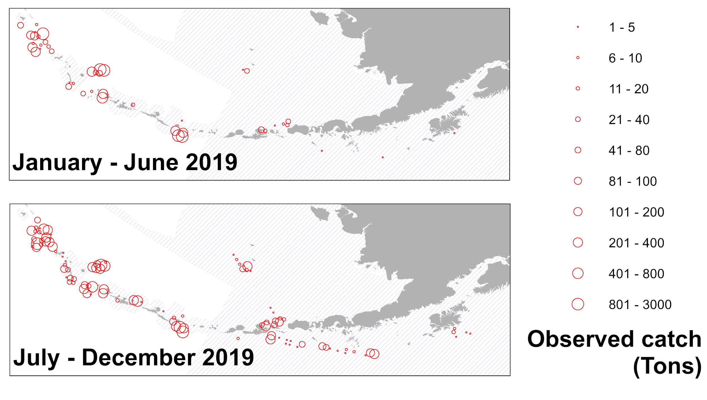

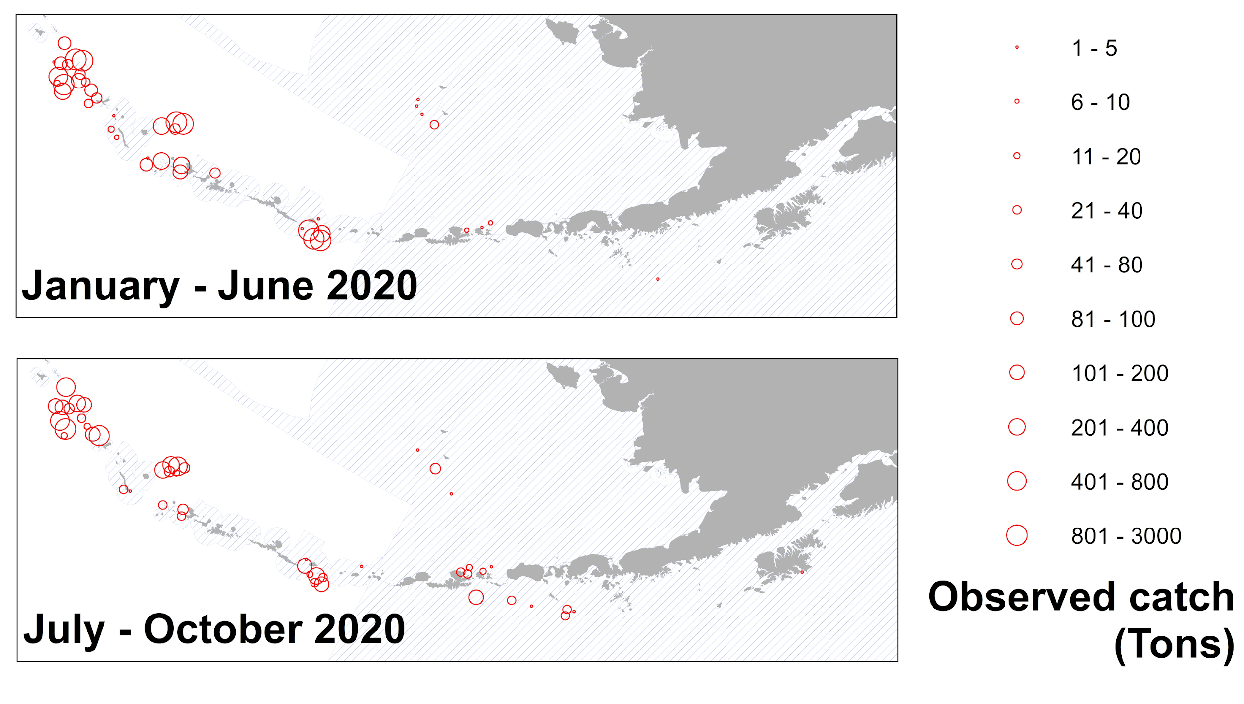

Figure 17.1. Observed catches of Atka mackerel summed for 20 km2 cells for 2019 and 2020 where observed catch per haul was greater than 1 t. Shaded areas represent areas closed to directed Atka mackerel fishing.

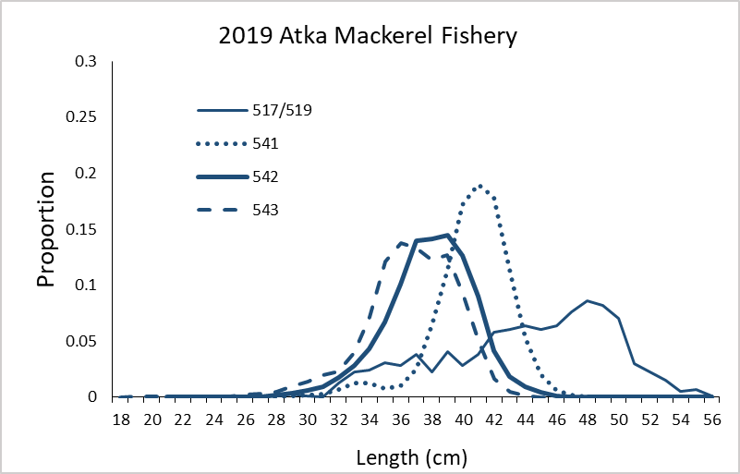

Figure 17.2. 2019 Atka mackerel fishery length-frequency data by area fished (see Figure 17.1). Numbers refer to management areas.

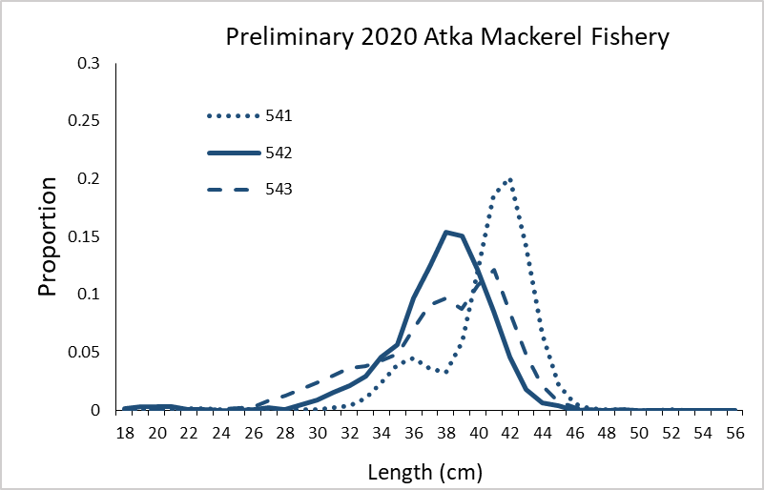

Figure 17.3. Preliminary 2020 Atka mackerel fishery length-frequency data by area fished. Too few fish from areas 517/519 were available for presentation (see Figure 17.1). Numbers refer to management areas.

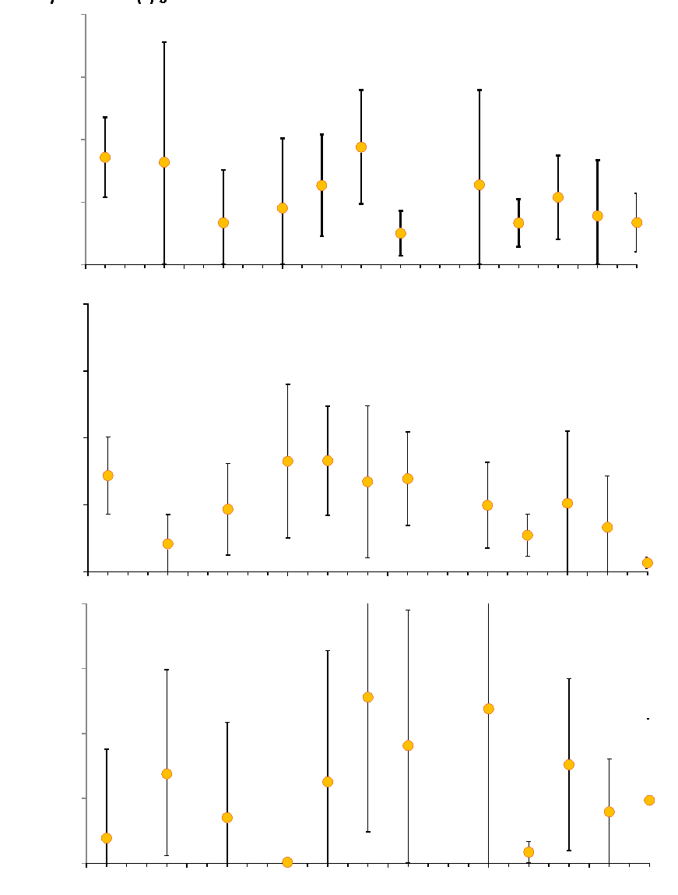

Figure 17.4. Atka mackerel Aleutian Islands survey biomass estimates by area and survey year. Bars represent 95% confidence intervals based on sampling error.

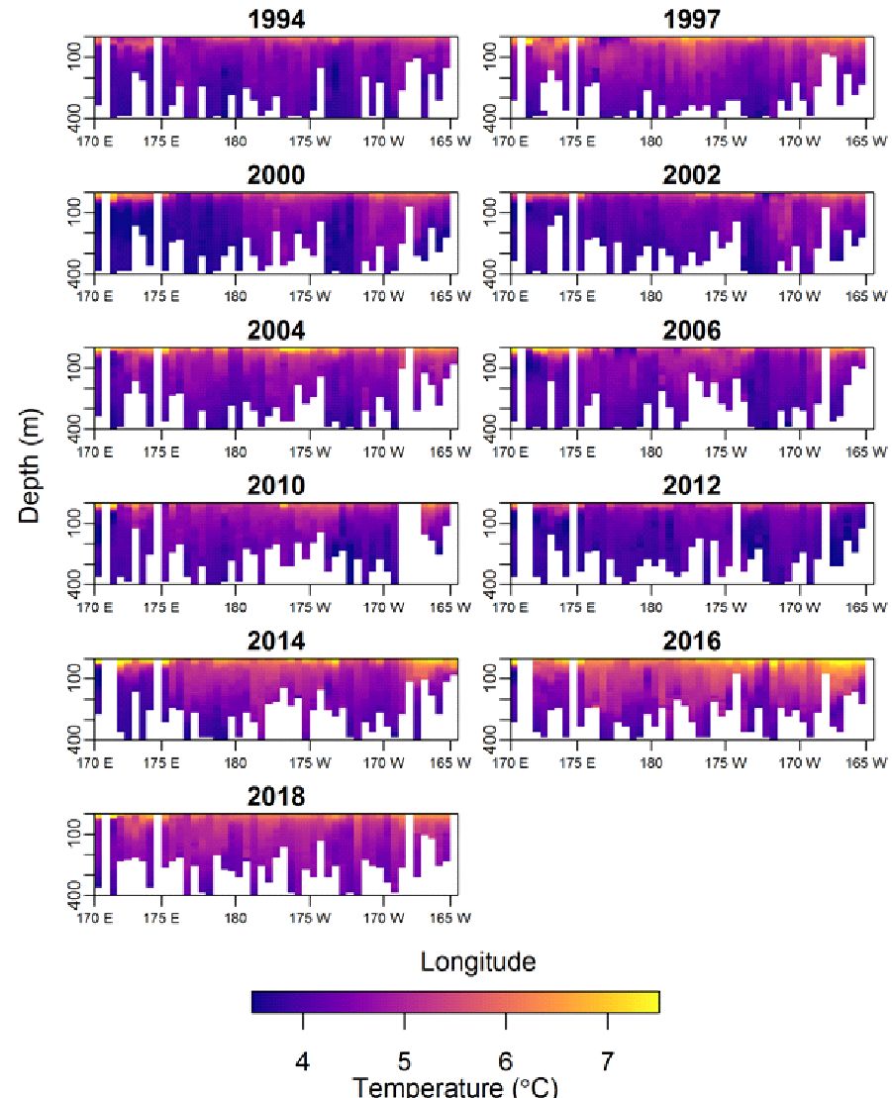

Figure 17.5. Median-survey-date-standardized, generalized additive model (GAM) predicted thermal (°C) anomaly profiles from water temperature measurements collected on Aleutian Islands bottom trawl surveys (1994-2018); to visually enhance near-surface temperature changes, values $≤$ 3.5°C or $≥$ 7.5°C were fixed at 3.5 or 7.5°C and the y-axis (depth) was truncated at 400 m though maximum collection depth was ca. 500 m. (Laman 2018).

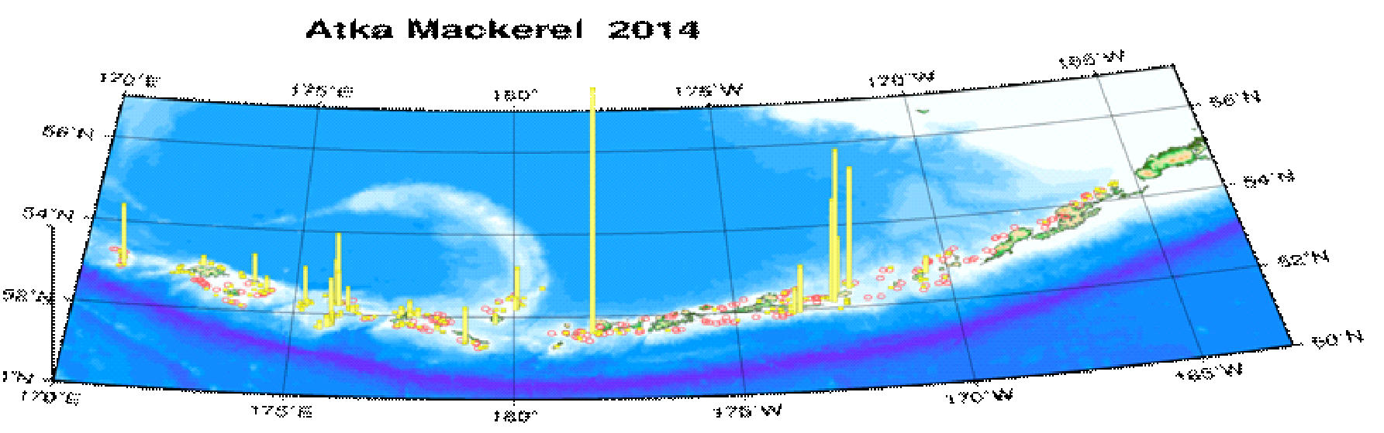

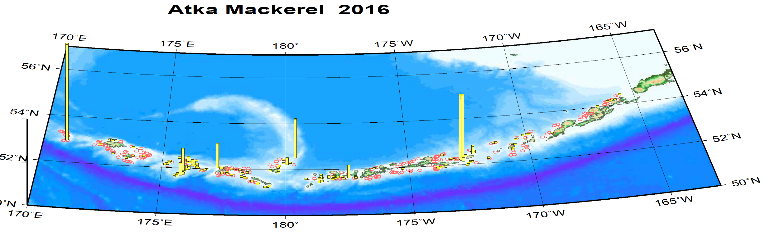

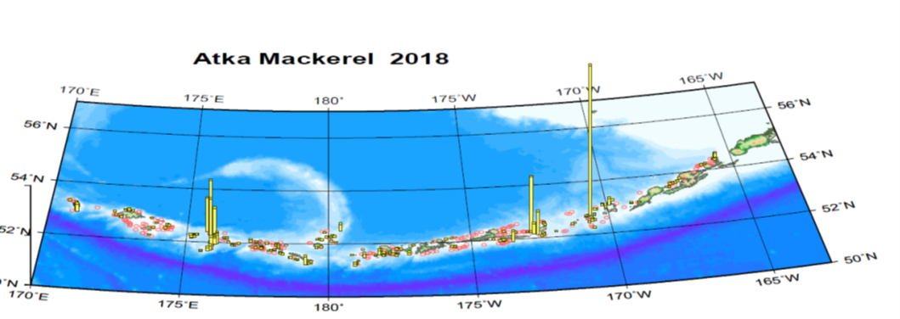

Figure 17.6. Bottom-trawl survey CPUE distributions of Atka mackerel catches during the summers of 2014, 2016, and 2018.

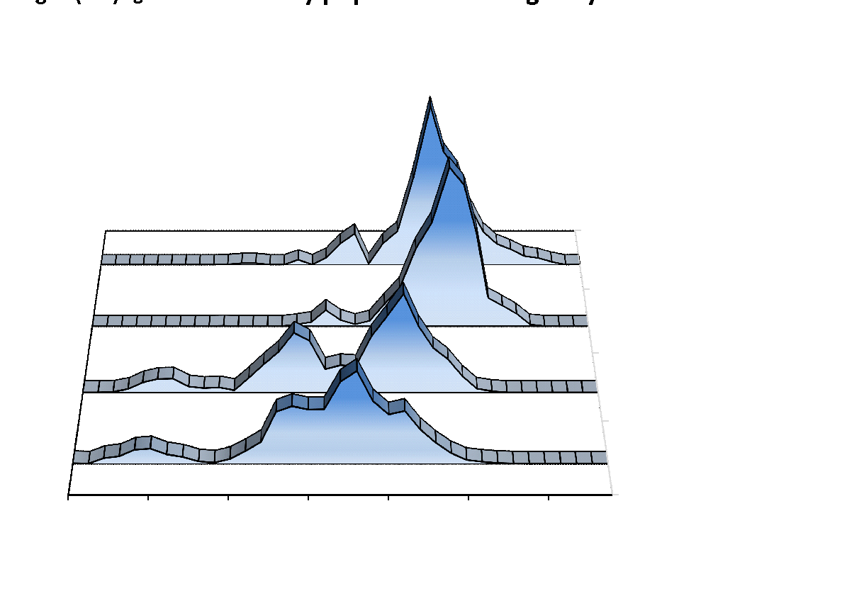

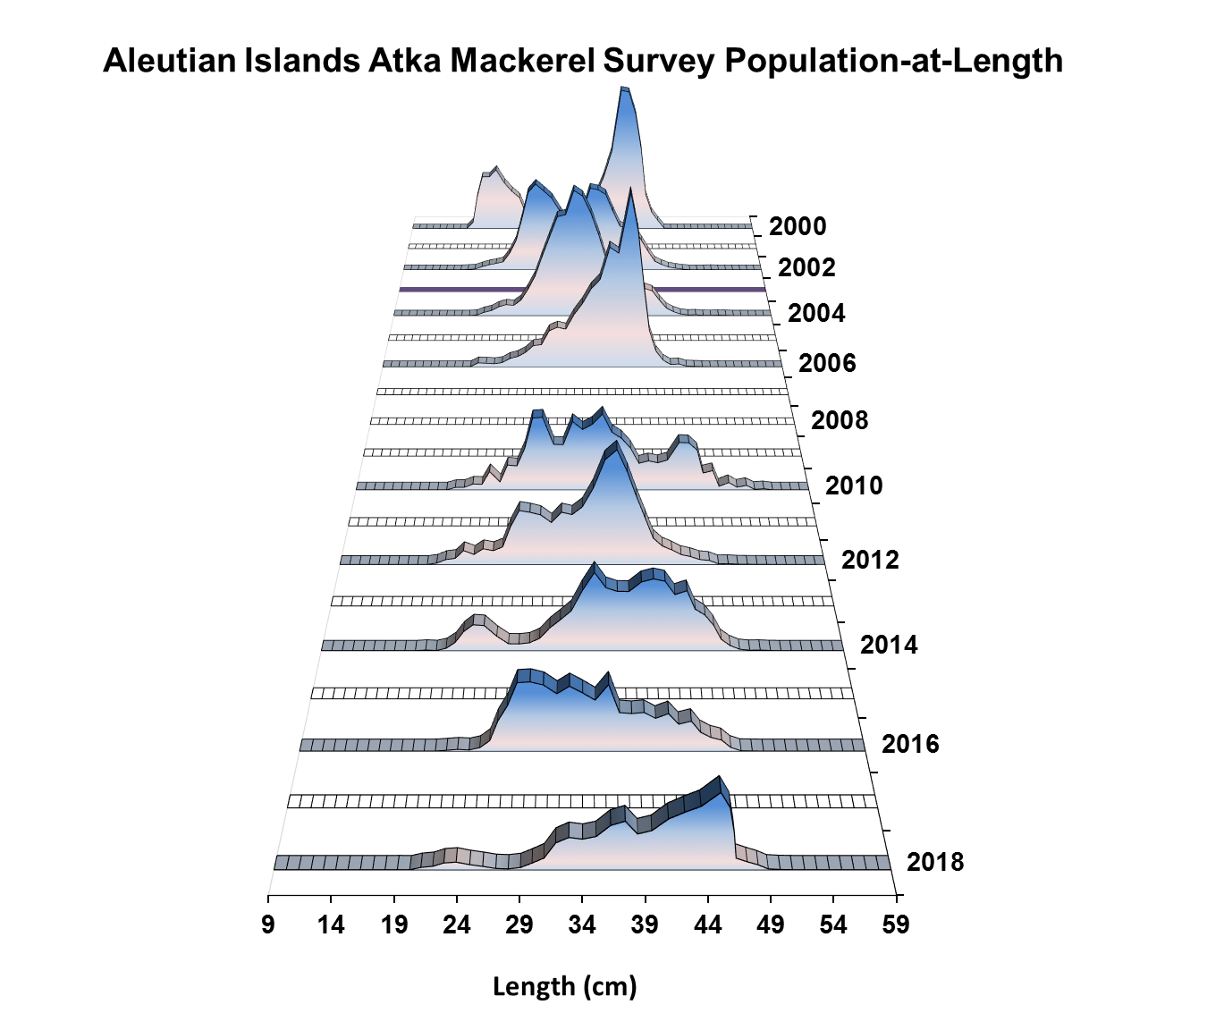

Figure 17.7. Atka mackerel bottom trawl survey length frequency data by subarea in 2018 (top) and for all areas, 2000-2018 (bottom). Vertical scales are proportional for a given area or year.

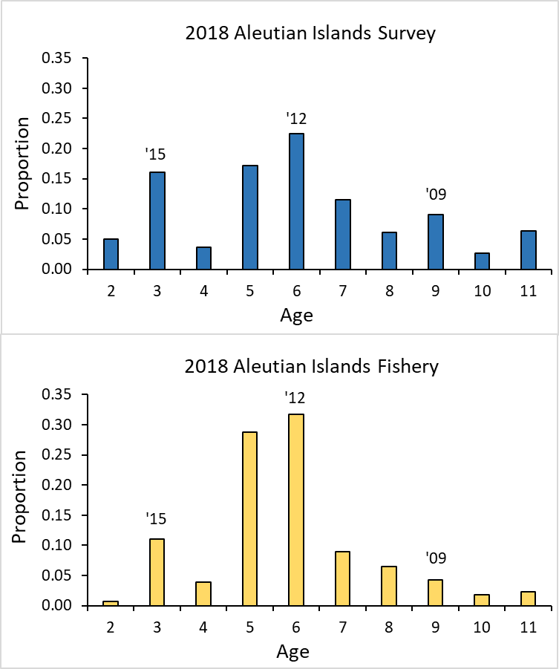

Figure 17.8a. Atka mackerel age distributions from the 2018 Aleutian Islands bottom trawl survey (top) and the 2018 Aleutian Islands fishery (bottom). A total of 1,052 otoliths were aged from the survey; mean age from the 2018 survey is 6 years. A total of 1,581 otoliths were aged from the fishery; mean age from the 2018 fishery is 5.8 years.

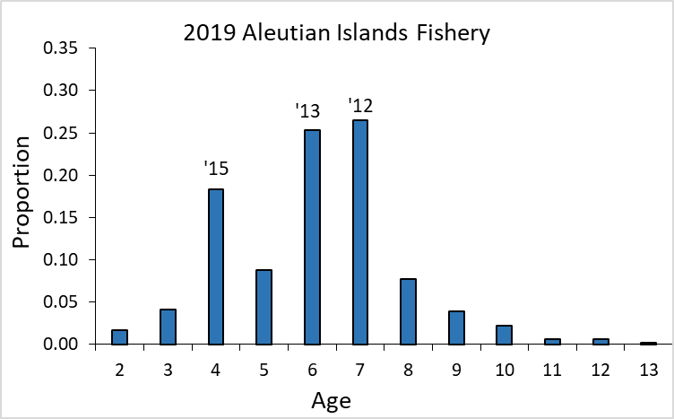

Figure 17.8b. Atka mackerel age distribution from the 2019 Aleutian Islands fishery. A total of 1,510 otoliths were aged from the fishery; mean age from the 2019 fishery is 6.1 years.

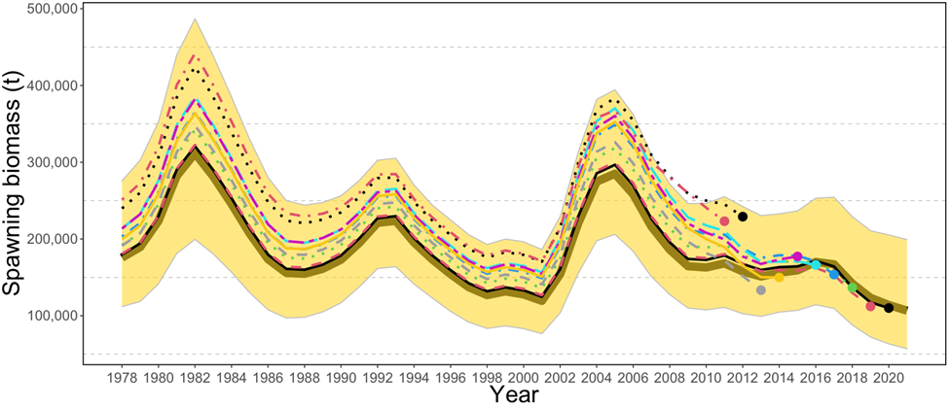

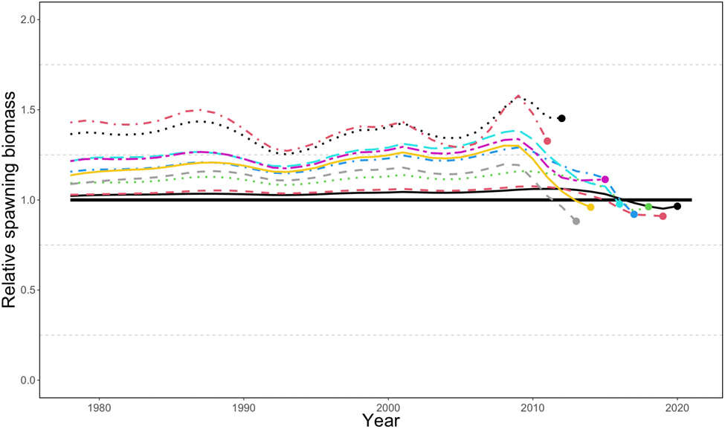

Figure 17.9. Retrospective plots showing the BSAI Atka mackerel spawning biomass over time (top) and the relative difference (bottom) over 10 different “peels”. Mohn’s rho was 0.047.

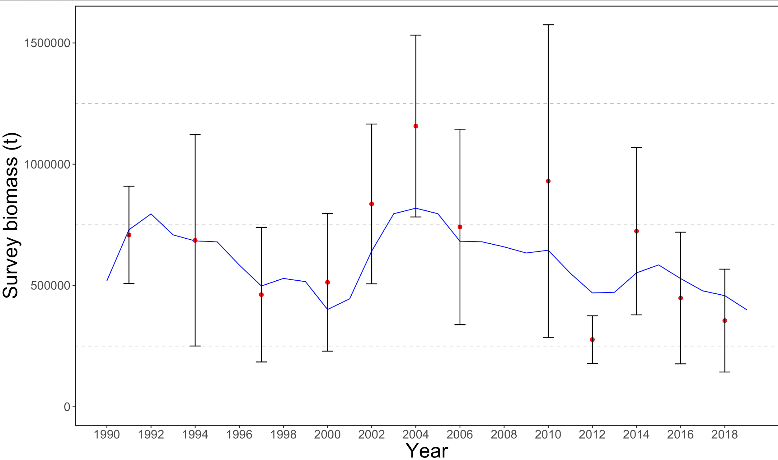

Figure 17.10. Observed (dots) and predicted (trend line) survey biomass estimates (t) for Bering Sea/Aleutian Islands Atka mackerel. Error bars represent two standard errors (based on sampling) from the survey estimates.

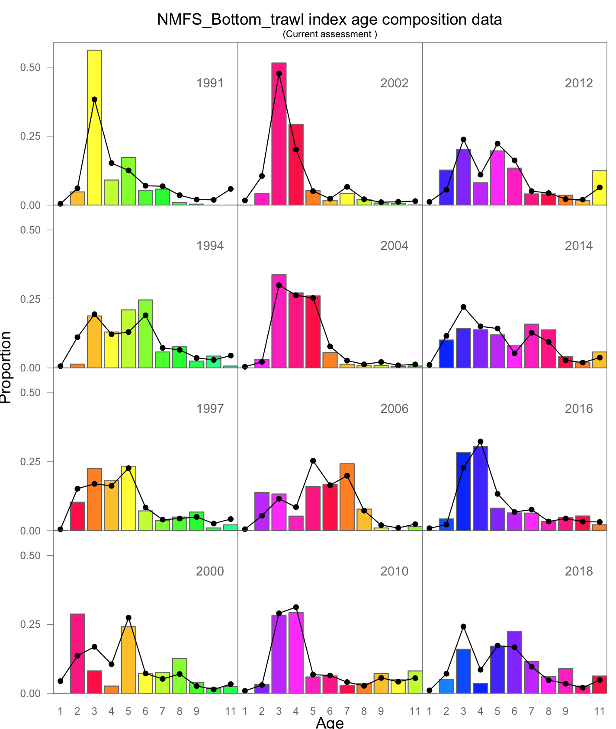

Figure 17.11. Observed and predicted **survey** proportions-at-age for BSAI Atka mackerel. Lines with “∙” symbol are the model predictions and columns are the observed proportions at age.

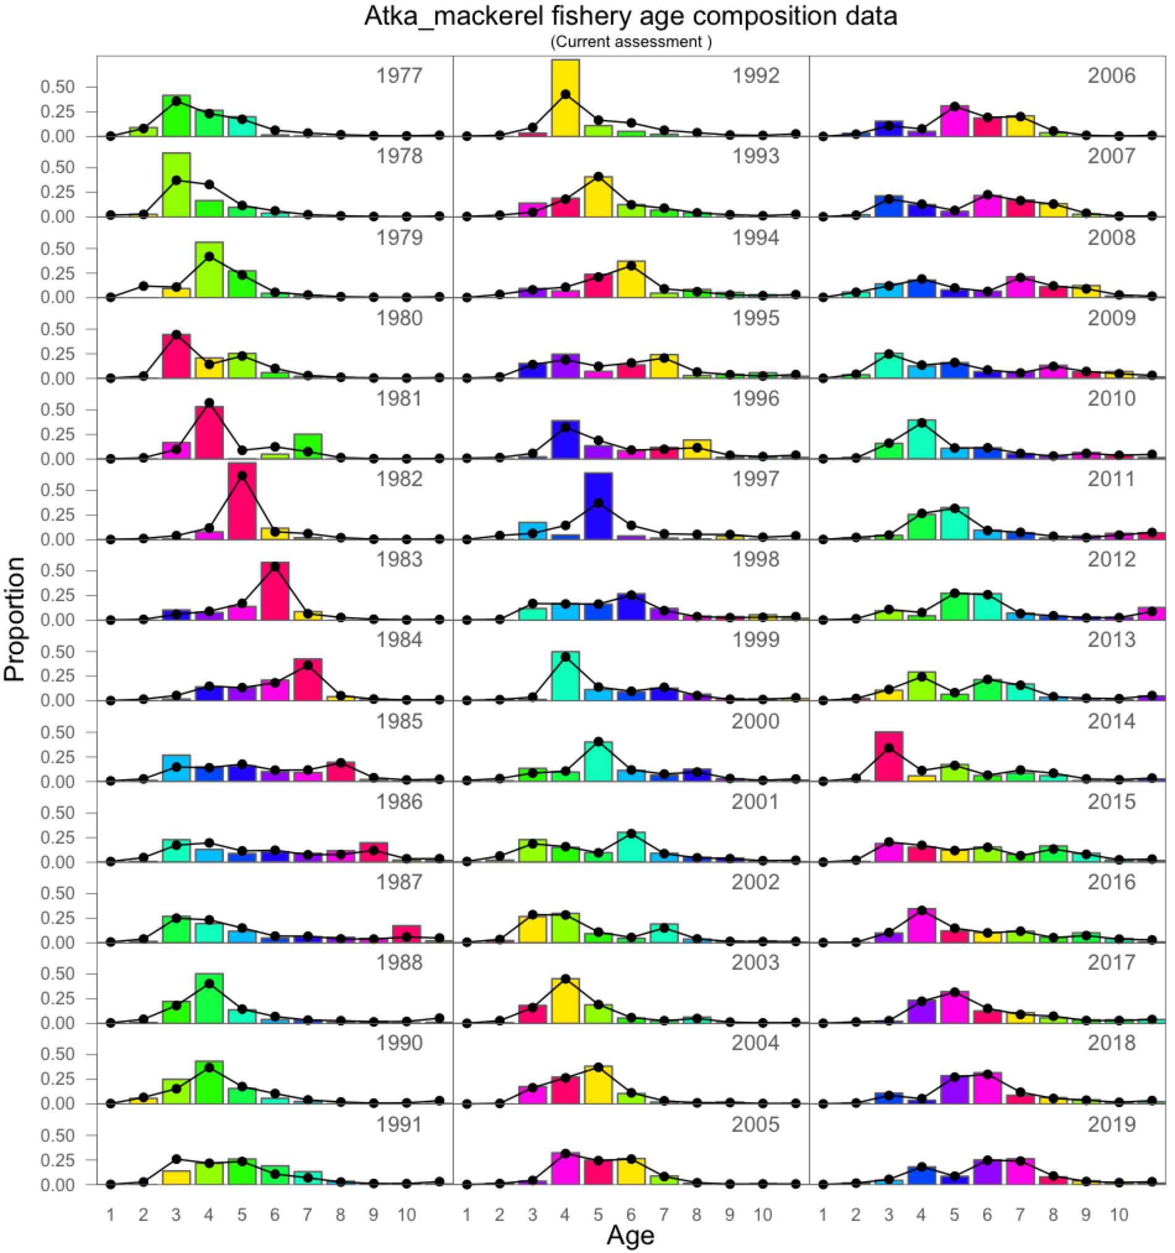

Figure 17.12. Observed and predicted Atka mackerel **fishery** proportions-at-age for BSAI Atka mackerel. Lines with “∙” symbol are the model predictions and columns are the observed proportions at age (with colors corresponding to cohorts).

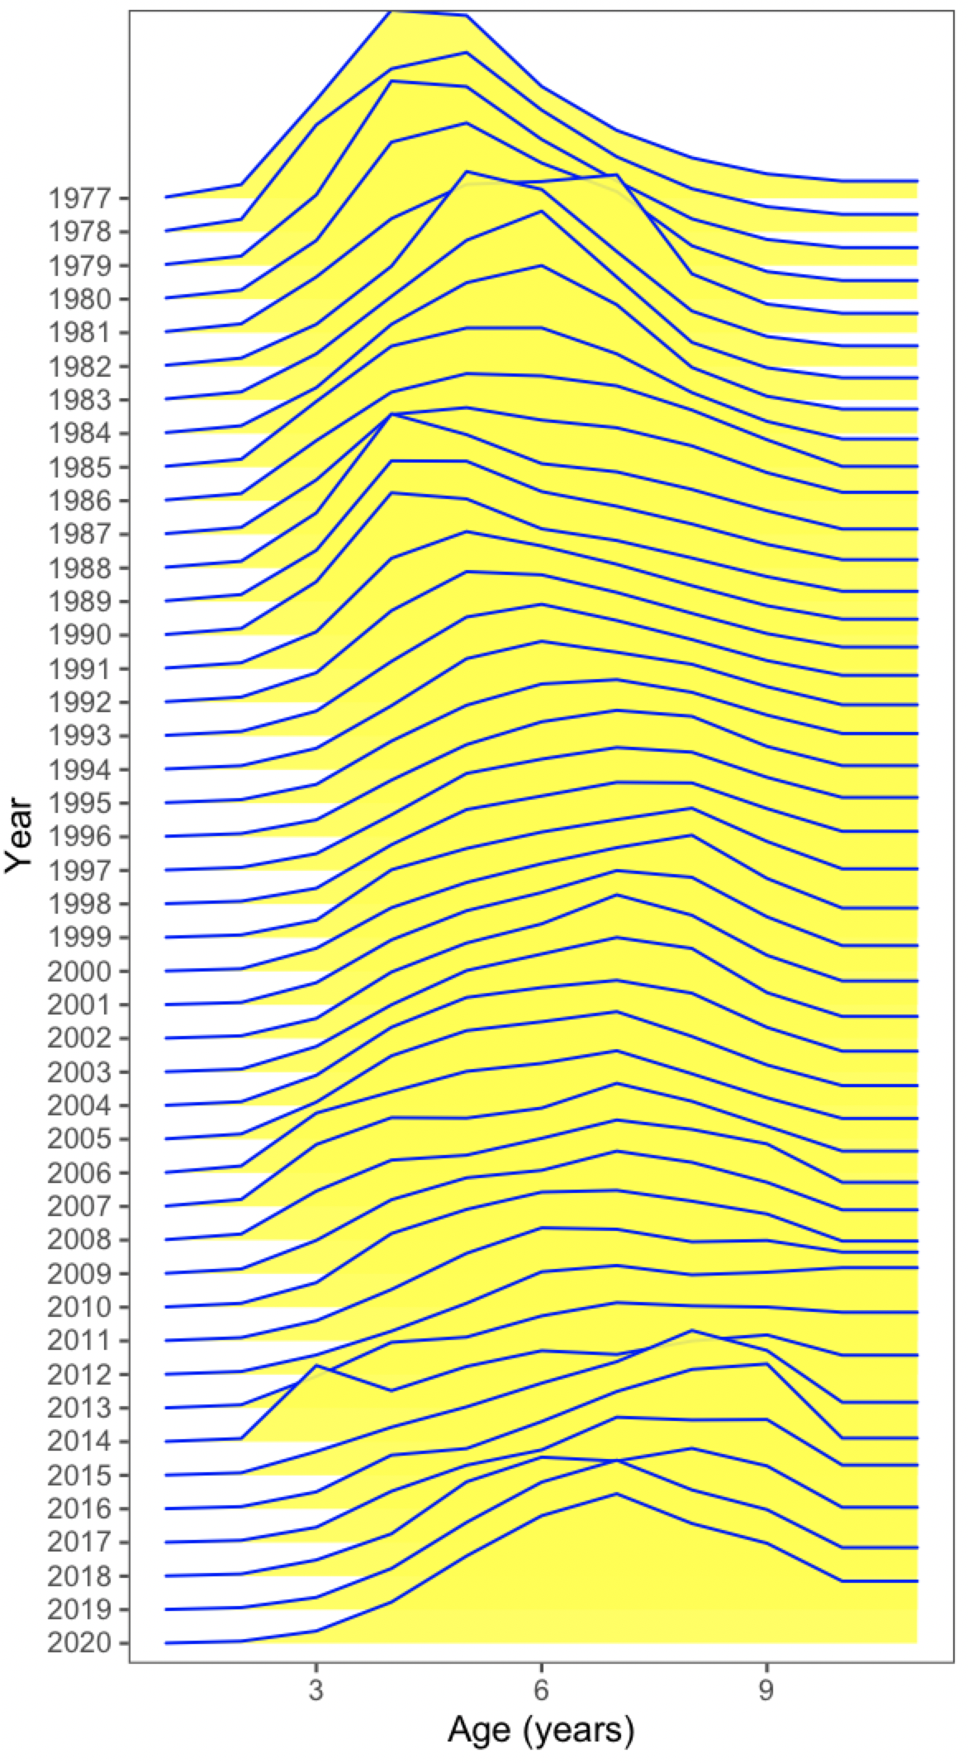

Figure 17.13. Fishery selectivity estimates over time for BSAI Atka mackerel.

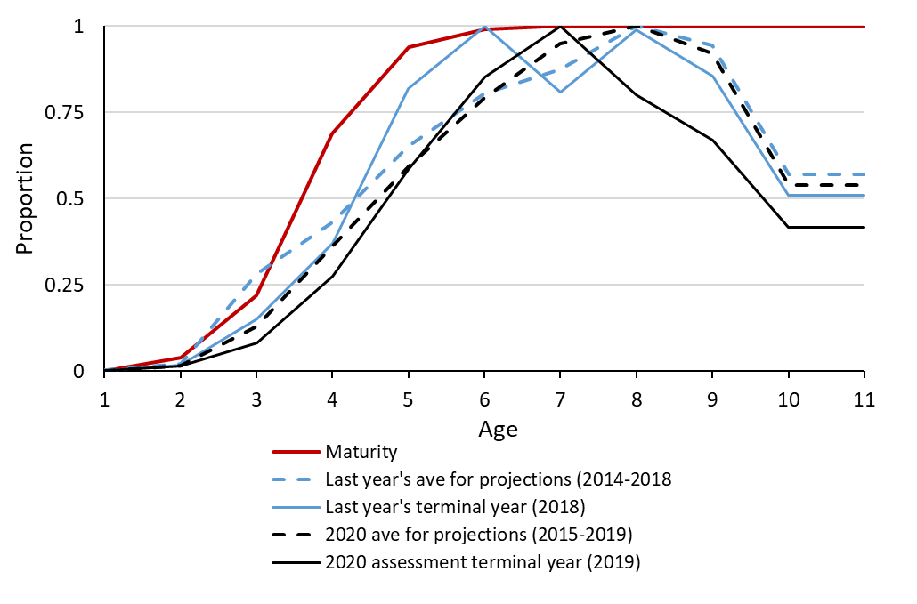

Figure 17.14. Estimated fishery selectivity patterns in the current assessment with a) last year’s average for projections (2014-2018), b) the 2020 assessment average selectivity used for projections (2015-2019), c) last year’s assessment terminal year (2018), and d) the 2020 assessment terminal year (2019) compared with the maturity-at-age estimates for BSAI Atka mackerel.

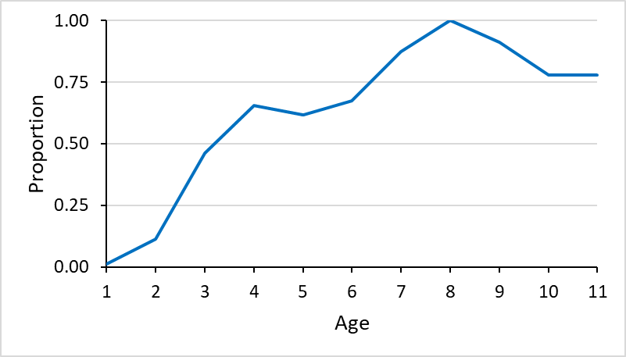

Figure 17.15. Estimated BSAI Atka mackerel survey selectivity-at-age from last year’s assessment (Model 16.0b). Selectivity estimates have been normalized to a maximum value of 1.0 for presentation.

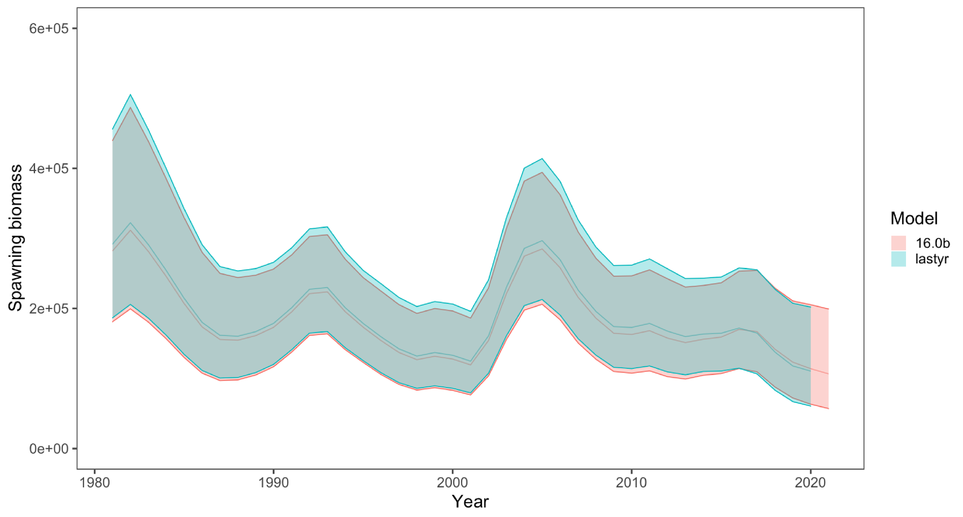

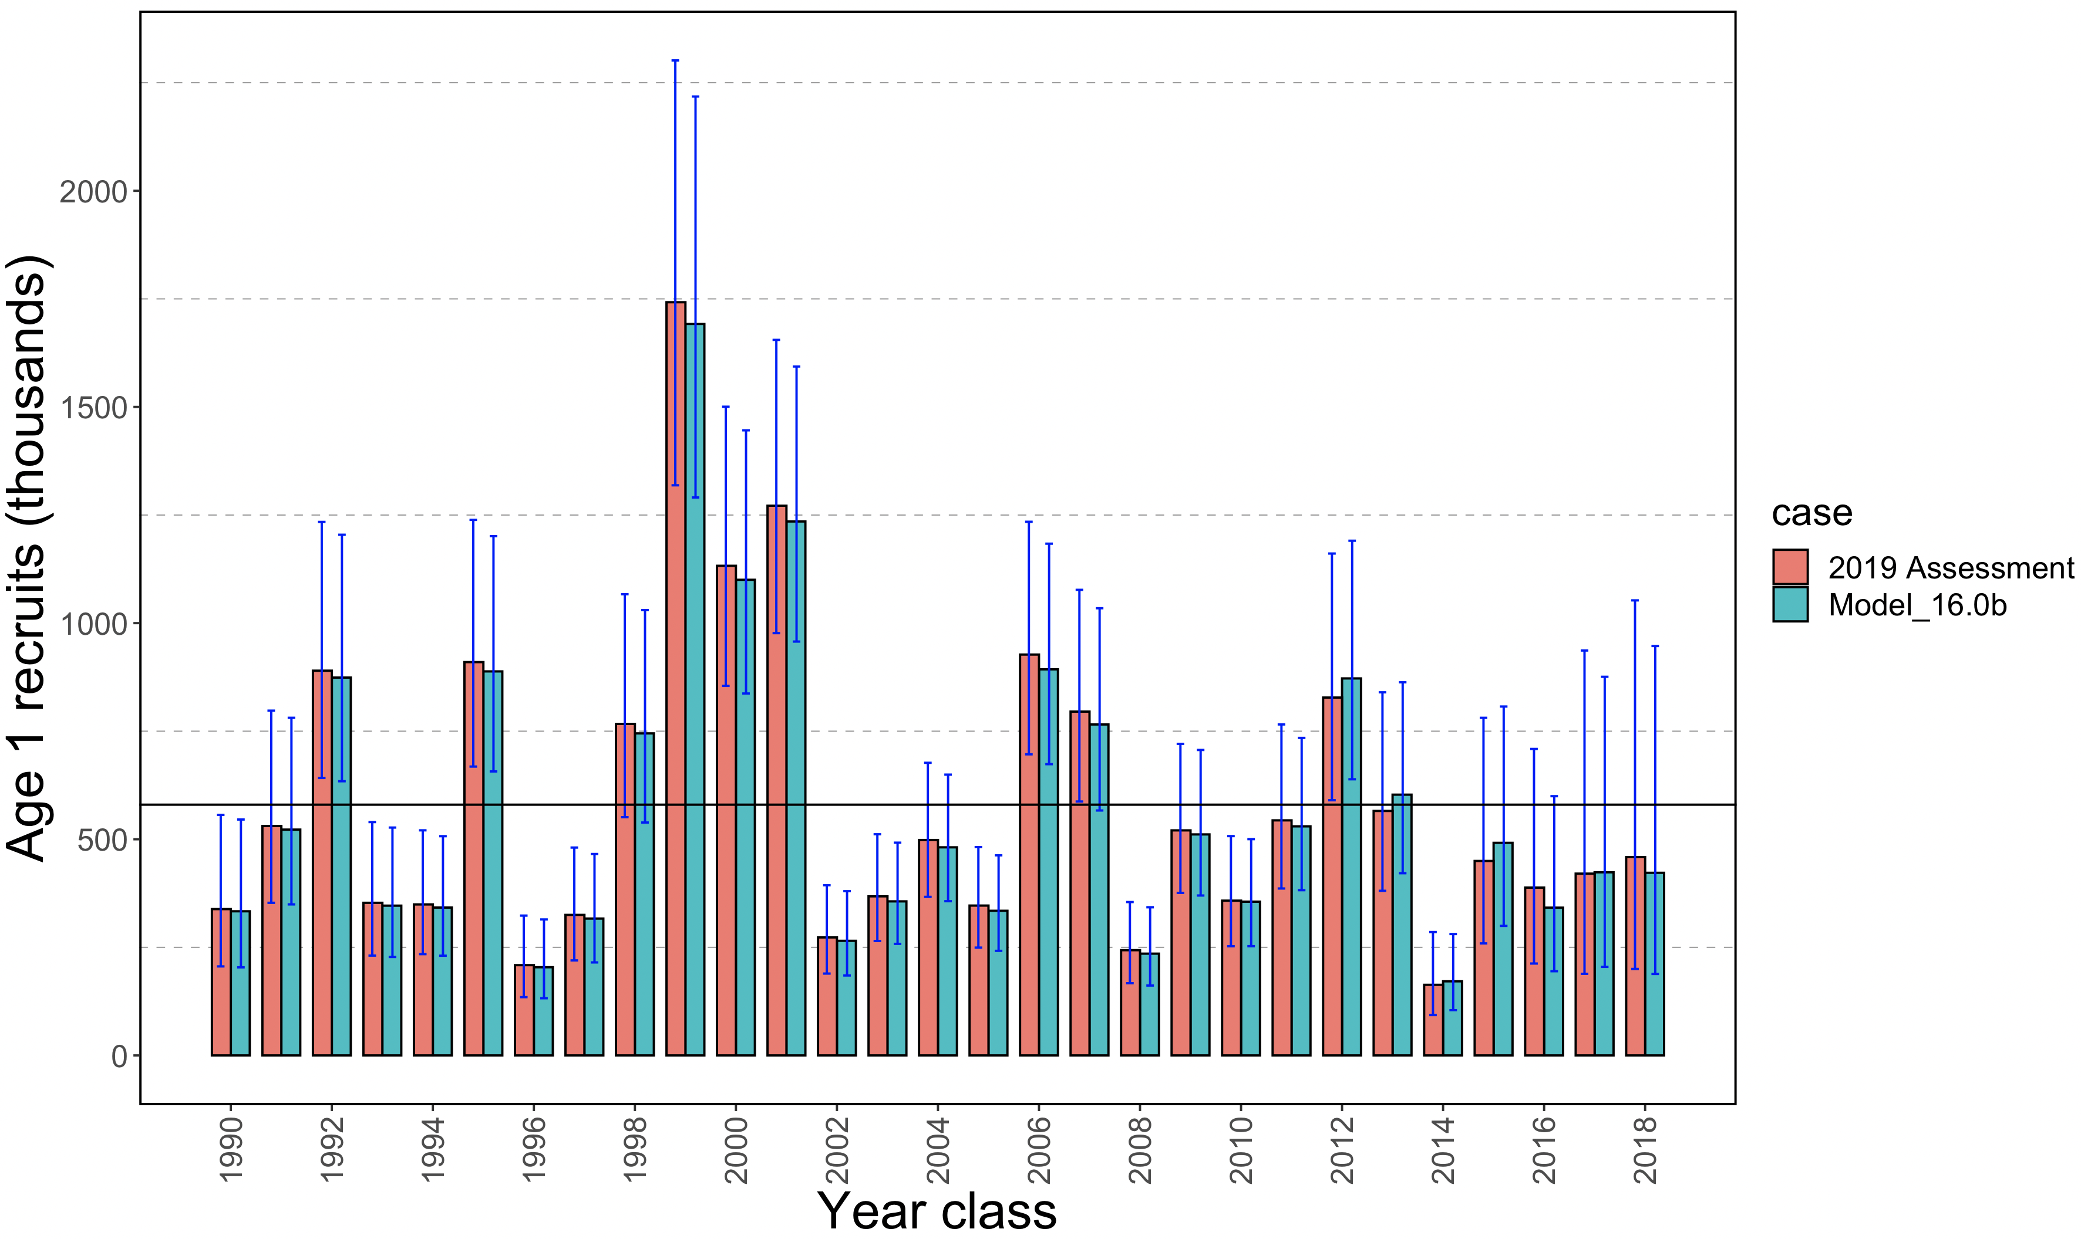

Figure 17.16. Time series of estimated Aleutian Islands Atka mackerel spawning biomass with approximate 95% confidence bounds (in t top), and recruitment at age 1 (thousands, bottom) from the current assessment (Model 16.0b) compared to last year’s 2019 assessment results (Model 16.0b). Dashed line represents average recruitment over the time series from the current assessment (580 million recruits).

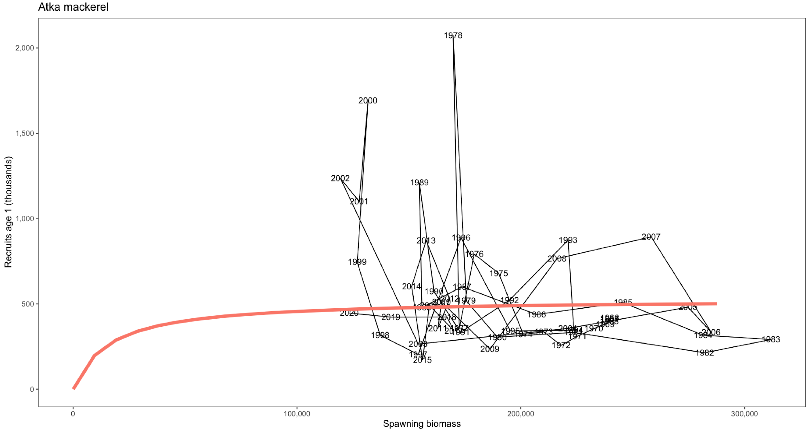

Figure 17.17 Estimated age 1 recruits (millions) versus female spawning biomass (t) for BSAI Atka mackerel. Solid line indicates Beverton-Holt stock recruitment curve (with steepness *h*=0.8).

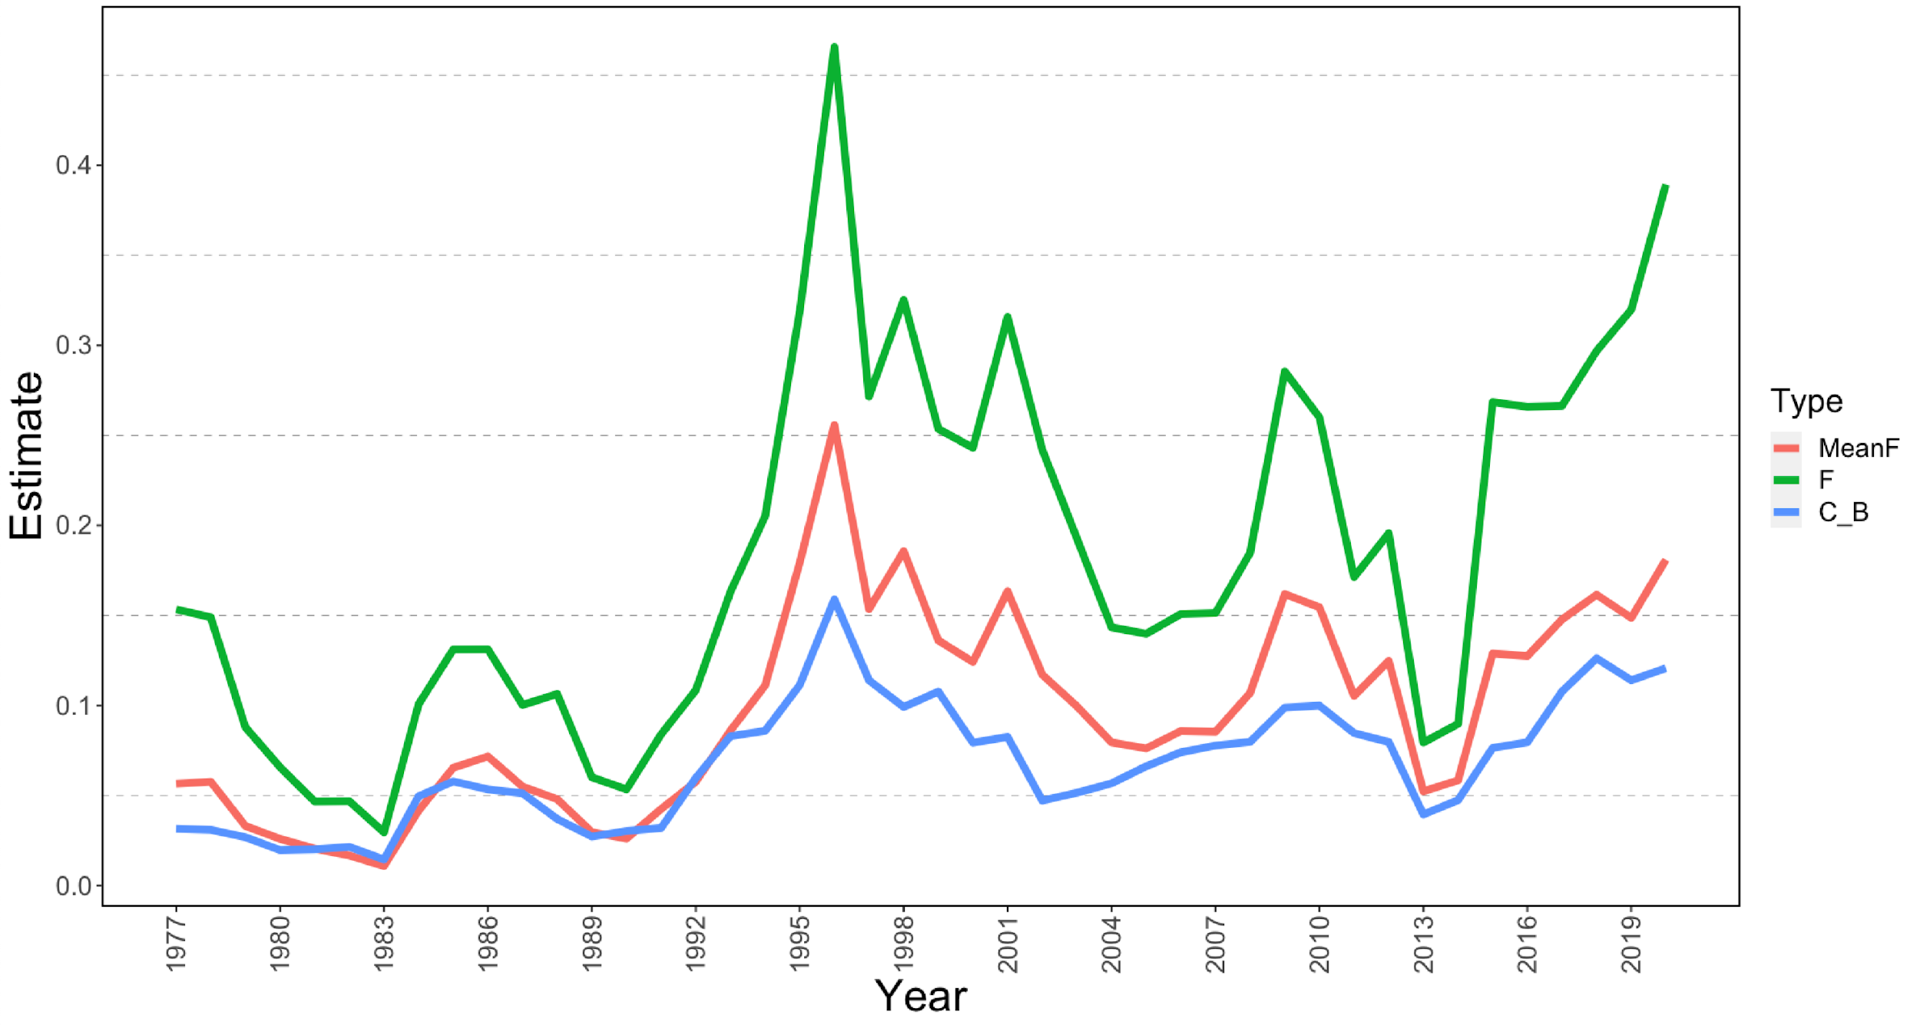

Figure 17.18 Estimated time series of Model 16.0b mean and full-selection fishing mortality and catch/biomass (C_B) exploitation rates of Atka mackerel, 1977-2020. Catch/biomass rates are the ratios of catch to beginning year age 3+ biomass.





Figure 17.19. Projected Atka mackerel catch (assuming TAC taken in 2020 and reduced catches in 2021 and 2022; top) and spawning biomass (bottom) in thousands of metric tons under maximum permissible harvest control rule specifications after 2022. The individual thin lines represent samples of simulated trajectories.

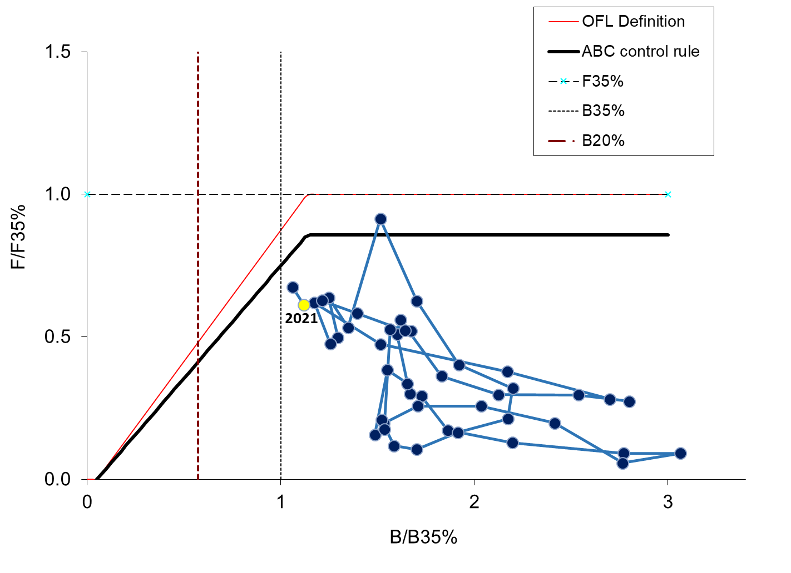

Figure 17.20. Aleutian Islands Atka mackerel spawning biomass relative to *B35%* and fishing mortality relative to *FOFL* (1977-2022). The ratio of fishing mortality to *FOFL* is calculated using the estimated selectivity pattern in that year. Estimates of spawning biomass and *B35%* are based on current estimates of weight-at-age and mean recruitment. Because these estimates change as new data become available, this figure can only be used in a general way to evaluate management performance relative to biomass and fishing mortality reference levels.

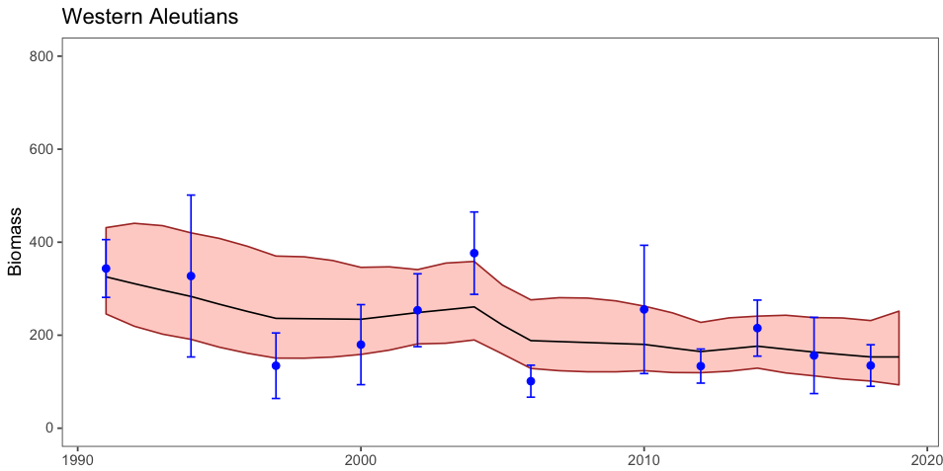

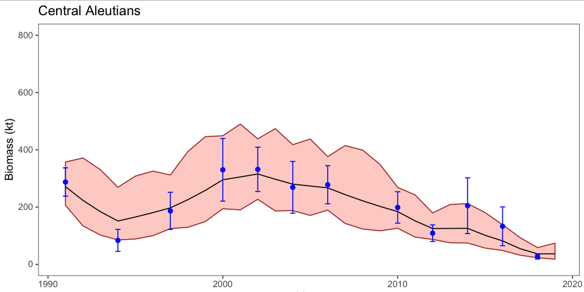

**Biomass (kt)**

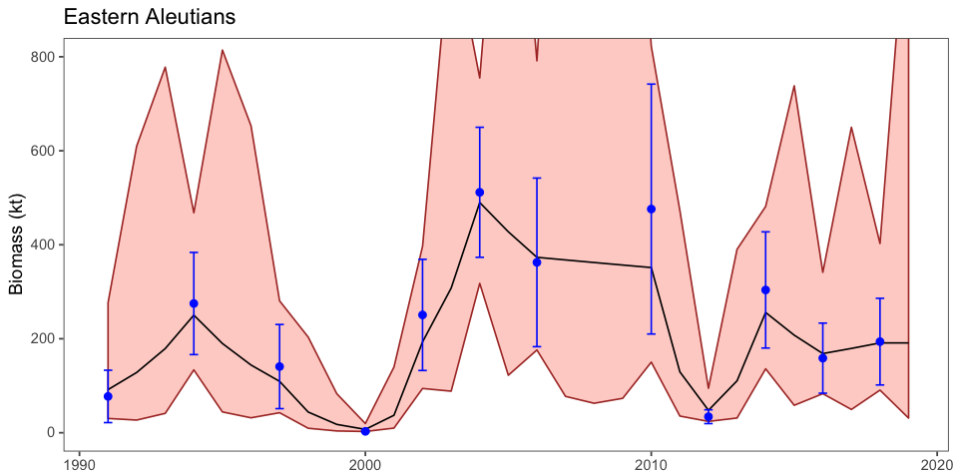

**Year**

Figure 17.21. Atka mackerel bottom trawl survey biomass by subarea 1991-2018 with random effects model fitting for area apportionment purposes. The random effects biomass estimates for 2019 in Eastern Aleutians is 191 thousand t, Central Aleutians is 37 thousand t, and Western Aleutians is 153 thousand t.

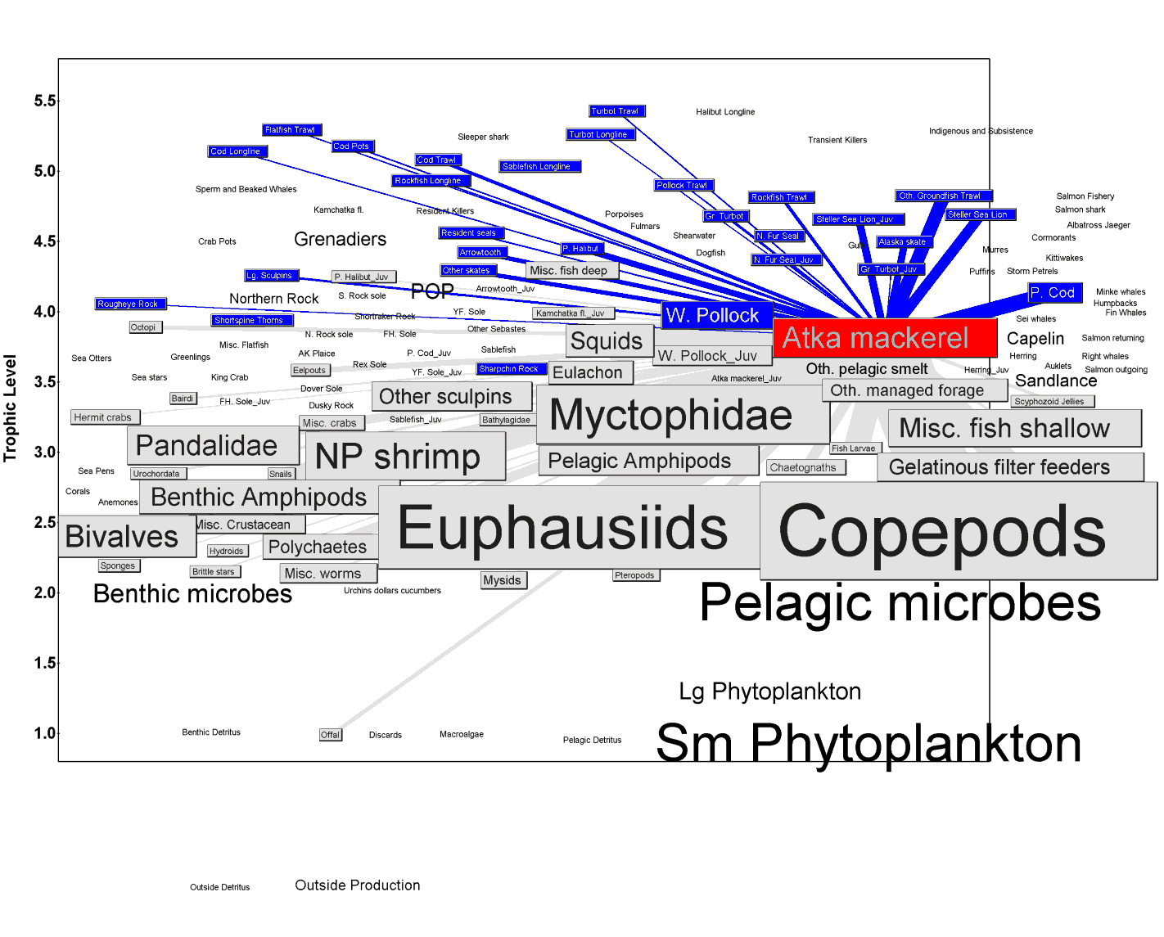

Figure 17.22. The food web of the Aleutian Islands survey region, 1990-1994, emphasizing the position of age 1+ Atka mackerel. Outlined species represent predators of Atka mackerel (dark boxed with light text) and prey of Atka mackerel (light boxes with dark text). Box and text size are proportional to each species’ standing stock biomass, while line widths are proportional to the consumption between boxes (t/year). Trophic levels of individual species may be staggered up to +/-0.5 of a trophic level for visibility.

(A)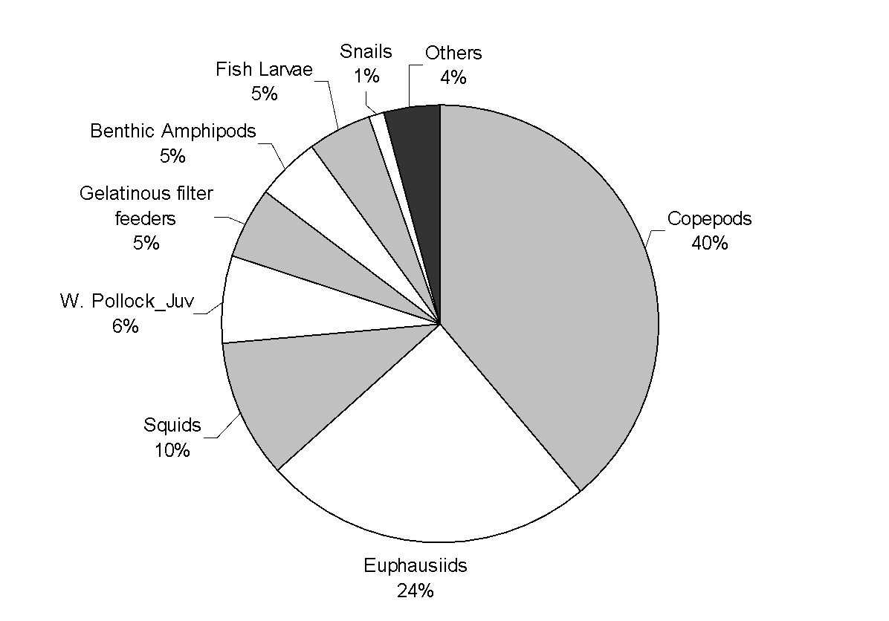

(B)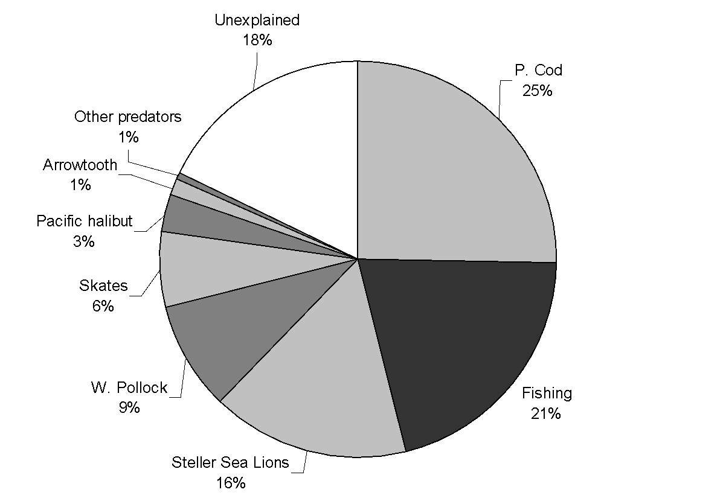

Figure 17.23. (A) Diet of age 1+ Atka mackerel, 1990-1994, by percentage wet weight in diet weighted by age-specific consumption rates. (B) Percentage mortality of Atka mackerel by mortality source, 1990-1994. “Unexplained” mortality is the difference between the stock assessment total exploitation rate averaged for 1990-1994, and the predation and fishing mortality, which are calculated independently of the assessment using predator diets, consumption rates, and fisheries catch.

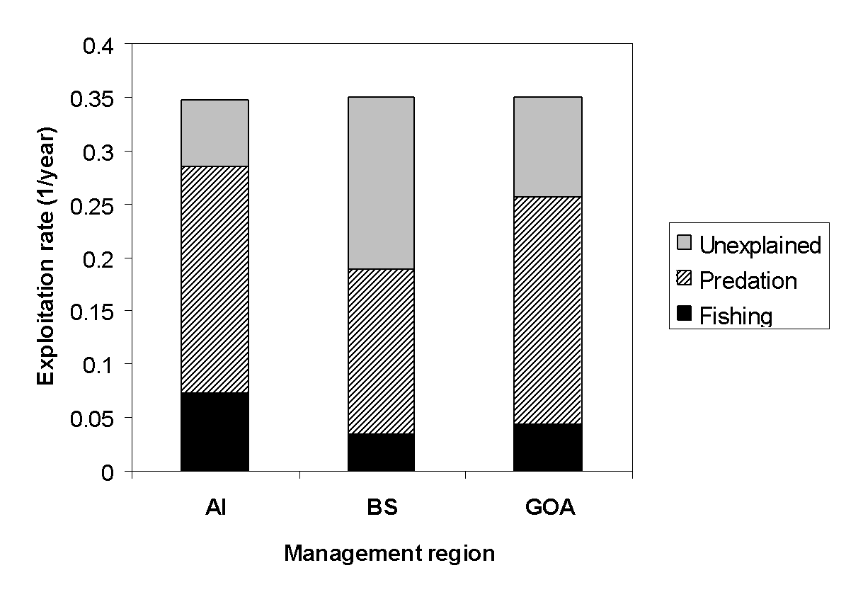

Figure 17.24. Total exploitation rate of age 1+ Atka mackerel, 1990-1994, proportioned into exploitation by fishing (black), predation (striped) and “unexplained” mortality (grey). “Unexplained” mortality is the difference between the stock assessment total exploitation rate averaged for 1990-1994, and the predation and fishing mortality, which are calculated independently of the assessment using predator diets, consumption rates, and fisheries catch.

# Appendix 17A Supplemental catch data

In order to comply with the Annual Catch Limit (ACL) requirements, two new datasets were generated to help estimate total catch and removals from NMFS stocks in Alaska.

The first dataset, non-commercial removals, estimates total available removals that do not occur during directed groundfish fishing activities. These include removals incurred during research, subsistence, personal use, recreational, and exempted fishing permit activities, but do not include removals taken in fisheries other than those managed under the groundfish FMP. These estimates represent additional sources of removals to the existing Catch Accounting System (CAS) estimates. Estimates for Atka mackerel from this dataset are shown along with trawl survey removals from 1977-2017 in Table 17A-1. Recent removals from activities other than directed fishing totaled <1 t in 2013, 111 t in 2014, <1 t in 2015, 78 t in 2016, and 2 t in 2017. This is approximately <0.1 % of the 2013, 2015, 2016, and 2017 ABCs, and 2% of the 2014 ABC. These low levels of non-commercial catch represent a very low risk to the stock. These removals were not incorporated in the stocks assessment. If these removals were accounted for in the stock assessment model, the recommended ABCs for 2019 and 2020 would likely change very little.

The second dataset, Halibut Fishery Incidental Catch Estimation (HFICE), is an estimate of the incidental catch of groundfish in the halibut IFQ fishery in Alaska, which is currently unobserved. To estimate removals in the halibut fishery, methods were developed by the HFICE working group and approved by the Gulf of Alaska and Bering Sea/Aleutian Islands Groundfish Plan Teams and the Scientific and Statistical Committee of the North Pacific Fishery Management Council. A detailed description of the methods is available in Tribuzio et al. (2011). There are no reported catches >0.5 t of BSAI Atka mackerel from this dataset.

**References**

Cahalan J., J. Mondragon., and J. Gasper. 2010. Catch Sampling and Estimation in the Federal Groundfish Fisheries off Alaska. NOAA Technical Memorandum NMFS-AFSC-205. 42 p.

Tribuzio, C.A., S. Gaichas, J. Gasper, H. Gilroy, T. Kong, O. Ormseth, J. Cahalan, J. DiCosimo, M. Furuness, H. Shen, and K. Green. 2011. Methods for the estimation of non-target species catch in the unobserved halibut IFQ fleet. August Plan Team document. Presented to the Joint Plan Teams of the North Pacific Fishery Management Council.

Table 17A-1. Total removals of BSAI Atka mackerel (t) from activities not related to directed fishing, since 1977. “Trawl” refers to a combination of the NMFS echo-integration; small-mesh; large-mesh; and Aleutian Islands bottom trawl surveys; and occasional short-term research projects involving trawl gear. “Longline” refers to either the NMFS or IPHC longline survey. “Other” refers to recreational, personal use, and subsistence harvest.

|  |  |  |  |  |  |  |
| --- | --- | --- | --- | --- | --- | --- |
|  |  |  | Longline | |  |  |
| Year | Source | Trawl | NMFS | IPHC | Other | Total |
| 1977 | AFSC | 0 |  |  |  | 0 |
| 1978 | AFSC | 0 |  |  |  | 0 |
| 1979 | AFSC | 0 |  |  |  | 0 |
| 1980 | AFSC | 48 |  |  |  | 48 |
| 1981 | AFSC | 0 |  |  |  | 0 |
| 1982 | AFSC | 1 |  |  |  | 1 |
| 1983 | AFSC | 151 |  |  |  | 151 |
| 1984 | AFSC | 0 |  |  |  | 0 |
| 1985 | AFSC | 0 |  |  |  | 0 |
| 1986 | AFSC | 130 |  |  |  | 130 |
| 1987 | AFSC | 0 |  |  |  | 0 |
| 1988 | AFSC | 0 |  |  |  | 0 |
| 1989 | AFSC | 0 |  |  |  | 0 |
| 1990 | AFSC | 0 |  |  |  | 0 |
| 1991 | AFSC | 77 |  |  |  | 77 |
| 1992 | AFSC | 0 |  |  |  | 0 |
| 1993 | AFSC | 0 |  |  |  | 0 |
| 1994 | AFSC | 147 |  |  |  | 147 |
| 1995 | AFSC | 0 |  |  |  | 0 |
| 1996 | AFSC | 0 |  |  |  | 0 |
| 1997 | AFSC | 85 |  |  |  | 85 |
| 1998 | AFSC | 0 |  |  |  | 0 |
| 1999 | AFSC | 0 |  |  |  | 0 |

Table 17A-1cont. Total removals of BSAI Atka mackerel (t) from activities not related to directed fishing, since 1977. “Trawl” refers to a combination of the NMFS echo-integration; small-mesh; large-mesh; and Aleutian Islands bottom trawl surveys; and occasional short-term research projects involving trawl gear. “Longline” refers to either the NMFS or IPHC longline survey. “Other” refers to recreational, personal use, and subsistence harvest.

|  |  |  |  |  |  |  |
| --- | --- | --- | --- | --- | --- | --- |
|  |  |  | Longline | |  |  |
| Year | Source | Trawl | NMFS | IPHC | Other | Total |
| 2000 | AFSC | 105 |  |  |  | 105 |
| 2001 | AFSC | 0 |  |  |  | 0 |
| 2002 | AFSC | 171 |  |  |  | 171 |
| 2003 | AFSC | 0 |  |  |  | 0 |
| 2004 | AFSC | 240 |  |  |  | 240 |
| 2005 | AFSC | 0 |  |  |  | 0 |
| 2006 | AFSC | 99 |  |  |  | 99 |
| 2007 | AFSC | 0 |  |  |  | 0 |
| 2008 | AFSC | 0 |  |  |  | 0 |
| 2009 | AFSC | 0 |  |  |  | 0 |
| 2010 | AFSC | 140 |  |  |  | 140 |
| 2011 | AFSC | 1,529 |  |  |  | 1,529 |
| 2012 | AFSC | 62 |  |  |  | 62 |
| 2013 | AFSC | 0 |  |  |  | 0 |
| 2014 | AFSC | 111 |  |  |  | 111 |
| 2015 | AFSC | 4 |  |  |  | 4 |
| 2016 | AFSC | 78 |  |  |  | 78 |
| 2017 | AFSC | 2 |  |  |  | 2 |
| 2018 | AFSC | 71 |  |  |  | 71 |
| 2019 | AFSC | 0 |  |  |  | 0 |

# Appendix 17B

# Atka mackerel (BSAI) Economic Performance Report for 2018

By

Ben Fissel

Alaska Fishery Science Center, Resource Ecology and Fishery Management Division,

Economic and Social Sciences Research Division

Atka mackerel is predominantly caught in the Aleutian Islands, and almost exclusively by the Amendment 80 Fleet. The fishery for Atka mackerel has been a catch share fishery since 2008 when Amendment 80 was implemented rationalizing the fleet of catcher/processor vessels in the Bering Sea and Aleutian Islands region targeting flatfish, Atka mackerel and Pacific ocean perch.[4] Atka mackerel is an important source of revenue for the Amendment 80 fleet because of its comparatively high price relative to other species. In 2019 Atka mackerel total catch decreased to 58.5 thousand t and retained catch decreased to 57.5 thousand t. Catch levels peaked in 2018 after significant reductions in the TAC in 2012 and 2013 when catch levels were low due to area closures to protect endangered Steller sea lions, and survey-based changes in the spatial apportionment of TAC. The 2019 decrease in the catch is a result of a reduction in the Allowable Biological Catch and TAC. Commensurate with the change in catch, first-wholesale production decreased to 34 thousand tons. The decrease in production coupled with a 14% decrease in price to $1.16 resulted in a 34% drop in first-wholesale revenue to $86.6 million.

The U.S. (Alaska), Japan and Russian are the major producers of Atka mackerel.[5] Typically, approximately 90% of the Alaska caught Atka mackerel production value is processed as head-and-gut (H&G) products, the remainder is mostly sold as whole fish (Table 1). In 2019 99% of the catch was processed as H&G as whole fish production dropped off. Virtually all of Alaska’s Atka mackerel production is exported, mostly to Asian markets. In Asia it undergoes secondary processing into products like surimi, salted-and-split and other consumable product forms (Table 2). Industry reports that the domestic market is minimal and data indicate U.S. imports are approximately 0.1% of global production.

The upward trend in first-wholesale and export prices through 2018 have been influenced by international factors. In particular, global supply of Atka mackerel was in decline because of substantial decreases in catch volume in Japan. In 2018 catch volumes in Japan began to increase, coupled with increasing supply from the U.S. in 2018, which may be putting downward pressure on prices that carried through into 2019. Despite the decrease, Atka mackerel prices remain high relative to pre-2017 levels.

Global production dropped from an average of 226 thousand t between 2008-2012 to an average of 108 thousand t between 2015-2017 (Table 2). The reductions in international supply meant that the U.S. has captured a larger share of global production in recent years relative to the 2008-2012 average (Table 2). The global supply reductions put upward pressure on the price which is reflected in the higher price after 2011. Additionally, the opening of previously restricted areas off the Aleutians has given industry more access to larger fish which yield a higher price per pound in the market. The increased price of Atka mackerel in recent years has helped to increase first-wholesale value (Table 1). International production of Atka mackerel was on the decline because of reductions in Japanese, and Russian catch and production which were particularly severe in 2015. The U.S. supplied 55% of the global market of Atka mackerel in 2018 (Table 2). This resulted in increased demand for U.S. Atka mackerel in Japan where it is used to make surimi among other products. Because Atka is primarily exported to Japan, which constitutes roughly 70% of the export value, the U.S. exchange rate can influence first-wholesale prices, and the exchange rate has remained stable since 2016 (Table 2).

Table 1. Atka mackerel catch and first-wholesale market data. Total and retained catch (thousand metric tons), number of vessel, first-wholesale production (thousand metric tons), value (million US$), price (US$ per pound), and head and gut share of production; 2010-2014 average and 2015-2019.

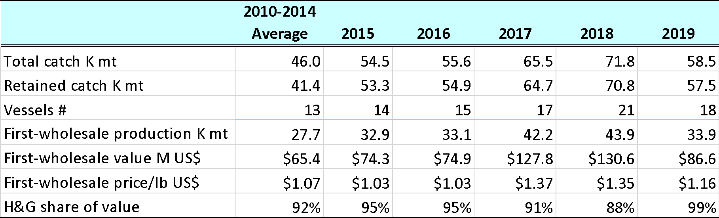

Source: NMFS Alaska Region Blend and Catch-accounting System estimates; NMFS Alaska Region At-sea Production Reports; and ADF&G Commercial Operators Annual Reports (COAR). Data compiled and provided by the Alaska Fisheries Information Network (AKFIN).

Table 2. Atka mackerel U.S. trade and global market data. Global production (thousand metric tons), U.S. share of global production, U.S. export volume (thousand metric tons), U.S. export value (million US$), U.S. export price (US$ per pound) and the share of U.S. export value from Japan; 2010-2014 average and 2015-2019.

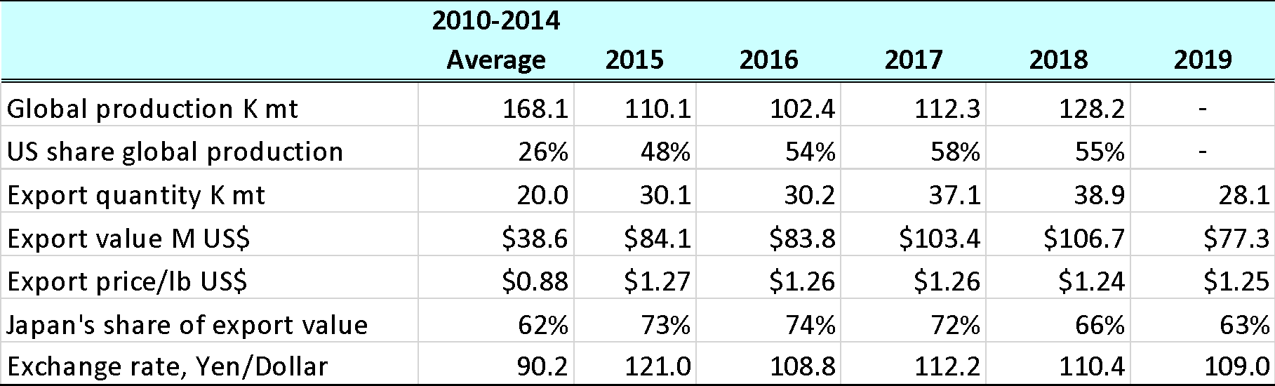

Source: FAO Fisheries & Aquaculture Dept. Statistics <http://www.fao.org/fishery/statistics/en>. NOAA Fisheries, Fisheries Statistics Division, Foreign Trade Division of the U.S. Census Bureau, <http://www.st.nmfs.noaa.gov/commercial-fisheries/foreign-trade/index>. U.S. Department of Agriculture <http://www.ers.usda.gov/data-products/agricultural-exchange-rate-data-set.aspx>.

# Appendix 17C

# Presented in September, 2019

# Using fishery independent and dependent indices for apportionment estimation of Bering Sea/Aleutian Islands Atka mackerel

James Ianelli, Pete Hulson, and Sandra Lowe

September 2019

# Introduction

Last year the 2018 Bering Sea Aleutian Islands (BSAI) Atka mackerel stock assessment incorporated the 2018 Aleutian Islands bottom trawl survey data. The 2018 survey indicated a 21% decrease in biomass for the overall survey area since the previous 2016 survey, including an unexpected 80% drop in biomass for the Central Aleutian Islands (Central AI). The updated Model 16.0b used last year, indicated an ongoing decline in spawning biomass from a peak in 2005 which is attributed to poor to average year class strengths since 2007. The 2019 spawning biomass was projected to be 106,800 t (*B*38%), just below *B*40%, and placing the stock into Tier 3b.

Since 2015, a random effects (RE) model has been fit to the bottom trawl survey to determine apportionments for the three Aleutian Islands subareas (Western, Central, and Eastern). Given the extreme drop in survey biomass for the Central AI, continued use of this method would have resulted in changes in apportionment for the Central AI that would have been reduced from 34.78% in 2018 to 10% for 2019 (a 71% decrease). We conducted a thorough investigation of survey and fishery data to try to explain the observed survey biomass decline in this area. Several aspects relating to observation error were evaluated for the 2014, 2016, and 2018 surveys (e.g., station location, timing, haul performance, etc.) and very few differences were noted. In addition, the survey protocols for the 2000 and 2018 surveys were compared (years of lowest Eastern and Central AI survey biomass estimates, respectively), and the only notable differences were the extreme low survey temperatures in 2000 in contrast to the high survey temperatures in 2018. It is puzzling that in the 2000 and 2018 surveys, the (low and high) temperatures were consistently observed across all areas in the Aleutian Islands, but only one area experienced an extreme decrease in biomass (Eastern AI in 2000, Central AI in 2018). NMFS fishery observer data indicated steady catch-per-unit effort (CPUE) trends in the Central AI with no obvious differences in catch rates, fishing dates and locations.

Since the fishery data were inconsistent with drop in relative Atka mackerel abundance in the Central AI, we recommended an intermediate approach (the 2015 method of a weighted average of the previous four surveys) be used that roughly split the difference between the 2018 apportionment and the estimates arising from the application of the random effects model. This dampened the change between assessments—the 2018 apportionment estimate of 35% dropped to 21% instead of 10% for the 2019 Central AI. The SSC and Plan Team requested that we investigate alternative approaches. As such, we applied an alternative more integrated approach to the random effects model following Hulson et al. *(in prep*), which applies a common process error across regions and also allows for multiple indices.

## Responses to 2018 SSC and Plan Team Comments Specific to the Atka Mackerel Assessment

1. The SSC noted: “…that having an apportionment method that is robust to large deviations in regional survey biomass estimates is critical.” Specifically, they recommended:
   1. The PT recommended additional research to develop appropriate apportionment methods for this stock in the future, with an emphasis on investigating the application and validation of the autoregressive spatio-temporal modeling approach developed in the VAST modeling framework for such purposes. The SSC supports additional research into a more robust allocation method.
   2. Given the differences between the survey and fishery trends in the Central AI, the SSC recommends giving further consideration to the connections between temperature and Atka mackerel responses and availability to the survey. The SSC supports the idea of using habitat-based covariates and recognizes that the survey is a major source of uncertainty in this assessment.

# Methods

The focus of this short discussion paper pertains primarily to item 1a above—a further investigation of how the area apportionments might best be specified. As a first step, we examined available NMFS observer data from the fishery. It was noted that only a handful of trawlers target Atka mackerel. Consequently, we focused only on the eight vessels that consistently operated from 2008-2019 (through Aug 15, 2019) and summarized their tow duration (Fig. 17C-1), observed catch (Fig. 17C-2), and mean nominal CPUE (computed as the sum of observed catch divided by hours fished; Fig. 17C-3). The nominal CPUE by region shows a decline in rates since 2015 in area 541 and 542, but has been stable but variable 543. The 2019 data point has only partial year’s data and is not comparable to earlier years.

An option and approach provided by Hulson *et al*. *In prep* (draft available [here](https://meetings.npfmc.org/CommentReview/DownloadFile?p=e1be2507-06d9-41e9-9b4d-0f45e7d9408e.pdf&fileName=Random%20effect%20model%20for%20two%20indices.pdf)) combines available survey data and a secondary index (in that case, region-specific estimates from the longline survey). The objective function that is minimized in the random effects model is the sum of the process error and observation error negative log-likelihood functions. Within the random effects model the estimated biomass that results is intended to balance variability in biomass over time (process error) and the precision of the fit to the bottom trawl survey estimates (observation error). Adding an additional index requires an additional observation error component added to the objective function. Thus, the random effects model as used here, includes region-specific fishery CPUE and an added observation error term. We note that in the RE model used in previous years in the Atka mackerel assessment, the process error variance term was freely estimated and treated independently among areas. In this analysis, a process error term is shared among regions.

We applied the same survey data as for the random effects model in Lowe *et al*. (2018), but added the information on nominal CPUE from the fishery. Note that since the period 2011-2014 had limited fishing records due to fishery management area closures, data from that time period are included but downweighted in variance terms—the code currently requires data from all sub-areas (but can have annual and area specific variances specified).

# Area apportionment application results

The model can be applied with varying the relative weights according to the indices. For this case we five models that spanned the range from 1) zero weight, 2) half the weight of the survey index, 3) equal weight as the survey index, 4) double the weight of the survey index, and 5) all the weight to the fishery CPUE data. For the zero weight configuration, this is essentially the basic random effects model as presented in 2018 assessment, but shares a process error term over regions (Fig. 17C-4). Increasing the relative weight on the fishery CPUE index improved the fit and resulted in better residual patterns (Figs. 17C-5-7). Relative to how biomass might be apportioned by region for this type of index, results range from just under 10% for the Central AI (no weight on the fishery CPUE index) to 26% if we only used the nominal fishery CPUE data (Table 17C-1).

# Discussion

While the application of nominal fishery CPUE data for abundance trends is problematic—for example data are unavailable for search time, and selectivity and catchability can differ—the relative patterns between regions may be a reasonable proxy for relative abundances. Incorporating auxiliary population information in the random effects model (in this case nominal fishery CPUE) as presented in Hulson *et al. In prep* is a reasonable approach to explore. A next step would be to apply the vector-autoregressive spatio-temporal (VAST) modeling framework. To date, challenges using VAST for the Aleutian Islands (for Atka mackerel at least), remain. These apparently are related to how anisotropy is modeled (having to do with the geographic shape of the Aleutian Islands). In the meantime, the expanded RE model used here incorporates multiple indices in a simple, flexible, and straight-forward way. This approach can also be used to further explore the region-specific data conflicts between the bottom trawl survey and fishery CPUE and also seems reasonable to use for apportionment of the BSAI Atka mackerel ABCs. Choice of weighting between indices, and evaluating other sensitivities (e.g., the impact of differences in survey and fishery selectivity) could be examined via simulations. This would provide some indication of the robustness of alternative approaches. Also, the Council could then judge their tolerance for deviations from true abundance-based apportionments of ABCs. Presently, apportionments are done to mitigate uncertainty in stock structure and to avoid “localized” depletion.

# Literature Cited

Hulson, P.-J. F. Ianelli, J. N., Spencer, P. D., and K. B. Echave. [*In prep*](https://meetings.npfmc.org/CommentReview/DownloadFile?p=e1be2507-06d9-41e9-9b4d-0f45e7d9408e.pdf&fileName=Random%20effect%20model%20for%20two%20indices.pdf)*.* Using multiple indices for biomass and apportionment estimation of Alaska groundfish stocks, Alaska Fisheries Science Center, National Marine Fisheries Service 17109 Point Lena Loop Rd. Juneau, AK 99801.

Lowe, S., J. Ianelli, W. Palsson. 2018. Stock assessment of Aleutian Islands Atka mackerel. *In* Stock Assessment and Evaluation Report for the Groundfish Resources of the Bering Sea/Aleutian Islands Regions. North Pacific Fisheries Management Council, P.O. Box 103136, Anchorage, Alaska, 99510.

# Tables

Table 17C-1. Apportionment percentages by Aleutian Islands management areas with different weightings of fishery CPUE data.

|  |  |  |  |
| --- | --- | --- | --- |
| CPUE weight | Eastern | Central | Western |
| 0.0 | 49.6% | 9.3% | 41.1% |
| 0.5 | 43.8% | 17.0% | 39.2% |
| 1.0 | 40.8% | 20.4% | 38.7% |
| 2.0 | 38.0% | 22.8% | 39.2% |
| 100 | 32.7% | 26.2% | 41.1% |

# Figures

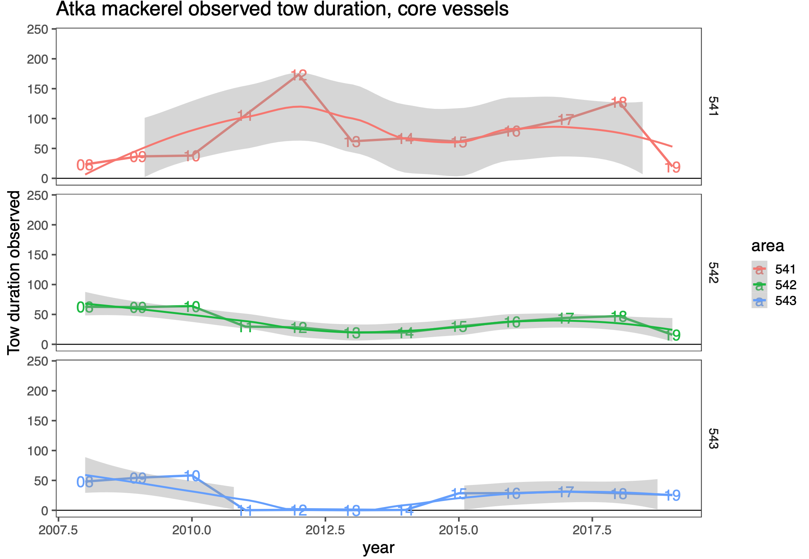

Figure 17C-1. Annual sum of observed tow duration (hours) by Aleutian Islands management areas (541=Eastern, 542=Central, 543-Western) from the eight “core” vessels selected for analysis. Shaded regions generated by smoother through the data.

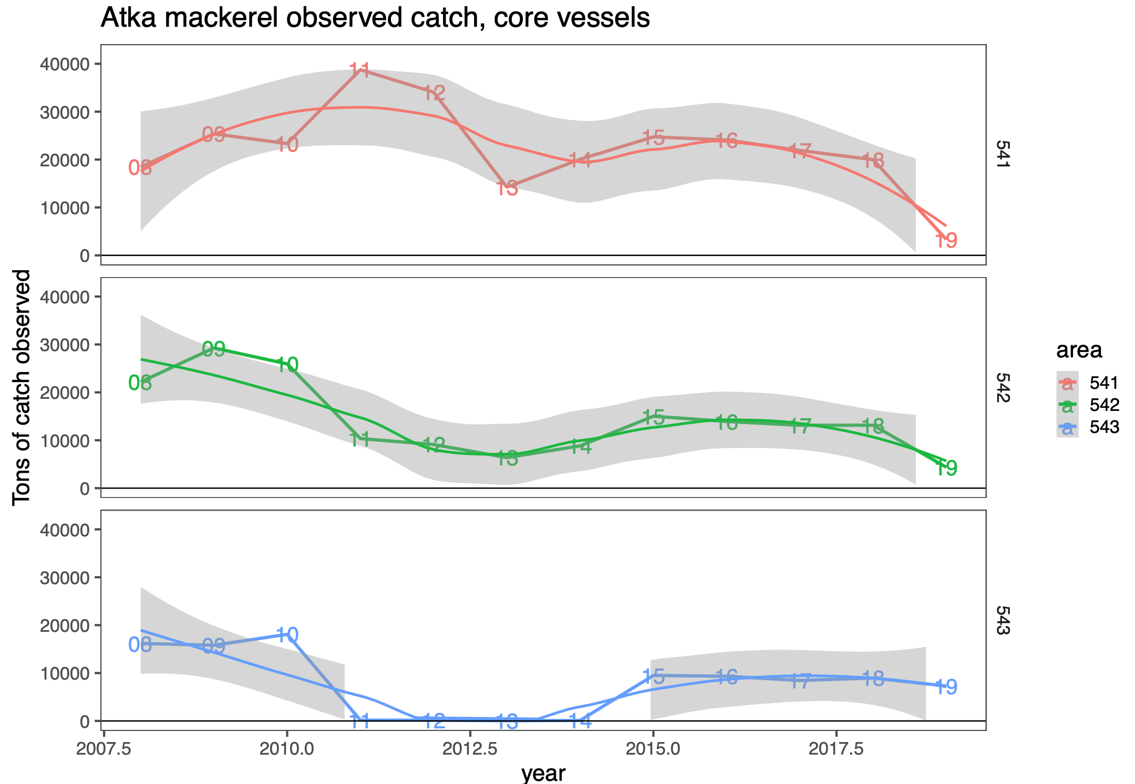

Figure 17C-2. Annual sum of observed catch by Aleutian Islands management areas (541=Eastern, 542=Central, 543-Western) from the eight “core” vessels selected for analysis. Shaded regions generated by smoother through the data.

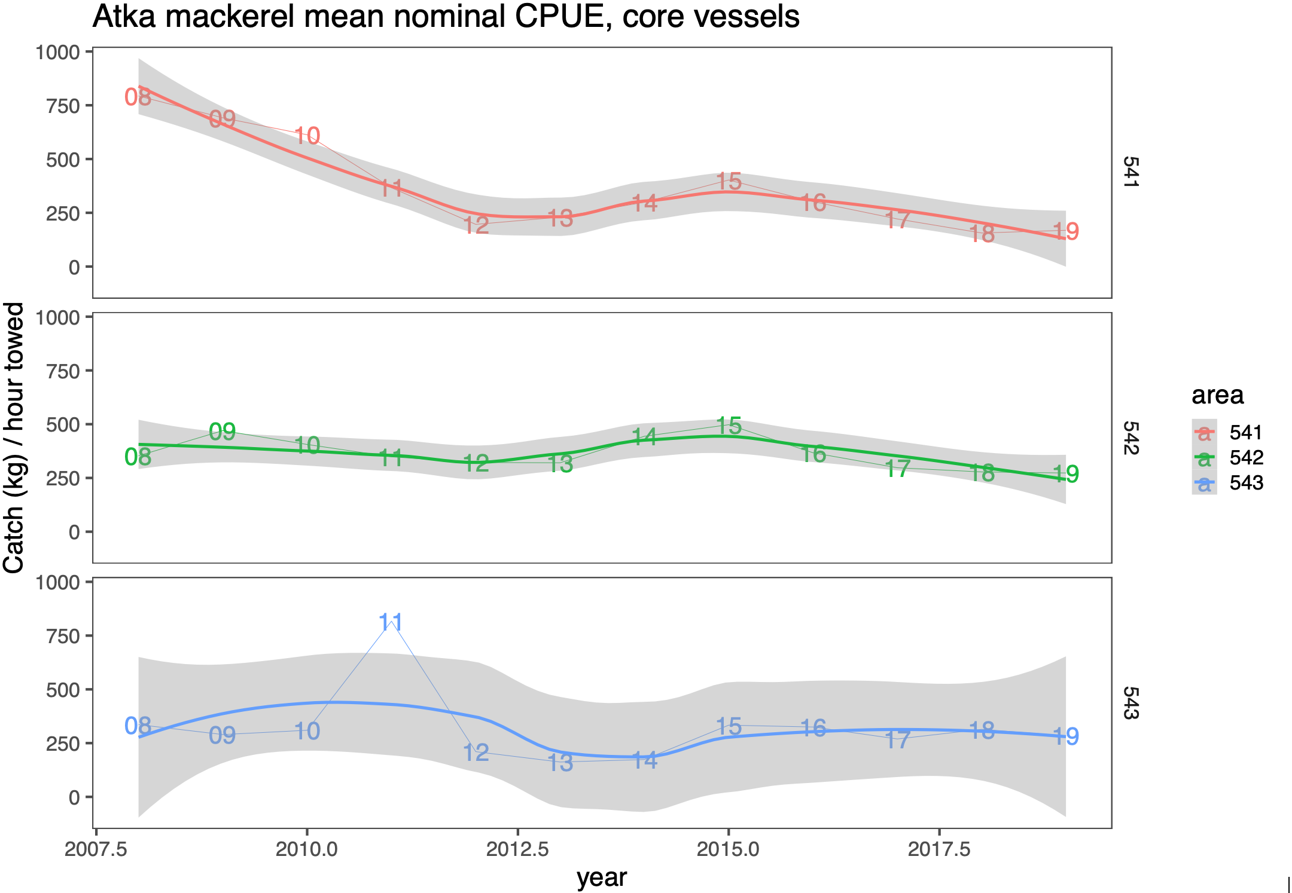

Figure 17C-3. Mean nominal CPUE for Atka mackerel for Aleutian Islands management areas (541=Eastern, 542=Central, 543-Western) from the eight “core” vessels selected for analysis. Shaded regions generated by smoother through the data.

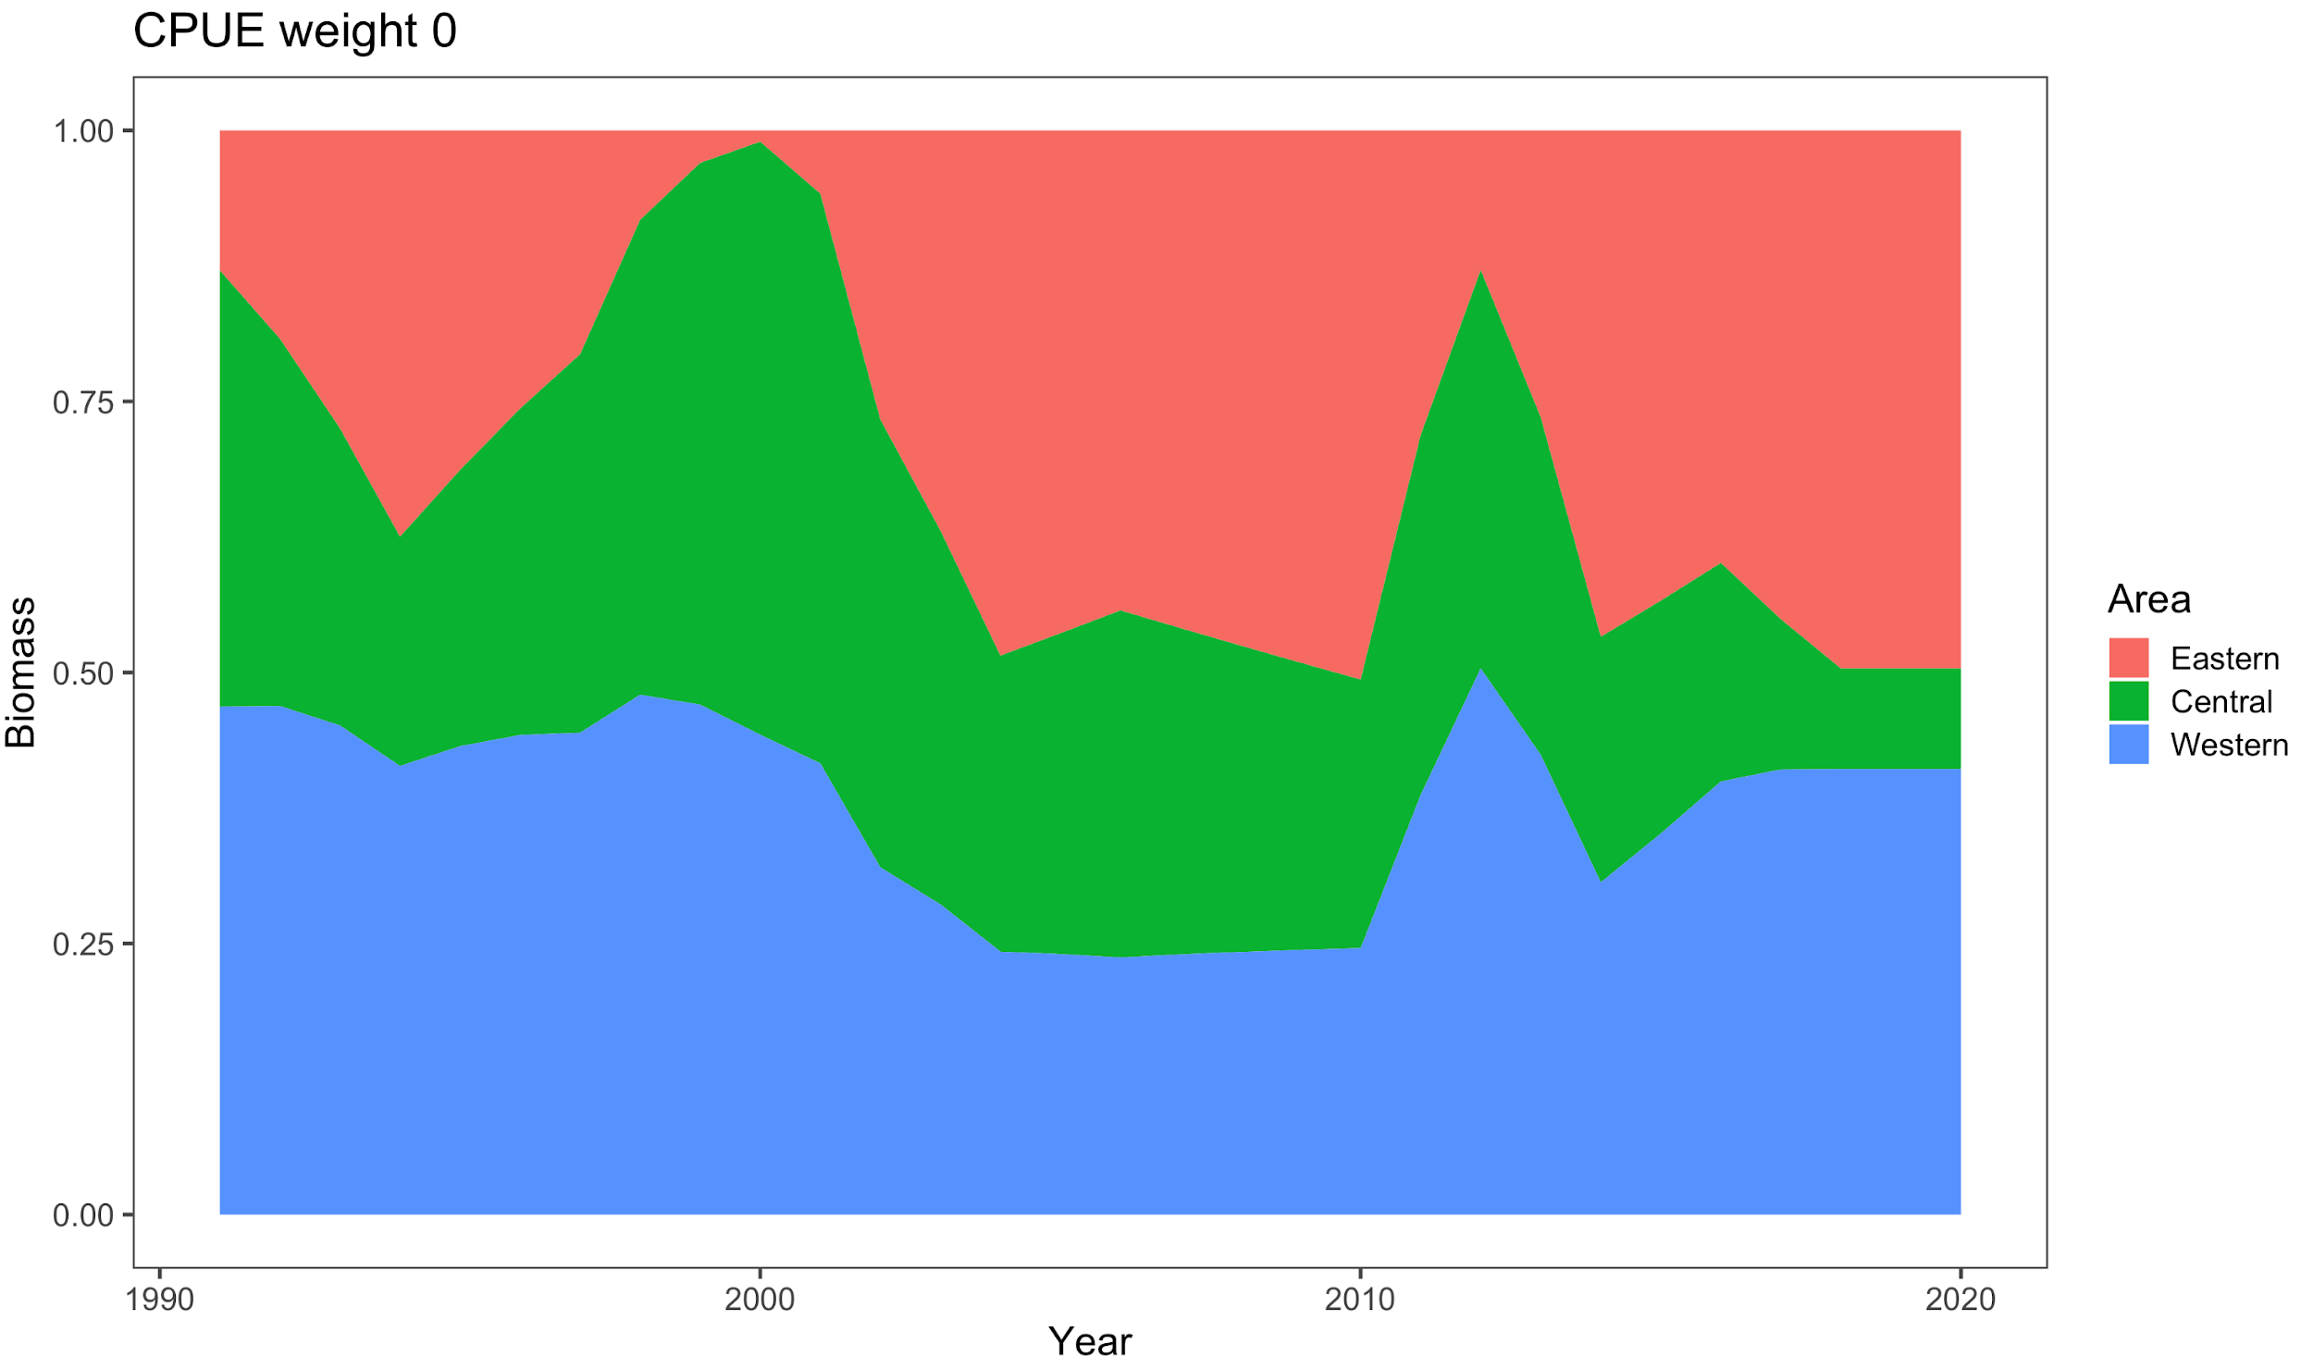

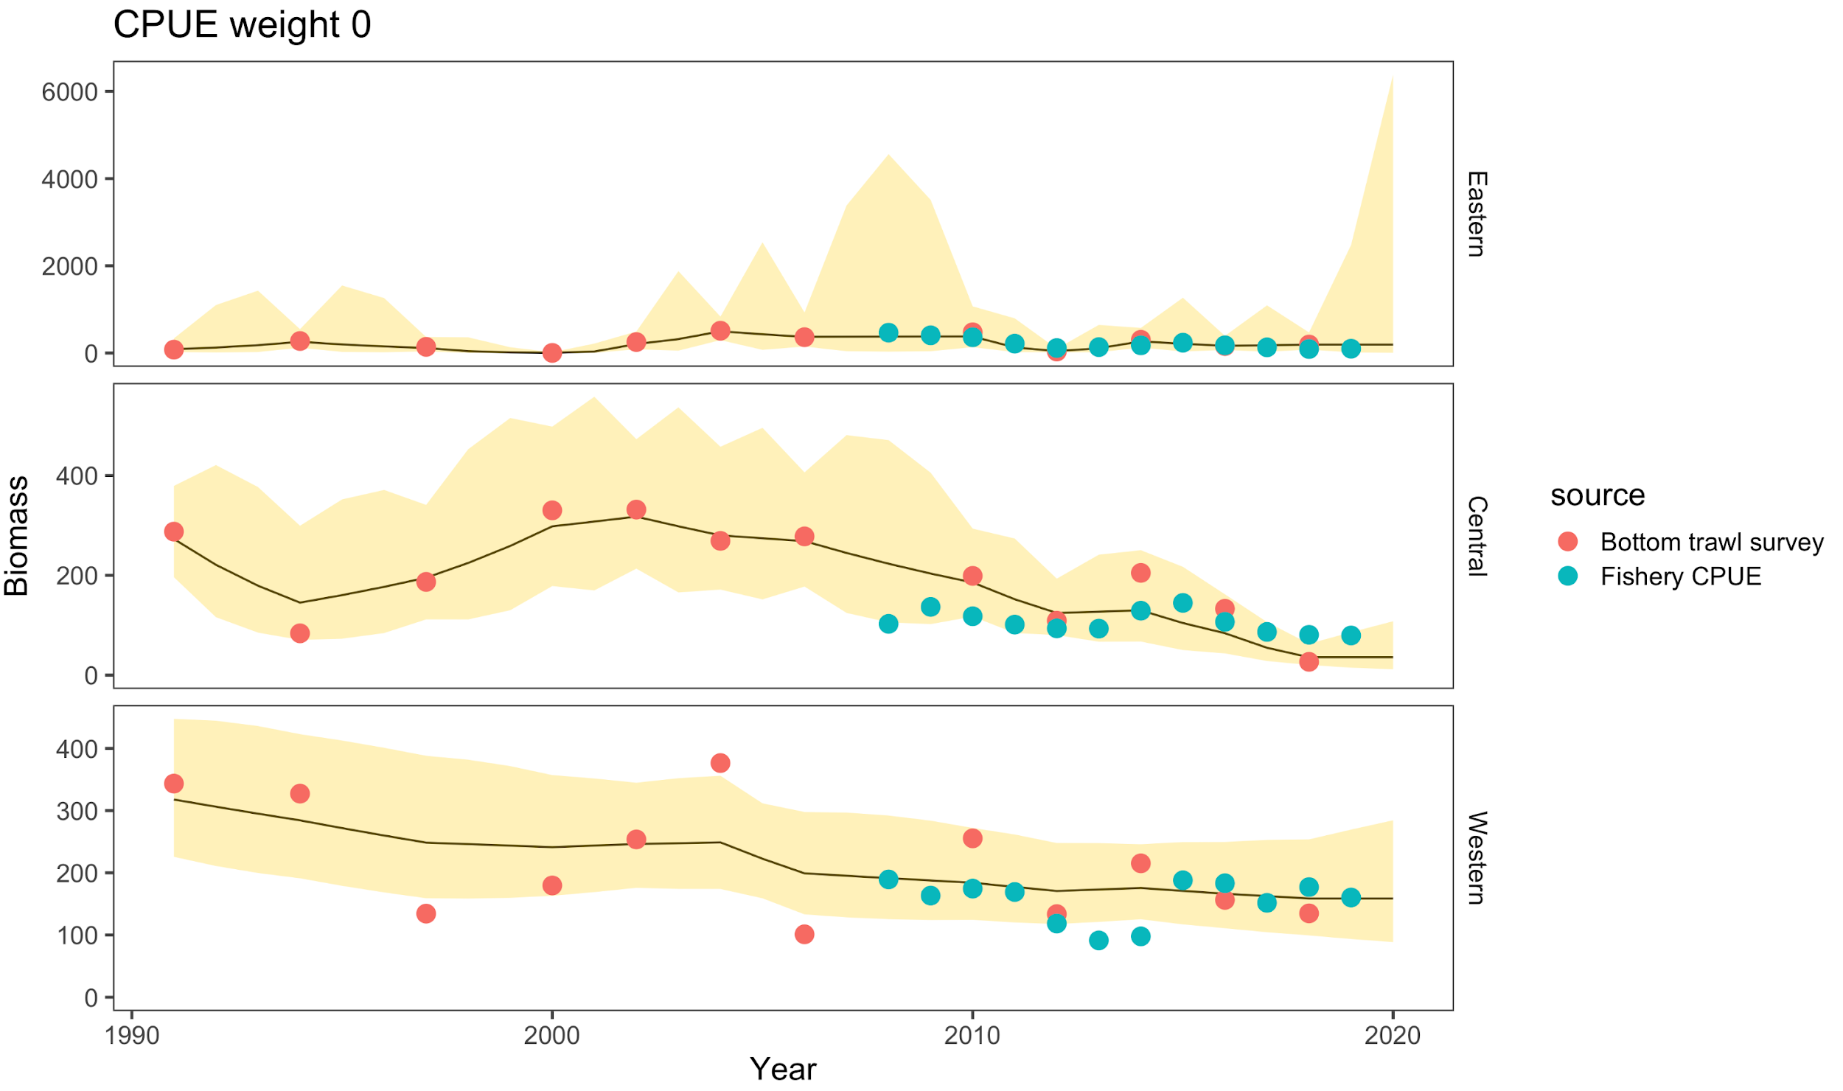

Figure 17C-4. Atka mackerel area-apportionment results fit with the random-effects model with proportions by region over time (top) and fit to both survey and nominal fishery CPUE data (with the western data from 2011-2014 downweighted). In this case, the weight is given to only the bottom trawl survey data for illustration purposes.

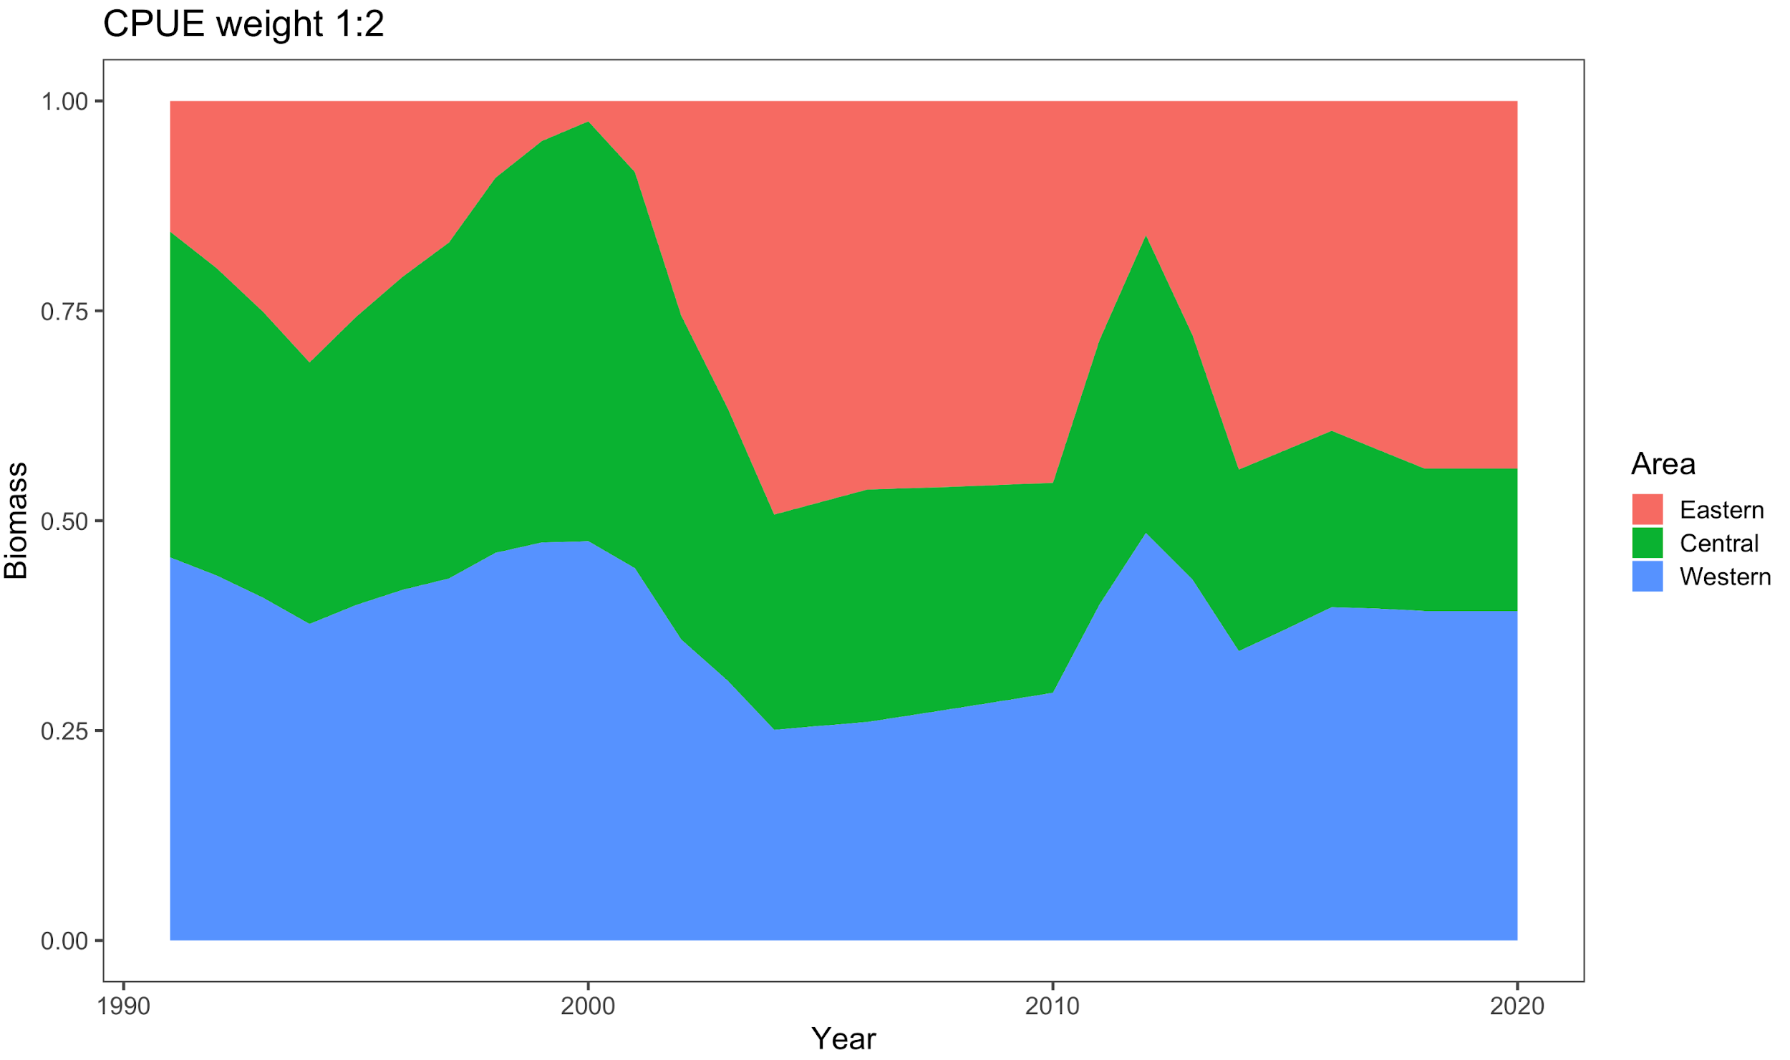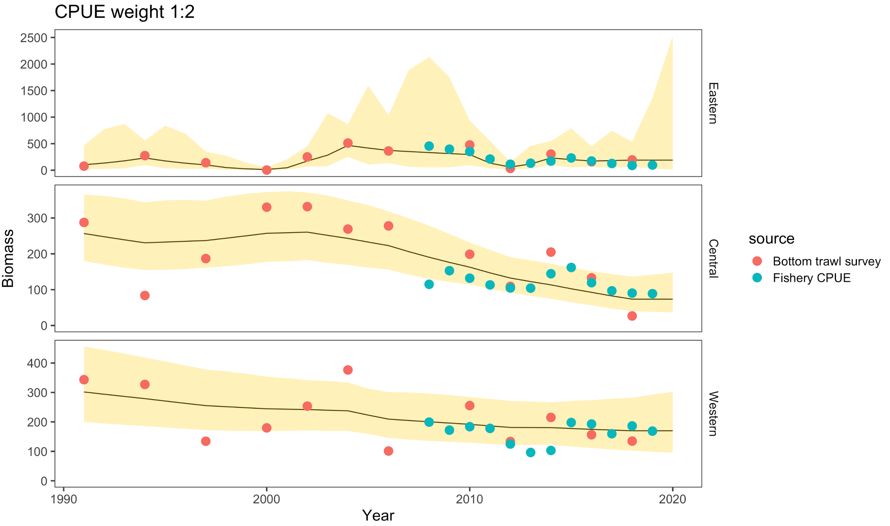

Figure 17C-5. Atka mackerel area-apportionment results fit with the random-effects model with proportions by region over time (top) and fit to both survey and nominal fishery CPUE data (with the western data from 2011-2014 downweighted). In this case, the weight is given to only the bottom trawl survey data for illustration purposes.

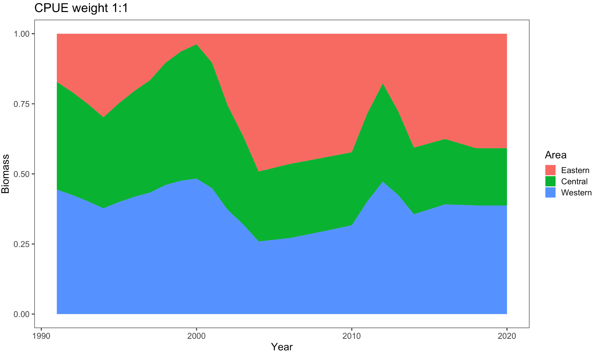

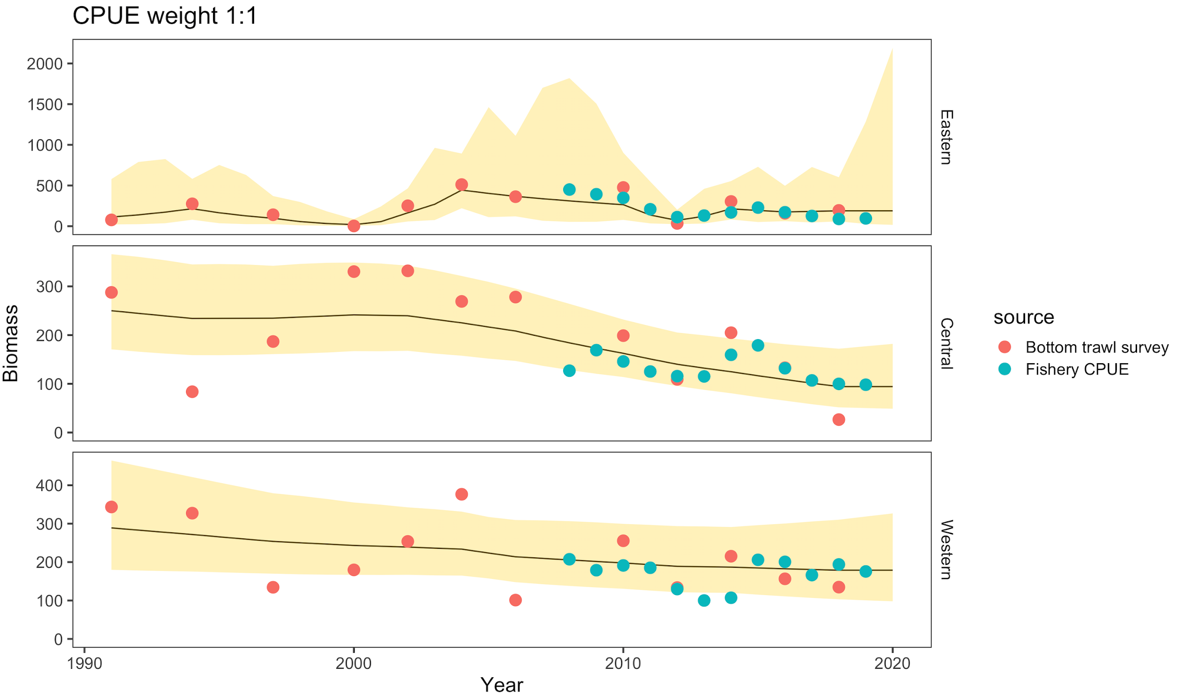

Figure17C-6. Atka mackerel area-apportionment results fit with the random-effects model with proportions by region over time (top) and fit to both survey and nominal fishery CPUE data (with the western data from 2011-2014 downweighted). In this case, the both indices are given equal weight.

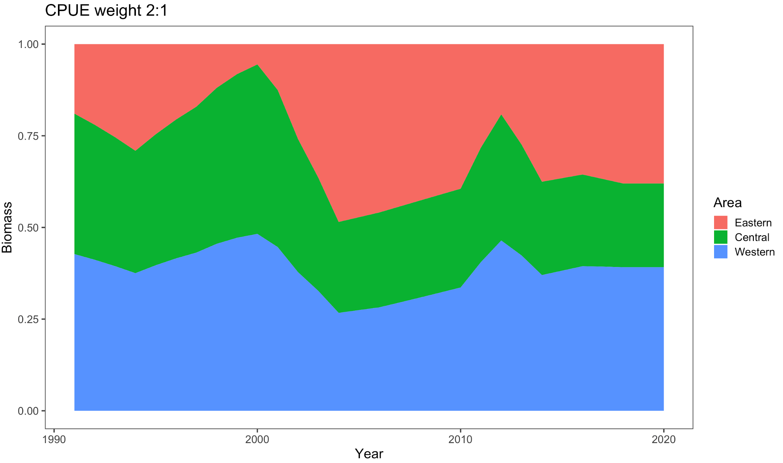

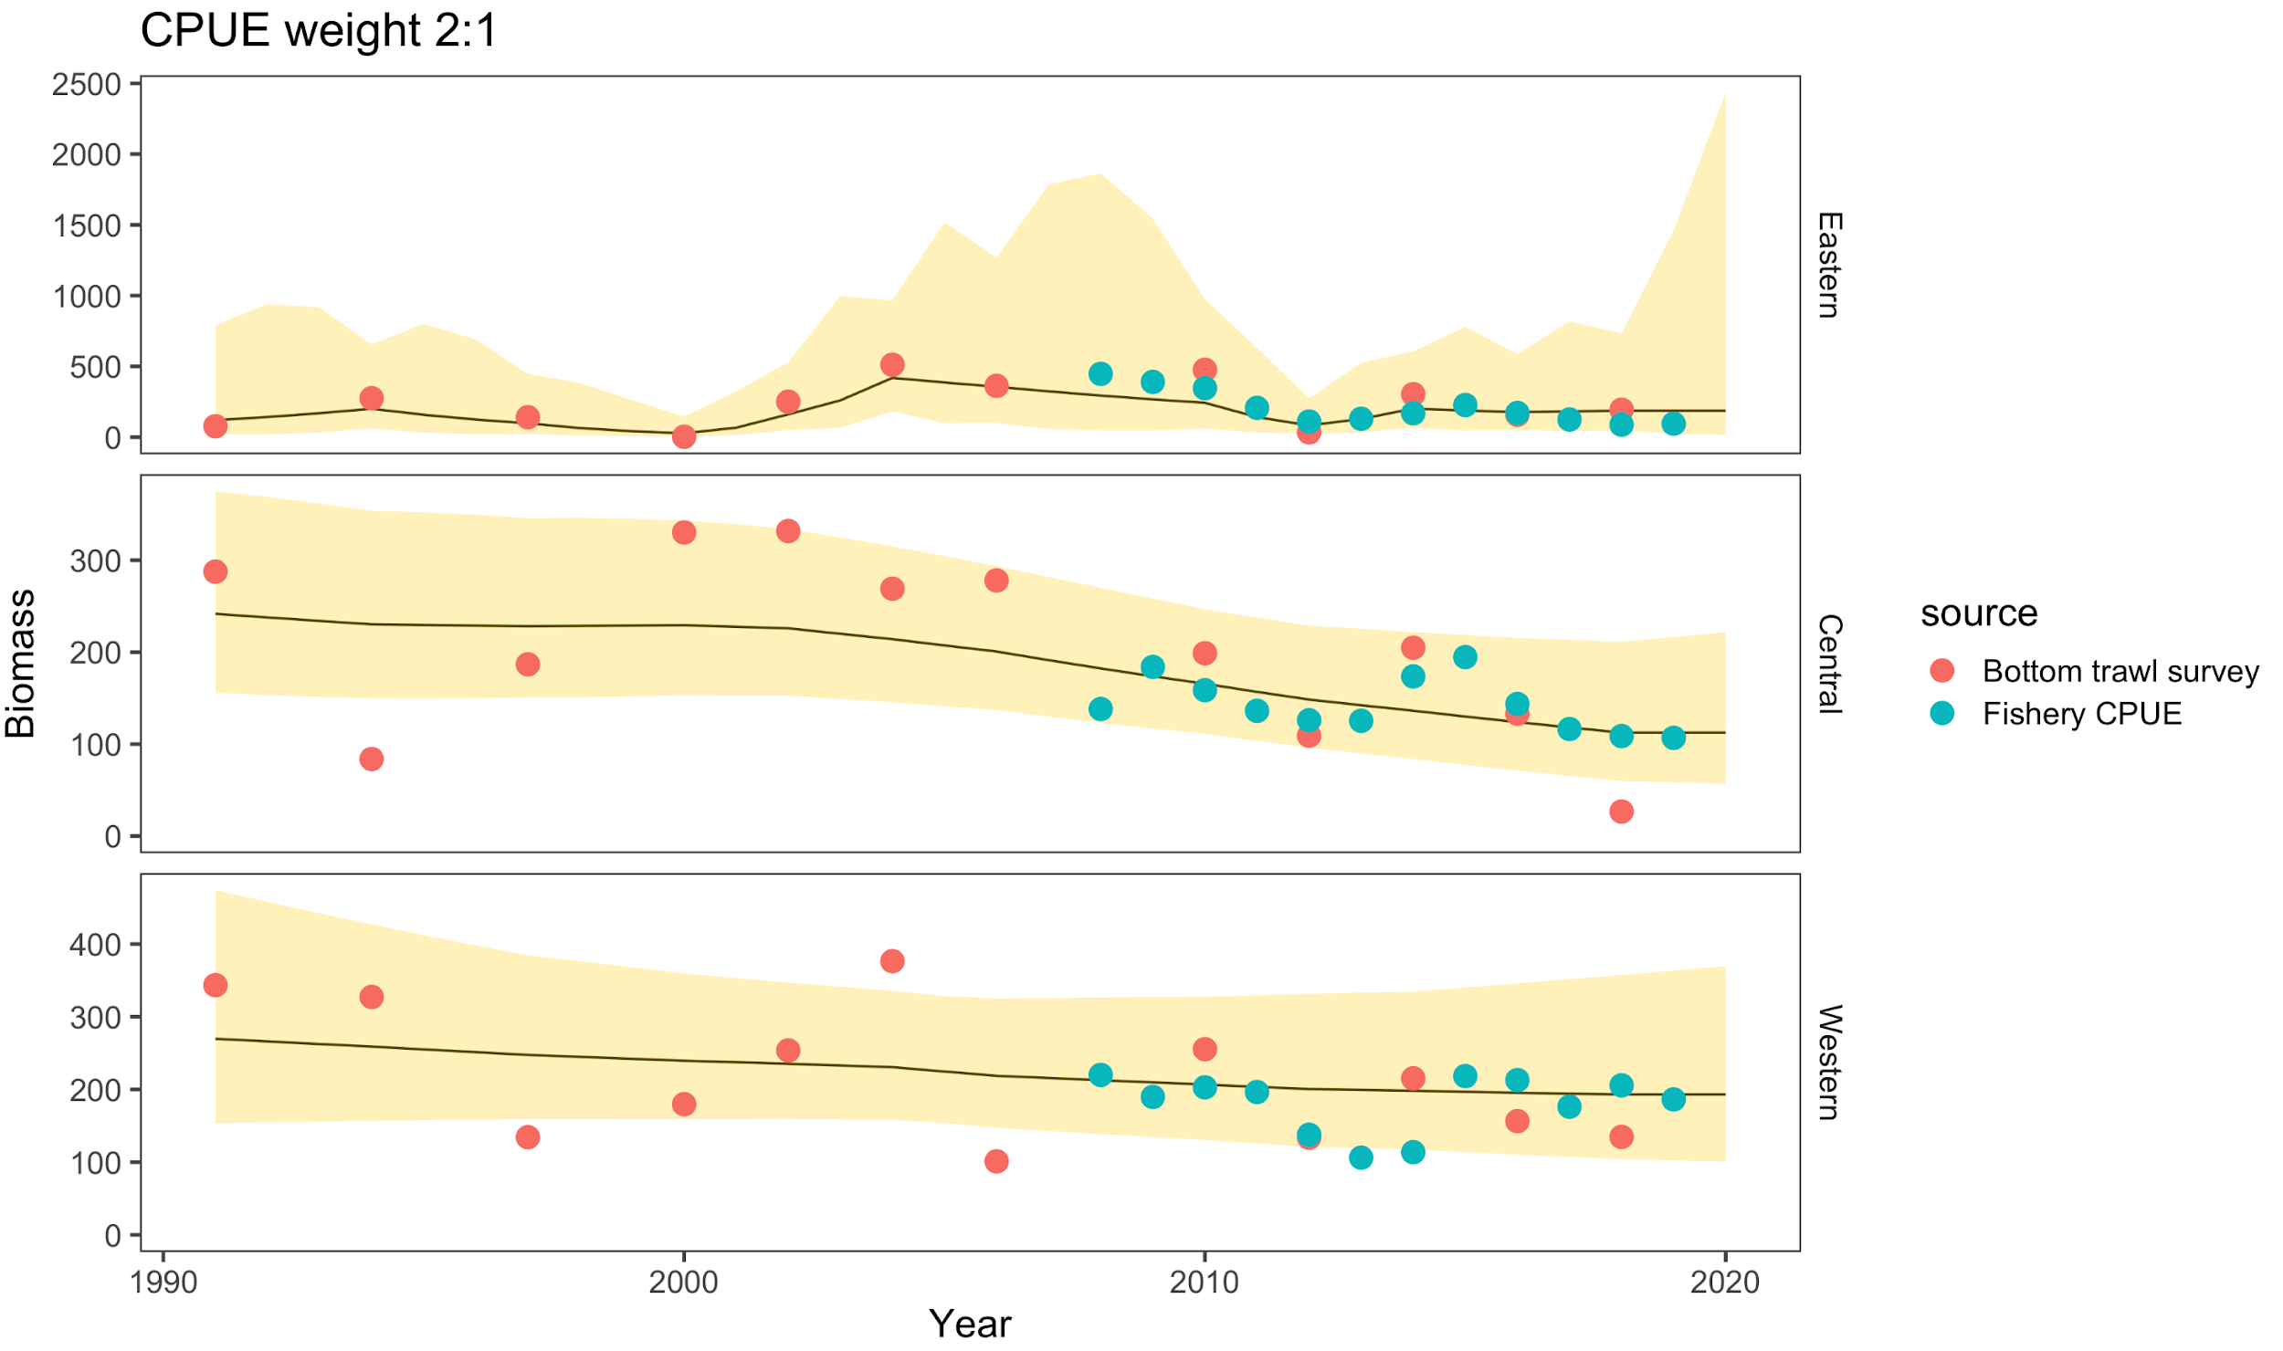

Figure17C-8. Atka mackerel area-apportionment results fit with the random-effects model with proportions by region over time (top) and fit to both survey and nominal fishery CPUE data (with the western data from 2011-2014 downweighted). In this case, the weight is given to only the bottom trawl survey data for illustration purposes.

# Appendix 17D

Table 17D-1. Variable descriptions and model specification.

|  |  |  |  |  |
| --- | --- | --- | --- | --- |
| **General Definitions** | **Symbol/Value** | **Use in Catch at Age Model** | | |
| Year index: *i* = {1977, …., 2018} | *i* | |  | |
| Age index: *j* = {1, 2, 3, …, *A*} | *j* |  | |  |
| Mean weight by age *j* | *Wj* |  | | |
| Maximum age beyond which selectivity is constant | *Maxage* | Selectivity parameterization | | |
|  |  | Dome-shape penalty variance term | | |
| Instantaneous Natural Mortality | *M* | Fixed *M*=0.30, constant over all ages | | |
| Proportion females mature at age *j* |  | Definition of spawning biomass | | |
| Sample size for proportion at age *j* in year *i* |  | Scales multinomial assumption about estimates of proportion at age | | |
| Survey catchability coefficient |  | Prior distribution = lognormal(1.0 , ) | | |
| Stock-recruitment parameters |  | Unfished equilibrium recruitment | | |
|  |  | Stock-recruitment steepness | | |
|  |  | Recruitment variance | | |
| **Estimated parameters** |  |  | | |
|  | | | | |

Note that the number of selectivity parameters estimated depends on the model configuration.

Table 17D-2. Variables and equations describing implementation of the Assessment Model for Alaska (AMAK).

|  |  |  |
| --- | --- | --- |
| **Description** | **Symbol/Constraints** | **Key Equation(s)** |
| Survey abundance index (*s*) by year |  |  |
| Catch-at-age by year |  |  |
| Catch biomass |  |  |
| Initial numbers at age | *j = 1* |  |
|  | *A 1 < j < A* |  |
| Maximum age | *j = A* |  |
| Subsequent years (*i >1977*) | *j = 1* |  |
|  | *1 < j < A* |  |
|  | *j = A* |  |
| Year effect, *i* = 1967, …, 2018 | *εi,* |  |
| Index catchability  Mean effect    Age effect |  |  |
| Instantaneous fishing mortality |  |  |
| mean fishing effect | *μf* |  |
| Annual effect of fishing in year *i* | *φi*, |  |
| Age effect of fishing (regularized) in year time variation allowed  In years where selectivity is constant over time | , | *,* |
| Natural Mortality | *M* |  |
| Total mortality |  |  |
| Recruitment   Beverton-Holt form |  |  |

Table 17D-3. Specification of objective function that is minimized (i.e., the penalized negative of the log-likelihood).

|  |  |  |
| --- | --- | --- |
| Likelihood /penalty component |  | Description / notes |
| Biomass indices |  | Survey biomass |
| Prior on smoothness for selectivities | $$λ_{2}^{l}=\frac{1}{2σ_{f_sel}^{2}}$$ | Smoothness (second differencing),  Note: *l={s,* or *f}* for survey and fishery selectivity |
| Prior on extent of dome-shape for fishery selectivity |  | Allows model some  flexibility on degree of  declining selectivity at age |
| Prior on recruitment regularity | $$L_{4}=λ_{4}\sum_{i}{}ε_{i}^{2}+$$ $$\sum_{i}{}\frac{{\left({lnR}_{i}-{ln\hat{R}}_{i}\right)}^{2}}{σ_{R}^{2}}$$ | Influences estimates where data are lacking (e.g., if no signal of recruitment strength is available, then the recruitment estimate will converge to median value). |
| Catch biomass likelihood | $$L_{5}=λ_{5}\sum_{i}{}{\left({lnC}_{i}-{ln\hat{C}}_{i}\right)}^{2}$$ | Fit to catch biomass |
| Proportion at age likelihood |  | *l={s, f}* for survey and fishery age composition observations |
| Fishing mortality regularity | $L_{}=λ_{}\sum_{i}{}ϕ_{i}^{2}$ | (removed in final phases of estimation) |
| Priors |  | Prior on natural mortality, and survey catchability (reference case assumption that *M is* precisely known at 0.3). |
| Overall objective function to be minimized |  |  |

1. Japan and Russia catch the distinct species Okhotsk Atka mackerel (*Pleurogrammus azonus*) which are substitutes as the markets treat the two species identically.
2. AMAK. 2015. A statistical catch at age model for Alaska, version 15.0. NOAA version available on request to authors.
3. Quasi likelihood is used here because model penalties (not strictly relating to data) are included.
4. Because Atka mackerel is only targeted by at-sea catcher/processor vessel there is not an effective ex-vessel market for it. Though ex-vessel statistics are computed for national reporting purposes.
5. Japan and Russia catch the distinct species Okhotsk Atka mackerel which are substitutes as the markets treat the two species identically.